July 5, 2018

Course: CIS570 – Business Intelligence

Name: Robert Palumbo

Assignment: HOE Data Visualization Part 1 - PowerBI

Due Date: Thursday, July 5@ 11:59pm

Re: PowerBI Report Charts

Report charts are on the following pages:

* **Population by Country**
* **Population & CO2 Comparisons – Column Chart**
* **Group of 8 Analysis – Interactive Scatter Chart**
* **World Population - Map**
* **GDP & CO2 Comparisons – Bubble Map**

1. **Population by Country**

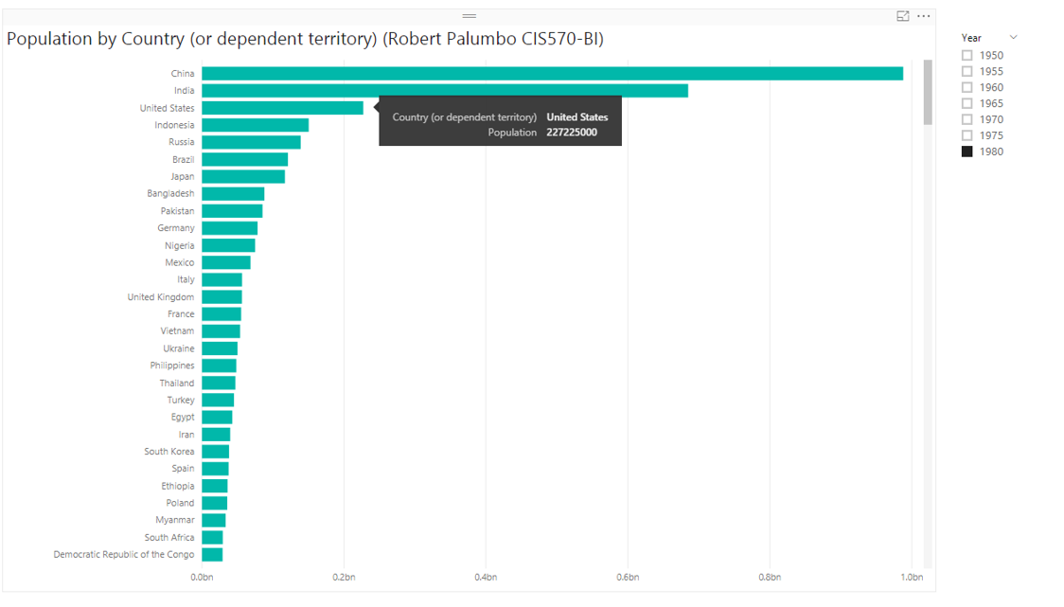

1. **Population & CO2 Comparisons – Column Chart**

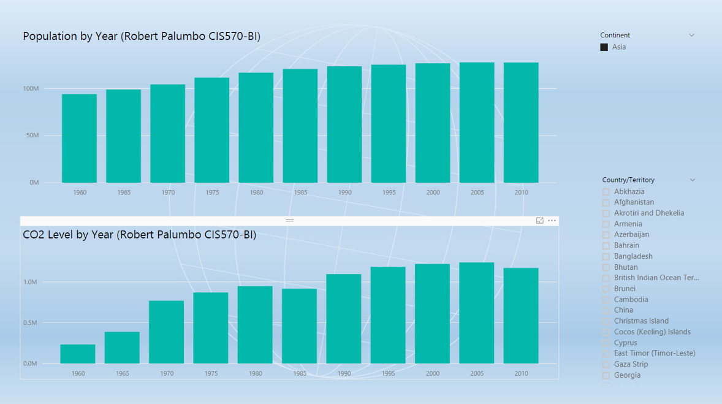

1. **Group of 8 Analysis – Interactive Scatter Chart**

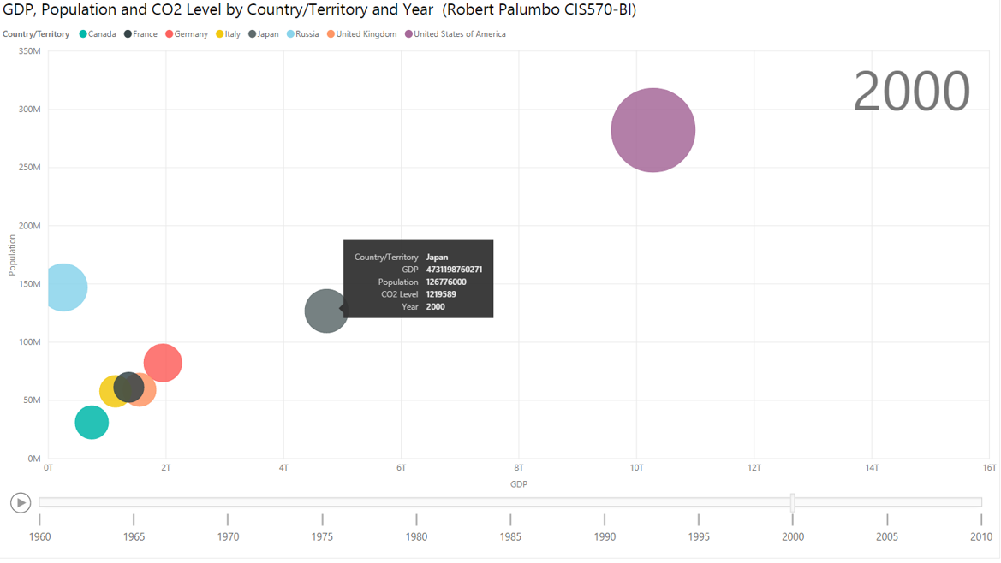

1. **World Population - Map**

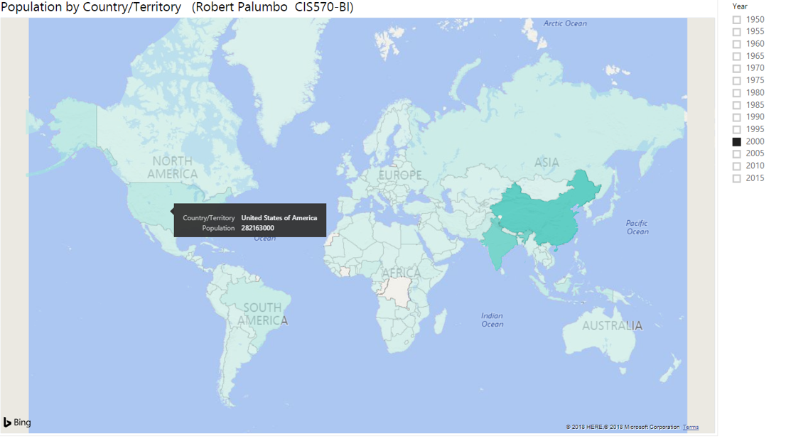

1. **GDP & CO2 Comparisons – Bubble Map**

