July 8, 2018

Course: CIS570 – Business Intelligence

Name: Robert Palumbo

Assignment: HOE Data Visualization Part 2 - PowerBI

Due Date: Thursday, July 8@ 11:59pm

Re: PowerBI Report Charts

Report charts are on the following pages:

Table of Contents

1. Sales in US Dollars by Sales Person 2

2. West Coast Sales Report 3

3. Customer Information 4

4. Sales in Units by Promotion 5

5. Sales in Units 6

6. Sales in US Dollars and Sales in US Dollars LY by Year 7

7. Sales YTD and Sales LY YTD by Month 8

8. Percent of Sales Report 9

# Sales in US Dollars by Sales Person

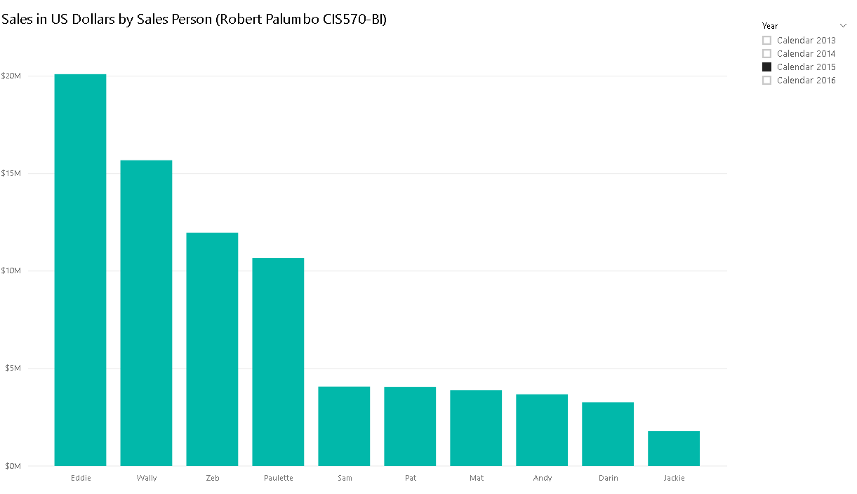

# West Coast Sales Report

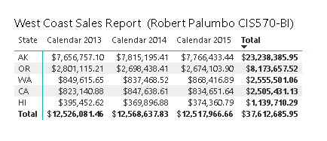

# Customer Information

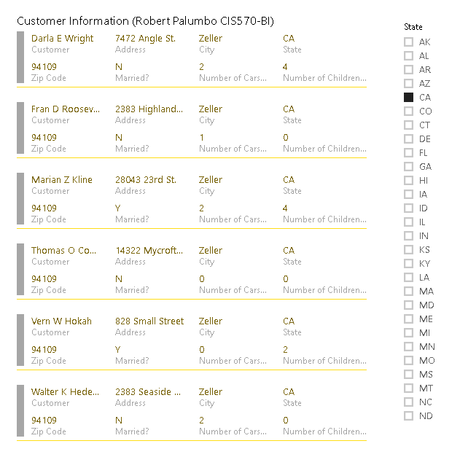

# Sales in Units by Promotion

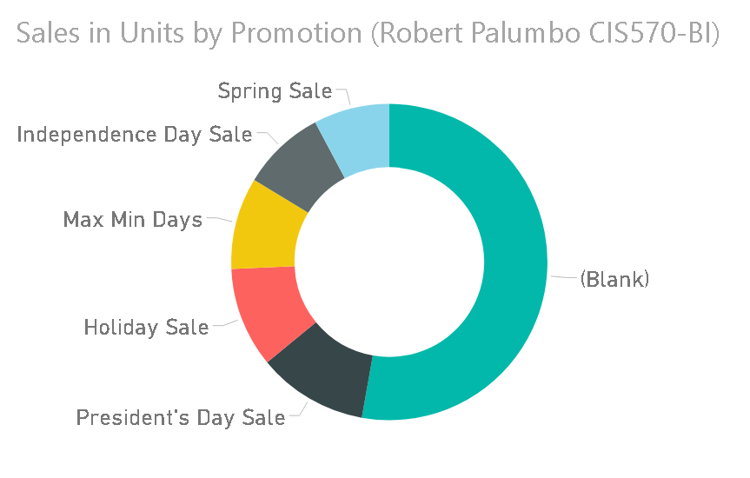

# Sales in Units

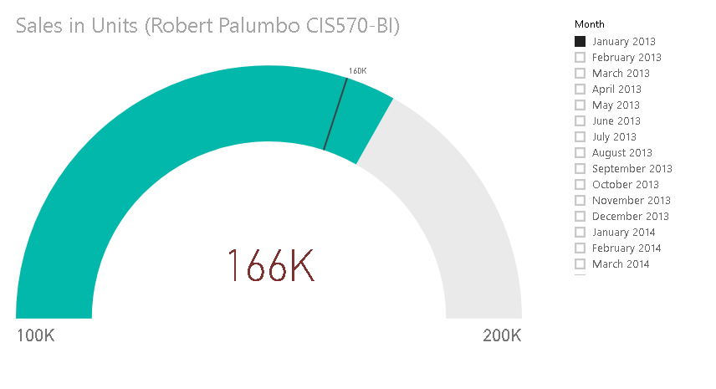

# Sales in US Dollars and Sales in US Dollars LY by Year

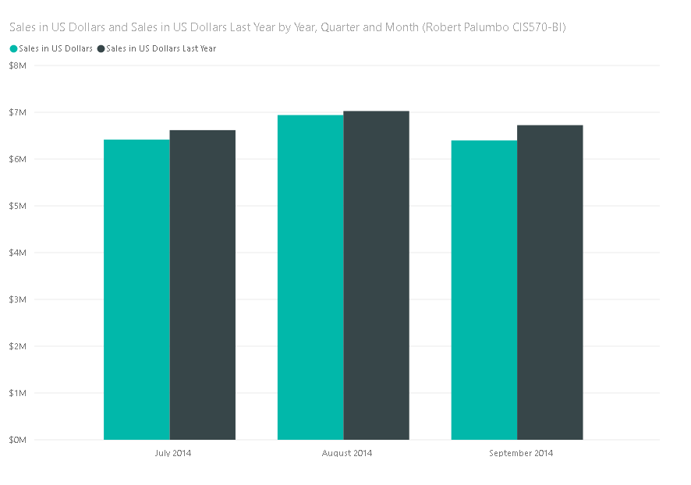

# Sales YTD and Sales LY YTD by Month

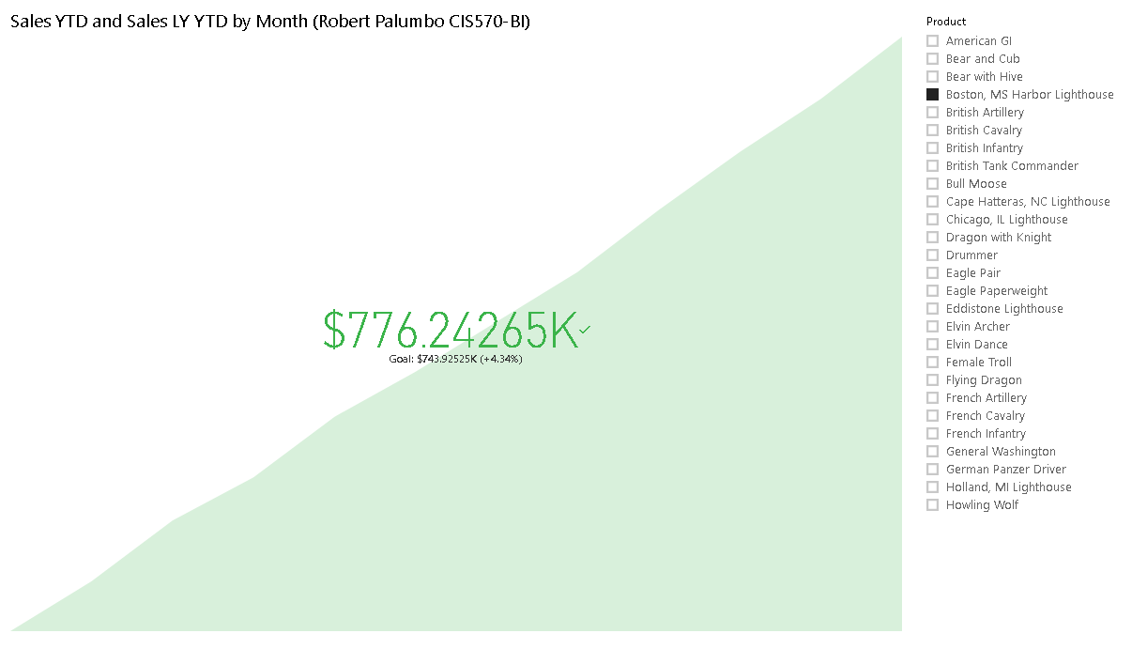

# Percent of Sales Report

