June 24, 2018

Course: CIS570 – Business Intelligence

Name: Robert Palumbo

Assignment: Reading Discussions – Week6-Session2

Due Date: Sunday, June 24 @ 11:59pm

Question 1. Attach a picture or a link to one in support of the adage, “a picture is worth a thousand words”.

One of my favorite visualizations of all time is that of the *Tip-of-the-Iceberg*. It is a clear and concise representation of the adage above. Here are 2 pictures as it is applied to a couple of applicable technologies.

Tip-of-the-Iceberg for BIG DATA!



Tip-of-the-Iceberg for Cloud-Services!

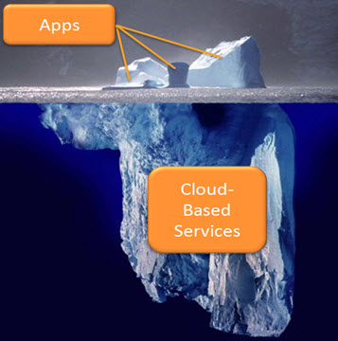

<https://twitter.com/nine23_mobile/status/662578842507284480>

<https://www.harrisgeospatial.com/Support/MaintenanceDetail/TabId/3428/ArtMID/13350/ArticleID/16424/Anatomy-of-an-App%E2%80%A6or-%E2%80%9CJust-the-Tip-of-the-Iceberg%E2%80%9D.aspx>

Question 2. Discuss a data/visualization driven media article.

For this question I chose an article from the NYTimes reference link entitled *“Before and After Satellite Images of Mosul Reveal the Devastation After the Islamic State Was Forced Out.”*

The images presented within the article show before and after views of various segments of the city of Mosul which at the time (2015) was the 2nd largest city in Iraq. A nine-month long campaign of war was waged against the Islamic State which had taken over and controlled the city. Mosul has a very diverse ethnic and diverse population with a very prosperous industrial and agricultural based economy. However, with the rise of the Islamic State within the city, it soon became a hub for support of international terrorism. In the effort to neutralize the stranglehold that ISIS held over the city, a major war effort was undertaken to remove ISIS and return the city back to the Iraqi citizens.

The images in the article document the horrible and utter destruction of the city – all incurred in the 9-month campaign. Medical complexes, ancient buildings, bridges, entire neighborhoods, mosques and so much more were completely obliterated.

The article and its stark contrasting images drive home without question the horrors of war. One only needs to view a single image to ascertain the level of destruction and associated loss of life – much of which was civilian.

Almost 3 years have now past and while much of the city is still in ruins it is slowly beginning to heal and rebuild itself. Only time will tell as to what extent it will be able to recover.

Mosul-Before:

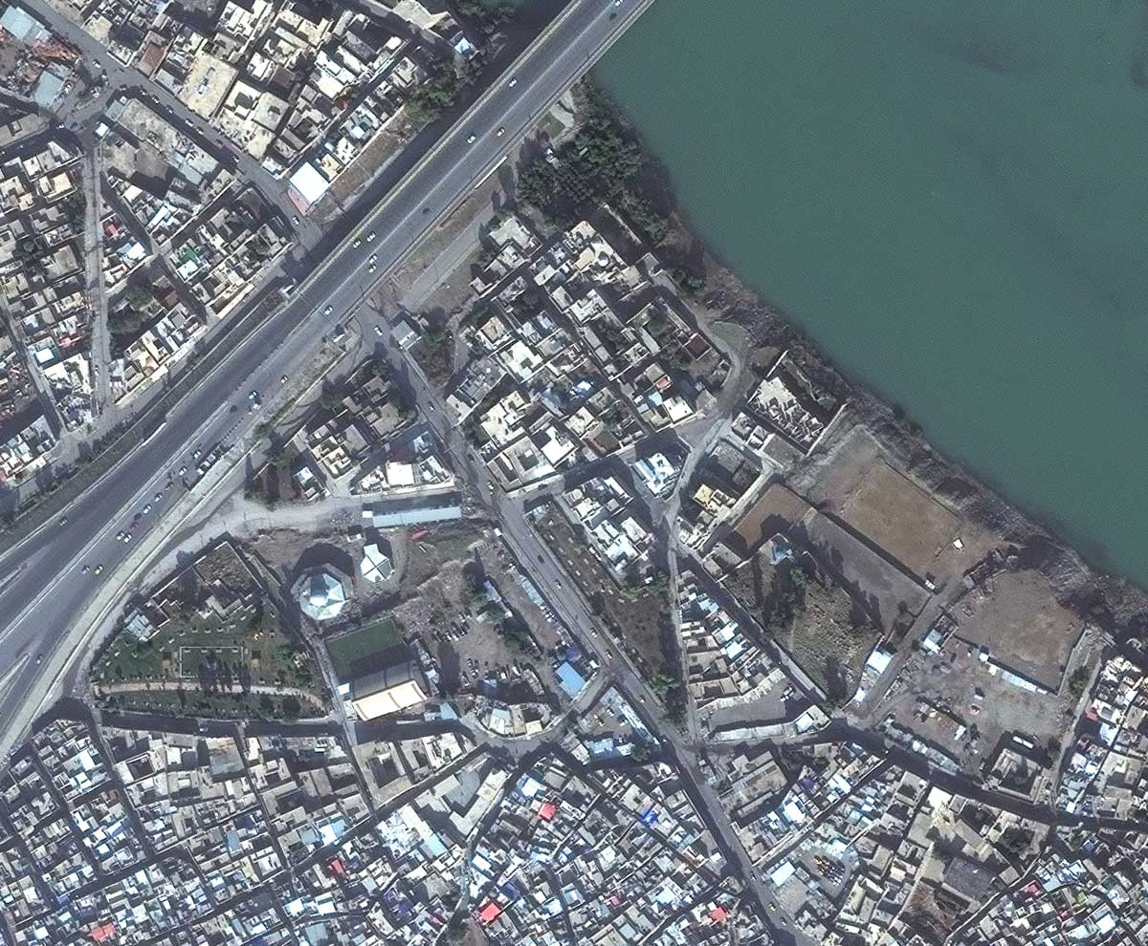

Mosul After:

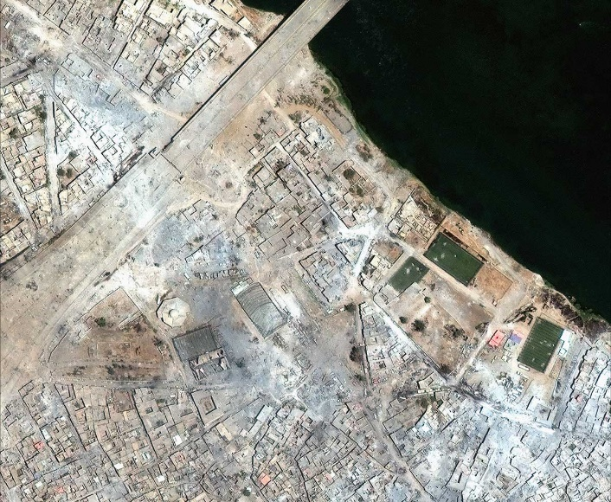

<https://www.nytimes.com/interactive/2017/07/15/world/middleeast/mosul-before-after.html>

<https://www.npr.org/sections/parallels/2018/03/03/587726649/months-after-isis-much-of-iraqs-mosul-is-still-rubble>

<https://www.britannica.com/place/Mosul>