Course: CIS655 – Ecommerce Applications
Name: Robert Palumbo
Assignment: Course Project Proposal
Due Date: Tuesday January 23, 2018

Description
Home Prescription (RX) Tracker Website. The purpose of this website will be to allow registered users to track and manage prescribed drug and medicinal prescription information securely in their own private accounts. Users can optionally include reminder notifications when intake of a prescription is due as well as for required refills.

Description
Website Functionalities:
- User Account creation and deletion
- Log In and Log Out of site
- RX Prescriptions
  - Add, Delete, Update, View
  - Notifications
    - Add, Update, Delete
- Pharmacy Info: business entity that will process prescription(s)
  - Add, Delete, Update, View
- Doctor – primary caregiver information
  - Add, Delete, Update, View

Assumptions
This website will be designed to be used by any individual that would like to automate (to an extent) tracking of their RX prescriptions. If time permits I would add a requirement that the users be of age 18 or older to access and enter data into this site.

Web Pages
The website will contain at a minimum the following web pages:
- Login web page. This will be the main screen and will look like this:
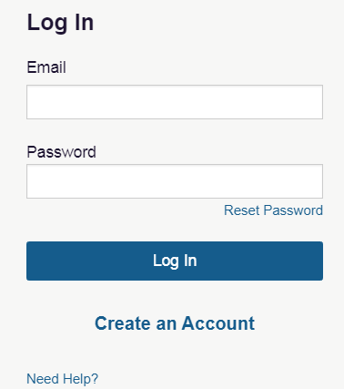

- Log out web page: This will be a simple page showing that the user has successfully logged out of the site. I will likely return the user to the main login page above.
- Main Page after successful login: This page will be displayed automatically when the user successfully logs in. It will display a summary of current prescribed medicines to include: med name, dosage, frequency, refill count, reminder info. From this page the user will also be able to modify med information, pharmacy information, and doctor information. The user will also be able to update and delete there associated account.
- Add user account: This page will be displayed when the user clicks on the ‘Create an Account’ button on the main login page. It will take as input user First/Last Name, Desired UserID, Email address, Password with verification.
- Update user account: This page will be used to update the user’s account information entered. The user can update First/Last Name, Email, and Password but the UserID cannot be changed.
- Delete user account: This page will be displayed

Validations

Model Sites

