Colorado State University
CIS665 – ECommerce Applications
Robert Palumbo
Final Exam Part 1
Due: May 4, 11:59pm

SQL Server: buscissql1601\cisweb
Database: PalumboExamDB

Database Diagram – Entity Relationships
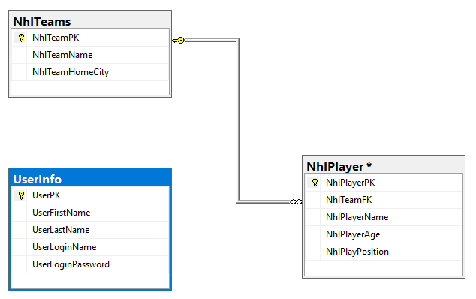

Tables / Columns / Keys
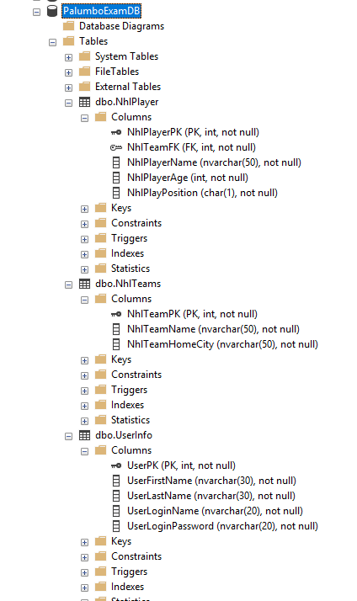

NHL Teams / Players Data
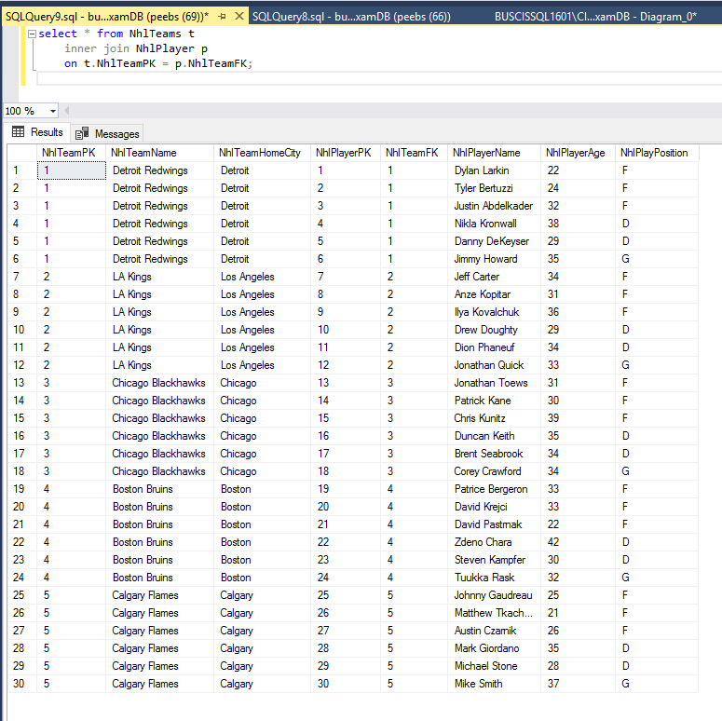

UserInfo Table Data
