CS454

Assignment 3

Design by: Johnson Chan and Andrew Jenkins

System Manual

Marshalling/Unmarshalling Data

The protocol for sending and receiving data between clients, server, and binder is as follows: first send an integer representing the length of a message to follow, then send an integer representing the type of request, then proceed to send the proceeding messages, which depend on the request/response type.

The length message is used to receive the number of arguments for a function, so that we may loop through and receive one containing for individual function argument. From the request type, the binder or RPC library will decipher, via hard-coded switches, the number of messages to follow and their argument types. In other words, data marshalling and unmarshalling is hard-coded and dependent on the type of request.

rpcInit: sends/receives no more data than initial length and type messages.

rpcRegister: sends: register request (int), hostname (char*), port (int), function name (char*),

argTypes (int*)

receives: response code (int)

rpcCall: sends: location request (int), function name (char*), argTypes (int*)

receives: function location response (int), port (int), hostname (char*),

sends: execute request (int), function name (char*), argTypes (int*), arg1 (void*),

arg2 (void*) … argn (void*)

receives: response code (int), function name (char*), argTypes (int*), arg1 (void*),

arg2 (void*) … argn (void*)

rpcExecute: receives: function name (char*), argTypes (int*), arg1 (void*), arg2 (void*)

… argn (void*)

sends: response code (int), function name (char*), argTypes (int*), arg1 (void*),

arg2 (void*) … argn (void*)

Binder Database

The binder database is in the form of a map of server_info and vector<function_info> where:

- **server_info** is a struct containing server_socket (int), server_name (string), port_num (int)

- **function_info** is a struct containing function_name (string), argTypes (int*), numArgs (int)

Insertion of a server into the binder database happens when rpcRegister is called by a server. When the binder receives the register request, handle_register_request is called.

First, the binder checks whether the server or the function is already in the database. It does this by looping through the database and checking if there's a server with the same information in the database. If there is, it checks if the function is in the database by searching the list of function information contained in the database for the server.

If the server and the function are both already in the database, a DUPLICATE_REGISTER message is sent back to the server.

If the server is not in the database, we create a server_info struct containing the server's information which was sent in the register request, then insert the server to the map. We then add the function information to to the list of function_info for the server.

If the server is already in the database, but the function is not in the server's list of function_infos, then a function_info struct is created containing the information sent in the request, and added to the back of the list in the list for the server within the map.

A success message is then returned to the server, to signify that the function has been successfully registered (and that the server has been registered, if it is new).

Function Overloading

In the binder server database, registered functions are stored in a list for each individual server. The registered functions are considered new and added to the list if and only if there is no function with the same name, the same number of arguments, and the same argument types.

If rpcCall is called on a function, the rpc library will also search for the function based on the function name, number of arguments, and argument types. Thus, multiple functions may have the same name, so long as they have different arguments.

If a function with the same name, number of arguments, and argument types as another function is registered, a DUPLICATE_REGISTER function will be thrown to the server, indicating that the function already exists in the database.

Scheduling

We use a vector vector<server_info> called all_servers to store all the connected servers in order to accomplish round robin scheduling, where:

- **server_info** is a struct containing server_socket (int), server_name (string), port_num (int)

When a client makes a rpcCall to a specific function, the binder searches through the binder database of all servers for every server that has said function registered—creating an array called valid_server containing these servers in the order that they are found. Then the binder will search through all_servers from the beginning to end to see if the server is in the valid_server.

Following this, the first “valid server” in all_servers is sent to the client. After sending the server location, binder will put the first “valid server” at the back of all_servers so that next time it will have lower priority being called.

Example:

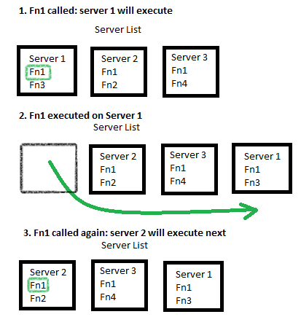

Therefore, the system implements a form of round-robin scheduling for remote procedure calls.

Termination Procedure

We use a vector vector<int> called servers_socket to store all the connected socket of servers.

When the binder receives a TERMINATE request, it proceeds through the list of server sockets and sends a TERMINATE request to every server individually.

If a server is in the middle of execution, and receives a TERMINATE request, the server will wait for all threads to finish execution (wait until number of threads < 0 and do not allow creation of any new threads), then stop listening for requests, and cease execution.

Once the server is closed, the binder will remove it from the binder database, the all_servers list and the servers_socket list. If all three data structures are empty and the TERMINATE requests are sent, the binder will then terminate itself.