NAME: PALURU PRAVALIKA
REG NO: 192371011
SLOT D
JAVA PROGRAMMING
QUESTION:
A shared listener object is registered on both a “Save” button and a “Save As” menu item that should trigger closely related but not identical logic. Explain how you would use the ActionEvent&#39;s action command string to differentiate the two triggers inside one listener method, rather than writing two separate listener classes
AIM :To implement a single shared ActionListener for both a Save button and a Save As menu item, using the ActionEvent's action command string to identify which control triggered the event.
PSEUDOCODE:
START
Create Save button
Create Save As menu item
Set action command of Save button as "SAVE"
Set action command of Save As menu item as "SAVE_AS"
Create one shared ActionListener
When actionPerformed(ActionEvent e) occurs:
command ← e.getActionCommand()
IF command = "SAVE" THEN
Perform normal Save operation
Display "File saved"
ELSE IF command = "SAVE_AS" THEN
Ask user for new file name
Perform Save As operation
Display "File saved with new name"
END IF
Register the same listener with both controls
STOP
CODE:
import javax.swing.*;
import java.awt.event.*;
public class SaveExample {
public static void main(String[] args) {
JFrame frame = new JFrame("Save Example");
JButton saveButton = new JButton("Save");
JMenuBar menuBar = new JMenuBar();
JMenu fileMenu = new JMenu("File");
JMenuItem saveAsItem = new JMenuItem("Save As");
saveButton.setActionCommand("SAVE");
saveAsItem.setActionCommand("SAVE_AS");
ActionListener listener = new ActionListener() {
public void actionPerformed(ActionEvent e) {
String command = e.getActionCommand();
if (command.equals("SAVE")) {
System.out.println("Performing normal Save operation");
JOptionPane.showMessageDialog(frame,
"File saved successfully!");
} else if (command.equals("SAVE_AS")) {
System.out.println("Performing Save As operation");
JOptionPane.showMessageDialog(frame,
"Save As: Choose a new file name");
}
}
};
saveButton.addActionListener(listener);
saveAsItem.addActionListener(listener);
fileMenu.add(saveAsItem);
menuBar.add(fileMenu);
frame.setJMenuBar(menuBar);
frame.add(saveButton);

frame.setSize(400, 200);
frame.setDefaultCloseOperation(JFrame.EXIT_ON_CLOSE);
frame.setVisible(true);
}
}
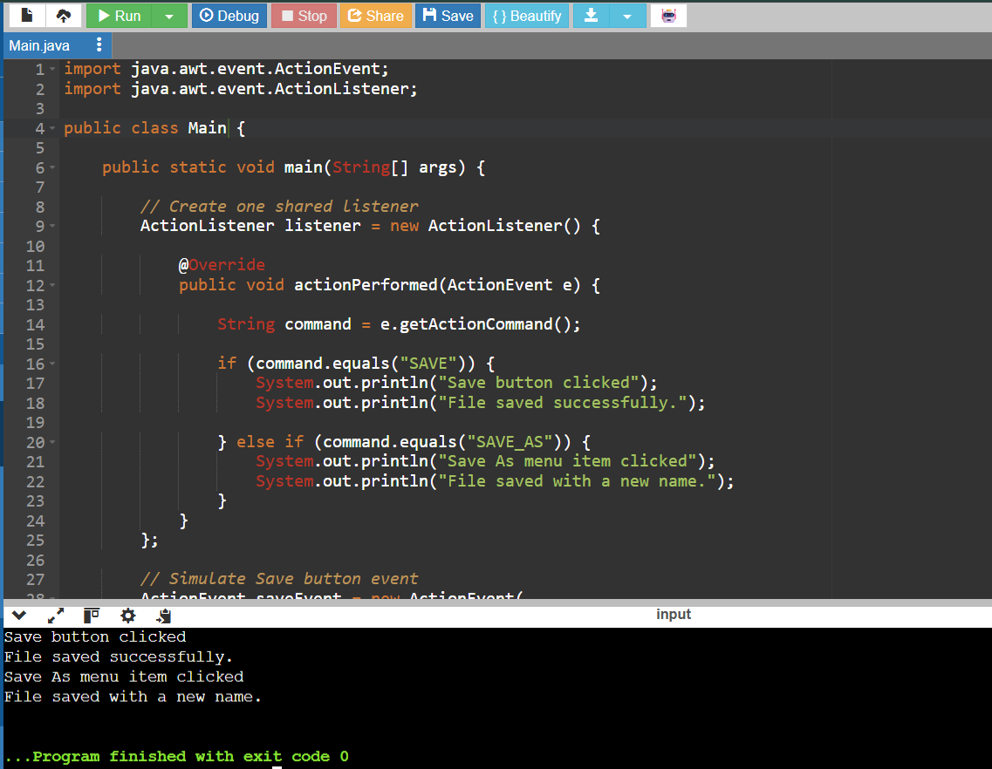

2. A single shared listener handles both a “Delete” toolbar button and a “Delete” right-click context menu item that should perform nearly identical logic with a minor difference in confirmation wording. Explain how reading the ActionEvent’s action-command string lets one listener method distinguish which control triggered it without writing two separate listener implementations
AIM:
To use a single shared ActionListener for both a Delete toolbar button and a Delete context-menu item, and differentiate them using the ActionEvent's action-command string.
PSEUDOCODE
START

Create Delete toolbar button
Create Delete context menu item

Set toolbar button action command = "DELETE_TOOLBAR"
Set context menu item action command = "DELETE_MENU"

Create one shared ActionListener

When actionPerformed(ActionEvent e):
command ← e.getActionCommand()

IF command = "DELETE_TOOLBAR" THEN
confirmation message ← "Delete selected item?"
ELSE IF command = "DELETE_MENU" THEN
confirmation message ← "Delete item using context menu?"
END IF

Display confirmation message

IF user confirms THEN
Delete the selected item
Display "Item deleted successfully"
END IF

Register the same listener with both controls

STOP
JAVA CODE
The following version works in online Java compilers because it does not create a GUI window:
import java.awt.event.ActionEvent;
import java.awt.event.ActionListener;

public class DeleteExample {

public static void main(String[] args) {

// Create ONE shared listener
ActionListener deleteListener = new ActionListener() {

@Override
public void actionPerformed(ActionEvent e) {

// Get the action command
String command = e.getActionCommand();

String message;

if (command.equals("DELETE_TOOLBAR")) {

message = "Delete selected item from toolbar?";

} else if (command.equals("DELETE_MENU")) {

message = "Delete selected item using context menu?";

} else {

message = "Unknown delete command.";
}

// Display confirmation message
System.out.println(message);

// Common delete operation
if (command.equals("DELETE_TOOLBAR") ||
command.equals("DELETE_MENU")) {

System.out.println("Item deleted successfully.");
}

System.out.println();
}
};

// Simulate Delete toolbar button event
ActionEvent toolbarEvent = new ActionEvent(
new Object(),
ActionEvent.ACTION_PERFORMED,
"DELETE_TOOLBAR"
);

// Simulate Delete context menu event
ActionEvent menuEvent = new ActionEvent(
new Object(),
ActionEvent.ACTION_PERFORMED,
"DELETE_MENU"
);

// Same listener handles both events
deleteListener.actionPerformed(toolbarEvent);
deleteListener.actionPerformed(menuEvent);
}
}
