BidSphere
Live Auction Platform — Project Report
React.js | Node.js | Express.js | MongoDB | Socket.io

INTRODUCTION:
BidSphere is a modern, full-stack real-time auction web application that enables buyers and sellers to participate in live online auctions. Sellers can list valuable items — ranging from electronics, fashion, vehicles, art, and jewelry — with a starting price and an auction end time. Buyers then place competitive bids in real time, with live price updates pushed instantly to all connected users via Socket.io WebSockets.
The platform features secure JWT-based authentication with three distinct roles: Buyer, Seller, and Admin. Advanced features include an AI-powered price suggestion engine (Google Gemini), an automated bidding system, real-time SMS outbid notifications via Twilio, Razorpay payment integration, and a fraud detection engine to prevent bot-like behaviour.

SCENARIO BASED CASE STUDY:
Meet Priya, a vintage watch collector who wants to sell her prized Rolex Submariner online and also acquire a rare mid-century chair at a fair market price.
User Registration & Authentication: Priya visits BidSphere and registers as a Seller. Her password is securely hashed using bcrypt before being stored in MongoDB. On login, she receives a JWT token which authenticates all subsequent requests.
Listing an Item: Priya navigates to "List Item," uploads a photo, writes a description, sets a base price of ₹80,000, and picks an end time. She clicks "Get AI Price Suggestion" — the Gemini API analyses the description and suggests ₹1,20,000. She applies it and submits.
Live Bidding: Rahul, a Buyer, opens Browse Auctions and sees the Rolex listed as LIVE. He bids ₹1,25,000. Instantly, Socket.io broadcasts the new price to every connected browser — no refresh needed. Priya, watching in another tab, sees the price update live.
Outbid Alert: When Meera outbids Rahul, he receives an SMS via Twilio: "You have been outbid on Rolex Submariner! New highest bid: ₹1,30,000."
Auction End: When the timer reaches zero, a backend cron job (node-cron) auto-closes the auction, marks the winner, and triggers a Razorpay payment request. The Admin Dashboard reflects updated stats instantly.

SYSTEM REQUIREMENTS:

Software Requirements:
- Node.js (v18+): Runtime environment for the Express.js backend server.
- npm (v9+): Package manager for installing all project dependencies.
- React.js (v18): Frontend library for building the dynamic component-based UI.
- Express.js: Lightweight backend web framework for building RESTful APIs.
- MongoDB (v6): NoSQL database for storing users, auctions, bids, and transactions.
- Socket.io: Enables real-time bidirectional communication between server and clients.
- Vite: Frontend build tool and lightning-fast development server.
- Postman: For testing and debugging all REST API endpoints during development.
- Visual Studio Code: Preferred code editor with integrated Git and terminal support.

Hardware Requirements:
- Processor: Intel Core i5 (8th Gen+) / AMD Ryzen 5 or better.
- RAM: Minimum 8 GB (16 GB recommended).
- Storage: At least 2 GB free disk space.
- Display: 1366×768 resolution or higher.

PROJECT ARCHITECTURE:
BidSphere follows the Model-View-Controller (MVC) architectural pattern on the backend and a Component-Based Architecture on the React.js frontend. The system is split into two separate applications — client and server — that communicate via REST APIs and WebSocket connections.

Technical Architecture:
The architecture consists of four main layers: Client Layer (React), API Layer (Express), Real-Time Layer (Socket.io), and Data Layer (MongoDB).
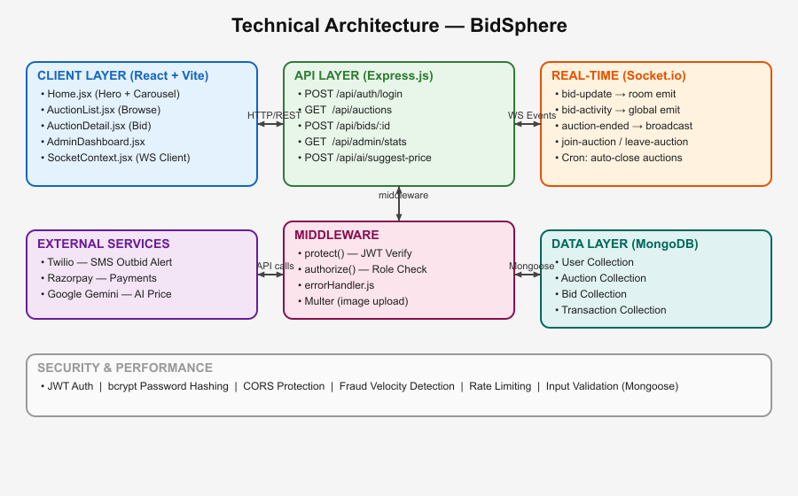

ER DIAGRAM:
The Entity-Relationship (ER) diagram for BidSphere shows the five core entities and their relationships within the auction management system.
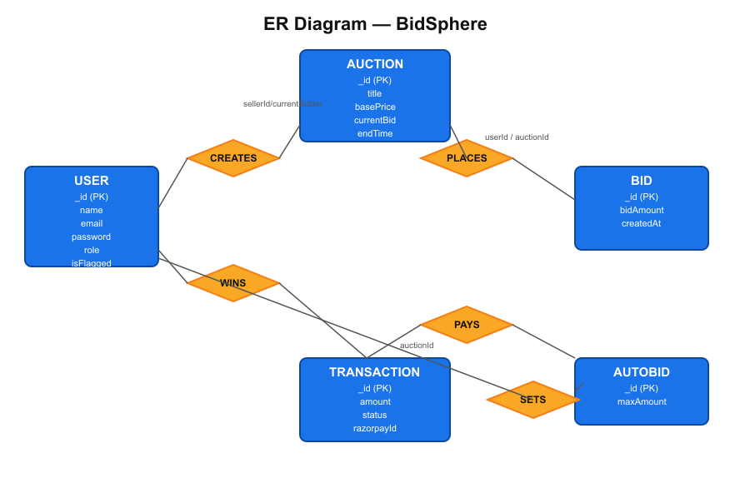
Entities and their key attributes:
- USER: _id, name, email, password, role (buyer/seller/admin), isFlagged, fraudViolations.
- AUCTION: _id, title, description, basePrice, currentBid, sellerId (FK→User), currentBidder (FK→User), winner (FK→User), endTime, status.
- BID: _id, auctionId (FK→Auction), userId (FK→User), bidAmount, createdAt.
- TRANSACTION: _id, auctionId (FK→Auction), userId (FK→User), amount, razorpayId, status.
- AUTOBID: _id, auctionId (FK→Auction), userId (FK→User), maxAmount.

Relationships:
- A USER creates many AUCTIONs (seller role).
- A USER places many BIDs across multiple AUCTIONs.
- An AUCTION has many BIDs but only one winner (USER).
- A TRANSACTION is created per won AUCTION and linked to the winning USER.

KEY FEATURES:
- Real-Time Live Bidding: Socket.io broadcasts every new bid instantly to all viewers — no page refresh required.
- AI Price Suggestion: Sellers can request a Gemini AI-powered price recommendation based on their item description.
- Automated Bidding: Buyers set a maximum budget; the system auto-bids on their behalf up to that limit.
- Live Countdown Timers: Each auction card displays a real-time countdown to the auction end time.
- Outbid SMS Notifications: Twilio sends an SMS to buyers the moment they are outbid.
- Razorpay Payment Integration: Winners are automatically prompted to complete their purchase via Razorpay.
- Fraud Detection Engine: Velocity check — users placing more than 4 bids in 10 seconds are flagged and auto-banned after 3 violations.
- Live Activity Feed & Ticker: The Browse Auctions page shows a real-time feed of recent bids and a scrolling horizontal ticker.
- Admin Dashboard: Full platform visibility — stats, user management, and auction moderation.
- Role-Based Access Control: Buyer, Seller, and Admin roles each have restricted access enforced via JWT middleware.

ROLES AND RESPONSIBILITIES:

User (Buyer):
- Registration & Account Management: Create an account, log in securely, and update profile details.
- Browse & Search: Search auctions, filter by category (Electronics, Fashion, Art etc.), and sort by price or time.
- Place Bids: Bid on any active auction. Server enforces minimum bid > current price.
- Auto-Bid: Set a maximum budget and let the system bid automatically.
- Watchlist: Save auctions of interest for easy access later.
- Payment: Pay via Razorpay after winning an auction.

Seller:
- List Items: Create auction listings with photo upload, description, base price, and end time.
- AI Pricing: Request an AI-suggested price before publishing the listing.
- Track Auctions: View bid counts and current prices in My Auctions page.

Admin:
- Dashboard: Real-time platform statistics — users, auctions, bids, revenue.
- User Management: View, deactivate, or flag users who exhibit suspicious behaviour.
- Auction Management: View or delete any auction on the platform.

USER FLOW:

Buyer Flow:
Register / Login → Browse Auctions → Filter by Category / Status → Open Auction Detail → Place Bid or Set Auto-Bid → Receive Outbid SMS if outbid → Win Auction → Complete Payment via Razorpay.

Seller Flow:
Register (as Seller) / Login → Navigate to List Item → Upload Photo + Write Description → Click AI Price Suggestion → Set End Time → Submit Listing → Track Live Bids in My Auctions → Auction Auto-Closes at End Time.

Admin Flow:
Login as Admin → View Dashboard Stats → Manage Users (flag / deactivate) → Manage Auctions (view / delete) → Monitor Fraud Flags.

MVC PATTERN:
BidSphere's backend strictly follows the Model-View-Controller (MVC) design pattern, separating concerns across three distinct layers.
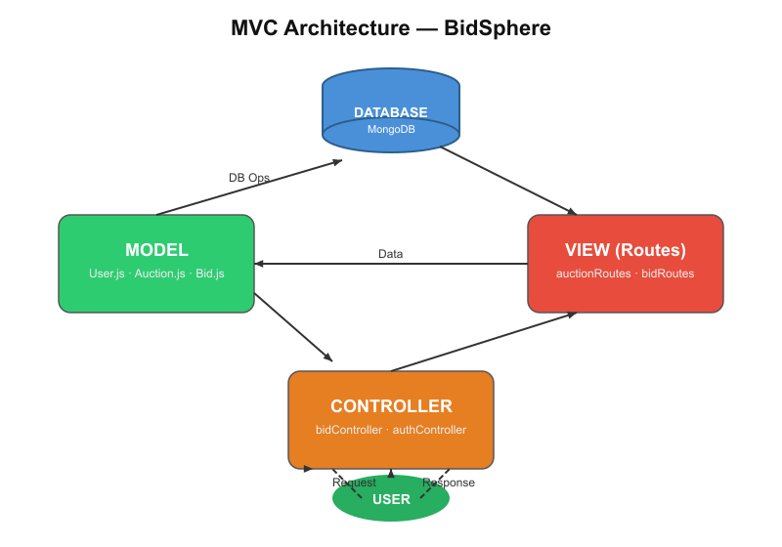

Model Layer (Data Layer)
All data schemas are defined using Mongoose. The models — User, Auction, Bid, AutoBid, and Transaction — handle schema validation, default values, and inter-collection references via ObjectId foreign keys.

Controller Layer
Controllers contain all business logic. For example, bidController validates the bid amount, saves the Bid document, updates the Auction's currentBid, triggers the Socket.io broadcast to the auction room, and sends the outbid SMS — all within one request lifecycle.

View Layer (Routes)
In a REST API context, the View is implemented as route files. Each file defines HTTP endpoints (GET, POST, PUT, DELETE) and maps them to controller functions. Protected routes invoke the protect() and authorize() middleware before reaching the controller.

Advantages of MVC in BidSphere
- Separation of Concerns: Each layer has a clearly defined responsibility, improving readability and maintainability.
- Scalability: New features (auto-bidding, AI pricing, payments) were added as new routes + controllers without touching existing code.
- Reusability: The authentication middleware is reused across all protected routes.
- Testability: Controllers and models can be tested independently.

PROJECT SETUP AND CONFIGURATION:

Step 1 — Create Project Folder:
Create a root folder "Auction Application" with two sub-folders: backend/ and frontend/. Open the root folder in VS Code.

Step 2 — Backend Setup (Node.js + Express):
In the backend folder terminal, run:
npm init -y
npm install express mongoose socket.io cors dotenv bcryptjs jsonwebtoken
npm install multer node-cron express-async-handler nodemailer twilio razorpay
Create the folder structure: models/ controllers/ routes/ middleware/ sockets/ config/ utils/ cron/

Step 3 — Frontend Setup (React + Vite):
In the frontend folder terminal, run:
npm create vite@latest . -- --template react
npm install axios react-router-dom socket.io-client react-hot-toast
npm run dev

Step 4 — Environment Variables (.env):
PORT=5000
MONGODB_URI=mongodb://localhost:27017/auctiondb
JWT_SECRET=your_jwt_secret_key
GEMINI_API_KEY=your_gemini_key
RAZORPAY_KEY_ID=your_razorpay_key
TWILIO_ACCOUNT_SID=your_twilio_sid

BACKEND DEVELOPMENT:

Backend Folder Structure:
backend/
├── config/ → db.js
├── controllers/ → authController.js, auctionController.js
│ bidController.js, adminController.js, aiController.js
├── middleware/ → auth.js, errorHandler.js
├── models/ → User.js, Auction.js, Bid.js, AutoBid.js, Transaction.js
├── routes/ → authRoutes.js, auctionRoutes.js, bidRoutes.js
│ adminRoutes.js, aiRoutes.js, paymentRoutes.js
├── sockets/ → bidSocket.js
├── cron/ → auctionFinalizer.js
├── utils/ → sendSMS.js
└── server.js

Controllers:
- authController.js → Register (hash password with bcrypt, save User) and Login (verify password, issue JWT).
- auctionController.js → CRUD for auctions with search, category filter, sort, and pagination support.
- bidController.js → Fraud check → validate bid → save Bid → update Auction → emit Socket.io events → send SMS.
- adminController.js → Platform-wide stats, user management, and auction moderation endpoints.
- aiController.js → Calls Google Gemini API with item title + description to generate an optimal price suggestion.

DATABASE DEVELOPMENT:

1. MongoDB Connection (config/db.js):
const connectDB = async () => {
const conn = await mongoose.connect(process.env.MONGODB_URI);
console.log(`MongoDB Connected: ${conn.connection.host}`);
};

2. User Schema (models/User.js):
const userSchema = new mongoose.Schema({
name: { type: String, required: true },
email: { type: String, required: true, unique: true },
password: { type: String, required: true, select: false },
role: { type: String, enum: ["buyer","seller","admin"], default: "buyer" },
watchlist: [{ type: ObjectId, ref: "Auction" }],
isFlagged: { type: Boolean, default: false },
fraudViolations: { type: Number, default: 0 },
}, { timestamps: true });
// Pre-save hook: hash password with bcrypt before storing
userSchema.pre("save", async function(next) {
if (!this.isModified("password")) return next();
this.password = await bcrypt.hash(this.password, 12);
});

3. Auction Schema (models/Auction.js):
const auctionSchema = new mongoose.Schema({
title: { type: String, required: true },
description: { type: String, required: true },
basePrice: { type: Number, required: true },
currentBid: { type: Number, default: 0 },
currentBidder: { type: ObjectId, ref: "User" },
sellerId: { type: ObjectId, ref: "User", required: true },
category: { type: String, enum: ["Electronics","Fashion",...] },
endTime: { type: Date, required: true },
status: { type: String, enum: ["active","completed","cancelled"] },
winner: { type: ObjectId, ref: "User" },
totalBids: { type: Number, default: 0 },
}, { timestamps: true });

4. Bid Schema (models/Bid.js):
const bidSchema = new mongoose.Schema({
auctionId: { type: ObjectId, ref: "Auction", required: true },
userId: { type: ObjectId, ref: "User", required: true },
bidAmount: { type: Number, required: true },
}, { timestamps: true });

FRONTEND DEVELOPMENT:

Frontend Folder Structure:
frontend/src/
├── api/ → axios.js (base Axios instance with JWT interceptor)
├── context/ → AuthContext.jsx (user state), SocketContext.jsx (WebSocket)
├── components/ → Navbar, AuctionCard, ActivityFeed, ActivityTicker,
│ CountdownTimer, AnimatedPrice, BidFeed, BidToast
└── pages/ → Home, AuctionList, AuctionDetail, CreateAuction,
Login, Register, AdminDashboard, MyAuctions, WonAuctions

Pages (src/pages):
- Home.jsx → Landing page with animated hero section, live stats, and swipeable auction carousel.
- AuctionList.jsx → Browse page: search, category filters, sort, live activity feed, real-time price cards.
- AuctionDetail.jsx → Single auction: countdown, bid history, animated price, bid form, auto-bid toggle.
- CreateAuction.jsx → Seller listing form with image upload, AI price suggestion, and category selector.
- Login.jsx / Register.jsx → Auth pages with role selection (Buyer / Seller).
- AdminDashboard.jsx → Admin-only: platform stats, user table, auction management.
- MyAuctions.jsx → Seller's auction listings with bid counts and status.
- WonAuctions.jsx → Buyer's won auctions with payment status.

Components (src/components):
- Navbar.jsx → Top bar with live connection indicator (green dot), role badge, and auth-gated links.
- AuctionCard.jsx → Renders auction image, title, category badge, LIVE badge, countdown, current bid, bidder count.
- ActivityFeed.jsx → Right-panel showing recent bids from DB, updated in real-time via Socket.io.
- ActivityTicker.jsx → Horizontal scrolling marquee of platform-wide bid activity.
- CountdownTimer.jsx → Animated HH:MM:SS countdown that turns red when under 1 hour remaining.
- AnimatedPrice.jsx → Price figure that pops/scales when a new live bid arrives.

OUTPUT SCREENSHOTS:

Landing Page (Home.jsx):
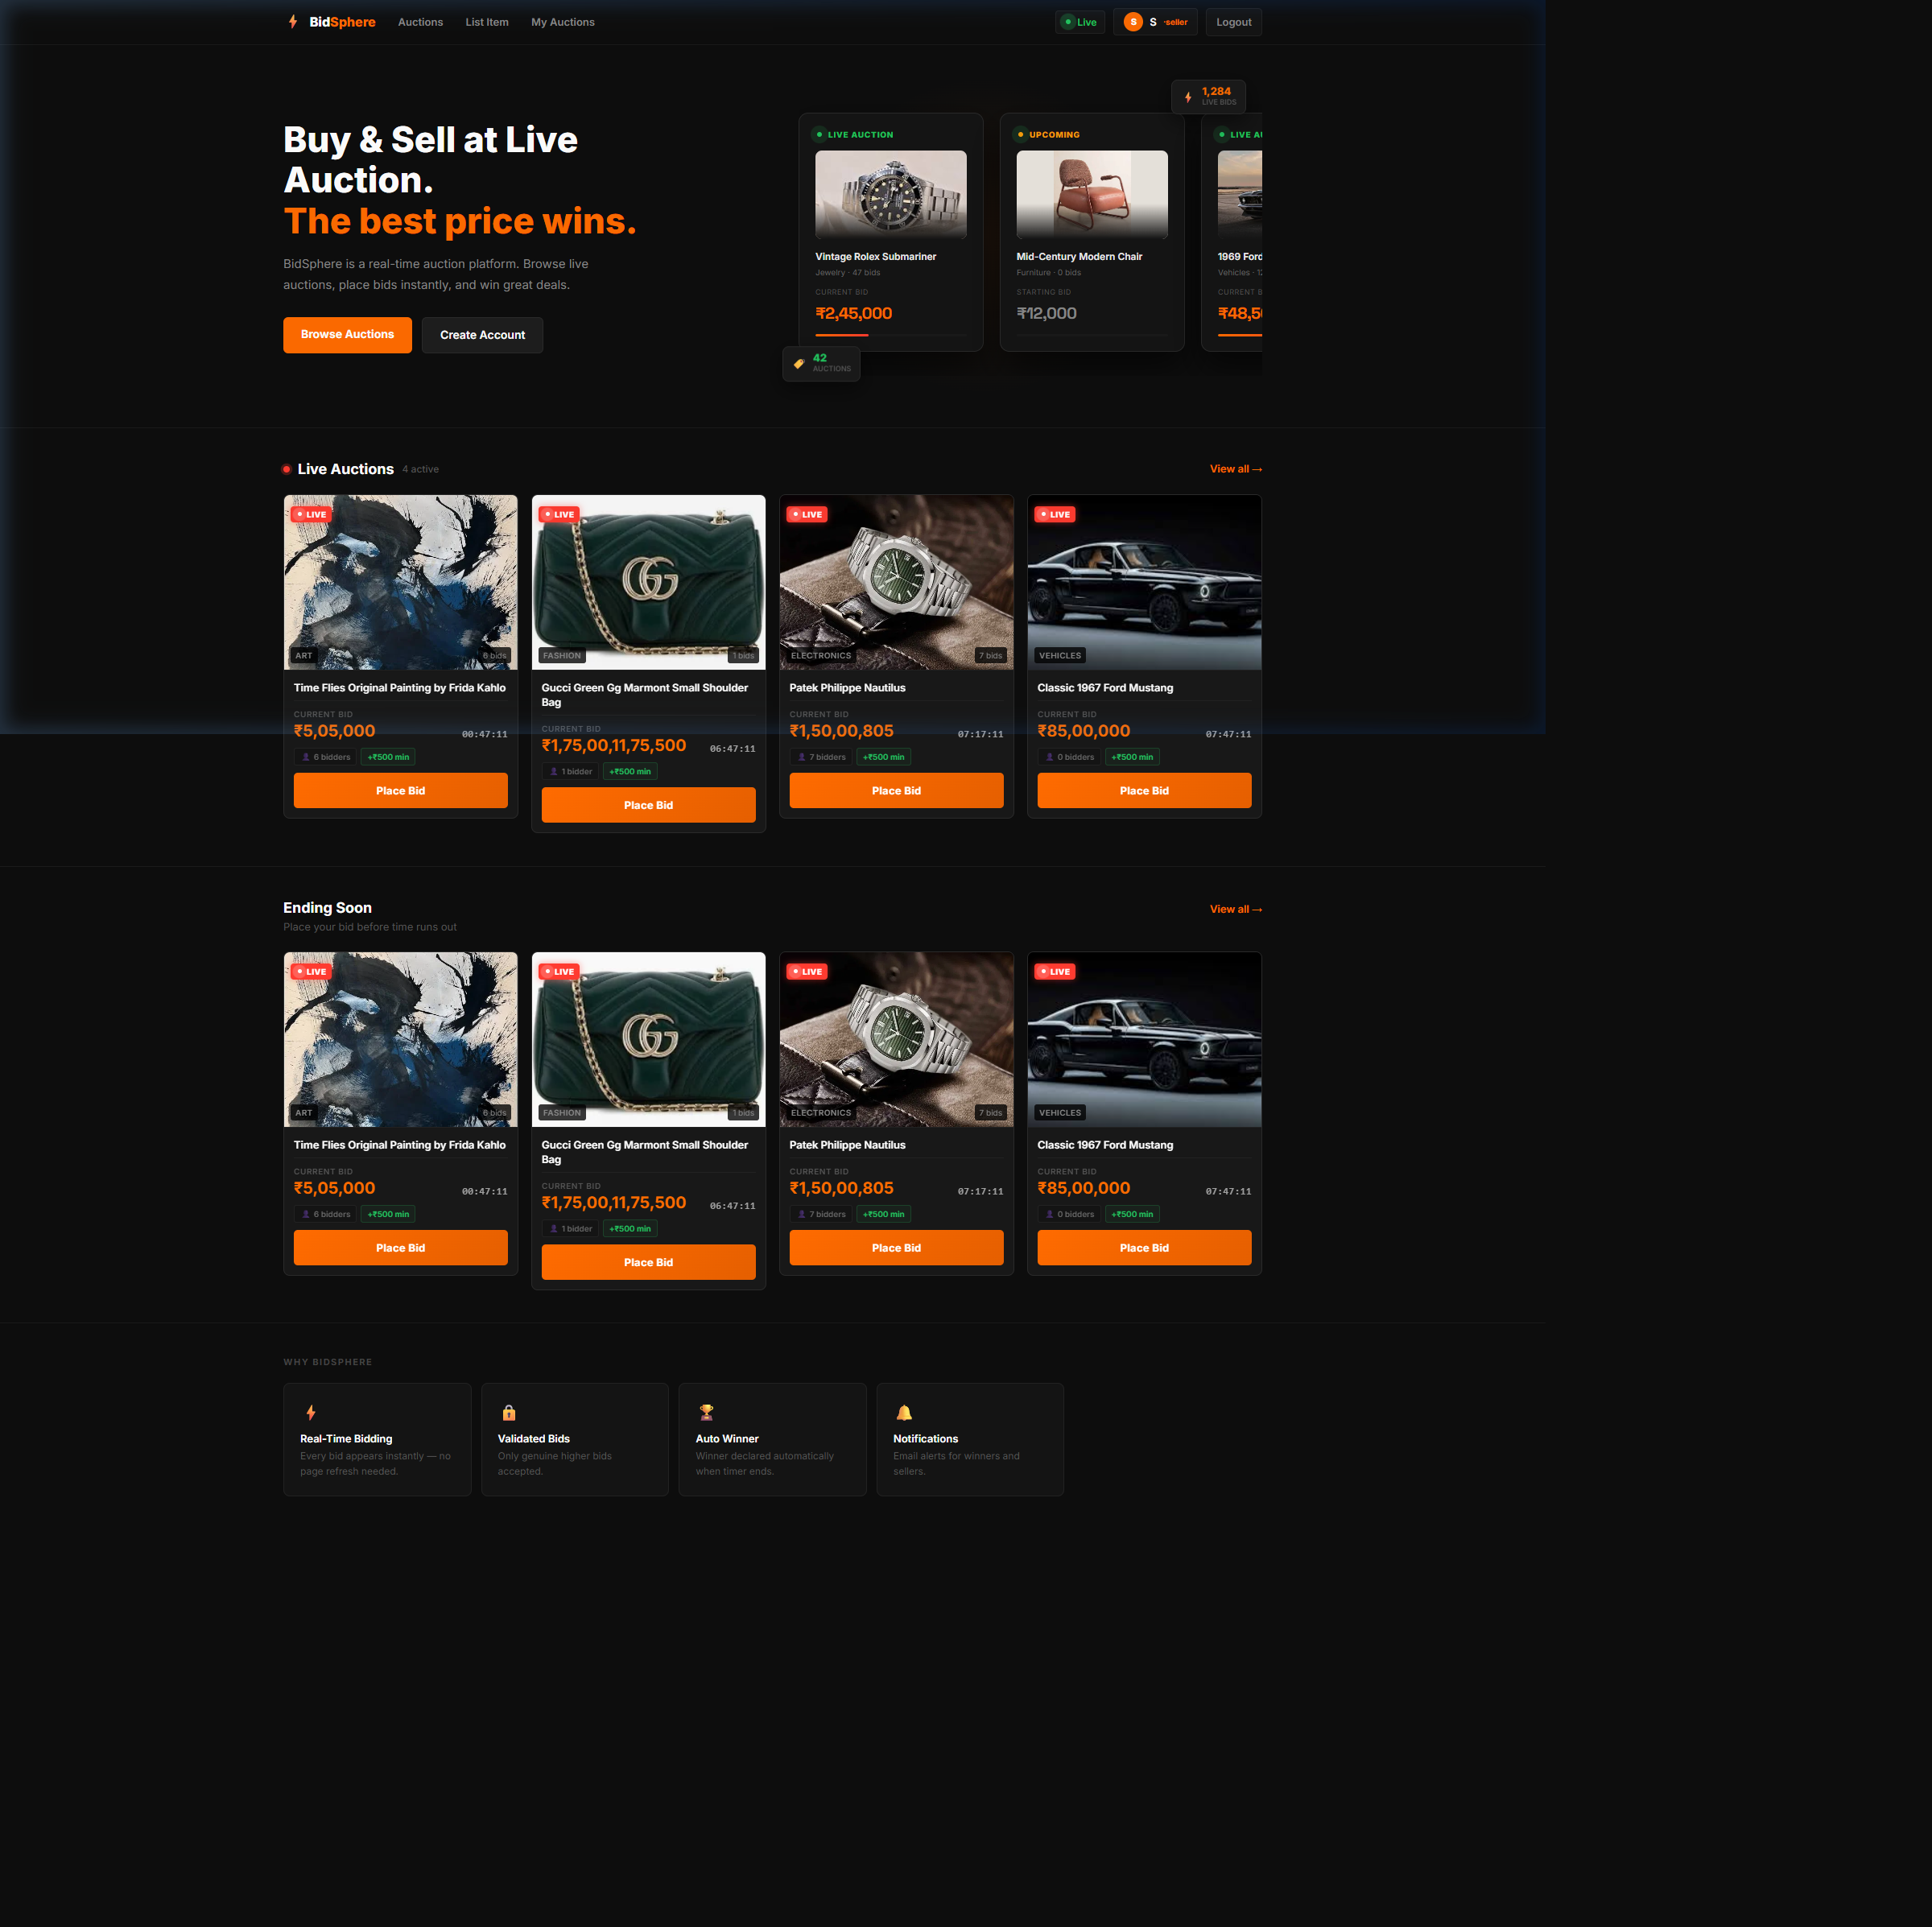

Browse Auctions Page (AuctionList.jsx):
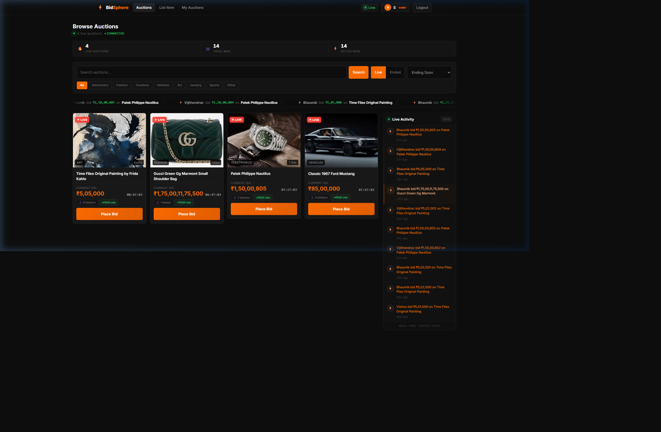

Login Page (Login.jsx):
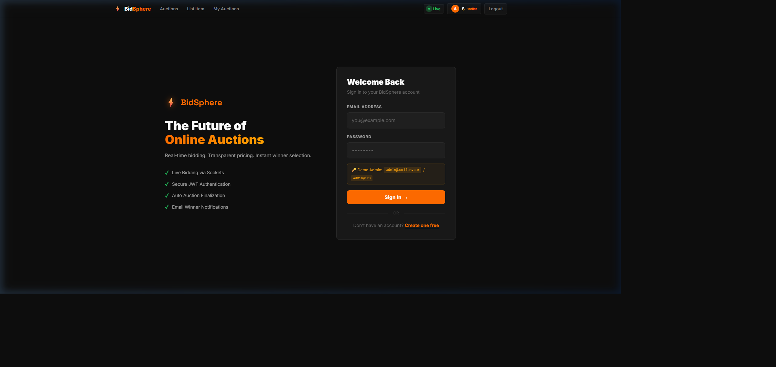

Register Page (Register.jsx):
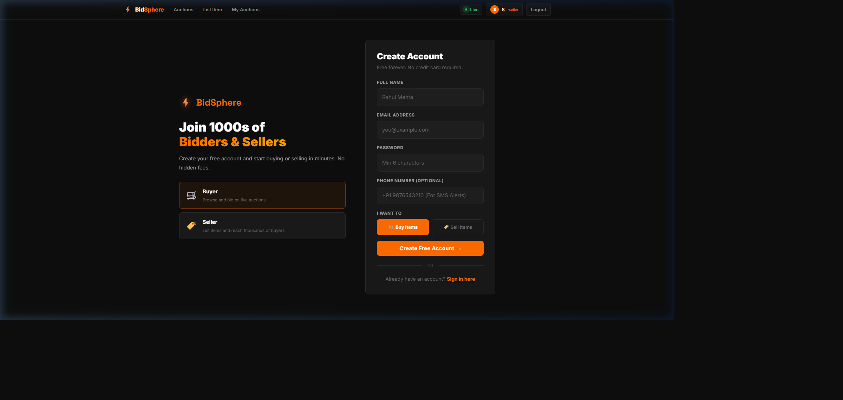

List Item / Create Auction Page (CreateAuction.jsx):
