**Development of Eco-Friendly Vamped Sunshade for Security Guards to resist Heat in summers.**

**Faizan Ahmad Wani*1, Palvi Thakur2, Rakesh Abrol3**

1(BE student, Department of Civil Engineering, MIET Jammu, India)

2(BE studentDepartment of Computer Science Engineering, MIET Jammu India)

3(Assistant Professor, Department of Civil Engineering, MIET Jammu, India)

**ABSTRACT**

In India, on an average in a year, three hundred days are clear and sunny making the sun rays reach us almost daily. With the mercury going as high as 50 degree Celsius in our summers, one can barely go out or just stand under the mighty sun. To worsen the situation more, last year the annual ozone hole reached average area coverage of 8.83 million square mile. Thus exposing everything living on the earth more to harmful ultraviolet (UV) rays from the Sun. In a recent study it was revealed that 90% of the skin cancers were caused by sun exposure. Moreover in another survey, it was found that most of the people resist and hesitate from even moving in their lawns when the sun is up. The current alternatives to prevent one’s own self from the harshness of sun which includes vibrant and colourful sunshades are often neglected and disowned by the common people as well as the science giants, reason being that of the high pricing for the common masses to even afford and the non-eco-friendliness in the manufacturing of the sunshades itself for the science giants. The main purpose of our study is to eradicate both the problems faced by the common masses as well as the science giants. We prepare and present a sunshade fully eco-friendly, nearly fifty times cheaper than the present one and more aesthetic. Our sunshade makes use of extensive wood shavings for the formation of its top frame and the base is made of wood shavings and sawdust which makes it completely eco-friendly and cost efficient.

***Keywords:*** *Bamboo, Cancer, wood shavings, Eco-friendliness, Sunshades,*

**INTRODUCTION**

Whenever wood is operated wood shavings are formed in huge numbers and are often collectively considered as a waste product which ends up burning or littering futile. This waste product can be used to craft beautiful and aesthetic sunshades at much lesser costs than those available in the market. The main problem of the non-eco-friendliness of current PVC made sunshades can also be brought to an end. The wood shavings can be carved into multiple designs that of square, rectangle or any polygon to design a sunshade according to the user’s needs. Moreover the area covered by shade can be increased or decreased at any point of time depending on the user’s will. The light weight capability of the sunshade also is a boon as it can be fitted and carried to any place.

The sunshades used presently aren’t up to the mark. The making of such giant and non-eco-friendly sunshades causes an exchange of gases that further damages our ozone layer (more specifically the environment).The pricing also is a major issue, in our country not everyone can afford a sunshade worth 12000 INR just to protect them from heat so people often take the solar radiations neglected.

**ANALYSIS**

The aesthetics of the sunshades has always been under the scanner for use of such paints that are again non-eco-friendly.

Our vamped sunshade consists of the following parts:

1. ***Top circular/rectangular/square shaped frame***

The sunshade make use of carved wood shavings, which makes it easier for the user to mend it in desired shape, size and colour.

1. ***Bamboo rod/Circularly compressed wood shavings***

A rod is used to connect the head of the shade to the foot or base made of either bamboo or wood shavings itself.

1. ***Block of wood shavings (highly compressed)***

Finally the block which is again entirely made of highly compressed wood shavings, is thus connected to give it the final shape of sunshade.

1. ***Stability***

The prototype make is tested against thermal and wind effects and it came out to be optimal for use under moderate conditions.

**RESULTS & DISCUSSIONS:**

|  |  |  |
| --- | --- | --- |
| **Feature** | **Used Sunshades** | **Our Vamped Sunshades** |
| Environment friendly | No | Yes |
| Cost(in INR) | 5000-12000 | 200 |
| Can be carved in desired shape at user’s will | No | Yes |
| Weight | Heavy | Light |
| Cooling ability | No | Yes |
| Aesthetics | Artificial & Hazardous | Natural and Safe |

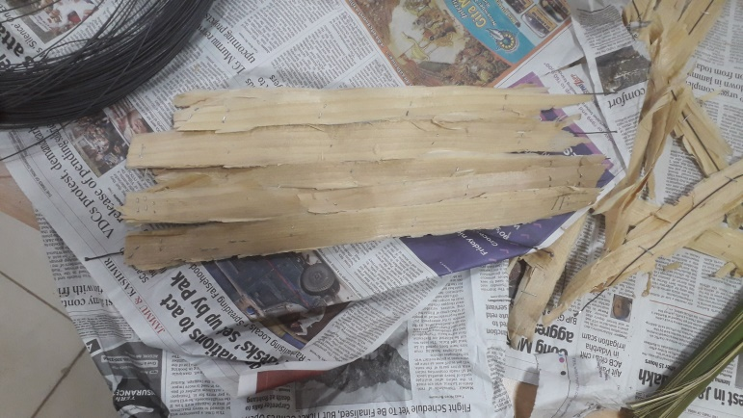

**Figure 1.** A small prototype of the roof enveloping main frame.

**CONCLUSION**

As per the study the following conclusions can be framed out of it:

1. People fall prey every year of exposure to sun’s hazardous radiation and in order to prevent themselves people need sunshades.
2. A security guard for example has to sit under the harsh sun for prolonged time and thus is vulnerable. Moreover people from our country often neglect the idea of purchasing a sunshade because of the space dependencies and high cost.
3. The making of current sunshades in itself posts a threat to our existence as it deals with manufacturing, handling, melting, molding and designing of PVC which is a non-ecofriendly substance.
4. Thus this sunshades should be brought in use which are light, can be dismantled, cheap and completely ecofriendly.

**REFERENCES**

1. Al-Kayiem, H.H., M.F.B.M. Sidik, and Y.R.A.L. Munusammy, Study on the thermal accumulation and distribution inside a parked car cabin. American Journal of Applied Sciences, 2010. 7(6): p. 784-789.
2. Rhea, T.C., J.R. Johnson, and M.S. Troublefield, Automated covering for an automobile. 2006, U.S. Patent 7008002 B2.
3. Phillips, A.J., Automatic retractable shade. 1988, U.S. Patent 4775180 A.
4. Shaft, W.S., Window-shade. 1918, U.S. Patent 1289281 A.
5. Scott, W.G., Window curtain and shade. 1883, U.S. Patent 289573 A.
6. Smith, E., Vehicle-curtain. 1916, U.S. Patent 1168343 A.
7. Ogino, T., Temporary curtains. 1975, U.S. Patent 3913655 A.