Pamela Mena – 00211564

Commands: grep MemTotal /proc/meminfo
grep VmallocTotal /proc/meminfo

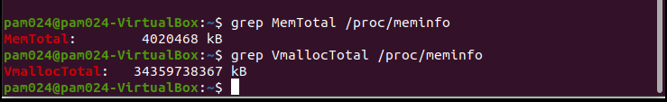
Command: top

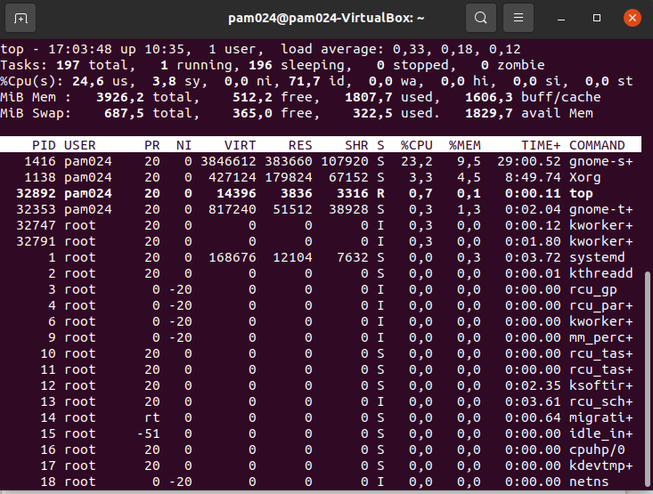

Command: cat /proc/sys/vm/overcommit_memory

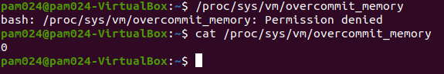

Commands: echo “Understanding Linux memory management” > my_file
sync
echo 3 > /proc/sys/vm/drop_caches
time cat my_file
time cat my_file

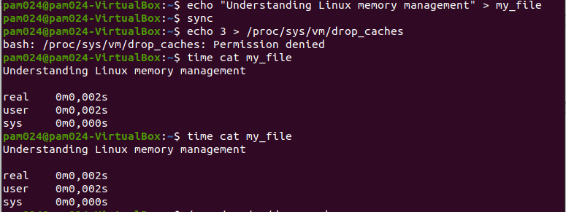

Commands: cat /proc/sys/vm/dirty_bytes
cat /proc/sys/vm/dirty_ratio
cat /proc/sys/vm/dirty_background_*
cat /proc/sys/vm/dirty_background_ratio
cat /proc/sys/vm/dirty_writeback_centisecs
cat /proc/sys/vm/dirty_expire_centisecs

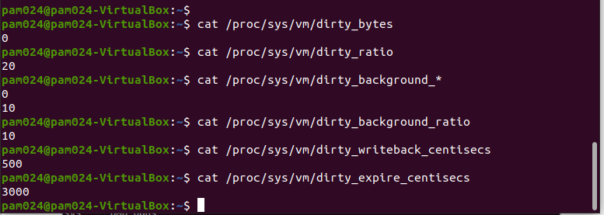

Command: grep -i active /proc/meminfo

