ASSIGNMENT -1

Arithmetic operations& variable Assignment

p.satwika

1): A variable is a name used to store a value in a program.

It's called a variable because the value it holds can change while the program runs.

They are called variables because their values can change or vary while the program runs.

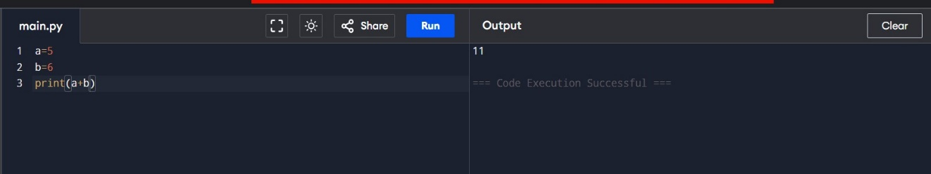

2)

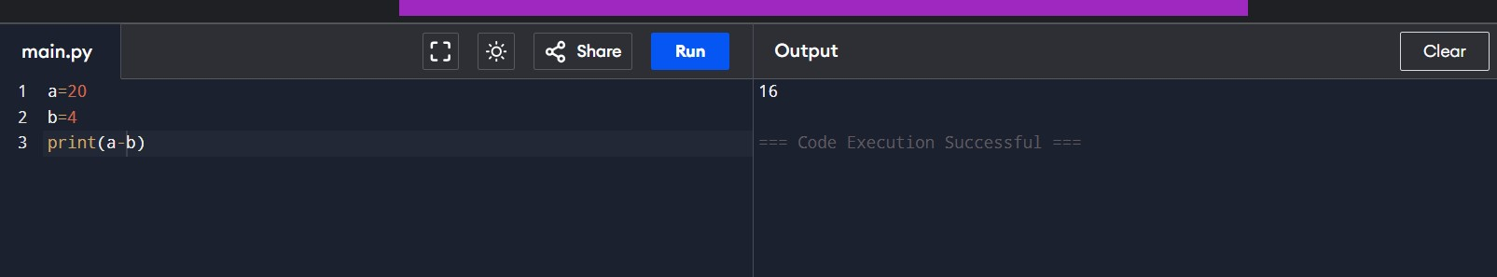

3)

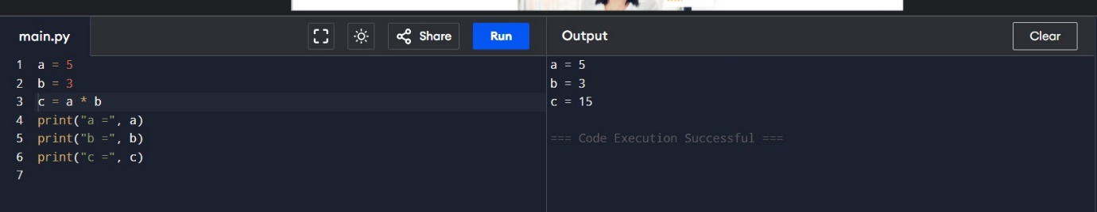4)

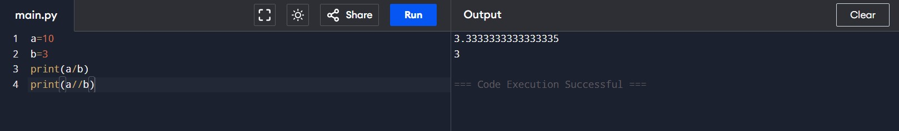

5)

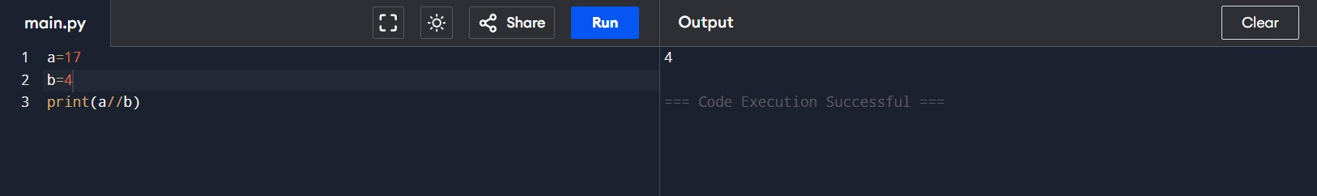

6) 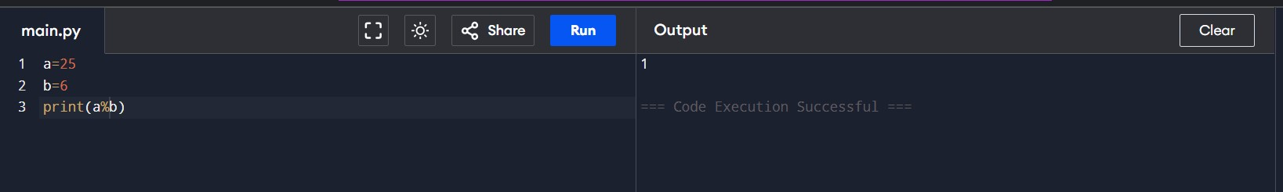

7)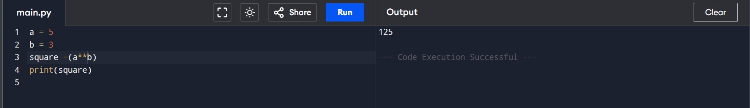

8)

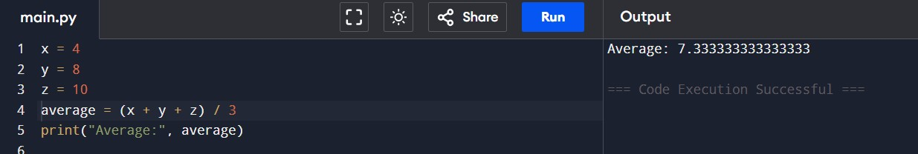

9)

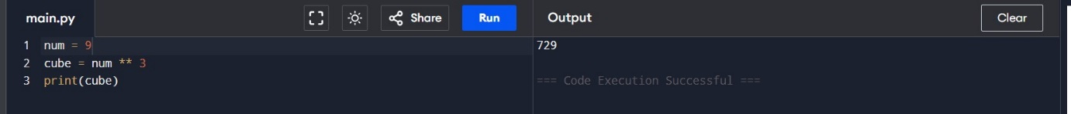

10)

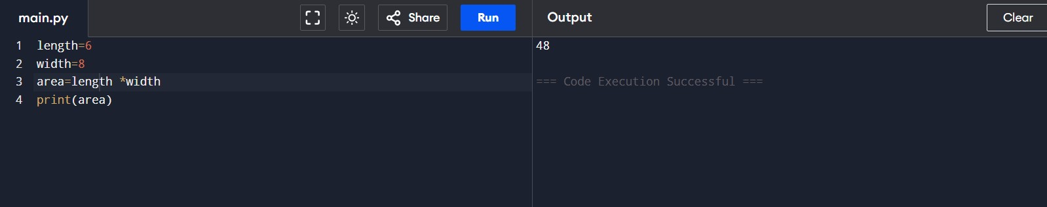

11)

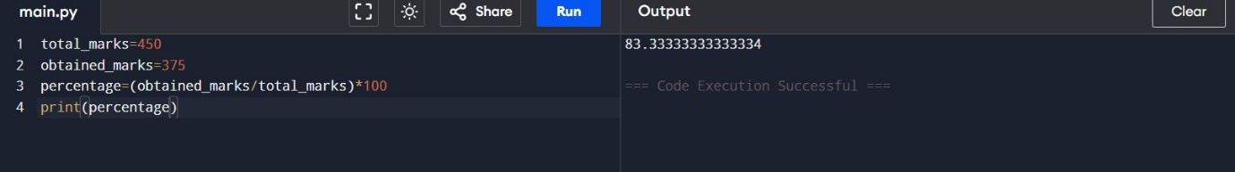

13) 