GitHub Copilot app automations: Issues from the Nov 3 office hours demo
Recording: Python + AI Office Hours, Nov 3, 2026

1. CRON triggers can't run in the cloud
Video: 17:40
The CRON trigger has no "Run in the cloud" toggle, unlike Daily, Weekly, and Hourly. So CRON automations can't run in the cloud or be shared. I expected CRON to support cloud runs too.
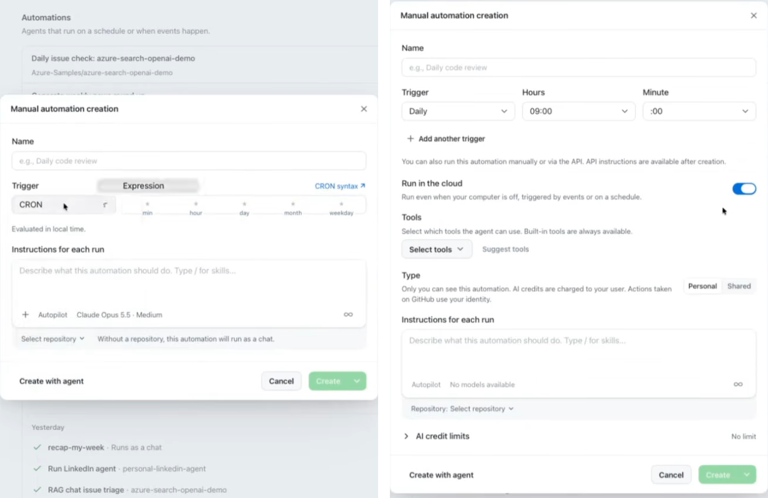

2. Automations created from a description default to CRON
Video: 15:30
I asked for an automation "every day at 10 p.m.", and it generated a CRON trigger (0 22 * * *) instead of Daily. Because of issue 1, it then couldn't run in the cloud or be shared. I'd expect it to prefer Daily/Weekly/Hourly when they fit.
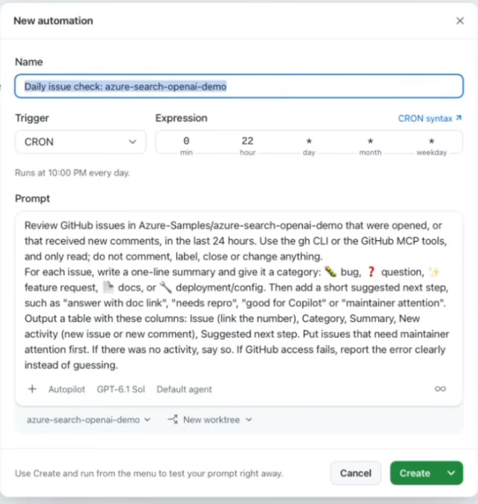

3. "Repository not found" error when creating a shared cloud automation
Video: 29:25
Creating a shared cloud automation for Azure-Samples/azure-search-openai-demo failed with the error below, even though I already have other automations on that repo. Retrying didn't help, but pamelafox/pamelafox-site worked.
Error: Could not check cloud automation availability. github API request failed (404): GitHub API request failed (404 Not Found): Repository not found [request_id=E8C7:336D37:1C6DBD:2863EC:6AEA37C5]
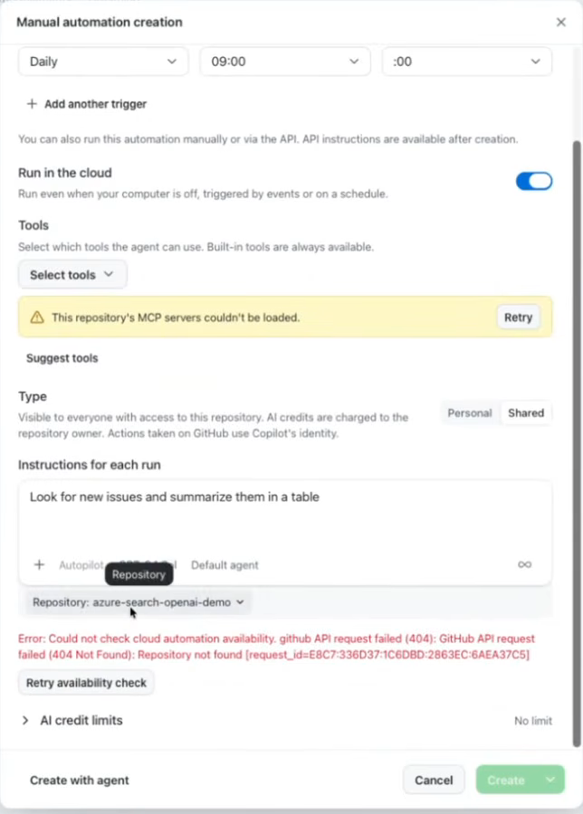

Feature request: Generic webhook trigger
Video: 18:20
Triggers only cover schedules and GitHub events. An attendee asked for a generic webhook trigger to start automations from non-GitHub systems.
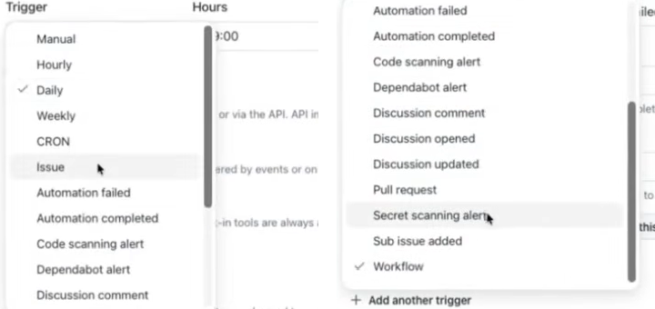

Question: Can an existing automation be changed to shared?
Video: 28:27
Shared is available when creating an automation, but it's unclear whether an existing one can be switched to shared later.

