
FULLSTACK ASSESSMENT MATERIAL RELEASE

THEORY QUESTIONS
SECTION TYPE | TOTAL MARKS AVAILABLE | NOTES
Design heuristics | 10
Redux | 10
React | 10
Agile | 10
 | 40 marks available total
Important notes:
- This document shares the first section of the Full Stack Assessment which is composed of 4 Full Stack Theory Questions
- You have 24 hours before the assessment to prepare.
- If any plagiarism is found in how you choose to answer a question you will receive a 0 and the instance will be recorded. Consequences will occur if this is a repeated offence. You can remind yourself of the plagiarism policy here.
- Answers need to be explained clearly and illustrated with relevant examples where necessary. Your examples can include code snippets, diagrams or any other evidence-based representation of your answer.
`Questions begin on the next page

- In design Heuristics, what does the term “advantages of Matching between system and the real world” mean? What are the advantages?
The term ‘advantages of matching between system and the real world refers to the designing of user interfaces and system to ensure they resemble real-life objects and languages that are familiar to users. It ensures there is familiarity for the user rather than using system-based terms. The interfaces present information in a more natural mundane way so it is easier to understand by users. The advantages include:
- Reducing cognitive load as users can use pre-existing knowledge when using the system, therefore they don’t have to spend hours trying to relearn the new system.
- Increasing productivity – because the user will be more familiar with the system, they are able to work more efficiently and at a fast rate.
- Eventually these would lead to improved user satisfaction. As the system is easier to navigate and use, the user will feel more at ease when working.
- It also reduces the number of errors made as the user’s familiarity allows them to work in their natural environment and produce good results.
- What do you understand by “Single source of truth”? and how does it relate to redux? What are the advantages?
The source of truth is an object that holds the entire state of the application – and in redux there is only one single store which is a JavaScript value. This store is where all the data for the application is stored. The advantage of it is that by having one, the application remains consistent and predictable (if there are no changes made). Because its consistent, it also allows consistent testing to be done. By having a single source of truth, it allows any changes made to be tracked and debugged at a much more efficient rate if errors occur. Another advantage is the code is more organised and cleaned due to the singular store value rather than having multiple.
- What is the difference between a stateless component and a stateful component in React?
A stateless component in React does not have its own internal state and requires input value in order to return an output (depending on the function conditions). They are much easier to write as they do not manage any states and are regular functions. In comparison, a stateful component in React does have a state meaning they manage and update the function over time depending on the data and if it changes or not. They have the ability to hold data which makes them more complex than stateless components.

- List out the advantages and disadvantages of exploratory testing (used in Agile) and scripted testing?
Advantages of exploratory testing | Disadvantages of exploratory testing
Can be ran without documentation | Lack of repeatability as it takes an explorative approach, so test scenarios are rarely the same
Depends on the skills of the coders | As there is no need for documentation, it is difficult to trace where errors may arise meaning more time to debug
Quick feedback due to quick bug and error detection | Subject to bias as individuals may explore certain areas over others (i.e., based on personal interest)
Very flexible as people are allowed to adapt their approaches and not follow rigid objectives/requirements | Cannot be automated meaning takes longer
More realistic as it can mimic how it may be used in a real-life situation | Not as predictable

Advantages of scripted testing | Disadvantages of scripted testing
Does not depend on the skills of the coders | More time consuming in terms of maintenance and having to consistent update
Easily repeatable/replicable | Can miss bugs or errors as it only follows the documentation
Easy to automate | Slower feedback as testing occurs much later
Easy to access scripts of fellow members | Time consuming to design and plan
Easy to set objectives | Limited flexibility in work

FULLSTACK ASSESSMENT - 2 HOURS

SECTION TYPE | TOTAL MARKS AVAILABLE | NOTES
Redux (pseudocode code/ | 25 | Multiple questions, all
reasoning explanation) |  | comprising 25 total
Algorithms 1 (Coding) | 15 | 1 question only
Algorithms 2 (Coding) | 20 | 1 question only
 | 60 marks available total

Questions begin on the next page

Redux

25 MARKS

This question involves using built-in React Hook for a simple attendance app.

Here are notes to help: -

- useState() : This allows you to have states variables in functional components. It helps to set and retrieve the state.
- A reducer: This is a function that returns some state data, triggered by an action type.

- An action: This is dispatched by components and is represented as one object that contains type property and sometimes payload property. It tells the reducer how to change the state. Here is an example of the shape of an action -> { type: 'GREETINGS',

payload: ‘Hello’}

  - Dispatch: this helps update the state by sending the type of action to the reducer function for it to perform its job. To invoke a dispatch function, you need to pass action as an argument to the dispatch function, e.g. dispatch ({type: "SOMETHING", payload: “SOMETHING” })}

- Remember: Submit pseudocode or simply describe the solution.

Part 1 (5 marks):
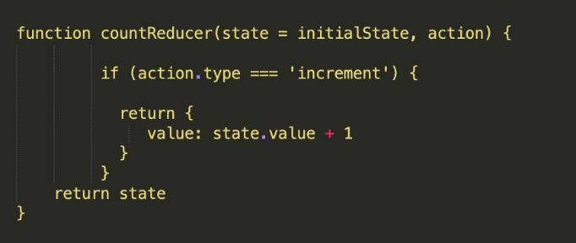

Figure 1

- Can you provide a brief summary of what is happening in this function code?
The function is a reducer and handles the action type ‘increment’. It adds the ‘value’ in the state by 1 and then returns the new updated state.

- Add one action that tells the reducer to reduce the state value by 1
Add an option for ‘decrement’. So (else) if the action type is decrement, the returned value is the state.value minus 1 rather than add one.

- Add one action that tells the reducer to reset the state
Add an option for ‘reset’. So (else) if the action type is reset, the initial state is returned.

Part 2 (10 marks):

This section involves handling state locally.
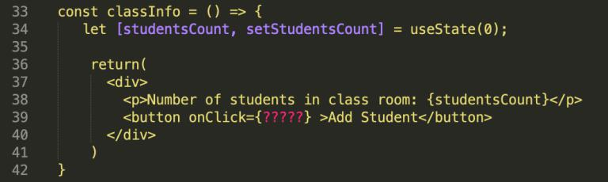

In the code above the useState hook is used to set the state of a variable inside the component.

- Can you provide a brief summary on what is happening on line 34, 39?
A useState is being used which is a react Hook. UseStates manage the components of a function in React. The line 34 sets the studentsCount value to 0 and the function will update the value using setStudentsCount.
Line 39 relates to the button on the JavaScript. It is within the return function When the button is clicked (using an event handler), it would carry out the called function however this would not happen as the function is ‘?????’ which does not exist.

- When a user clicks on the “Add student” button update the state (studentsCount) to include only the total number of students who are present. Using the data provided below:
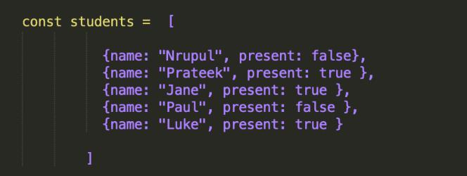

Create a function to update students count and set studentsCount to 0. Then let i = 0. For each student present, where the Boolean expression is ‘true’ the students count has 1 added to it.

- How do you ensure that the function is triggered when the button is clicked?
Where the ????? is, add ‘AddStudent’ then create a constant that is called AddButton. This allows it to be called. Then using an event listener, specifically click, when the button is clicked, the function is called and the student count is updated

- How will you update the state with the result of your function?
State the student count to equal the student count (at the end of the function)

Part 3 (10 marks):

Now let’s use dispatch to update the state on button click
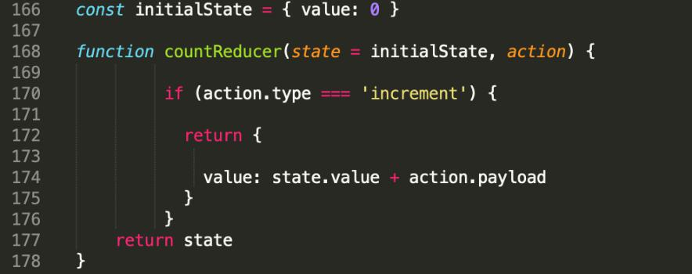

Figure 4

- A change of code was made on line 174 (fgure 4), can you briefy explain what that would do?
If it was changed, the value would be be updated.
- Let’s say we don’t want to set the state locally anymore and want to use dispatch. How would you ensure that an “increment” action that also contains the result of the studentCount is dispatched on button click? According to your answer in part 2.2b what would need to be changed?
- Which code do you think is best suited to ensure that the “increment” action updates the state with the correct total number of students who are present. Is it Figure 4? Or
Figure 5? Explain the code difference and your reasoning
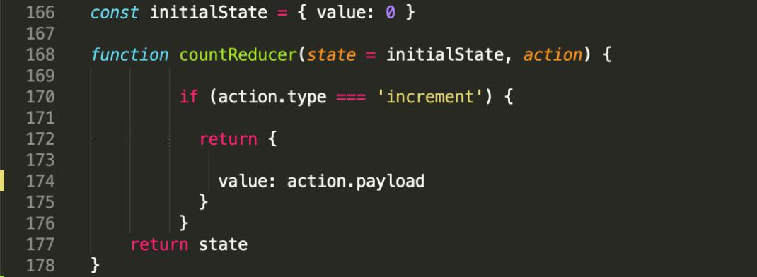

Figure 5

Algorithms 1 (Coding)

- MARKS (1 question)

Write an algorithm that returns true if the given string is a palindrome. Otherwise, return false.

Note: A String is said to be a palindrome if the string is spelled the same way forward and backwards.

For example, some sample input and outputs would be:

 | stringA value | Output value
Sample Input 1 | radar | True
Sample Input 2 | level | True
Sample Input 3 | Pencil | False
Sample Input 4 | a | True

In your answer, please discuss your solution - what is its Big O Time & Space complexity? Why have you chosen this approach? Could there be a more efcient way (and if so, how)?

If you are short on time, you can also submit pseudocode or simply describe what solution you’d write in code (just describe what you have in your mind) - this cannot attain full marks, but it is still a perfectly acceptable answer and can get partial marks.

In essence, just submit what you have even if you don’t know the answer!

First define the function.
Then create two variables that take in the value of the first letter and last letter.
Secondly, If the first letter – let’s say the variable is first - is equal to end – in this case called last - , the increment first by 1 and decrement last by 1. This process would be in a loop.
Lastly, if the loop continues to the end and completes without returning a false value, then it is a palindrome so the returned value of the function is ‘true’.
The Big O Time complexity is O(n) where n is the number of letters in the word. So if the word is ’rabbit’, then n is 6 but the loop only runs 3 times (half of the word).
The Big O Space complexity is O(1) as space is needed to store. I have chosen this approach because it is easy to implement and with the use of a loop, it keeps the code clean so much easier to debug.

def isPalindrome(word):
start = 0
end = len(word) - 1

while start <= end:
if word[start]!= word[end]:
return False
start += 1
end -= 1

return True
print(isPalindrome("abcdcba"))
print(isPalindrome("aba")) #
print(isPalindrome("c"))
print(isPalindrome("radar"))
print(isPalindrome("pencil")) #
print(isPalindrome("ark")) #
print(isPalindrome("aa"))

Algorithms 2 (Coding)

- MARKS (1 question)

Write a function that takes in an unsorted array of any size. These elements are in the range of 1 to n. In the input array one number is missing. Your function should return the missing number.

If the input array contains a negative number or non-numeric value then return an error with the correct error message.

For example, some sample input and outputs would be:

 | Array input | Output
Sample Input 1 | [4,5,1,3, 5] | Missing = 2
Sample Input 2 | [4, 3,5, 6, 8, 2, 1, 3] | Missing = 7,
Sample Input 3 | [1,2,3,4] | “Nothing is missing”
Sample Input 4 | [4,5, -1,3, 5] | “Invalid input, negative number
 |  | detected”
Sample Input 5 | [ 3, 4, 5, 6, 'cfg' ] | “Invalid input, non-numeric
 |  | value detected”

In your answer, please discuss your solution - what is its Big O Time & Space complexity? Why have you chosen this approach? Could there be a more efcient way (and if so, how)?

If you are short on time, you can also submit pseudocode or simply describe what solution you’d write in code (just describe what you have in your mind) - this cannot attain full marks, but it is still a perfectly acceptable answer and can get partial marks.

In essence, just submit what you have even if you don’t know the answer!

First define the function that takes in the array. Create.a value for the missing number and set it to 0. Secondly check for any non-numerical values or values that are not positive integers using the isStance – checks through using a loop if the instance/input is a number and an integer. Create a set that will look at the array inputted and check through all numbers. Create a value of n which will act as the range and create a loop, so it checks all numbers between 1 and n to see if its in the array. If it is not, the missing value switches from 0 to the missing number and this is printed.

def isMissing(arrayInput):
missing = 0

if not all(isinstance(num, int) for num in arrayInput):
return "Invalid input, non-numeric value/negative number detected"

numSet = set(arrayInput)
n = len(arrayInput) + 1

for i in range(1, n):
if i not in numSet:
missing = i
break

return f"{missing} is missing"

print(isMissing([1, 2, 3, 4, 5]))
print(isMissing([4, 5, 1, 3, 5, 6]))
print(isMissing([1, 3, 7, 5, 6, 2]))
print(isMissing([4, 5, -1, 3, 5]))
print(isMissing([1, 3, 7, 5, 6, "2"]))

The Big O Time complexity is O(n) which is the number of values in the array. So if there are 5 values in the array as in sample input 1, then the time complexity is O(5).
The Big O Space complexity is O(n) because it uses space to store the values of the array, the length of the array, the initial and total sum.

