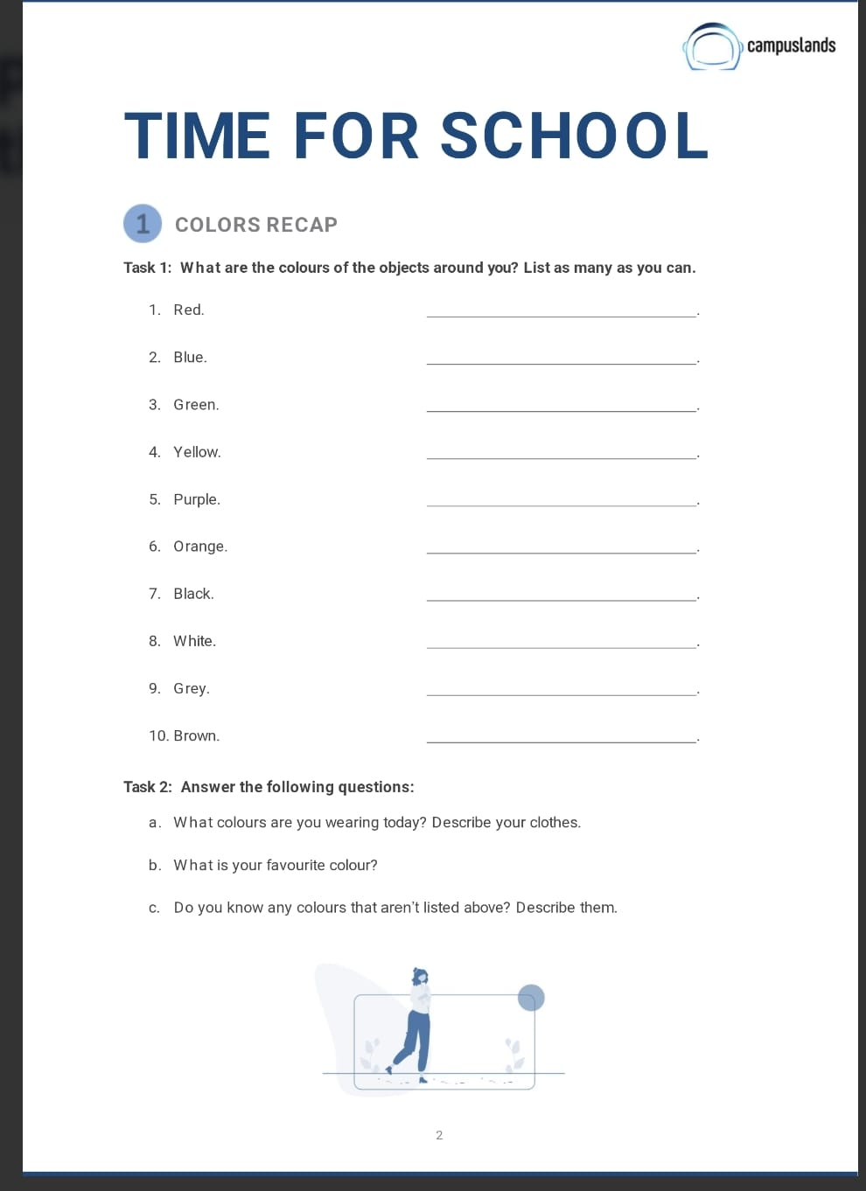
Yes, I know pink. Pink is a light red colour, like a flower or cotton candy.
My favorite color is yellow
I'm wearing a fuchsia shirt, blue pants, and grey and pink shoes.
The color of my eyes
my shoes
the walls of the living room
my sweater
the LED lights on my mouse
the keyboard's LED lights
the lid of my water thermos
the keyboard's LED lights
My pants
Carol’s shirt

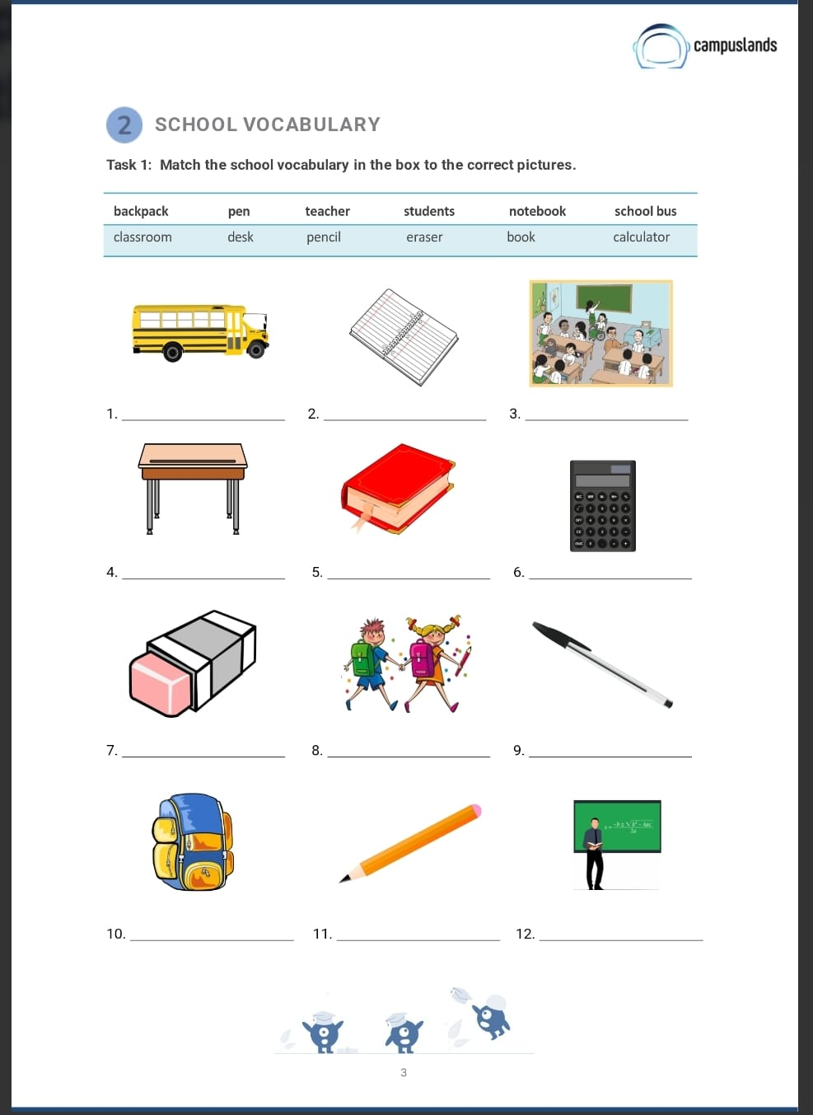
School bus
eraser
notebook
desk
teacher
backpack
clasroom
pencil
pen
calculator
book
students

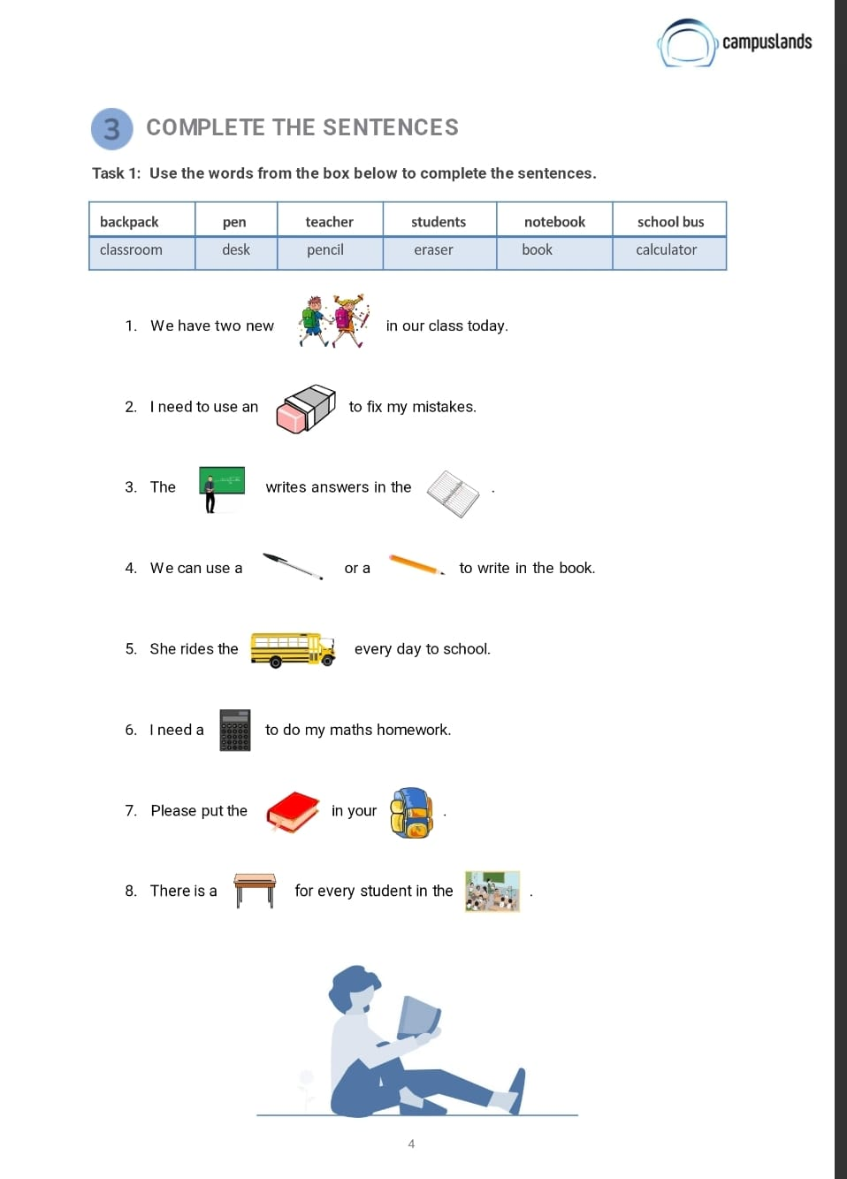
backpack
School bus
desk
pencil
pen
calculator
teacher
book
clasroom
students
earser
notebook

