.
.
.
.
.
.
.
.
.
.
.
.
The happiest
The happiest
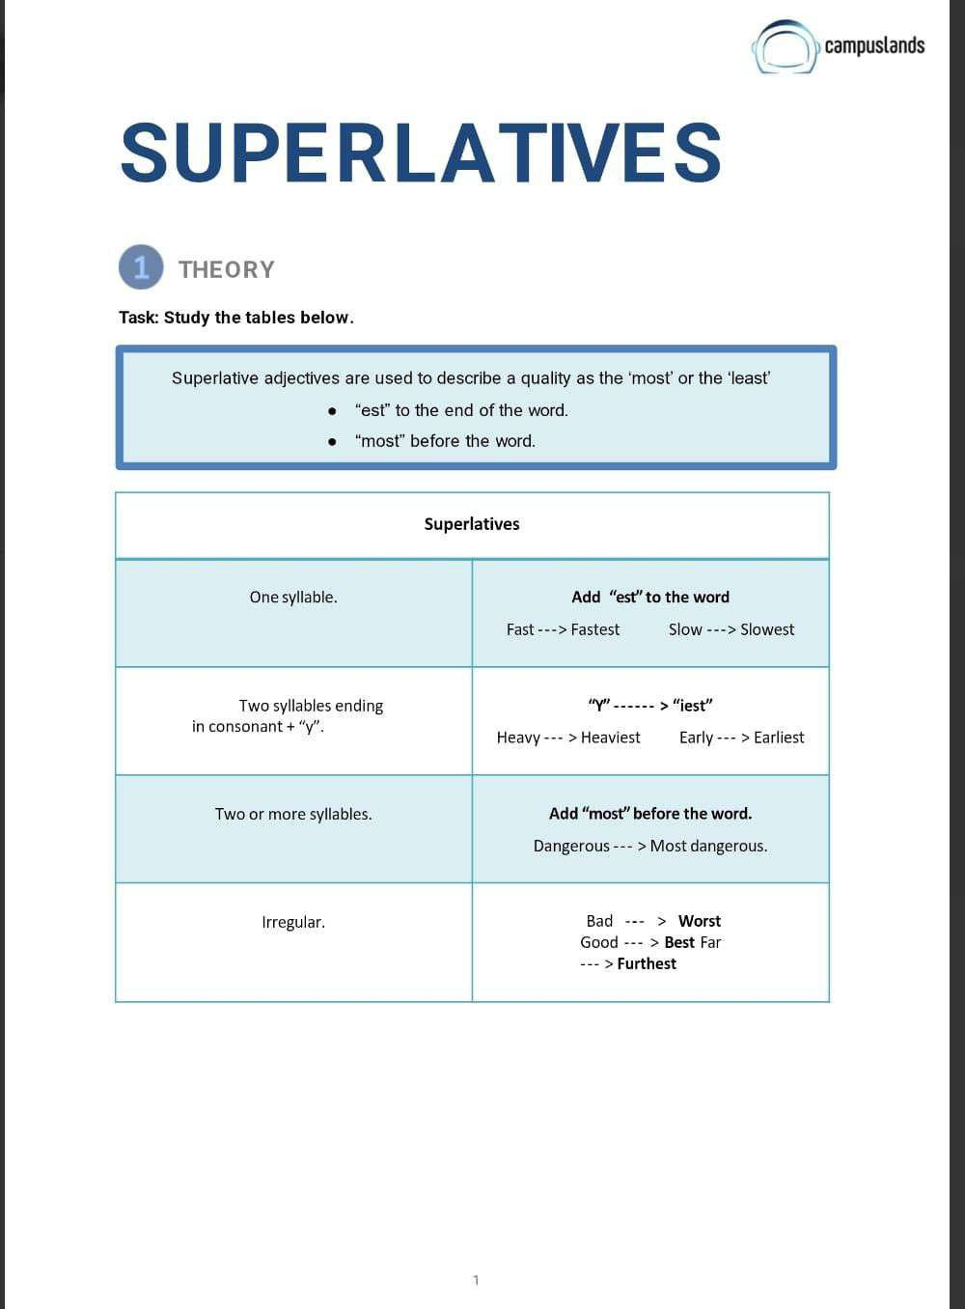
The furthest
The most amazing
The calmest
The gentlest
The most intelligent
The strongest
The most honest
The most generous
The shyest
The best
The most patient
The most stylish
The fastest
The tallest
The closest
The most helpful
The most modern
The happiest
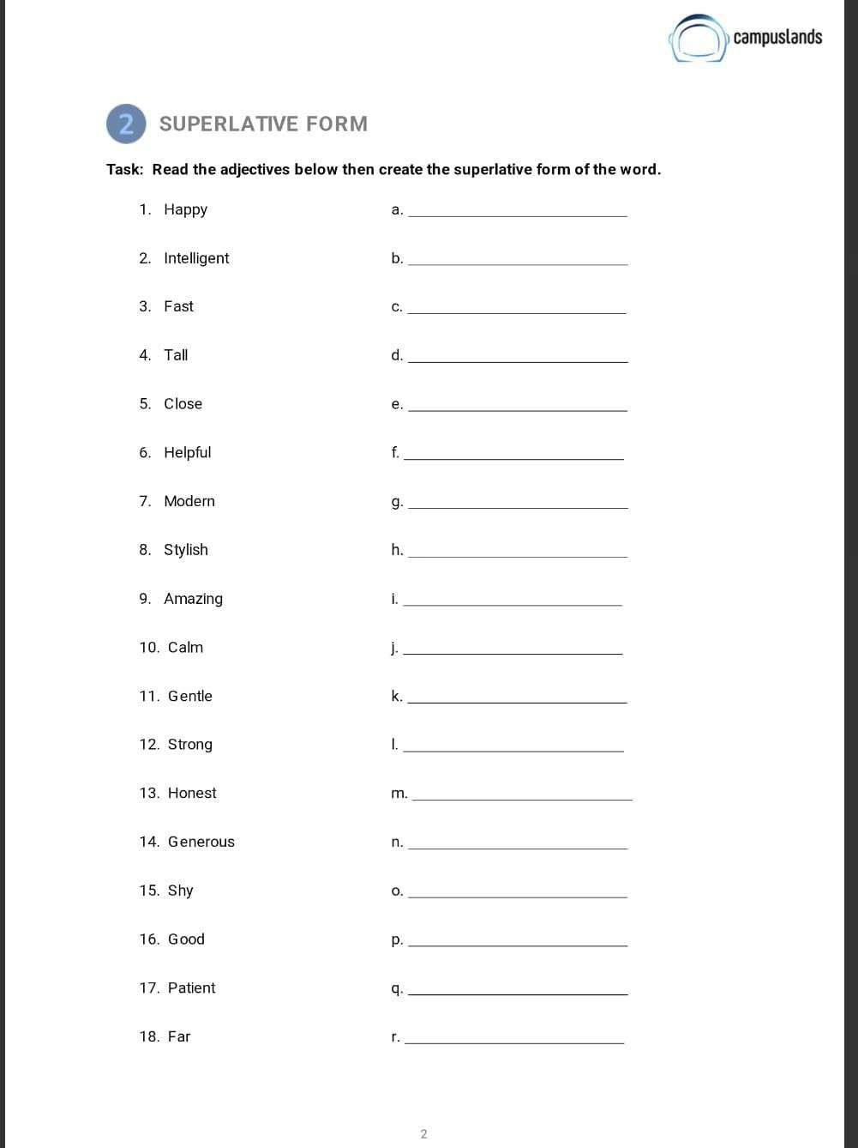
shyest
most patient
best
most generous
most honest
strongest
gentlest
calmest
most amazing
most stylish
safest
most comfortable
brightest
healthiest
biggest
fastest
richest
most modern
busiest
dirtiest
.


