BR version

Main Report

Basic processing
In this study, the STK QC flag was “fair”, . Biological variability was “high”.
Details about QC flags and the Data Variability Indicator are provided in Supplement section 2.2.2.
Normalization: VSN normalization and ComBat correction were applied.
Following VSN normalization, observed effects are expressed relative to the overall data average.

Supplement

Quality Control
The quality of the data was assessed using criteria shown in Table 1. The QC results for the data in this study are shown in Table 2.
Two criteria were checked using a flag system is used to indicate a quality level:
- Phosphosite signal strength (i.e., the 99th percentile of S100 AU (arbitrary units).
- Phosphosite number control (i.e., how many phosphosites passed quality control).
Each criterion is individually rated good, fair, or poor (see Table 1).
The overall QC flag is: good only if both criteria are individually good; poor only if both criteria are individually poor; fair for any other combination.
Table 1: Flag system used to assess data quality
Level | Flag¹ | Signal Strength (AU) | QC-passed phosphosites (PTK) of 195 | QC-passed phosphosites (STK) of 142
Good |  | >= 2,000 | >= 123 | >= 90
Fair |  | 1,000 - 2,000 | 78 - 123 | 56 - 90
Poor |  | < 1,000 | < 78 | < 56
¹The QC flag is based on the criteria shown. All criteria must be met to get a green QC flag.

Data Variability Indicator
Alongside the QC flag, biological variability is reported across three tiers (low/medium/high, Table 3). Lower biological variation enables detection of smaller effect sizes from the covariates of interest. The Data Variability Indicator uses average peptide standard deviation (SD) per condition (e.g. test, control). Table 4 reports the range (minimum – maximum) of this average SD across all conditions and normalizations in the study.
If high variability persists post-normalization alongside low phosphosite significance, the study likely requires a larger sample size to detect differentially active kinases reliably.
Table 3: Data Variability Indicator tiers
Level¹ | Variability (SD)
Low | < 0.2
Medium | 0.2 - 0.35
High | > 0.35
¹Informational only — not part of the QC flag.
Table 4: Data Variability Indicator — Variability (Biological)
Normalization | Variability (STK)
Log | 0.12 - 1.72
Log + ComBat | 0.33 - 1.5
VSN | 0.11 - 0.8
VSN + ComBat | 0.11 - 0.75

TR version

Main report

Basic processing
In this study, the STK QC flag was “fair”, .
Normalization: VSN normalization was applied.
Following VSN normalization, observed effects are expressed relative to the overall data average.

Supplement
The quality of the data was assessed using criteria shown in Table 1. The QC results for the data in this study are shown in Table 2.
Three criteria were checked using a flag system is used to indicate a quality level:
- Phosphosite signal strength (i.e., the 99th percentile of S100 AU (arbitrary units).
- Phosphosite number control (i.e., how many phosphosites passed quality control).
- Data variability (i.e., the average within-condition peptide signal standard deviation (SD), based on technical replicates).
Each criterion is individually rated good, fair, or poor (see Table 1).
The overall QC flag is: good if all three criteria are individually good; poor if no criterion is good and at least two criteria are poor; fair in every other case.
Table 1: Flag system used to assess data quality
Level | Flag¹ | Signal Strength (AU) | QC-passed phosphosites (PTK) of 195 | QC-passed phosphosites (STK) of 142 | Technical Variability (STK)
Good |  | >= 2,000 | >= 123 | >= 90 | < 0.2
Fair |  | 1,000 - 2,000 | 78 - 123 | 56 - 90 | 0.2 - 0.35
Poor |  | < 1,000 | < 78 | < 56 | > 0.35
¹The QC flag is based on the criteria shown. All criteria must be met to get a green QC flag.

Phoshosite analysis

main report

Table 1: Phosphosite Analysis
Assay Type | STK
Comparisons | Up | Down
1-A219 - T1 vs Controlª | 11 | 16
1-A219 - T2 vs Controlª | 0 | 8
ªSignificance was obtained using Limma, p<0.1.

Supplement

Differential statistical analysis methods...
The following plot(s) show the results from the statistical tests:
- Volcano plot, useful for an overview of the Test condition vs control. Volcano plots visualize the significance (y-axis, -log10(p value)) versus the effect size (x-axis, LFC or delta) of each test. Red dots are phosphosites that show significant difference compared to control (p<0.1, i.e. -log10(p)>1.00).

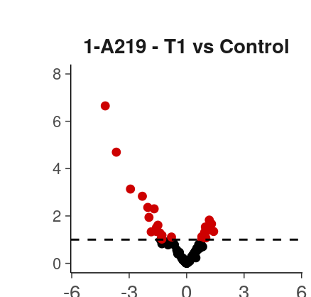

Supplement - Data Analysis Overview
The general workflow for data analysis is shown below (Figure 2), which was used to derive the results described in the Report and this Supplement, with details following.
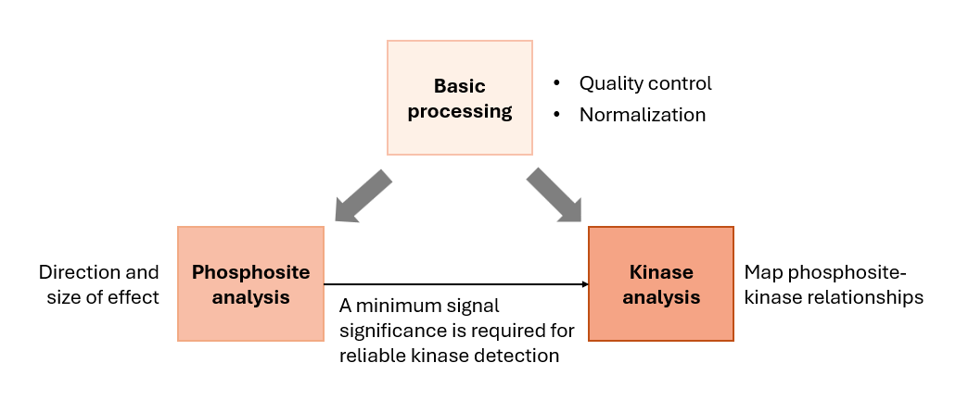

Tercen workflow export csv naming Autoreport (Rik skip this)
Sample annotation: if there are technical replicates, it must have a column defininig Sample that is unique to TRs. This column must have „sample” in the name, e..g Sample name, Sample_id, sample_no. (This is anyway the default in our newest Sample annotation)
From now we must export the qc files from the latest normalization(s). After log Combat, the QC csv includes both .logTransformed and .CmbCor values, similarly for VSN it is .identity & .CmbCor (log & VSN can be also exported).
In a project with BRs and TRs, we do TR average step. Then we must export 2 QCs!
- TR QC: either after log or VSN or logCmb or VSN-Cmb step. Ideally you don’t have to change anything.
- BR QC: after normalization(s), the TRs are averaged producing the „.value” column. The sample from then is defined by the Sample name (or id, or no) instead of Barcode, Array. Set up a new QC export step with:
  - Sample Name
  - ID
  - Test Condition, Supergroup
  - .value
From a simple project having only BR or TR, not both, save csv with names as:
- QC_PTK_01_[TR or BR]
- If you have 2 branches log and vsn, you will have also QC_PTK_02_TR
From a project having both BR and TR, save csvs:
- QC_PTK_01_TR
- QC_PTK_01_BR_<normalization>
  - Normalization: log, logcmb, vsn, vsncmb, case insensitive.
  - This is needed because averaging produces .value column and we have to indicate where that is coming from.

The manual „Normalizations” checkbox in the ui will be only used for BioNavigator.

