At this stage 02, it is primary to know meaning, datatype, validity of each data field. If this task is not done thoroughly, the program can handle the data wrong while the charts created likely still look reasonable.

Why to open vesla_metadata.xml?
- Real data API Sample
- Example:
  - ”SampleDepth_m”: ”1.0”
    - This was returned by API in the previous sample
- So API returns the data
- OData metadata A description of the data structure
- Example:
  - Name=”SampleDepth_m” Type =”Edm.String”
    - So, metadata helps to know datatype of each field
- Metadata describes the source structure
- Data contract Rules that designed by data scientist
Parse numeric string → validate → preserve raw → classify depth
    - These are the rules that pipeline has to follow and check by tests
- Data contract determines how the program uses the data

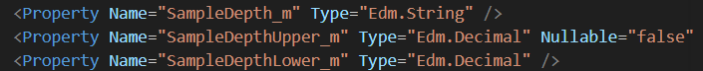
So <Property /> is a field. Name is name of the field. Type is the data type was declared. Nullable: whether or not a property is allowed to have a null value when it is declared.

