01 – Problem Lock
GitHub Repository – center of project history management; Commit – a snapshot to be recorded in the project history; Working tree – file status on local desktop, possibly different from final commit.
Git status – to check the local changes. Git log – to check the commit history. Pytest – run the automated tests if they exist and environment was setup correctly.
Created GitHub repo. Cloned the repo to local folder using GitHub Desktop (easy method).

Review the setup using the following Git commands:
git status --short
git branch --show-current
git log --oneline -5
git ls-files
python --version
python -m pytest -q
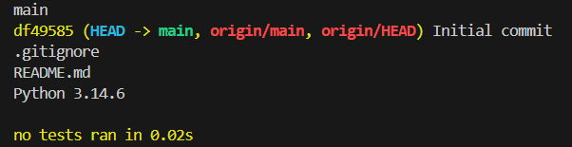 (Terminal ouput)
Explanation for the terminal output:
- No output for git status –short
- Git branch –show-current main
- Git log –oneline -5 df49585 Initial commit
- git ls-files .gitignore, README.md
- python –version Python 3.14.6
- python -m pytest -q no tests ran in 0.02s This doesn’t mean tests PASSed. This means pytest ran but no test was found. This is obviously ok because no implementation was done.
- Simutaneously, the output does not prove that the libraries needed for project F1 are compatible with Python 3.14.6. I will check when it’s really needed.

Git is a version control system. Git Bash is a terminal shell.

Thus, need not to initiate the Git repo again, or a README.md.

02 – Data Contract
Goal of this stage is to build docs/data_contract.md, describe exactly how SYKE VESLA data is understood, and check before developing ingestion pipeline.

Self-assumptions:
Data grain – each data row or data observation represent for each observation which contain all the recorded information of the observation/sample, e.g. measurements of the observation, calculated values, categorical values, etc; Composite key – to identify only one observation, we should consider the unique variables/parameters that changes according to the numerical order, alphabetical order, predetermined IDs, or codes, etc, but not according to information relying on real-worlds activities such as measurements; Data validation – to figure out if the data is missing, wrong in type, or duplicated, we should first know the pattern/rule of recording each parameter/variable from the people who are responsible for recording the data, then use the tools like Python to find the behaviors different from known common pattern in each variable.
In the water quality data, Sample_ID is mostly likely not enough to identify a specific data observation because the ID is commonly determined as rough number without background description or any insights, thus it can be more useful to combine Sample_ID with e.g. places of recording, time of recording, etc.
Correct answers:
Data grain - The data grain defines exactly what one row represents.
Ví dụ: One row represents one analytical determination result associated with one water sample.
Composite key - A composite key is a combination of two or more fields that uniquely identifies a record within a defined dataset.
Quan trọng: key phải đáp ứng điều kiện uniqueness thực tế. Nếu có repeated determinations hoặc phiên bản kết quả khác nhau, candidate key ban đầu có thể không đủ.
Data validation - Data validation checks whether data satisfy defined structural, relational, and scientific rules.
Ví dụ kiểm tra required columns, data types, uniqueness, missing values, measurement qualifiers và units. Nhưng một giá trị censored như < 0.5 µg/L không tự động là dữ liệu lỗi.

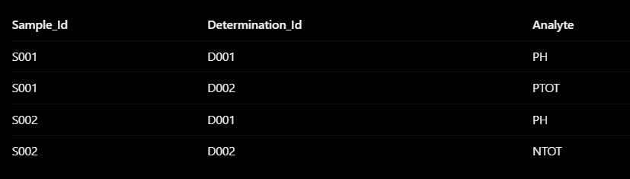(Exercise)
Self-assumption: In this table, both Sample_Id and Determination_Id cannot separately uniquely identify a record because each of them alone repeats themselves throughout the dataset, i.e. each Sample_Id variable repeats twice while each Determination_Id variable repeats many times. However, when they two are combined, they can uniquely identify specific records with their associated Analyte values.
Correct answer: Neither Sample_Id nor Determination_Id is individually unique because their values repeat across multiple records. However, each combination of Sample_Id and Determination_Id appears exactly once in this dataset. Therefore, the two columns form a composite key that uniquely identifies each record.

Data validation with Python. Here, df is a DataFrame.
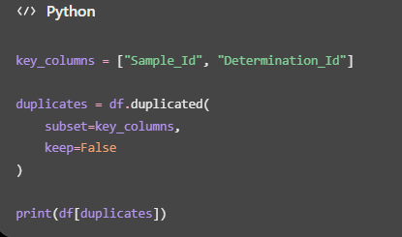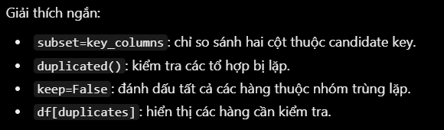

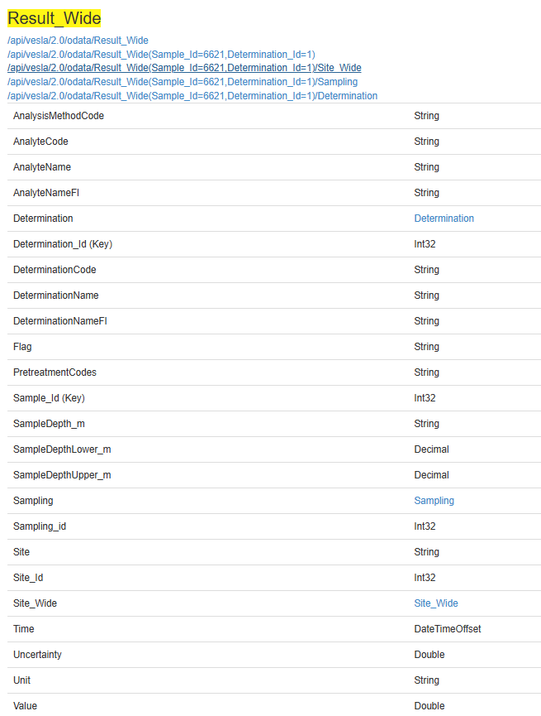(Table of Result_Wide containing fields associated with their Data types)
Remarkably, SampleDepth_m is in String type, even it relates to height measured by meter. Thus, it’s not good to assume this field always contain valid numbers for direct calculations.

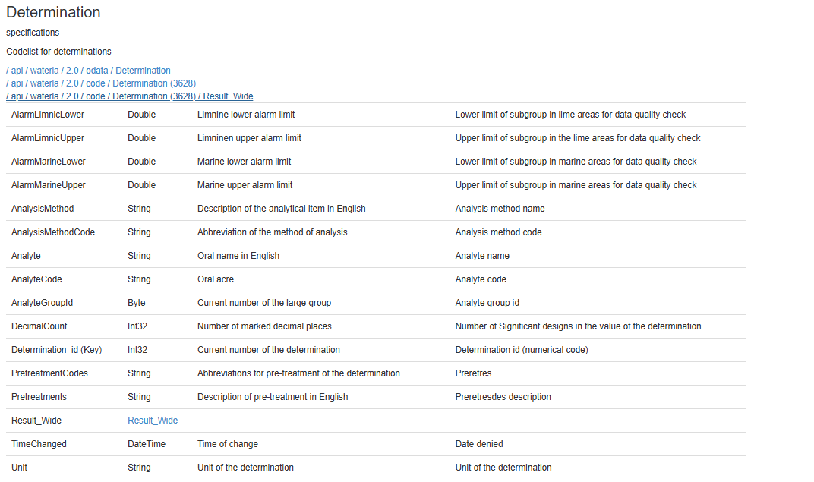 (Table of Determination entity containing fields associated with their Data types)

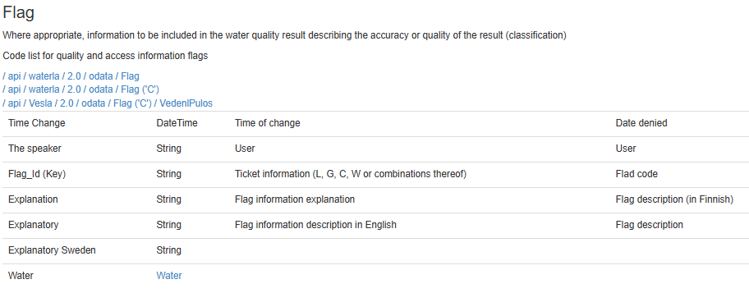(Table of Lippu (Flag) entity containing fields associated with their Data types)

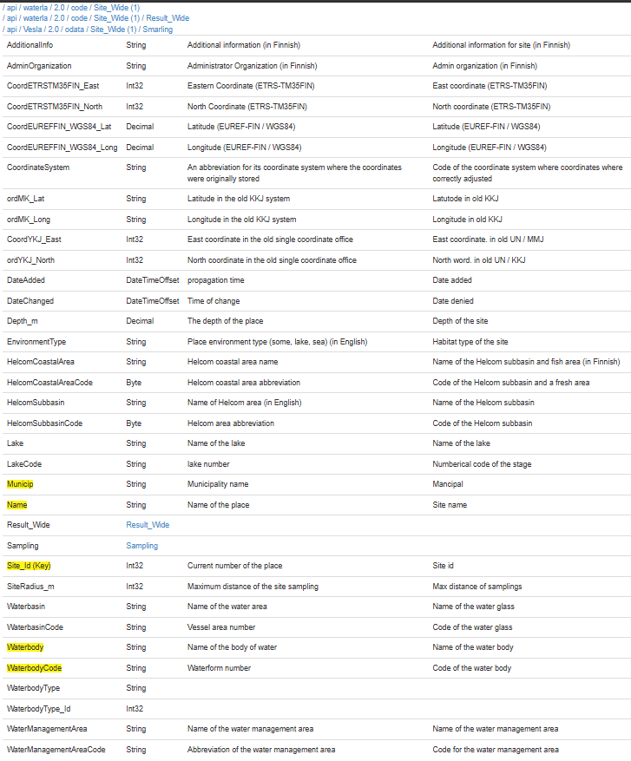(Table of Site_Wide entity containing fields associated with their Data types)

Entities such as Determination, Lippu, and Site_Wide help explain analyte/method, flag semantics, and site metadata.

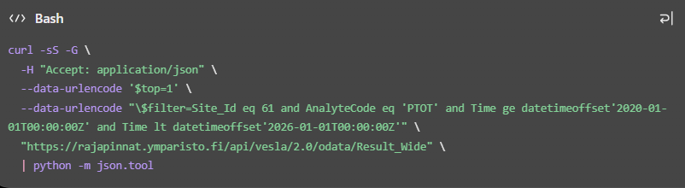 (read-only HTTP GET request đến API)
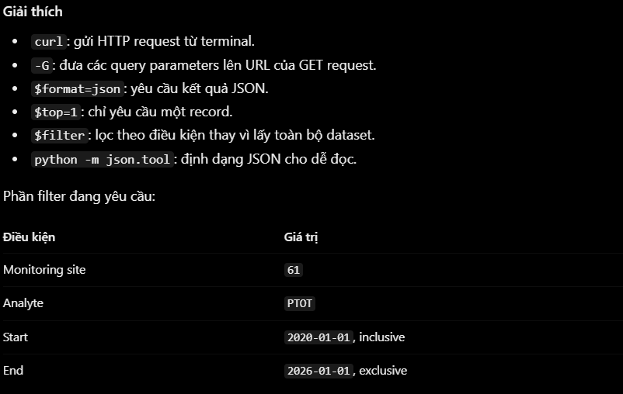
This is just a small record gotten to study the schema, not the whole dataset.

TERMINAL OUTPUT:
{
"odata.metadata": "https://rajapinnat.ymparisto.fi/api/vesla/2.0/odata/$metadata#Result_Wide",
"value": [
{
"Site_Id": 61,
"Site": "P\u00e4ij\u00e4nne, Pernasaari 26",
"Sampling_id": 1488482,
"Time": "2020-08-13T10:20:00+02:00",
"SampleDepth_m": "1.0",
"SampleDepthUpper_m": "1.0",
"SampleDepthLower_m": null,
"Sample_Id": 3253063,
"Determination_Id": 315,
"Flag": null,
"Value": 9.0,
"Unit": "\u00b5g/l",
"Uncertainty": null,
"AnalyteCode": "PTOT",
"AnalyteName": "Total phosphorous",
"AnalyteNameFI": "Kokonaisfosfori",
"PretreatmentCodes": "D11",
"AnalysisMethodCode": "SP",
"DeterminationCode": "PTOT;D11;SP",
"DeterminationName": " (315) Total phosphorous [\u00b5g/l]; Pretreatments:Digestion in K2S2O8; AnalysisMethod:Spectrophotometry, flow injection analysis, colourimetric",
"DeterminationNameFI": " (315) Kokonaisfosfori [\u00b5g/l]; Esik\u00e4sittelyt:Hajotus K2S2O8; M\u00e4\u00e4ritysmenetelm\u00e4:Spektrometria, FIA, kolorimetrinen"
}
]
}
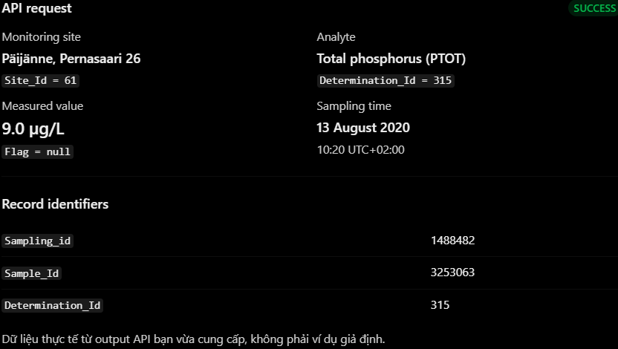(The first real record taken from SYKE VESLA OData API v2.0. Presented nicely by ChatGPT)
Notably, DeterminationCode = "PTOT;D11;SP". This provides more information about analyte, pretreatment and analysis method. This is precisely why F1 does not automatically treat all the measurements involving the same analyte as equivalent in terms of the analytical method used.
Three important findings in terms of Data Quality
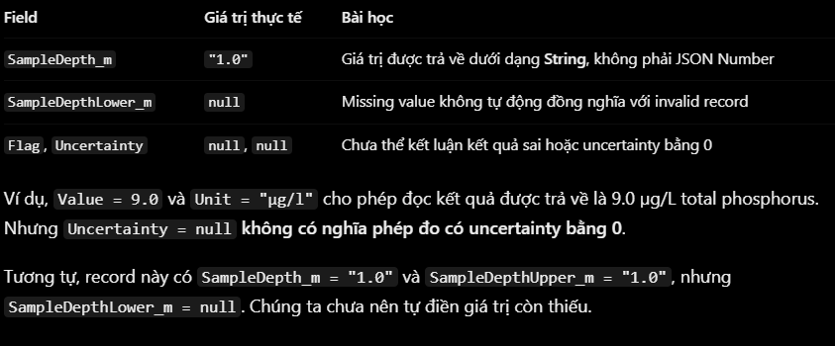

What this record proves:
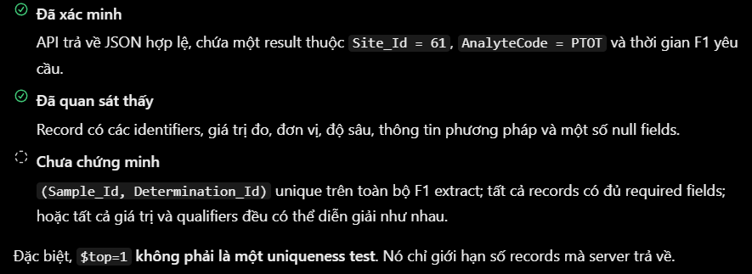

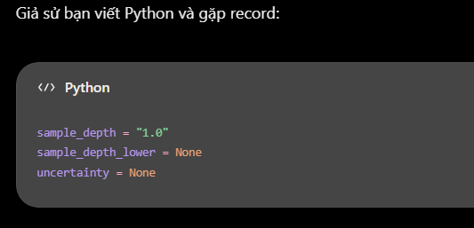(Exercise)
Self-assumption: Tôi chọn KEEP. Lý do: sample_depth = "1.0" is still useful if it can be converted into integer. so it is good to keep it.
uncertainty = none and sample_depth_lower = None meaning that the fields are missing. However, we should keep them becuase they are in the same measurement result as sample_depth ad sample_depth can be utilized later on. Moreover, we have to consider validation rules. I think vlaidation rules are basically what analyst, in this case me, will decide but I don't know how and if this statement is correct.
Correct answer: I would retain the record because the missing fields do not necessarily invalidate its other measurements. I would validate the depth field before converting it to a numeric type and preserve missing uncertainty information without inventing values. Validation rules should be based on source documentation, scientific principles, and explicitly justified project requirements.

Who and how to determine Validation Rules
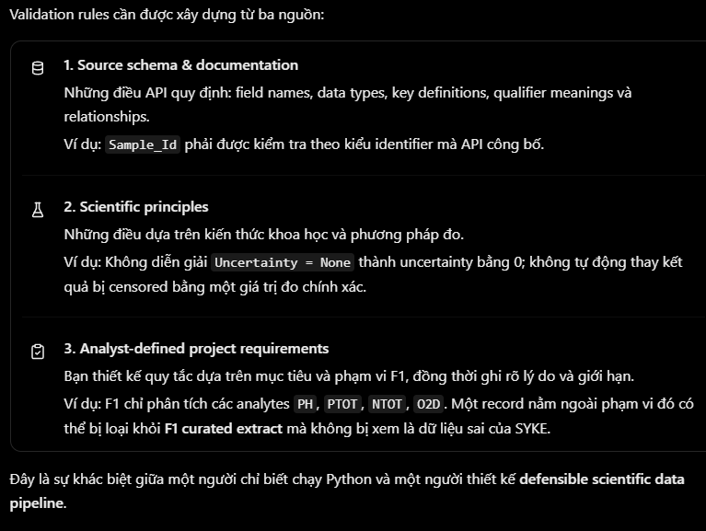 Nhà Phân Tích, Analyst, sẽ thiết kế và triển khai validation rules, nhưng không được tùy ý quyết định điều gì là đúng hoặc sai về mặt khoa học.

Distinguishing Between "Invalid" and "Out-of-Scope
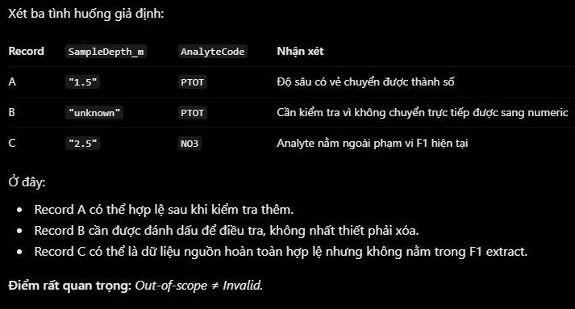

If SYKE API returns sample_depth = “unknown”, while project F1 needs to use depth as a float number in meter (m), float(“unknown”) will return error ValueError. This is called type conversion failure – original value cannot be converted to another data type as the validation step requires. “Unknown” does not necessarily prove that source data is wrong, it can be a way presenting the missingness in the source system. Thus, F1 project needs to keep the raw value and record that type conversion failed.

How to execute Flagging
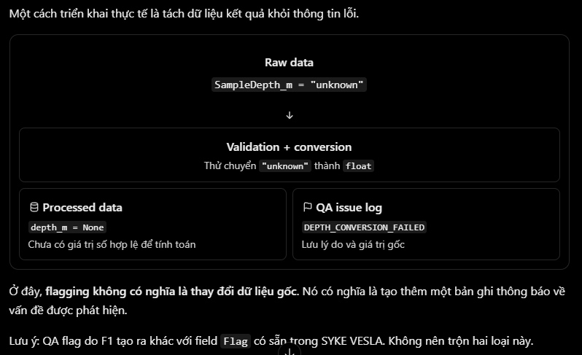
Two common ways of Flagging:
- Add 1 QA into dataset
  - 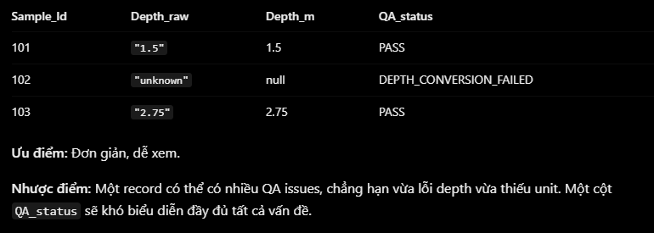
- Create a table of QA issue log (Suggested for project F1)
  - 