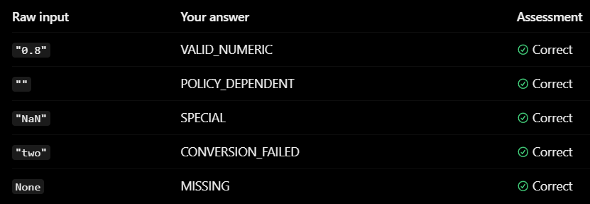(Exercise)
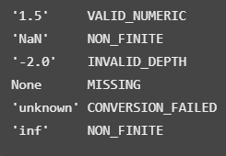

To validate the raw_input = True or False, we use isinstance(raw_input, bool), but not with isinstance(raw_input, int) or not with (raw_input == True or raw_input == False) because True 1.0 and False 0.0.
This will not e.g. cause classify_depth(1.0) to output INVALID_TYPE.
Int set includes the actual numbers while bool set includes only True and False which not numbers 1 or 0.

#REGRESSION CASES CHECKING:
import math
def classify_depth(raw_value):
# Step 1: Handle missing values
if raw_value is None:
return "MISSING"
if raw_value == "":
return "MISSING"
if isinstance(raw_value, bool):
return "INVALID_TYPE"
# Step 2: Attempt numeric conversion
try:
depth = float(raw_value)
except (ValueError, TypeError):
return "CONVERSION_FAILED"
# Step 3: Your independent implementation
# Check whether depth is finite.
if not math.isfinite(depth):
return "NON_FINITE"
# Step 4: Reject negative depths.
if depth < 0:
return "INVALID_DEPTH"
return "VALID_NUMERIC"

TESTING the above codes (REGRESSION CASES CHECKING):
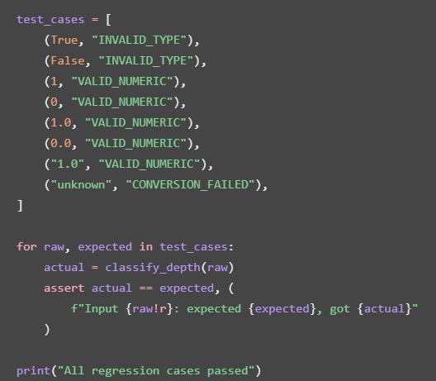

Suggested first Data Contract, not an approved contract:
F1 Data Contract
Status: DRAFT — Mission 2
Source: SYKE VESLA Surface Water Quality API v2.0
Scope: Päijänne, sites 61/100/112, analytes PH/PTOT/NTOT/O2D, 2020–2025
Sample depth — Parsing and Validation
1. Source evidence
The previously observed Result_Wide record contains:
- SampleDepth_m: "1.0"
- SampleDepthUpper_m: "1.0"
- SampleDepthLower_m: null
These are observed field names and values from one API response. Full metadata verification remains pending.
2. Proposed parsing rules
Raw values must be preserved without modification.
Input condition | Classification
None | MISSING
Empty string | MISSING (proposed policy)
Boolean | INVALID_TYPE
Finite non-negative number | VALID_NUMERIC
Parseable finite non-negative numeric string | VALID_NUMERIC
Unparseable non-missing value | CONVERSION_FAILED
NaN or infinity | NON_FINITE
Negative finite depth | INVALID_DEPTH
3. Scientific interpretation
A successfully parsed numeric value is not automatically a scientifically valid observation.
The project must validate depth values before using them to determine surface eligibility.
For the planned surface view, the depth threshold is 2 m. Missing or invalid depths must not automatically be classified as surface observations.
4. Data preservation
The pipeline must preserve the original source fields and create separate derived values.
Invalid data must not be silently replaced with zero or removed from the raw evidence.
5. Verification status
- Boolean-rejection and numeric-conversion learning exercise: 8/8 local assertions passed on 2026-10-25.
- Official depth field semantics: pending verification.
- Production contract tests: not yet implemented.
- Final missing-value and depth-interval policy: pending review.

Git Bash:
Git status --short
Terminal Ouput:
?? docs/
This output confirmed that the folder docs/ is just created in the production repo.

Git Bash:
cat docs/data_contract.md
- This will print the whole content inside the data_contract.md on the terminal without modifying the content. So, cat is the syntax to do this task.

