Of course! Let’s explain the OSI Model like a Telugu movie story — imagine it as a drama film where every layer is a hero with a special duty, and they all work together to send a love letter (data) from Hero to Heroine in a faraway village (another computer). Ready? Let's roll!

🎬 Movie Title: "OSI Premalekha – 7 Layers of Love!"
👦 Hero: Srinu (the sender)
👧 Heroine: Sita (the receiver)
💌 Premalekha (Love Letter): The actual data you want to send
🏡 Destination: Heroine’s village (another system)

📶 Layer 7: Application Layer – The Writer Srinu
Srinu writes a love letter using a pen and paper (application like Gmail, browser, WhatsApp).
He decides what to say, whom to send, and when to send.
This is where communication begins – Srinu is fully aware of whom he loves!
Eg: HTTP, FTP, DNS – these are tools he uses to write/send.

📜 Layer 6: Presentation Layer – The Translator Friend
Now Srinu’s friend helps him convert the letter into a secret code (encryption/formatting) so others can’t understand it.
Also, he ensures it’s in a language Sita understands (data formatting, encoding).
Eg: SSL, JPEG, MP3 – these make sure the format is right.

📦 Layer 5: Session Layer – The Meeting Arranger
He calls Sita and says,
“Hey! Let’s meet at 6 PM near the temple… I’ll send something!”
He manages the start, maintain, and end of the session between Hero and Heroine.
Eg: Sessions in WhatsApp, Zoom calls – connection management.

🔀 Layer 4: Transport Layer – The Trusted Messenger
Srinu hands over the letter to a trusted messenger who says,
“Don’t worry boss, I’ll deliver it safely.”
He divides the letter into multiple pages (segments), numbers them, and ensures no page is lost (reliable delivery).
Eg: TCP (guaranteed), UDP (fast but no guarantee) – the messengers.

🛣️ Layer 3: Network Layer – The Map Guide
The messenger doesn’t know the path to Sita’s village.
So he asks the Map Guide (Router) to get the best route (IP address) to reach her house.
Eg: IP, ICMP, Routers – responsible for deciding the route.

🚗 Layer 2: Data Link Layer – The Local Driver
Once the route is known, the local auto driver takes the letter through the local town roads.
He ensures no one steals or changes it on the way and uses the house number (MAC address) to deliver it locally.
Eg: Ethernet, MAC address, Switch – local delivery mechanism.

🔌 Layer 1: Physical Layer – The Road
Now, the actual roads, wires, signals, voltage – everything physical is involved here.
It converts the love letter into electrical signals, light pulses, or radio waves and transmits them.
Eg: Cables, Wi-Fi, Fiber optics – this is the physical journey.

📥 Now at Sita’s House:
Sita gets the signals, and layer-by-layer, the letter is decoded:
- Road (Physical)
- Delivered to house (Data Link)
- Found correct route (Network)
- Reassembled pages (Transport)
- Session confirmed (Session)
- Decoded from secret code (Presentation)
- Sita reads it with love (Application Layer) 💖

🎉 The Love Message is Delivered Successfully!
And that, my friend, is how data travels from one computer to another – just like a Tollywood love story with action, drama, emotion, and technology!
Would you like a diagram or animation style too? 😄
You said:
yes
ChatGPT said:
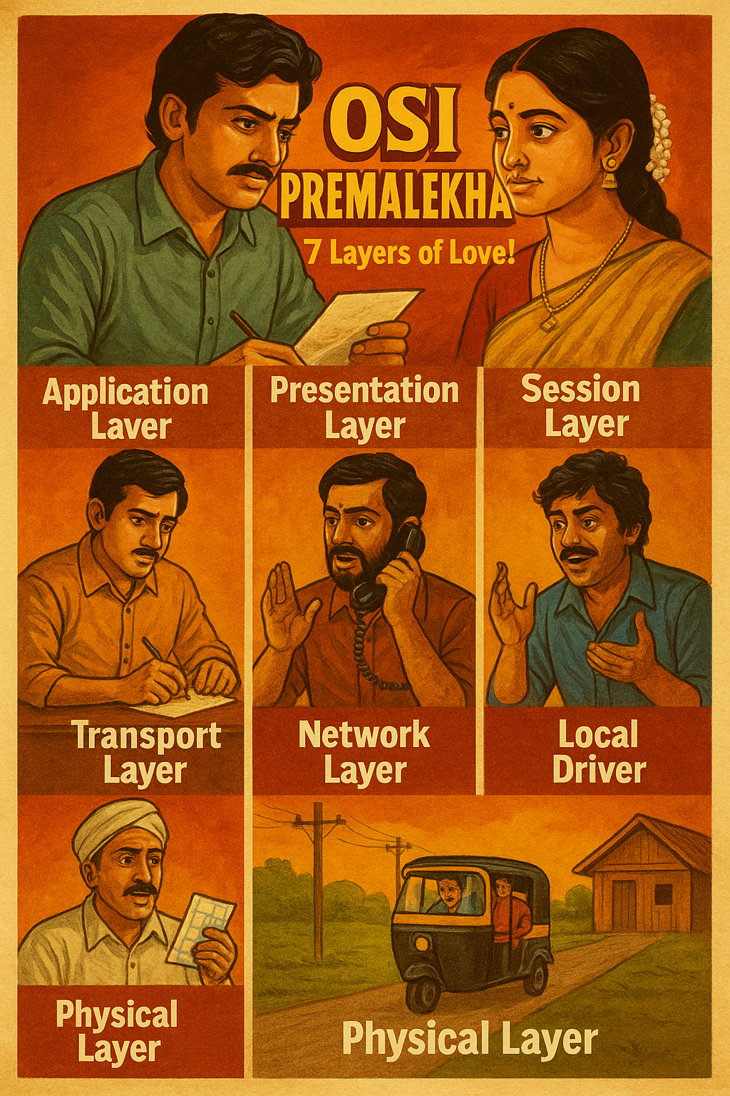

Share
You said:
please add commands to this story for all layers -- so that incase some thing fails we need to debug it
ChatGPT said:
Absolutely! Here's the same Telugu-movie-style OSI story, now with real-life Linux commands that a DevOps engineer might use to debug issues layer-by-layer — like a script writer checking the flow of a drama.

🎬 "OSI Premalekha – 7 Layers of Love" (with Debugging Tools!)

🧑‍💻 Layer 7: Application Layer – Hero Srinu Writing the Letter
🛠️ Debug Tools/Commands:
- curl -I http://example.com → Check HTTP response headers
- dig example.com or nslookup example.com → Check DNS
- telnet example.com 80 → Can the application port be reached?
If curl fails → Application not responding or port blocked.

🎭 Layer 6: Presentation Layer – Translator Friend (Encryption, Format)
🛠️ Debug Tools/Commands:
- openssl s_client -connect example.com:443 → Test SSL/TLS handshake
- file filename → Check format type
- iconv -l → Check supported encodings
- Browser dev tools → Inspect certificate/encoding issues
If SSL fails → Cert expired, invalid cipher, misconfigured web server.

📞 Layer 5: Session Layer – Arranging Meeting (Session Control)
🛠️ Debug Tools/Commands:
- ss -tunap → Check active TCP/UDP sessions
- netstat -anp → View session states
- App-specific logs (e.g., /var/log/httpd/access.log)
If session drops → Firewall/NAT timeout, app config, timeouts.

📦 Layer 4: Transport Layer – Reliable Messenger (TCP/UDP)
🛠️ Debug Tools/Commands:
- netstat -s → View TCP/UDP errors
- ss -s → Socket statistics
- iptables -L -v -n → Check if firewall is dropping packets
- tcpdump -i eth0 port 80 → Sniff packets at port level
If no ACKs, high retransmits → Network congestion or packet loss.

🗺️ Layer 3: Network Layer – Map Guide (IP Routing)
🛠️ Debug Tools/Commands:
- ping <IP> → Is the destination reachable?
- traceroute <IP> → Track route hops
- ip route or route -n → Check routing table
- ip a → Check local IP address
If ping fails → Wrong route, ICMP blocked, downed interface.

🛺 Layer 2: Data Link Layer – Local Driver (MAC, Switches)
🛠️ Debug Tools/Commands:
- ip link or ifconfig → Interface up/down
- ethtool eth0 → Check cable/link status
- arp -a → Check MAC address of neighbors
- brctl show → Show bridge info (if using virtual machines)
If link is down → Cable unplugged, bad NIC, no ARP response.

⚡ Layer 1: Physical Layer – The Actual Road (Wires & Signals)
🛠️ Debug Tools/Commands:
- Check physical cable connection
- Look at switch/router port LED status
- dmesg | grep eth → Kernel logs for hardware issues
- Test with another cable or port
If completely down → Cable issue, power failure, NIC/hardware issue.

✅ Pro Tip: Debugging Layer-by-Layer (Bottom to Top 🪜)
If something breaks, always start from the bottom (Physical) and go upwards:
- Cable connected?
- Interface up?
- IP assigned?
- Can you ping?
- Can you connect via port?
- Can app respond?

