**AWS**

**EC2: It is a Server Management service**

**Custom AMI: AMI + April_security_patch**

**Instance Type:**

**nano, micro, small, medium, large, xlarge**

**t2, t3, m4, m5, c4, c5, f1, g2, g3, m5a, m5d, r5n, r5dn…**

**Volume: (Nothing but External Hard Disk, pendrive)**

**We can attach to servers & detach as per the requirement**

**Note: Volume should be in the same AZ(Availability Zone)**

**While creating the instance we can setup the storage size (8GB)of instance**

**Once it is done, we can upgrade the Existing storage to (60GB) but it is not possible to decrease it to (34GB). Here Volume comes into the Picture.**

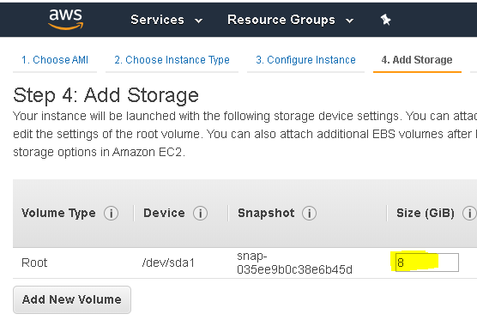

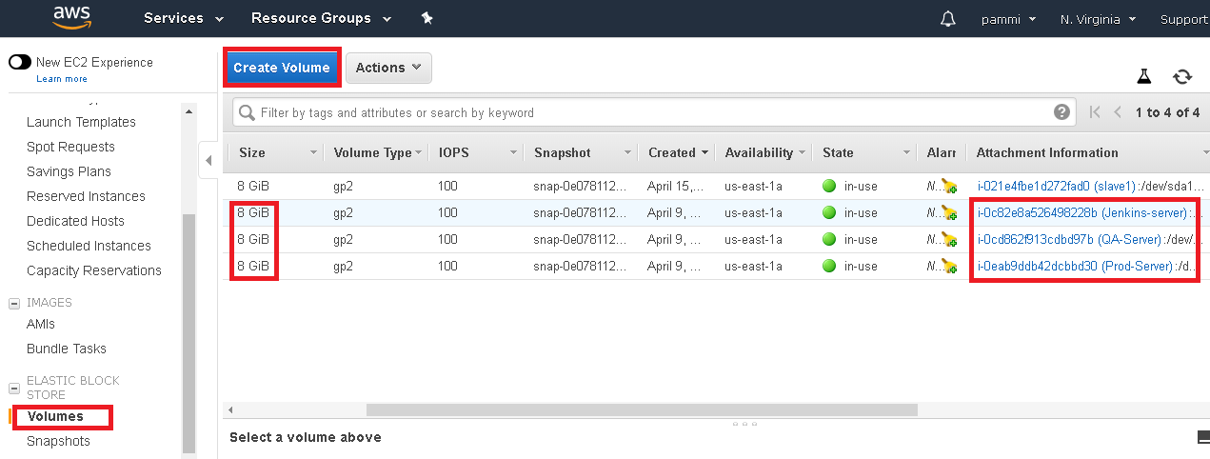

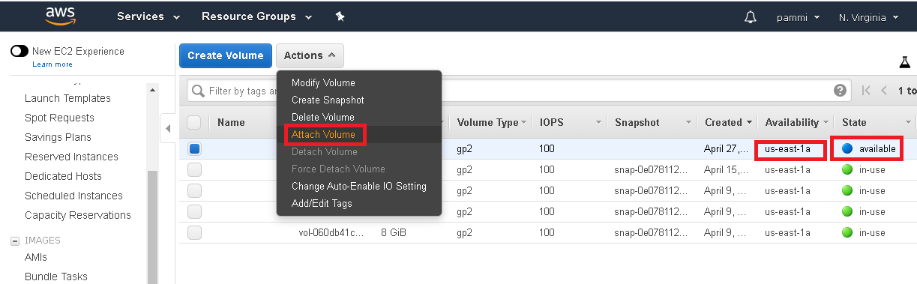

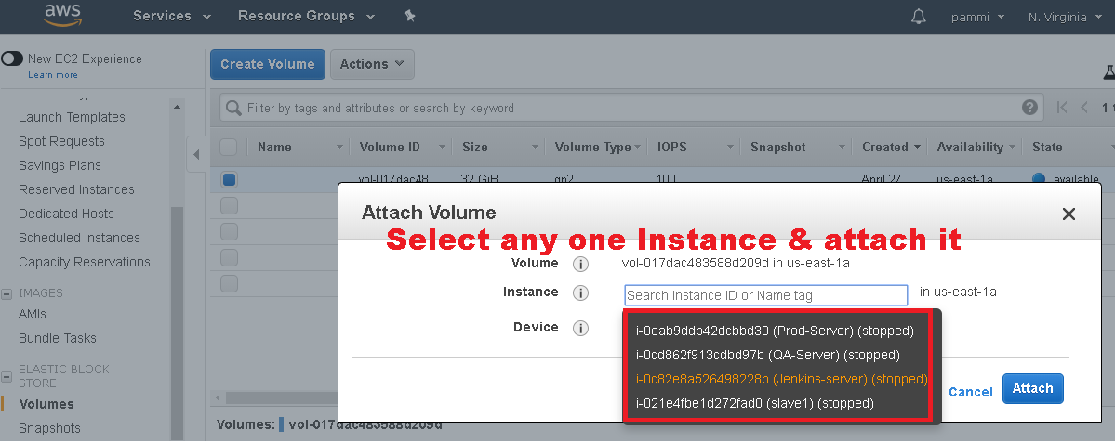

**IP Address**

**Public IP Address:**

**Whenever we create an Instance, we will get Private & Public ip address**

**Here Public ip address will be changed Once the Instance reboot, stop**

**To Overcome this issue, Elastic ip address come into picture**

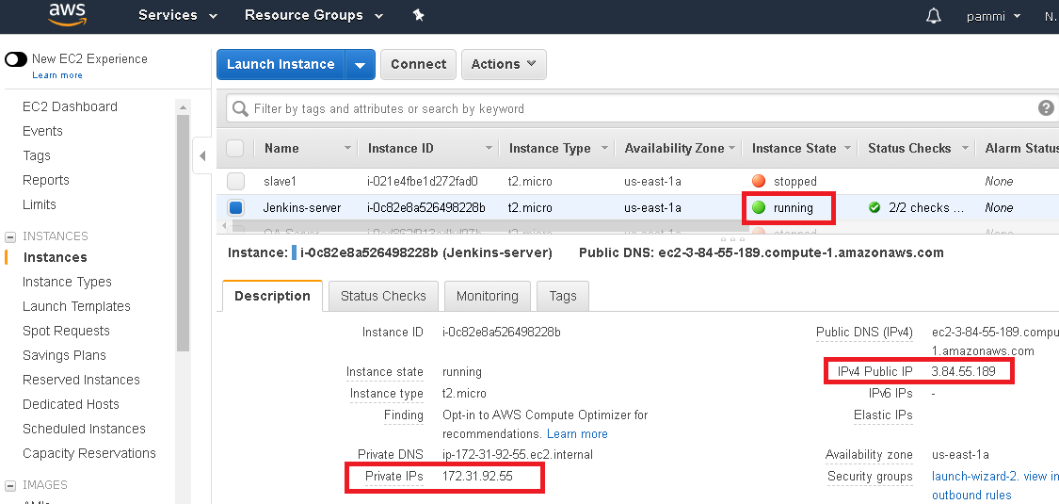

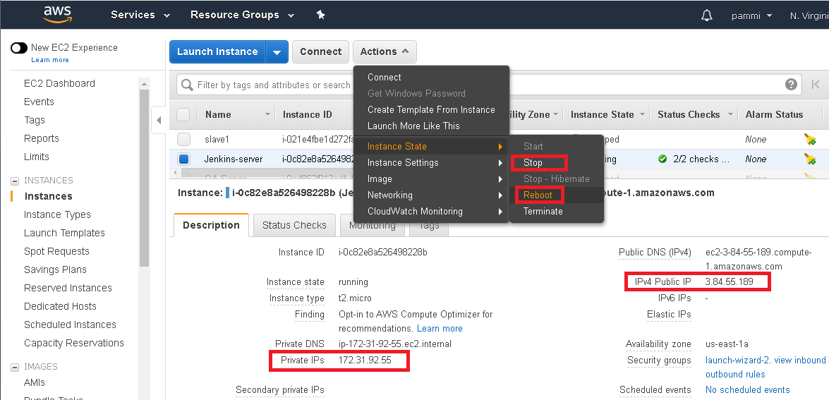 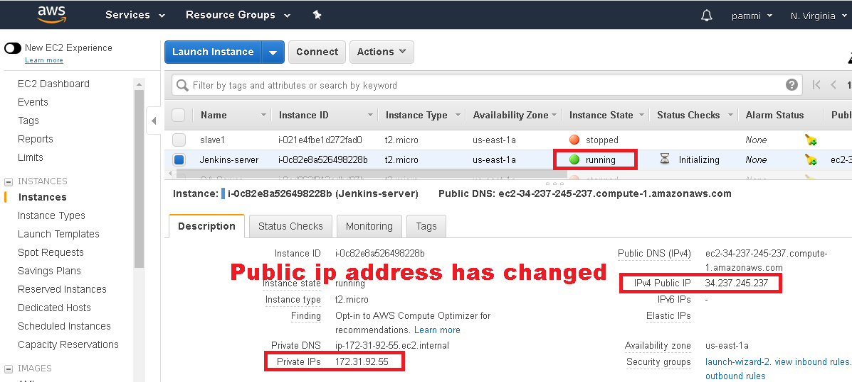

**Solution: Elastic ip-address**

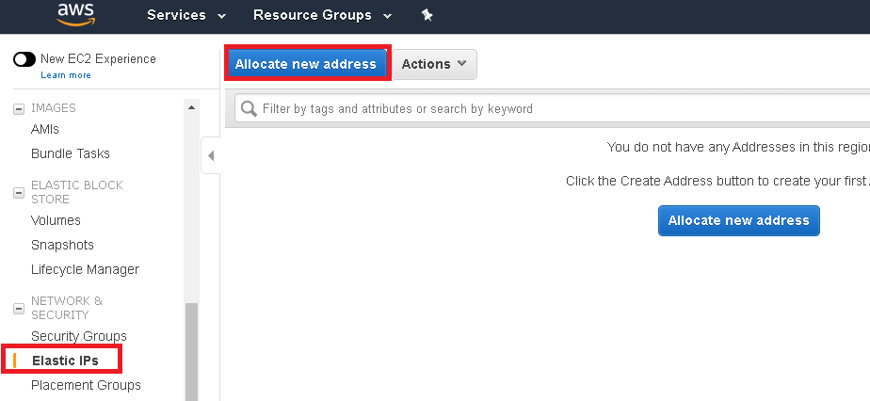

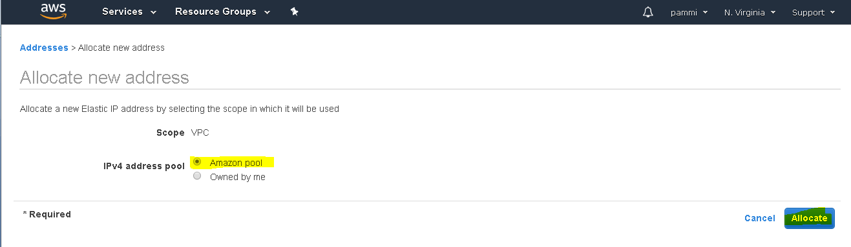 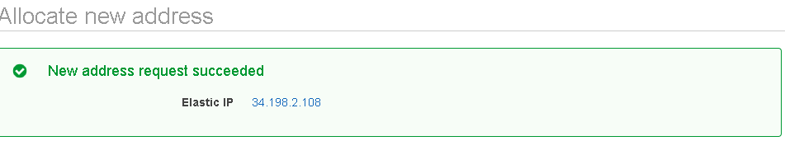

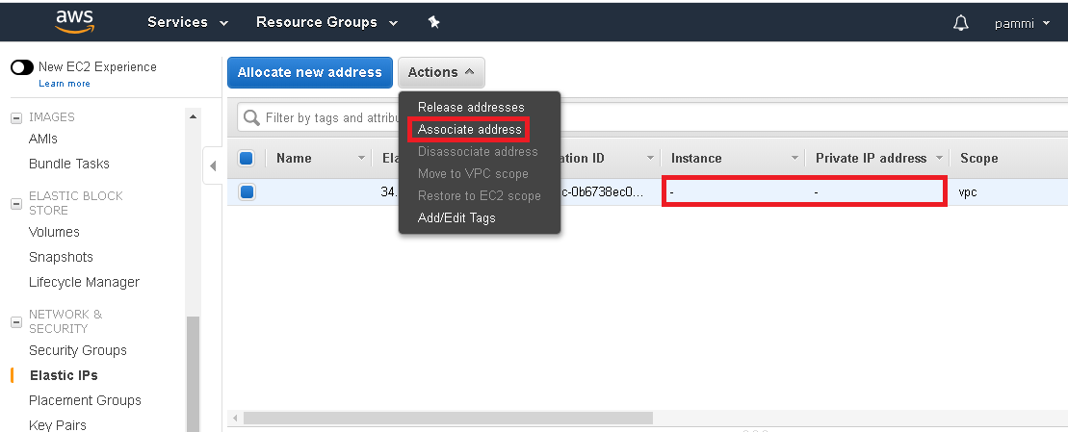

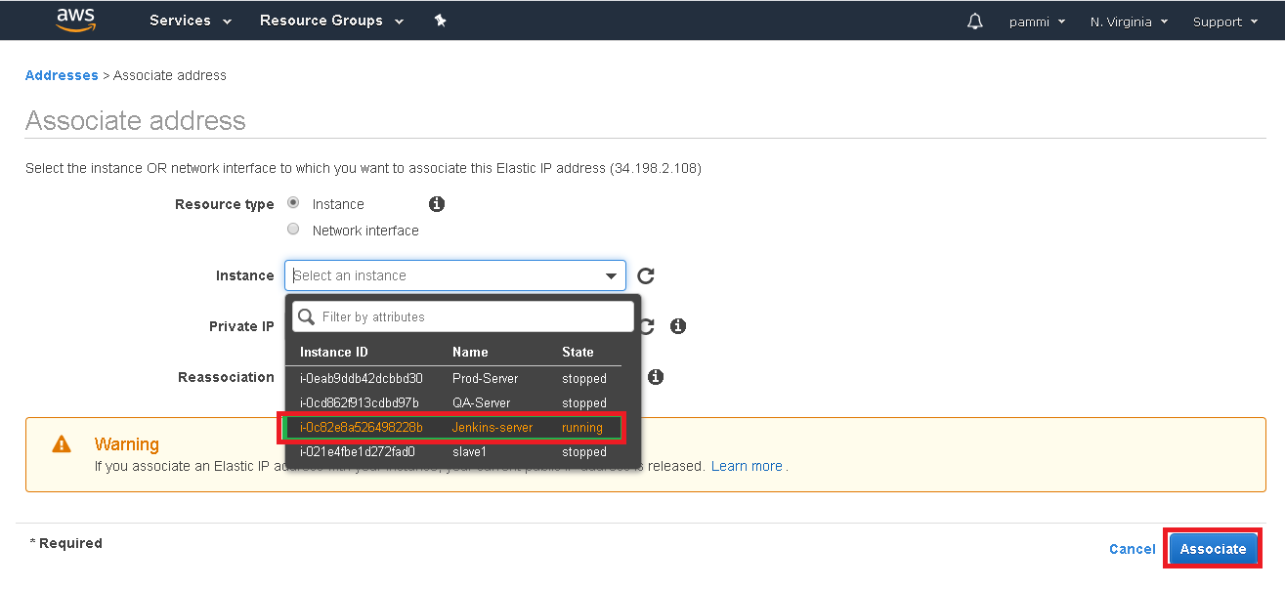

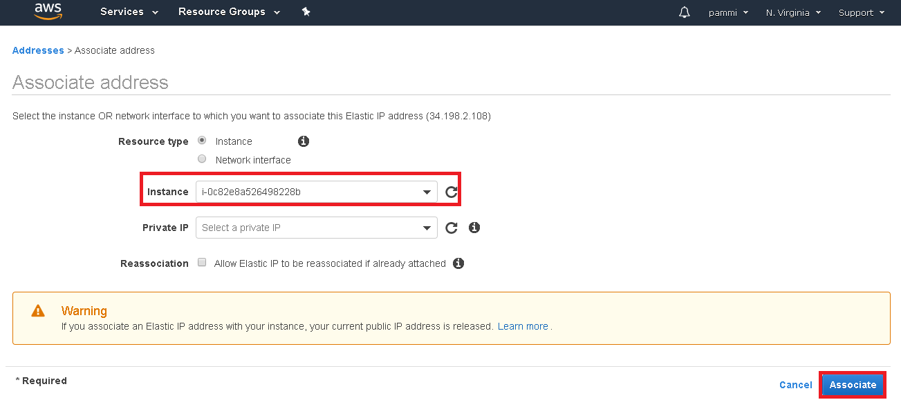

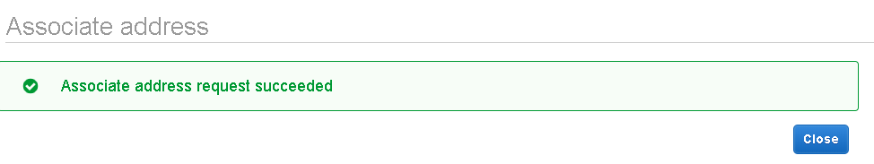

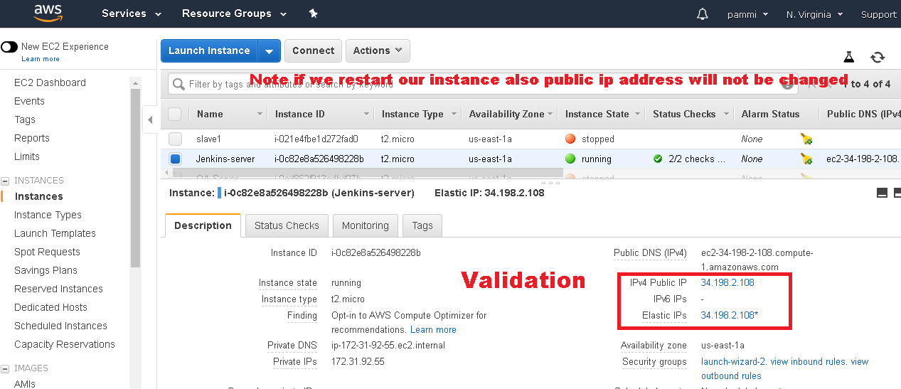

**Security group: Act as a firewall to EC2 instance**

**Sever up gradation: It’s just like upgrading laptop from i3 processor to i5/i7 processor**

**Ex:- t2.micro ---🡪 100 request/min upgrade to t2.small ----> 500 request/min**

**Sever down gradation: It’s just like upgrading laptop from i5/i7 processor to i3 processor**

**Ex:- t2.small ----> 500 request/min down grade to t2.micro ---🡪 100 request/min**