**Git – setup**

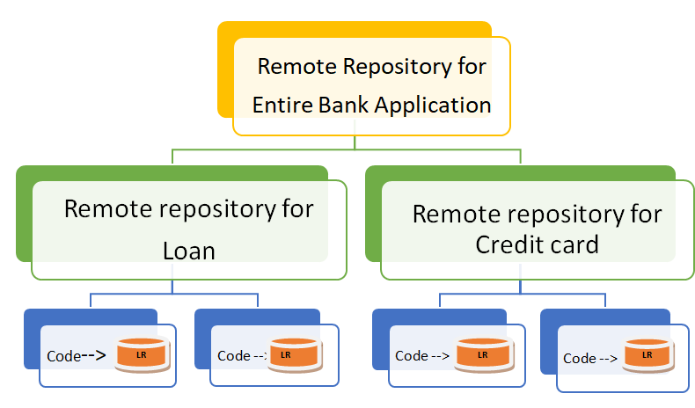

**Local Machine(individual employee work space)**

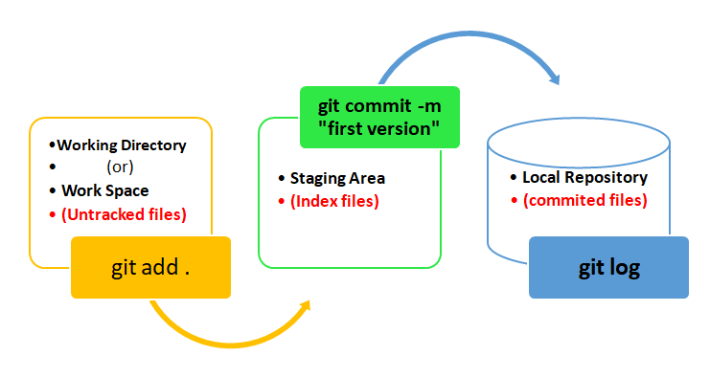

**Working Directory:**

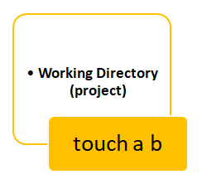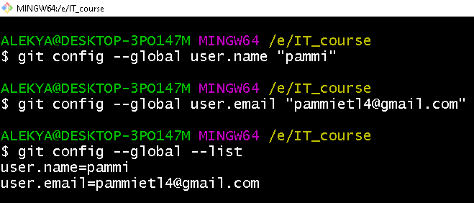

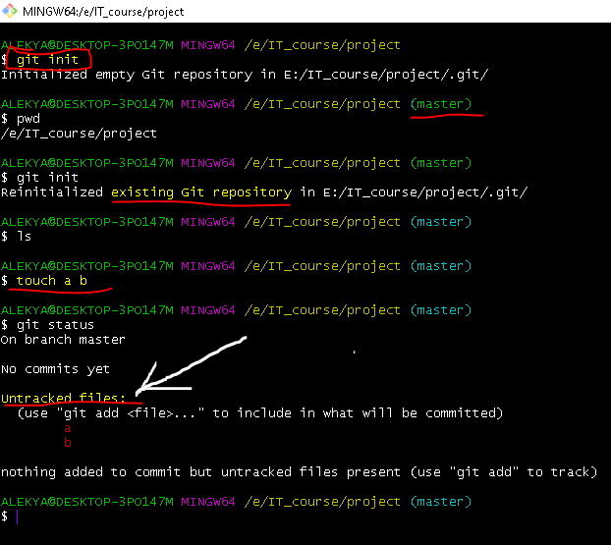

**Move files from working directory to Stage area**

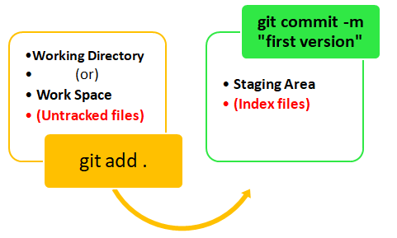

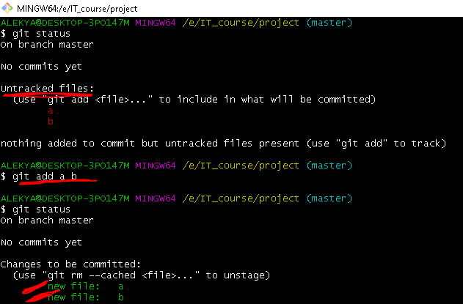

**Send back file from stagging area to working Directory (unstage)**

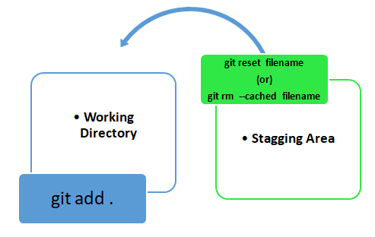

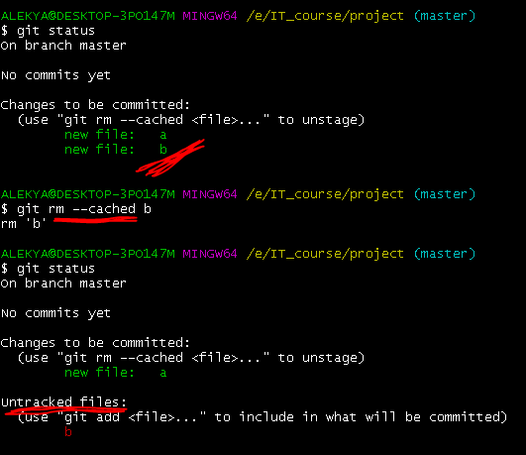

**Move files from staging area to Local Repository**

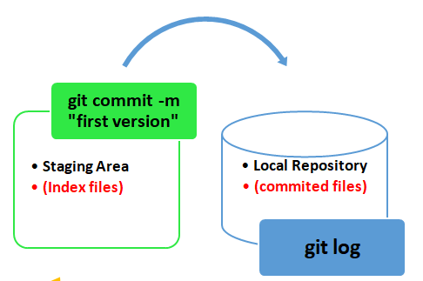

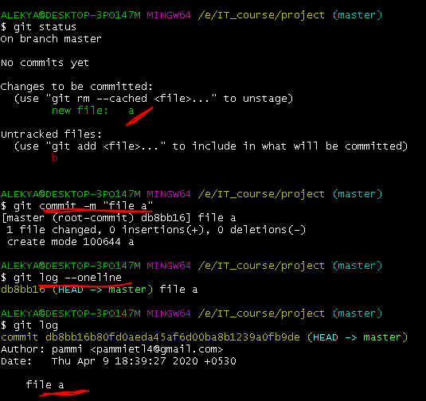

**.gitignore**

**1. .gitignore file is used to save the private file.**

**2. Any file name mentioned in .ignorefile can not be accessed by git**

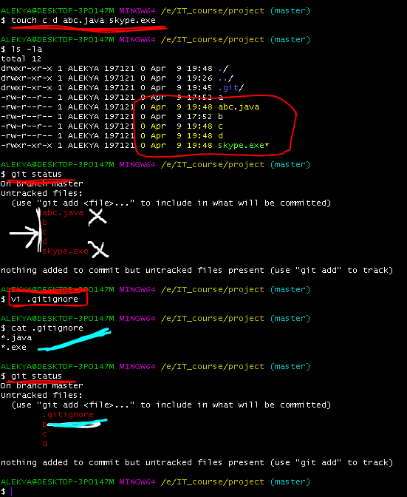

**Advantage: we can secure the content present in the files.**

**Disadvantage: Others can read our file names**

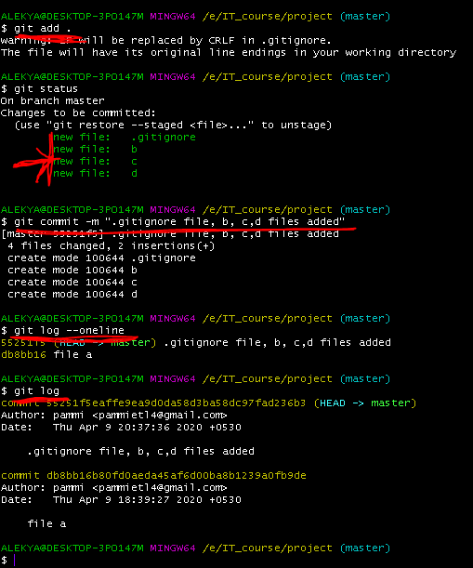

**GIT Branching**

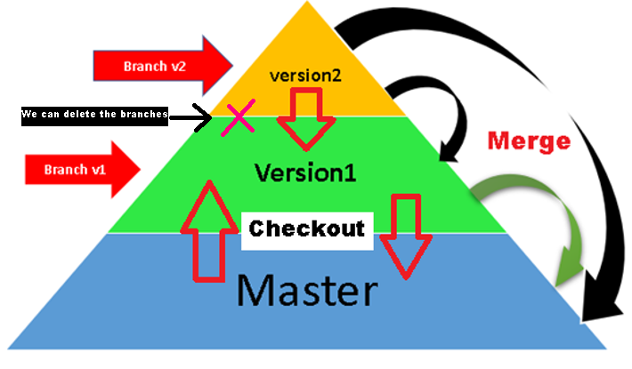

Arrow indicates : Merge

**We can merge version to version (OR) We can merge version to Master**

Explanation:

ALEKYA@DESKTOP-3PO147M MINGW64 /e/IT_course/project

$ git init

**Output:**

ALEKYA@DESKTOP-3PO147M MINGW64 /e/IT_course/project (master)

**Note:**

**Untill we commit some files to Local repository (LR). Branch master will not create**

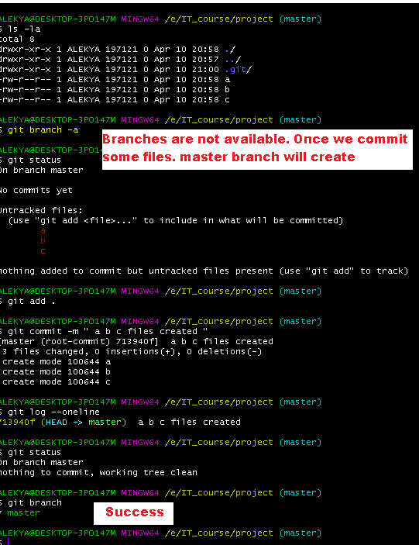

**Data present in the master will copied into branch v1 & v2**

**Incase v1 created new file (a) it will be viewed by master & v2**

**Incase new file (a) is committed by v2 then master & v1 can’t be view the data present in the new file.**

**Git Branch**

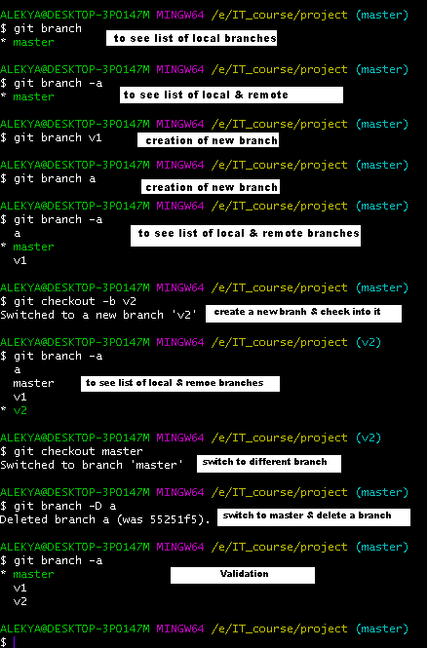

**Data present in the Master will automatically copied into the new branches v1 & v2**

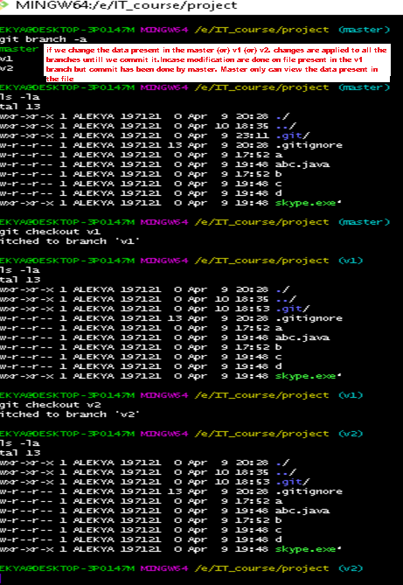

**If we delete the files in Master it will apply to branches**

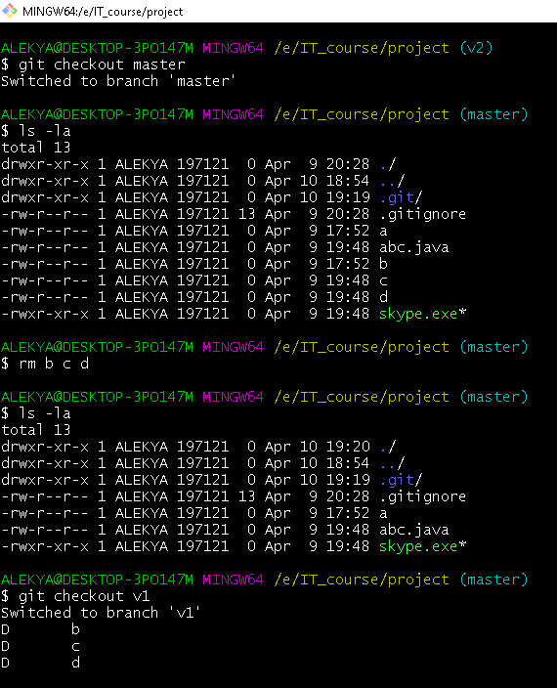

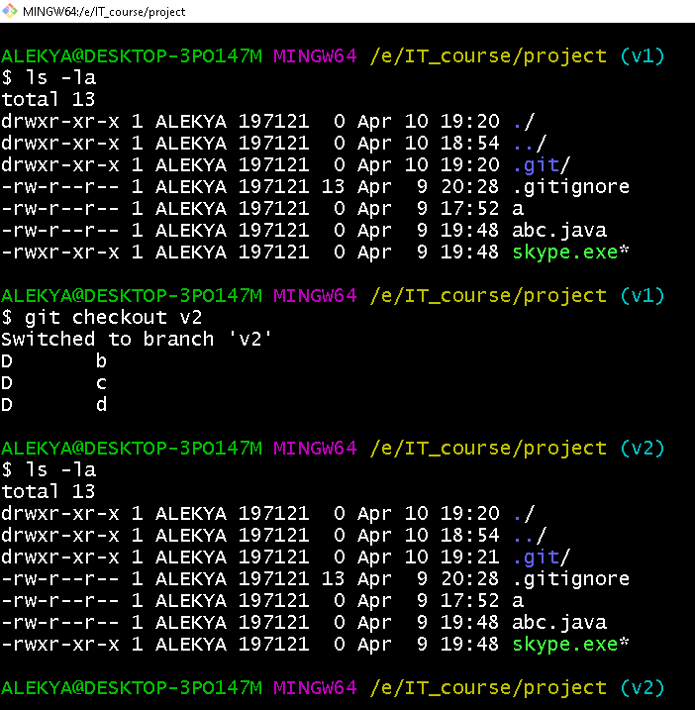

**Uploading code from Local Repository(LR) to Remote Repository(RR)**

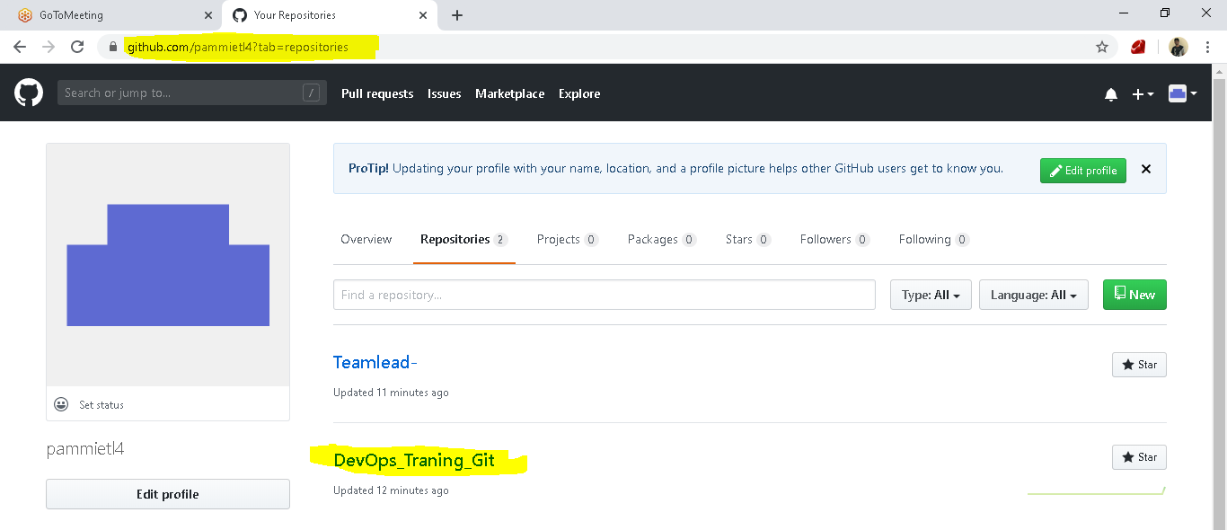

**Local Repository**

**Steps**

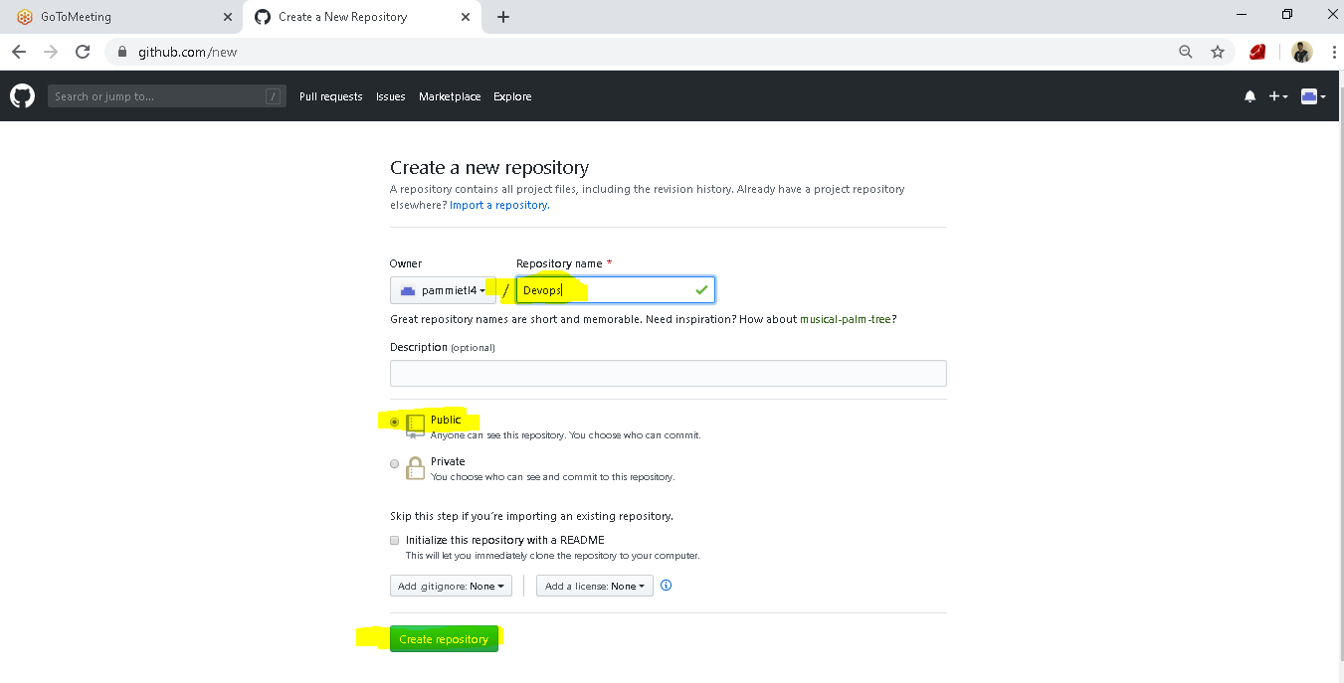

**Go to Git bash**

**git remote add origin https://github.com/pammietl4/Teamlead-.git**

**git push -u origin master**

**Downloading from Github to Local Repository**

Local Repository

**(LR)**



**We can download the data in 3 ways**

**Git Clone Git Fetch Git Pull**

**GIT RESET**

**Ordering the files**

[**https://onlywei.github.io/explain-git-with-d3/#zen**](https://onlywei.github.io/explain-git-with-d3/#zen)

**Git Merging: (it will be merged on time based)**

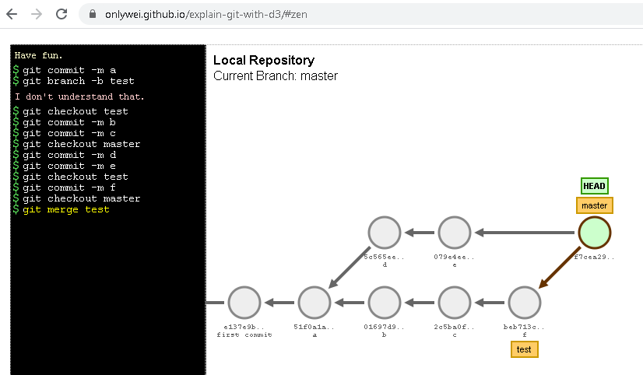

**Git Rebasing:**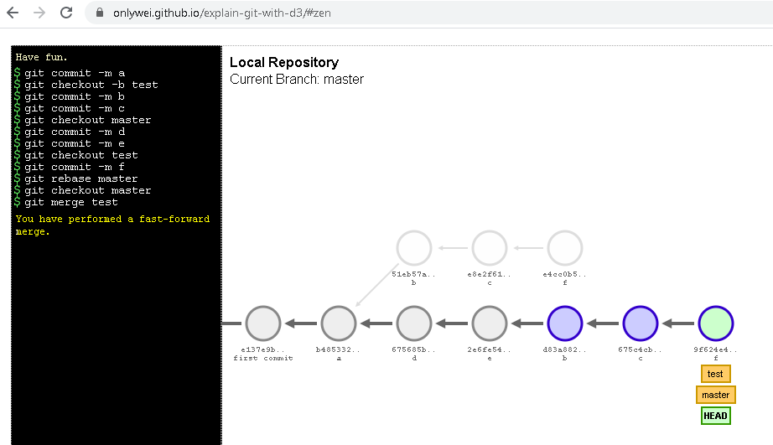

**Git Cherry-pick: here we can pick the required**

**Git Stash:**

**Git Amend:**