5. Change Request: Online Payment Integration
5.1 Description of the Change
After the design phase was finalized, a new requirement was introduced to integrate an Online Payment Gateway. The clinic management decided that they want patients to pay a mandatory "Booking Fee" online to confirm their appointment. This is intended to reduce the number of "no-show" cases where patients book slots but do not show up, causing a loss of time for doctors.
5.2 Impact Analysis
Since we are following a strict Waterfall model, introducing this feature at this stage has a significant impact on our previous work:
On Requirements: We now need to add new functional requirements such as "Secure Payment Processing" and "Transaction History Viewing."
On Design: Our initial ER Diagram is no longer sufficient. We need to introduce a new 'Payments' table to store transaction IDs and statuses. Additionally, our UI wireframes need a new "Checkout Page" and a payment confirmation screen.
On System Flow: The logic of the system changes from a simple 'Search -> Book' flow to a 'Search -> Book -> Pay -> Confirm' flow.
On Process: We are forced to "backtrack" to the design phase to update our schemas before we can start coding, which is a classic challenge in the Waterfall model.
5.3 Risk Analysis
Timeline Delay: The most immediate risk is a delay in the final delivery. Redesigning the database and integrating a 3rd party API (like Stripe or Pay Here) will take more time than initially planned.
Security Risks: Handling financial data increases our responsibility. If not implemented correctly, it could expose patient data to security vulnerabilities.
Technical Complexity: Integration with external payment gateways requires handling API callbacks and potential payment failures, which adds complexity to the implementation phase.
5.4 Accept / Reject Decision
Decision: Accepted.
Justification: Although this change significantly impacts our timeline and requires revisiting the design phase, we have decided to accept it. From a business perspective, the "Online Payment" feature is crucial for the clinic’s financial stability and operational efficiency. We will adjust our remaining schedule to accommodate this rework.

DFD Diagram
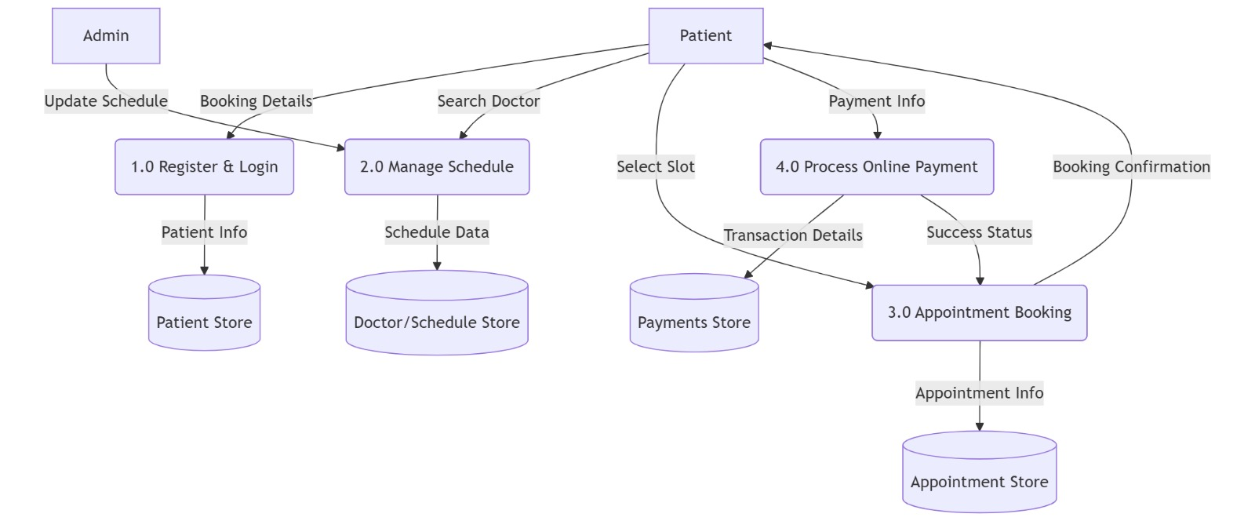

ER Diagram

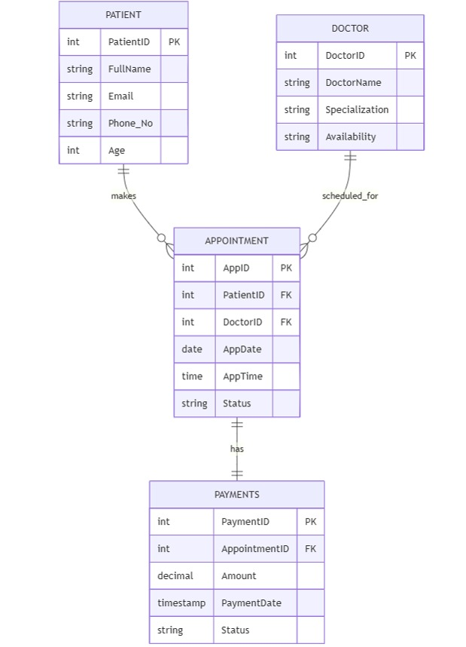
UI Wireframes
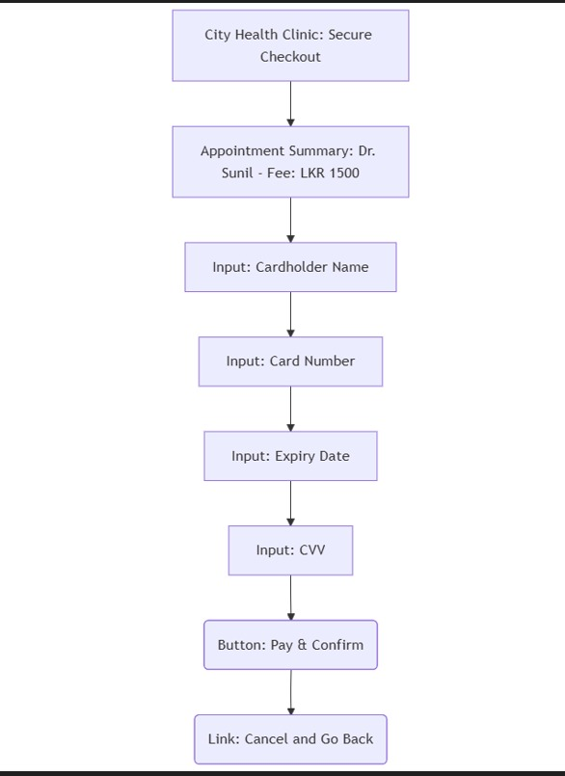
UI Diagram

