Step 6: Implementation Phase

6.1 Overview of the Phase
In this phase, we translated our finalized design models into a functional system. The primary goal was to develop a Minimal Working Prototype (MWP) for the Clinic Appointment Management System. Following the Waterfall methodology, this stage was only initiated after the design specifications and the late Change Request (Online Payment) were clearly documented.

6.2 Development Approach
Since this is a prototype, I used a standard web-based tech stack to ensure the system is lightweight and runs on any browser.
- Frontend: HTML5 and CSS3 were used to build a clean, user-friendly interface.
- Logic: JavaScript was utilized to handle the form validations, navigation between the booking and payment sections, and to simulate the final confirmation.
- Integration: The system was developed as a single-page application (SPA) style prototype to demonstrate the seamless flow from appointment selection to payment confirmation.

6.3 Implementing the Change Request
The most critical part of this phase was implementing the Online Payment Gateway which was introduced in Phase 5.
- I added a secure-looking payment interface that captures simulated credit card details.
- The logic was updated so that an appointment is only "Confirmed" after the user interacts with the payment module.
- This demonstrates how the system architecture was modified to accommodate new business requirements mid-way through the project.

6.4 Version Control & Tagging

To maintain professional development standards, the source code was managed using GitHub. This allowed for proper tracking of the implementation process. As per the assignment requirements, the final stable version of the code has been tagged.
- GitHub Repository: https://github.com/pamodikavindya/Clinic-Appointment-Management-System
- Release Tag: v3.0-implementation

HTML/JS CODE

<div id="paymentSection">
<h3>Secure Payment</h3>
<input type="text" placeholder="Card Number">
<button onclick="confirmBooking()">Confirm & Pay</button>
</div>

6.5 Snapshots of the Implementation
Below are the screenshots of the functional prototype developed during this phase:
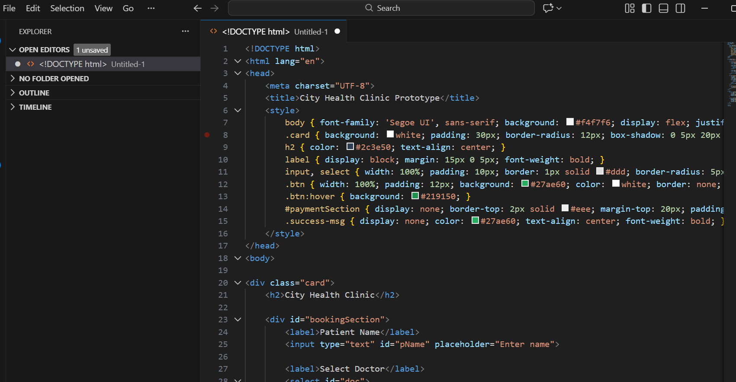 Figure 6.1: Source code of the Clinic Management System
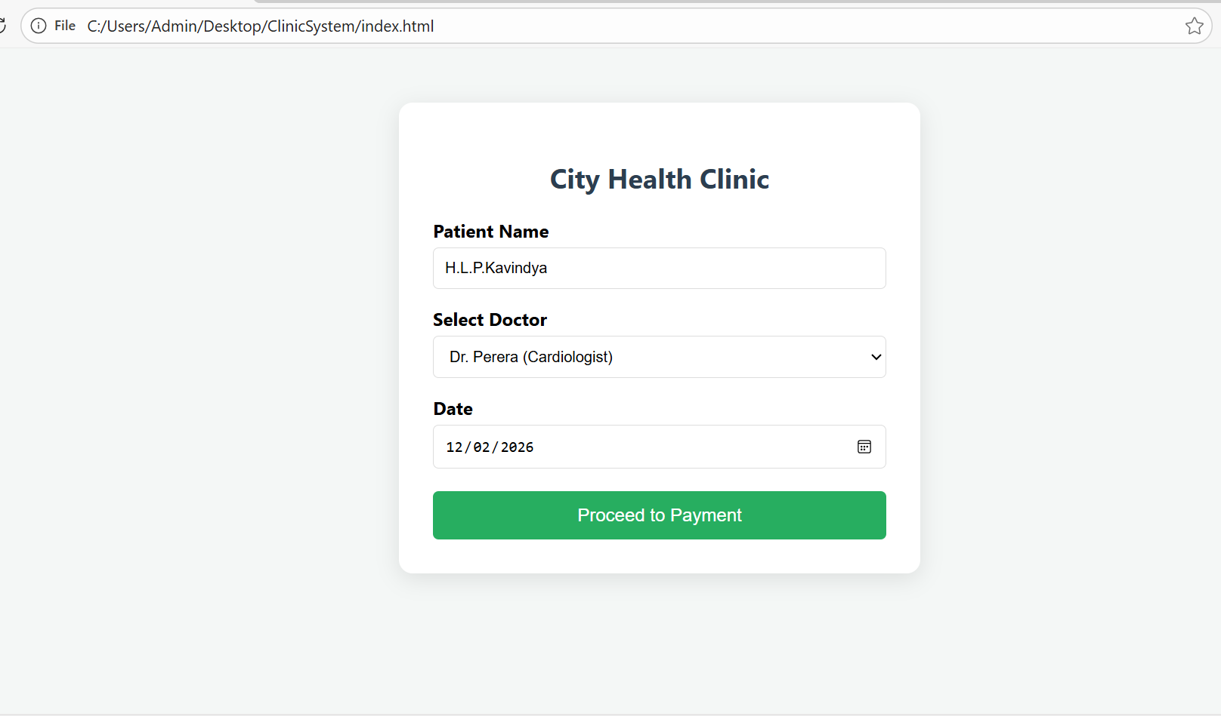
Figure 6.2: The main booking interface where patients enter details.

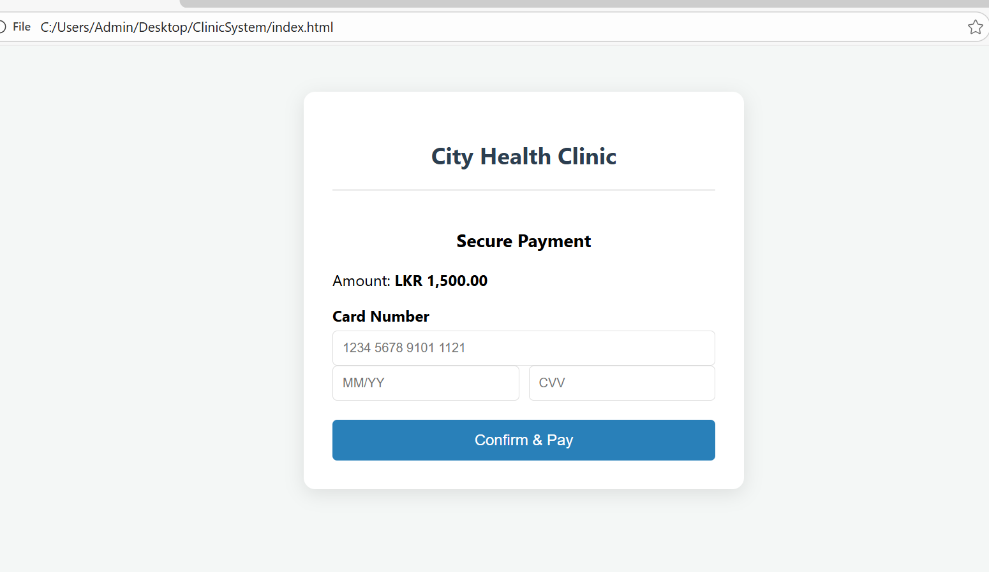Figure 6.3: The newly added Payment UI based on the Change Request.

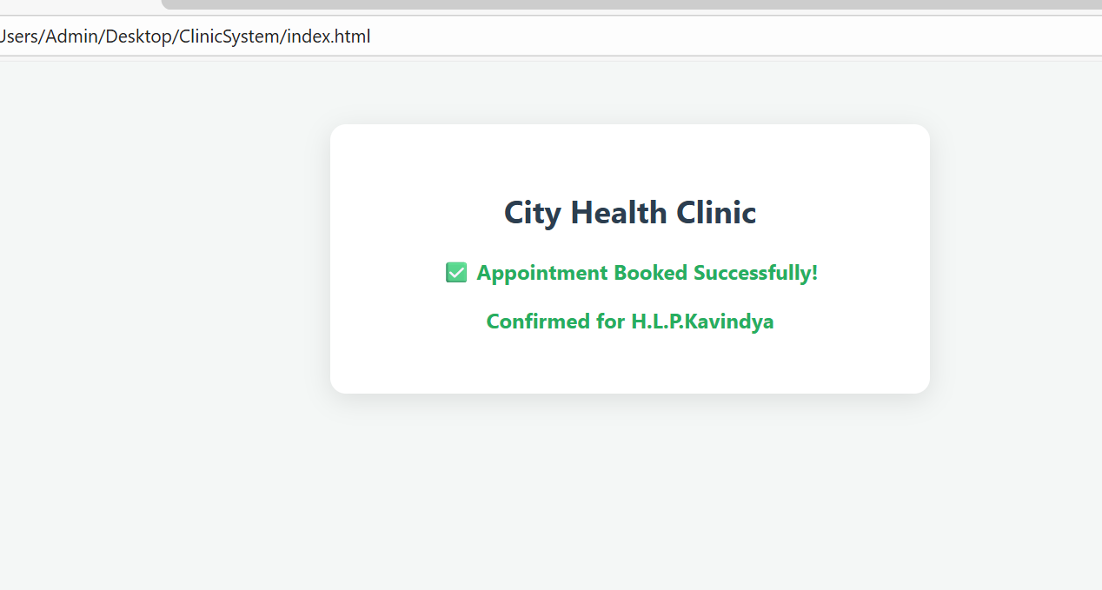
Figure 6.4: Successful booking and payment confirmation screen.

