**CSE 572 Data Mining Assignment 2**

**Due Date: September 6, 2017**

**Smart Diet Assessment Project**

**Phase two (Due September 6) – Data annotation**

Task 1 - Download the data of your own group from the following link (<https://drive.google.com/open?id=0B8udLM8htaYwZDNkOVdQSWdVLXM>). Note that, you have to use your ASU account to access this link. Each file is named after group leader. Each file includes two folders, “fork” and “spoon”. Within each folder, you will find three files. They are *.mp4, *_EMG.txt, *_IMU.txt. For assignment 2, you only need the mp4 file.

Task 2 - Open video file using the tool provided. We will provide you a tool to annotate your video. Please download *Labeling.m* and *Labeling.fig* on Blackboard and run *Labeling.m* in Matlab. *Labeling.m* and *Labeling.fig* must be in the same folder. A window should show up as figure 1.

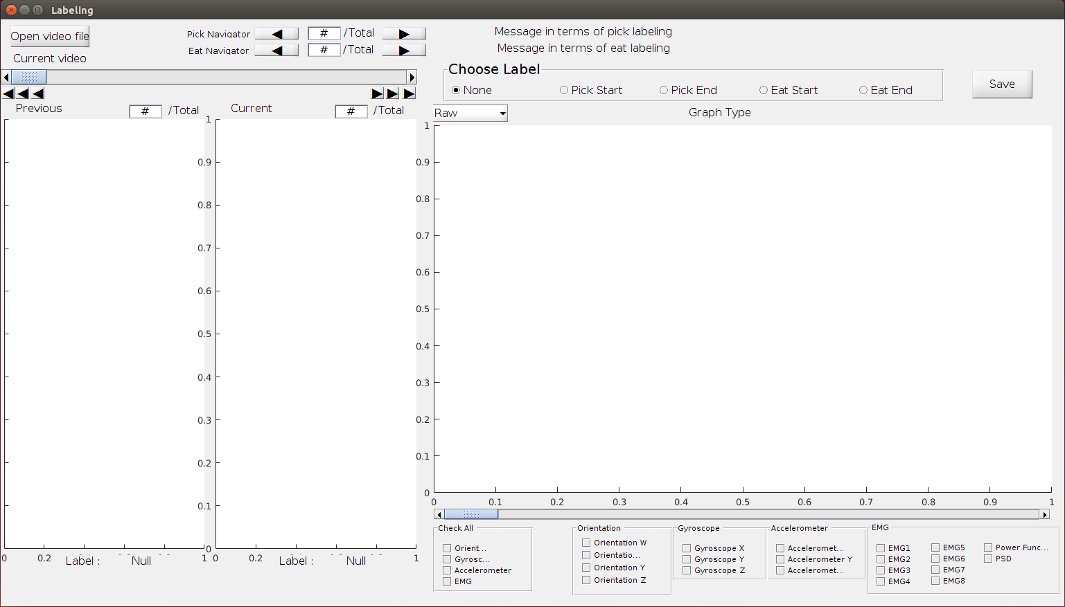

Figure 1

Open your video file by clicking “Open video file” in the upper left corner. This may take several minutes depending on your device configuration and the size of the video file. You need to keep *.mp4, *_EMG.txt, *_IMU.txt in the same folder, otherwise, video won’t open.

Note: if you cannot see complete window and you cannot adjust it, try to open *Labeling.fig* in GUIDE. Go to “GUI option” by “Tools->GUI Options…”, select “Proportional” for “Resize behavior”. Click “OK” and run again, you will get a complete and adjustable window.

Task 3 - Annotate video data. For each video, you need to create a txt file which indicates the start frame and end frame of pick action and which area you are eating. This txt file should have same name with the video. As you did in data collection, there are 4 areas in the plate, as shown in figure 2. You can get the number of frame by clicking those 6 button which are in the red rectangle. For the left three, you can go backwards 50 frames, 10 frames, 1 frame from left to right. For the right three, you can go forward 1 frame, 10 frames, 50 frames from left to right. That is all you need for this assignment. You just need to record the start frame number and end frame number for each pick action and the number of the area you are taking this action in. Finally, you should have 40 rows and 3 columns for each video.

Note: if you click the buttons frequently, this tool may respond slow. Please be patient.

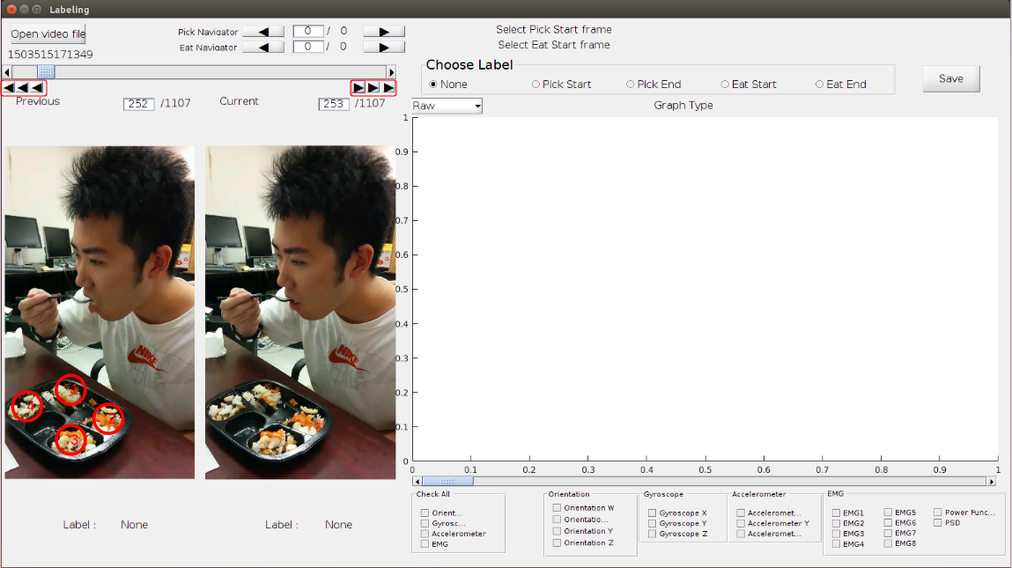

Figure 2

Task 3 - Submit your annotation file on Blackboard.

**Frame numbers for Picking Action:**

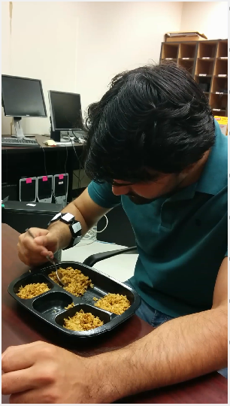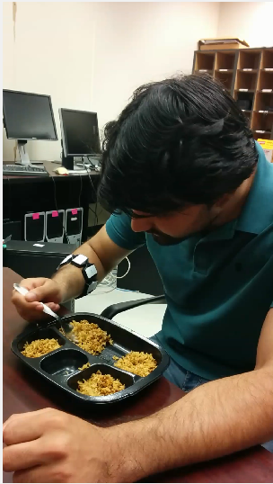

(1)Picking (2) Complete Pick

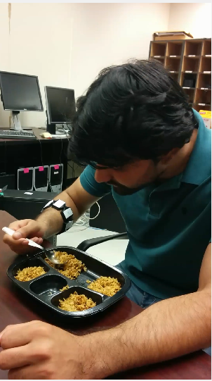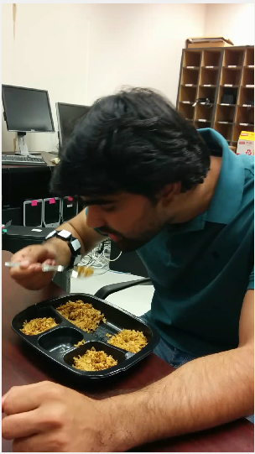 (3) Start Carrying food (4) Carrying food

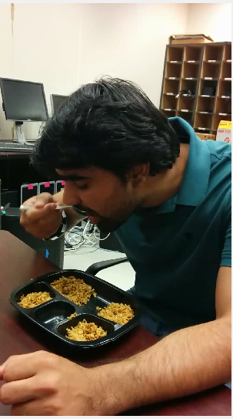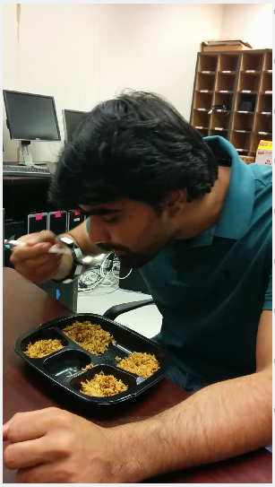 (5) Complete Carrying food (6) Complete Eating

For the data annotation, students should save the frame number of (3) Start Carrying food, (5) Complete Carrying food, and plate section number.