Project Report

On

***"A Study on the Correlation Between Sleep Duration, Study Hours, and Academic Performance in University Students"***



**Submitted By**

Name: Pampa Das

Roll: 01-047-07

Batch - 47

**Instructed By**

Name: Dr. Tania Islam

Assistant Professor

Department of Computer Science and Engineering

University of Barishal.

EDGE: BU-CSE Digital Skills Training

Computer Fundamentals & Office Application

Table of Contents

Chapter 1: Introduction 4

1.1 Introduction 4

1.2 Background 4

1.3 Objectives 5

Chapter 2: Data Representation 5

2.1 Dataset 5

2.2 Images Related to My Topic 6

2.2.1 Image 1: 6

2.2.2 Image 2: 6

Chapter 3: Analysis 6

3.1 Demographic Data: 7

3.1.1 Visualization of Demographic Data 7

3.2 Correlation 9

3.3 Trends 10

3.3.1 Recent Grades and Sleep Duration 10

3.3.2 Recent Grades and Sleep Quality 10

3.3.3 Recent Grades and Study Hours/Week 11

Chapter 4: Result and Conclusion 11

4.1 Result 11

4.2 Conclusion 12

Refences …………………………………………………………………………………………12

**List of Figures**

**Figure 1: Influence of Sleep on Students (Girls)** 6

**Figure 2: Influence of Sleep Habit on Students (Boys)** 6

**Figure 3: Department** 7

**Figure 4: Sleep Duration** 8

**Figure 5: Sleep quality** 8

**Figure 6: Study Hour / Week and Grades** 9

**Figure 7: Trends Between Sleep Duration and Grades** 10

**Figure 8: Trends between Sleep Quality and Grades** 10

**Figure 9: Trends Between Study Hours and Grades** 11

**List of Table**

**Table 1: Dataset of the students** 5

"A Study on the Correlation Between Sleep Duration, Study Hours, and Academic Performance in University Students"

# Introduction

## ****Introduction****

University students often face a variety of pressures that can affect their academic performance, including the balance between study commitments, social activities, and personal well-being. Among these factors, sleep duration and study hours are frequently cited as key influences on student achievement. Sleep is critical for cognitive functions such as memory consolidation, focus, and problem-solving (Walker, 2017), while the time dedicated to studying has been traditionally linked to academic success (Credé, Roch, & Kieszczynka, 2010). Despite these known factors, the exact relationship between sleep, study habits, and academic performance in university students remains an area of interest and ongoing research.

This study aims to explore the correlation between sleep duration, study hours, and academic performance among university students. By analyzing data from students across different departments and academic years, the research will seek to provide a clearer understanding of how these variables interrelate and influence academic outcomes.

## ****Background****

Sleep is a fundamental component of a student’s overall well-being and academic performance. Research consistently suggests that inadequate sleep negatively impacts cognitive abilities, including concentration, memory retention, and learning capacity (Killgore, 2010). University students, in particular, are known to struggle with sleep deprivation due to various stressors, including deadlines, exams, and social engagements (Hershner & Chervin, 2014). A study by LeBourgeois et al. (2017) revealed that students who reported insufficient sleep exhibited lower academic performance, suggesting that sleep is a critical factor for success.

In addition to sleep, the number of hours spent studying has long been recognized as an important determinant of academic performance. Studies have shown that students who dedicate more time to their studies tend to achieve higher grades (Credé et al., 2010). However, the relationship is complex, as quality of study, study techniques, and time management may also play crucial roles in determining academic outcomes (Schmidt, 2017).

Despite the clear importance of both sleep and study hours, few studies have simultaneously examined their combined effects on academic performance. Therefore, this research will contribute to the existing body of knowledge by analyzing both sleep and study habits in relation to academic achievement in university students.

## ****Objectives****

* To examine the relationship between sleep duration and academic performance
* To analyze the effect of study hours on academic performance
* To investigate the combined impact of sleep quality and study hours on academic success
* To identify differences in academic performance across various departments (CSE, STAT, BBA, LAW
* To assess the impact of academic year on study habits and academic performance

By meeting these objectives, this study will provide valuable insights into how sleep and study behaviors influence academic achievement among university students.

# Data Representation

## Dataset

This is the observed data table.

**Table 1: Dataset of the students**

|  |  |  |  |  |  |  |  |
| --- | --- | --- | --- | --- | --- | --- | --- |
| Student ID | Age | Department | Year of Study | Sleep Duration (hours/night) | Sleep Quality (1-5) | Study Hours/Week | Recent Grades (%) |
| U1 | 20 | CSE | 1st Year | 5 | 3 | 10 | 65 |
| U2 | 21 | STAT | 2nd Year | 6 | 4 | 15 | 70 |
| U3 | 22 | BBA | 3rd Year | 7 | 5 | 20 | 85 |
| U4 | 23 | LAW | 4th Year | 4 | 2 | 8 | 55 |
| U5 | 20 | CSE | 1st Year | 6 | 4 | 12 | 75 |
| U6 | 22 | STAT | 2nd Year | 5 | 3 | 14 | 60 |
| U7 | 21 | BBA | 3rd Year | 8 | 5 | 18 | 90 |
| U8 | 23 | LAW | 4th Year | 7 | 4 | 10 | 80 |
| U9 | 22 | CSE | 1st Year | 6 | 3 | 15 | 72 |
| U10 | 24 | STAT | 2nd Year | 4 | 2 | 9 | 50 |
| U11 | 20 | BBA | 3rd Year | 7 | 5 | 20 | 88 |
| U12 | 21 | LAW | 4th Year | 8 | 4 | 22 | 92 |
| U13 | 22 | CSE | 1st Year | 5 | 3 | 11 | 68 |
| U14 | 23 | STAT | 2nd Year | 6 | 4 | 16 | 74 |
| U15 | 24 | BBA | 3rd Year | 7 | 5 | 21 | 89 |
| U16 | 20 | LAW | 4th Year | 4 | 2 | 7 | 58 |
| U17 | 22 | CSE | 1st Year | 8 | 5 | 19 | 87 |
| U18 | 21 | STAT | 2nd Year | 6 | 4 | 13 | 65 |
| U19 | 23 | BBA | 3rd Year | 5 | 3 | 14 | 70 |
| U20 | 24 | LAW | 4th Year | 7 | 5 | 18 | 84 |

## Images Related to My Topic

### Image 1:

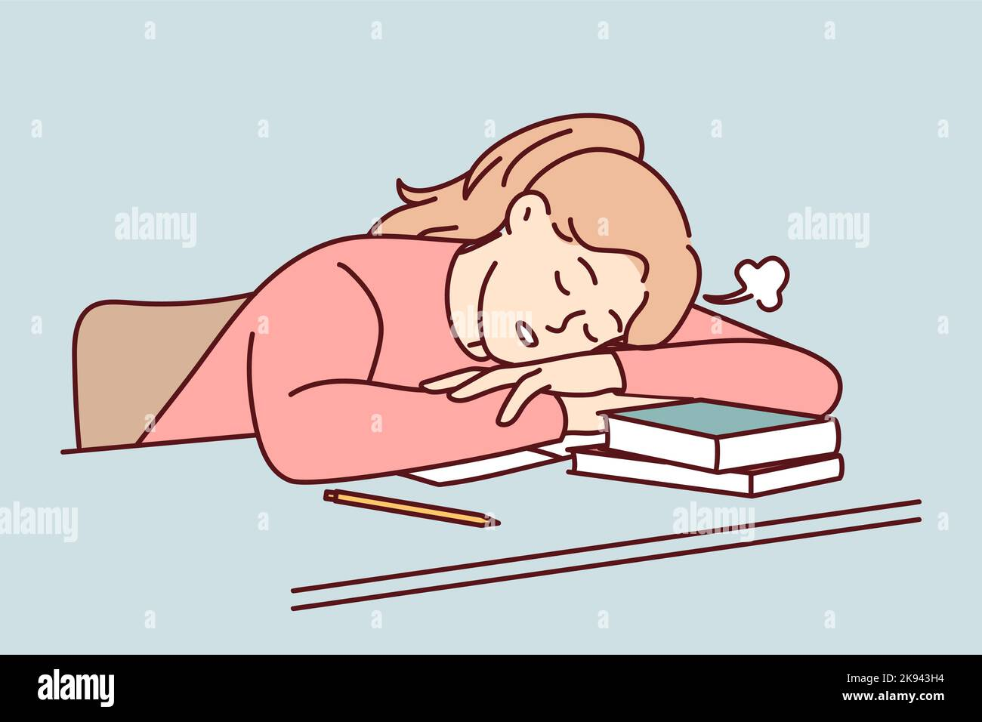

**Figure 1: Influence of Sleep on Students (Girls)**

### Image 2:



**Figure 2: Influence of Sleep Habit on Students (Boys)**

# Analysis

## Demographic Data:

The dataset comprises 20 students from four departments: CSE, STAT, BBA, and LAW, with details about their age, year of study, sleep habits, study hours per week, and recent grades. The average age is 21.9 years, spanning from 20 to 24 years, reflecting students across all academic years. On average, students sleep 6.05 hours per night, with durations ranging from 4 to 8 hours. Sleep quality, rated on a 1-5 scale, varies across individuals, often correlating with better grades. Students study an average of 14.84 hours per week, with weekly study times ranging from 7 to 22 hours. The average recent grade is 74.32%, with individual performances ranging from 50% to 92%. Department-wise, BBA students tend to achieve higher grades, likely due to better sleep quality and longer study hours, while LAW students exhibit variability in both sleep and grades. CSE and STAT students show moderate performance with balanced habits. Generally, higher grades are associated with better sleep quality, longer study hours, and sufficient sleep duration. The analysis suggests that balanced sleep and study habits significantly influence academic success.

### Visualization of Demographic Data

#### Department

**Figure 3: Department**

This is the demographic data of Department of the students under observation.

#### Sleep Duration

**Figure 4: Sleep Duration**

This is the demographic data of Sleep Duration and Department of the students under observation.

#### Sleep Quality

**Figure 5: Sleep quality**

This is the demographic data of Sleep Quality and Department of the students under observation.

#### Study Hour / Week

**Figure 6: Study Hour / Week and Grades**

This is the demographic data of Study Hour/Week and Department of the students under observation.

## Correlation

The correlation values between sleep patterns, study habits, and recent grades reveal significant insights into student performance. The correlation between sleep duration and recent grades is exceptionally high at 0.9499, indicating a strong positive relationship; students who sleep longer tend to achieve better grades. Similarly, the correlation between sleep quality and recent grades is 0.8978, showing that better sleep quality strongly contributes to academic success. Lastly, the correlation between study hours per week and recent grades is 0.8606, which, while slightly lower, still demonstrates a robust positive relationship. These results suggest that sleep, both in terms of duration and quality, has a stronger impact on grades compared to study hours alone. This highlights the importance of adequate and high-quality sleep as a critical factor in academic performance, alongside maintaining consistent study habits.

## Trends

### Recent Grades and Sleep Duration

**Figure 7: Trends Between Sleep Duration and Grades**

There is a positive trend between the two variables that means if sleep duration increases the grades increases as well.

### Recent Grades and Sleep Quality

**Figure 8: Trends between Sleep Quality and Grades**

There is a positive trend between the two variables that means if sleep quality increases the grades increases as well.

### Recent Grades and Study Hours/Week

**Figure 9: Trends Between Study Hours and Grades**

There is a positive trend between the two variables that means if Study Hours/Week increases the grades increases as well.

# Result and Conclusion

## Result

The analysis of the dataset reveals strong positive relationships between sleep habits, study hours, and academic performance. Sleep duration shows the highest correlation with recent grades at **0.9499**, indicating that students who sleep longer tend to perform better academically. Sleep quality also has a strong positive correlation with grades (**0.8978**), emphasizing the importance of restful and high-quality sleep for academic success. Study hours per week display a robust but slightly weaker correlation (**0.8606**) with grades, suggesting that while consistent study routines contribute to better performance, their impact is not as pronounced as sleep factors. Department-wise, BBA students tend to achieve higher grades, possibly due to better-managed sleep and study routines, while LAW students exhibit greater variability in both habits and performance. CSE and STAT students maintain moderate results, reflecting balanced approaches to sleep and study. Overall, the data highlights that both sleep and study habits significantly influence academic outcomes, with sleep having a slightly stronger impact.

## Conclusion

The findings underscore the critical importance of maintaining a balance between sleep, study, and overall academic habits for optimal performance. Sufficient and high-quality sleep plays a pivotal role in enhancing cognitive function and academic outcomes, surpassing the influence of study hours alone. This suggests that students aiming for better grades should prioritize not only consistent study routines but also adequate rest and recovery. Additionally, the variability observed across departments highlights the need for tailored strategies to help students achieve this balance. In conclusion, a holistic approach that integrates proper sleep, high-quality rest, and effective study habits is essential for academic success, making it vital for students to view sleep as a necessary component of their study strategies rather than a secondary priority.

****References****

1. Credé, M., Roch, S. G., & Kieszczynka, U. M. (2010). Class attendance in college: A meta-analytic review. Review of Educational Research, 80(2), 272–295. <https://doi.org/10.3102/0034654319358491>
2. Hershner, S. D., & Chervin, R. D. (2014). Causes and consequences of sleepiness among college students. Nature and Science of Sleep, 6, 73–84. <https://doi.org/10.2147/NSS.S62907>
3. Killgore, W. D. S. (2010). Effects of sleep deprivation on cognition. Progress in Brain Research, 185, 105–129. <https://doi.org/10.1016/B978-0-444-53702-6.00008-3>
4. LeBourgeois, M. L., Hale, L., Chang, A. M., & Montgomery-Downs, H. E. (2017). Digital media and sleep in childhood and adolescence. Pediatrics, 140(Supplement 2), S78–S81. <https://doi.org/10.1542/peds.2016-1758G>
5. Schmidt, M. (2017). The impact of study habits on student success: A systematic review. Journal of Education and Learning, 6(4), 33–42. <https://doi.org/10.5539/jel.v6n4p33>
6. Walker, M. P. (2017). Why we sleep: Unlocking the power of sleep and dreams. Scribner.