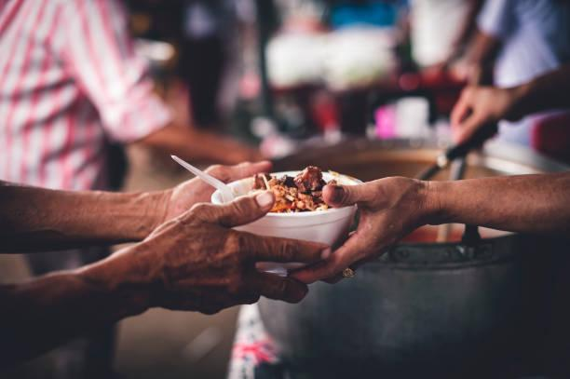

PRESENTED BY: P. Praveen

College Email:22341A1281@gmrit.edu.in

Registered Email:ppraveenbye@gmail.com

GMR INSTITUTE OF TECHNOLOGY

RAJAM

# PROJECT INDEX

| S no | Content | Sub-Content | Page .no |
| --- | --- | --- | --- |
| 1. | Introduction: | 1.1 Project Overview  1.2 Objective | 2 |
| 2. | Phase I: Requirement Analysis & Planning: | 2.1 Understanding Business Requirements:  2.2 Defining Project Scope & Objectives: | 3-5 |
| 3. | Phase II: Salesforce Development – Backend & Configurations: | 3.1 Set Environment  3.2 Customization of Objects and Fields  3.3 Automation (Flows and Process Builder) | 6-8 |
| 4. | Phase III: UI/UX Development & Customisation: | 4.1 Lightning App Setup  4.2 Page Layouts and Dynamic Forms  4.3 Tabs  4.4 User Management  4.5 Reports and Dashboards | 9-12 |
| 5. | Phase IV: Data Migration & Security: | 5.1 Data Loading  5.2 Ensuring Data Access and Security | 13-15 |
| 6. | Phase V: Deployment, Documentation & Maintenance: | 6.1 Deployment  6.2 Documentation  6.3 Maintenance | 16 |
| 7. | Phase 6: Conclusion: |  | 17-18 |

1. Introduction

### Project Overview:

FoodConnect is a Salesforce CRM application that has been developed to efficiently connect food donors to poor, then needy, communities. The system manages venues with leftover food plus allocates tasks for volunteers. It tracks drop-off points too, delivery execution details, and perceptive reports to cut food wastage while ensuring operational transparency.

### 1.2 Objectives:

The primary aims of FoodConnect are:

• To register venues that donate leftover food and their drop-off points.

• To make task creation for food pickup and delivery automated.

• To properly allocate volunteers to every activity according to their

availability.

• To monitor the details of food pickups and deliveries correctly.

• To provide reports and dashboards to monitor operations and plan for the future.

2. Phase I: Requirement Analysis & Planning

2.1 Understanding Business Requirements:

FoodConnect meets these user requirements:

• Venues: Wish to register their excess food availability and drop-off locations with ease.

• Volunteers: Require precise task allocation with location and drop-off information.

• Admin: Needs real-time monitoring of every task and execution details for the management.

• Organisation: Requires operational information for open reporting and planning food distribution drives.

2.2 Defining Project Scope & Objectives:

The scope entails:

• Developing custom objects of Venue, Drop-Off Point, Task, Volunteer, Execution Details

• Automatically creating task record flows on venue food registration.

• Adding triggers for status changes in execution details.

• Developing reports and dashboards for task tracking and volunteer performance analysis.

• Configuring security settings with profiles, roles, and sharing rules

2.3 Design Data Model & Security Model:

**Data Model:** Custom objects are:

• Venue: Stores the donor venue information.

• Drop-Off Point: Stores delivery points for the distribution of food.

• Task: Symbolizes pickup and delivery tasks.

•Volunteer: Stores volunteer information and availability.

• Execution Details: Stores Details about the Volunteer and which task he is volunteering for.

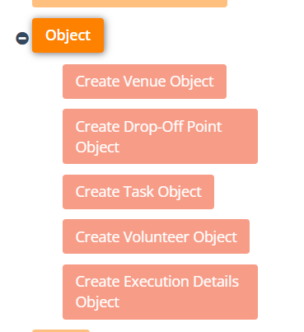

* **Security Model:** In FoodConnect, an NGO's Profile was implemented to provide access to volunteers and coordinators belonging to various NGOs. Coordinators can manage volunteers and view all their records, whereas volunteers can view only their allocated data.
* Sharing rules were established for the Drop-off Point object by distance:
  + If the distance is less than 15 km, the records are shared with the Iksha group.
  + If the distance is between 15 km and 30 km, records are exchanged with the NSS group.
  + If the distance is between 30 km and 50 km, records are exchanged with the Street Cause group.
* This arrangement ensures that the volunteers can view only drop-off points close to them, enhancing data security and allowing them to work more efficiently.

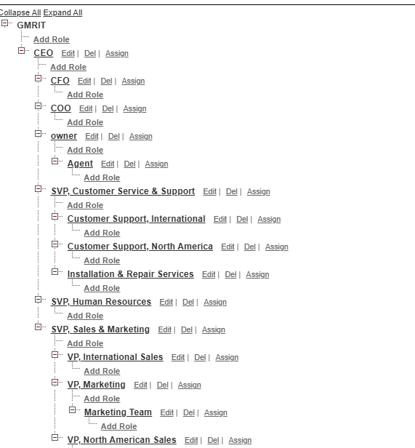

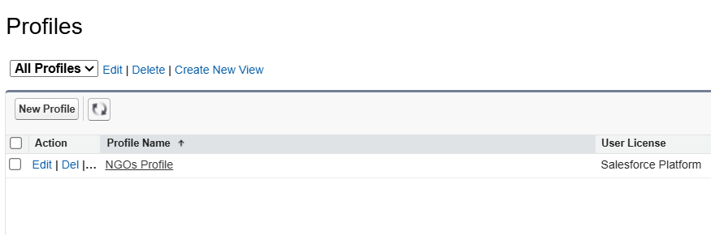

3. Phase II: Salesforce Development– Backend & Configurations

3.1 Set Environment:

* Created Salesforce Developer Org for FoodConnect implementation.

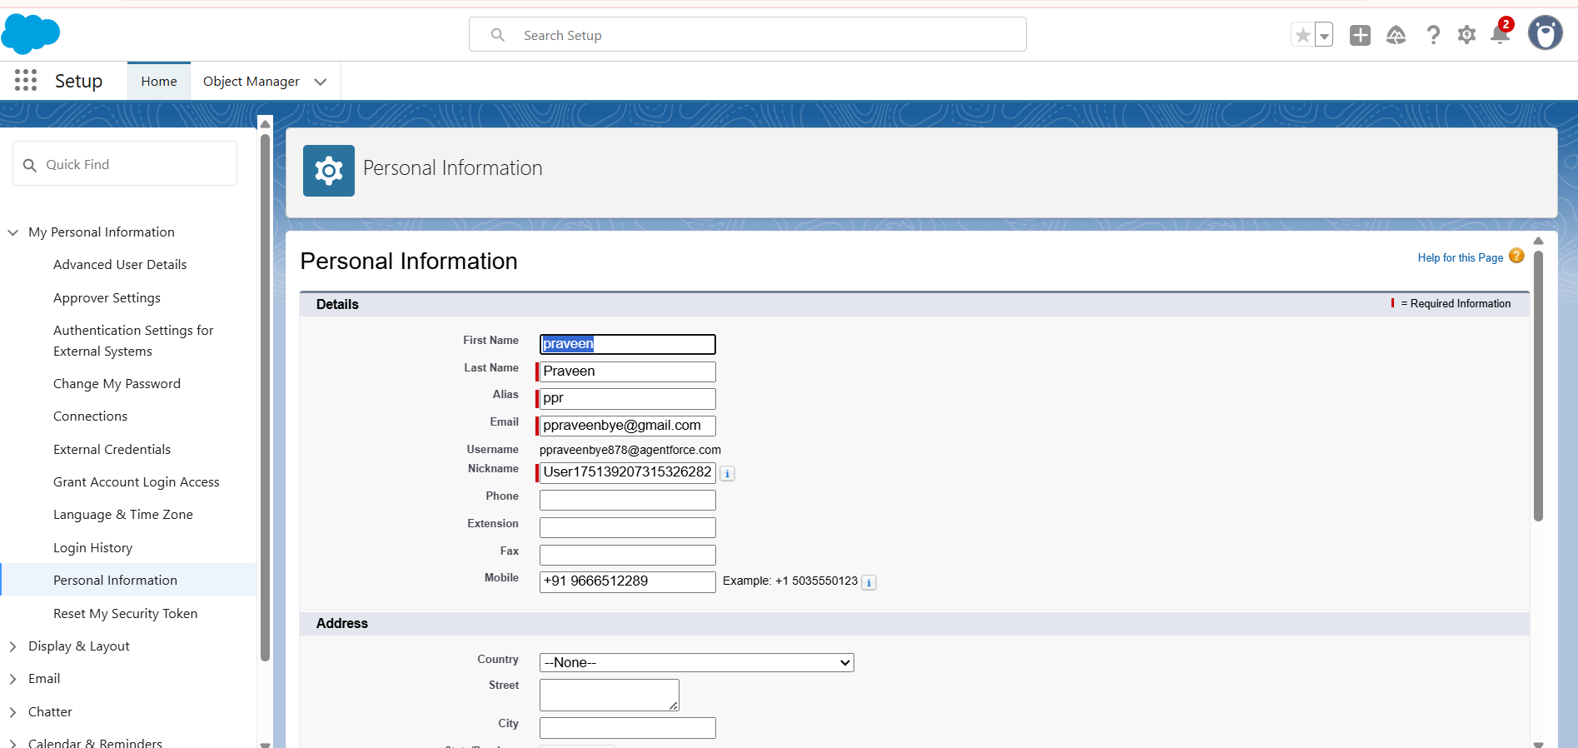

3.2 Customization of Objects and Fields:

* **Objects Created:**
  + Venue: Contact Email, Contact Phone, Location, Venue Location, Venue Name.
  + Drop-Off Point: Distance, distance calculation, Drop-Off Point Name, Location 2, State, Venue__c.
  + Task: Name of the Person, Food Category, Feedback, Number of People Served, Phone, Rating, Task ID, Task Name.
  + Volunteer: Address, Age, Available On, Contact Number, Date of Birth, Email, Execution ID, Gender, Owner Name, Volunteer ID, Volunteer Name.
  + Execution Details: Execution Detail Name, Task, Volunteer.
* **Fields:** Created fields for each object to support business logic.

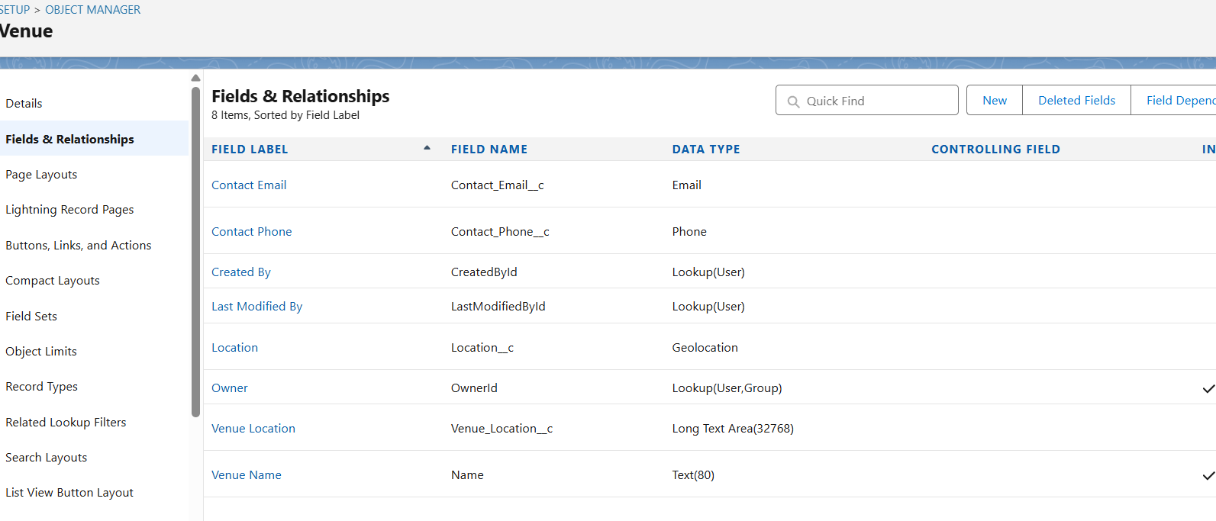

3.3 Automation (Flows and Process Builder):

* Flows :

Venue Flow:

A flow was established to automatically create corresponding Task records whenever a new Venue record is created. This ensures that each newly created venue has an assigned pickup task for further processing by default.

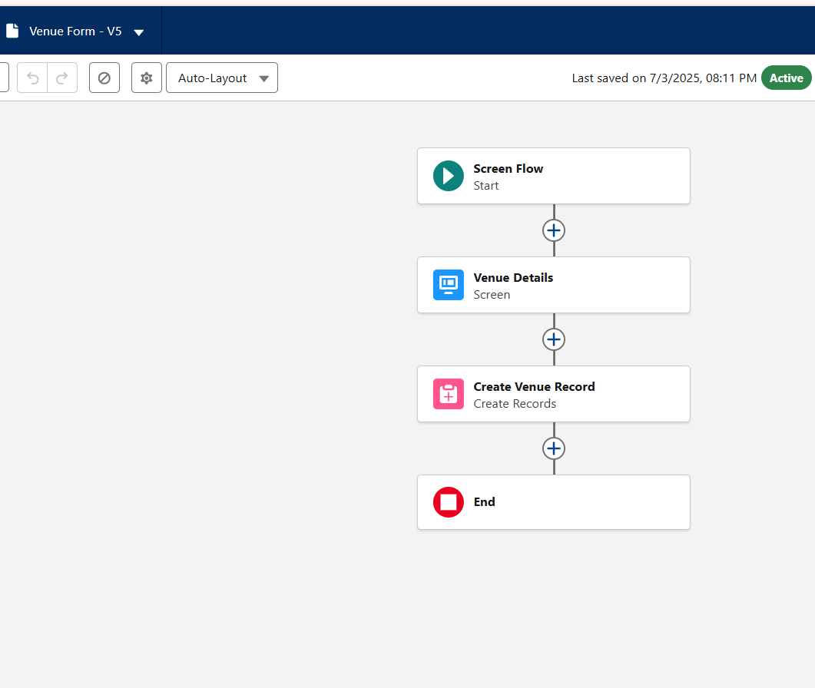

* Triggers
* Drop-off Trigger:

An automation was created on the Drop-off Point object to change the associated Task status to 'Ready for Delivery' every time a new Drop-off Point record is inserted. This simplifies the workflow by making tasks ready as soon as drop-off information is entered.

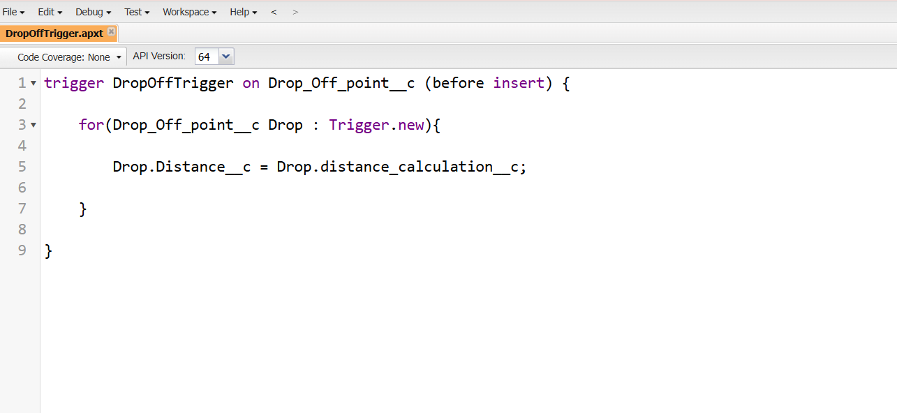

4. Phase III: UI/UX Development & Customisation:

4.1 Lightning App Setup:

* Custom Lightning App “FoodConnect” created with tabs for Venue, Drop-Off Point, Task, Volunteer, and Execution Details.

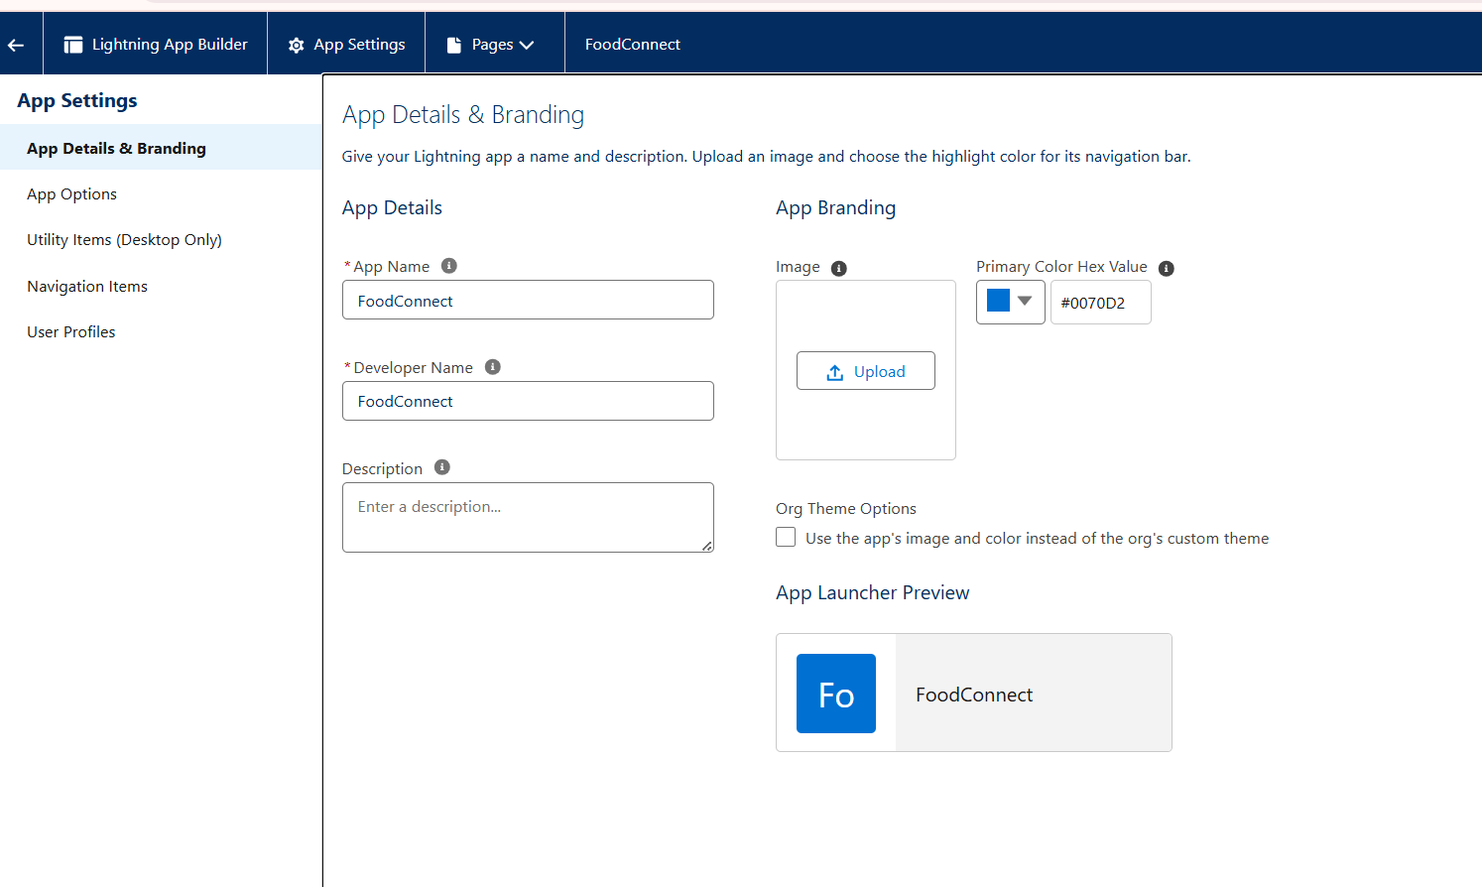

4.2 Page Layouts and Dynamic Forms:

* Set up page layouts for every object to show the important information to view and edit easily.

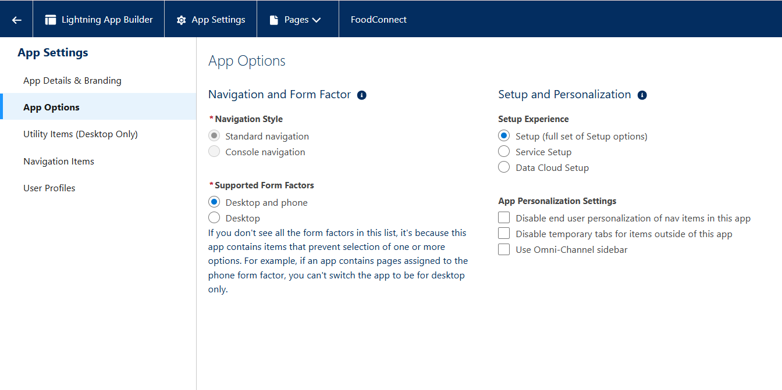

4.3 Tabs:

* Tabs are designed for all five custom objects of the FoodConnect app for easy access.

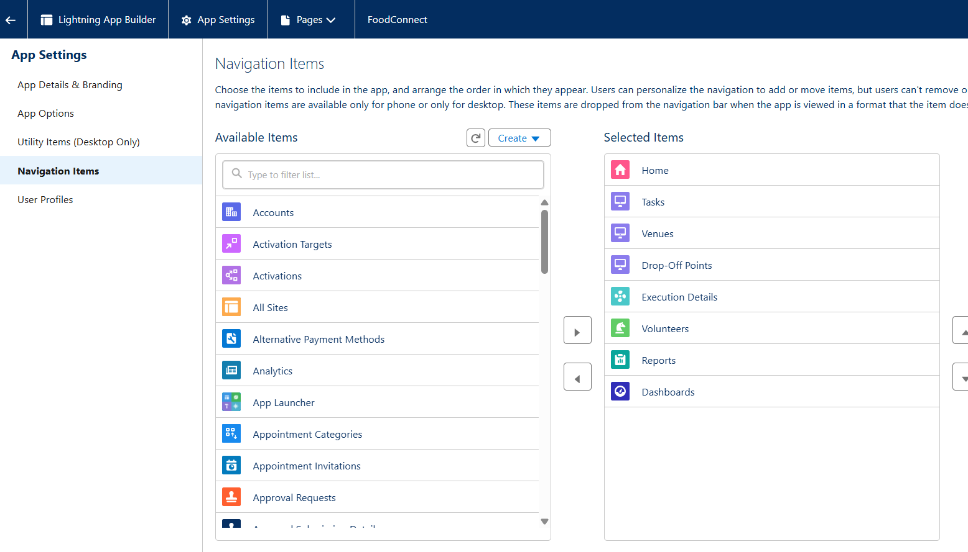

4.4 User Management:

* Users created with profiles: System Administration, NGO’s Profile.

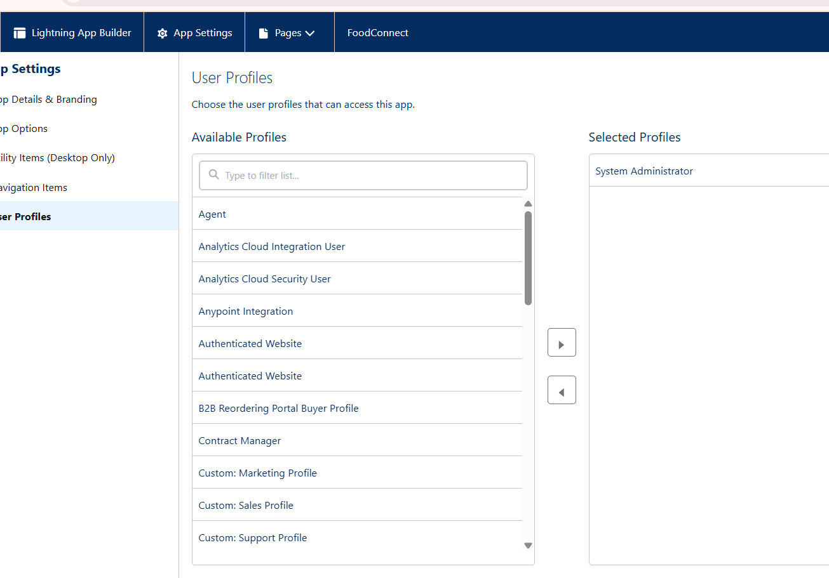

4.5 Reports and Dashboards:

* Reports:
* venue and drop-off point
* Volunteer Task

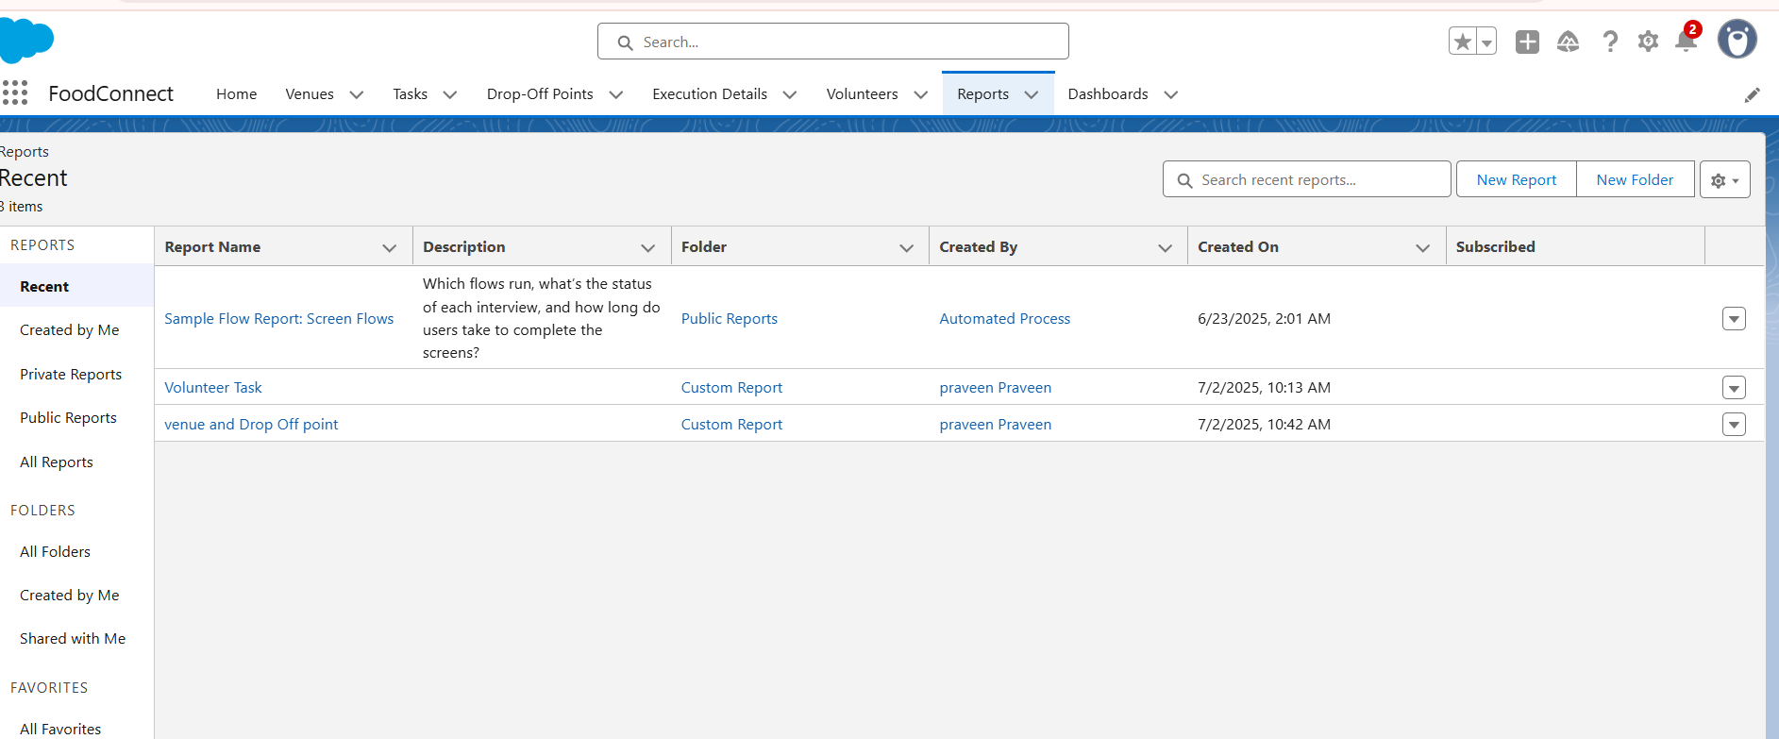

* Dashboards:
* Operations dashboard with overall tasks, done tasks, outstanding tasks, and volunteer utilization statistics.
* Task Execution Details.
* Organization Details

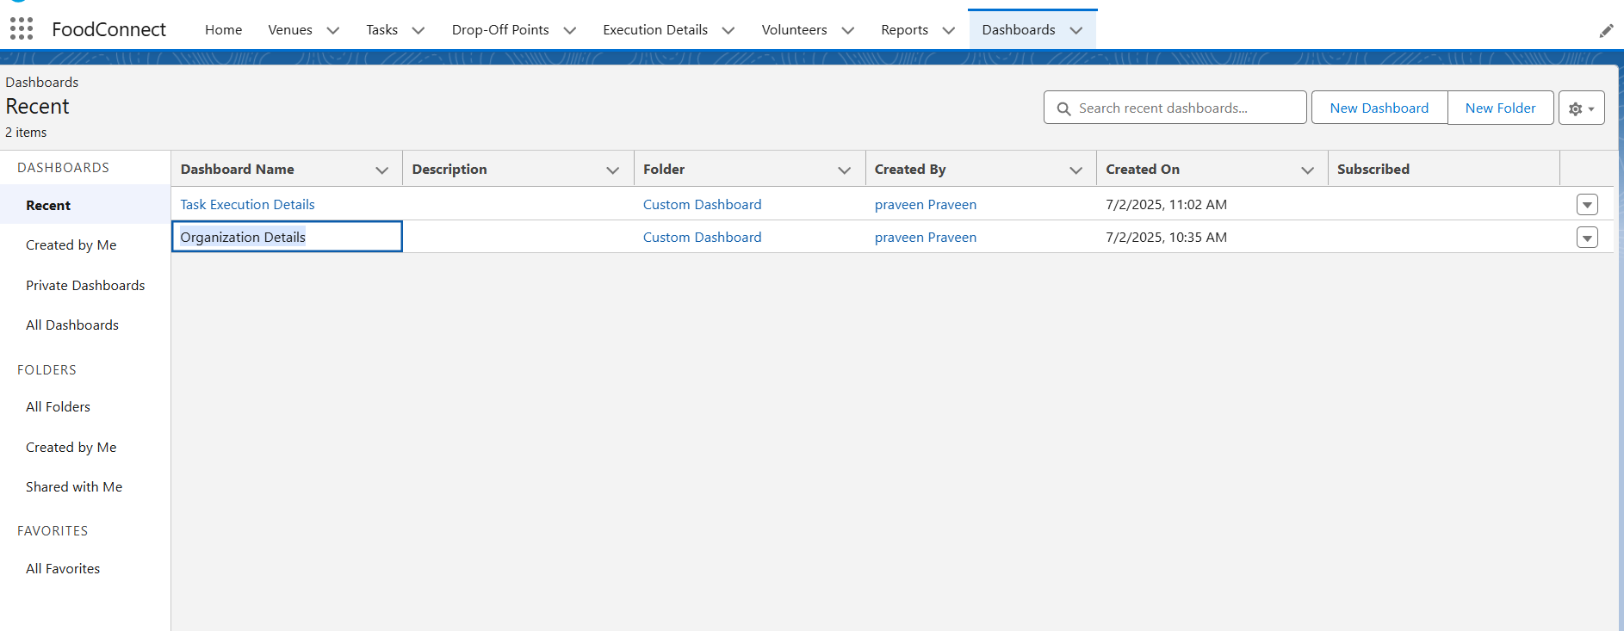

* Lightning Page:
* Configured record pages for objects with related lists and dynamic forms for a better user experience.

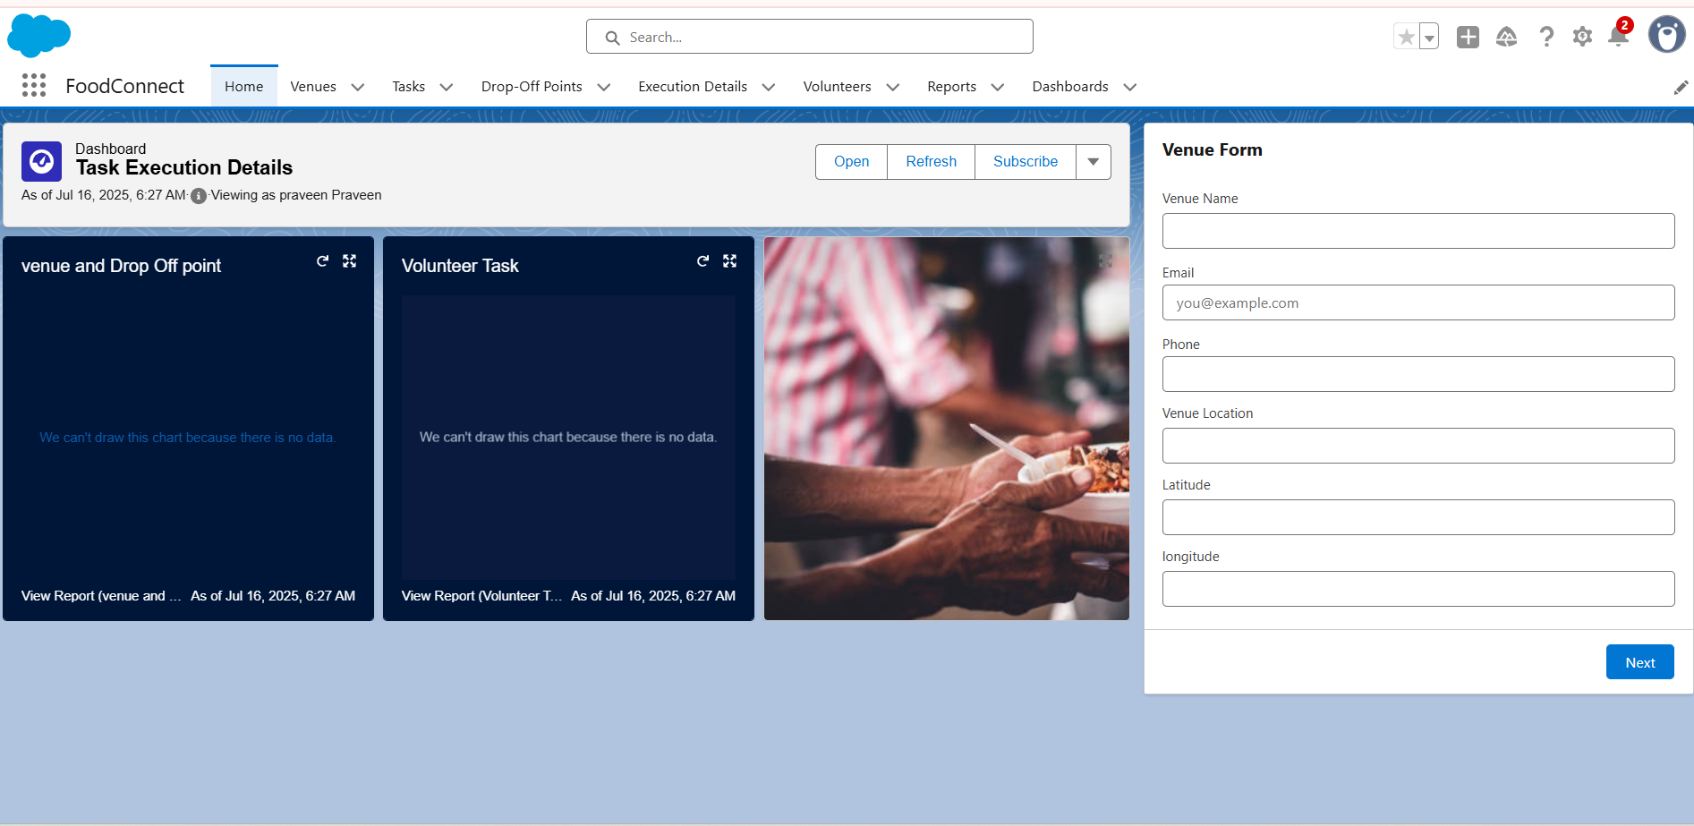 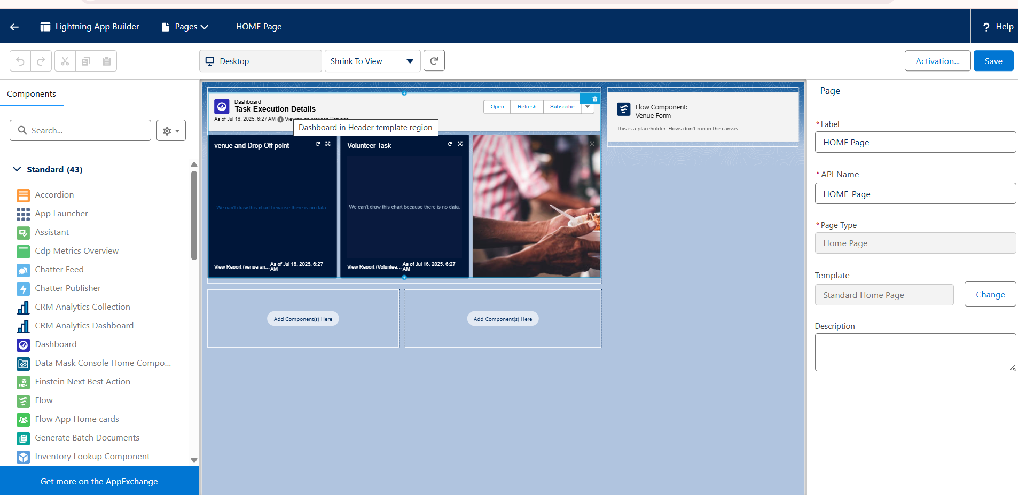

5. Phase IV: Data Migration & Security

5.1 Data Loading:

* In the FoodConnect project, data migration was performed via the Salesforce Data Import Wizard.
* An Excel spreadsheet was set up with fields like Venue Name, Contact Email, Contact Phone, Location, Latitude, Longitude, and Venue Location for the Venue object.
* The data was imported into Salesforce to easily create multiple Venue records.
* Utilizing the Data Import Wizard facilitated fast uploading of bulk data, having the system prepared with sample records for testing flows, triggers, and reports.

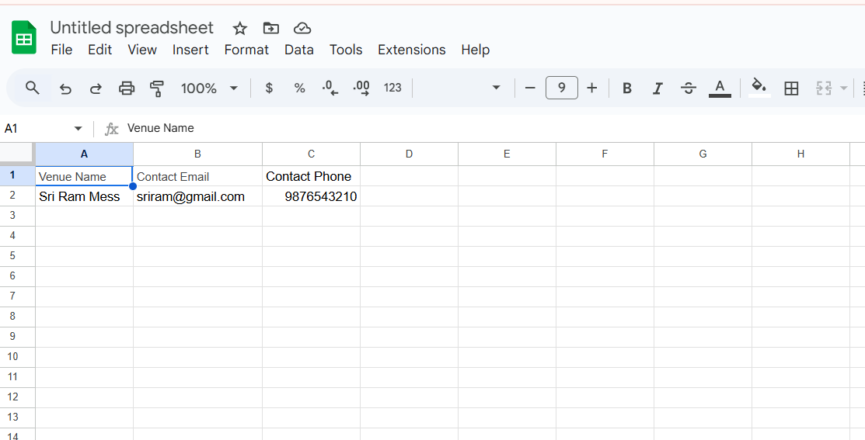 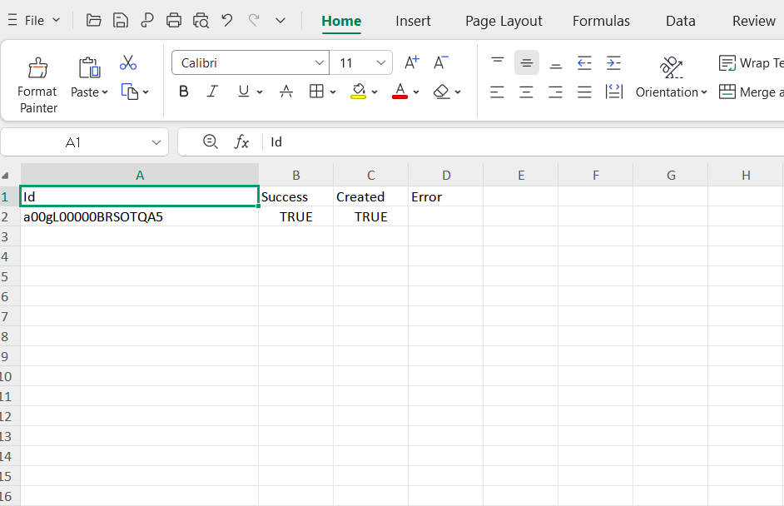

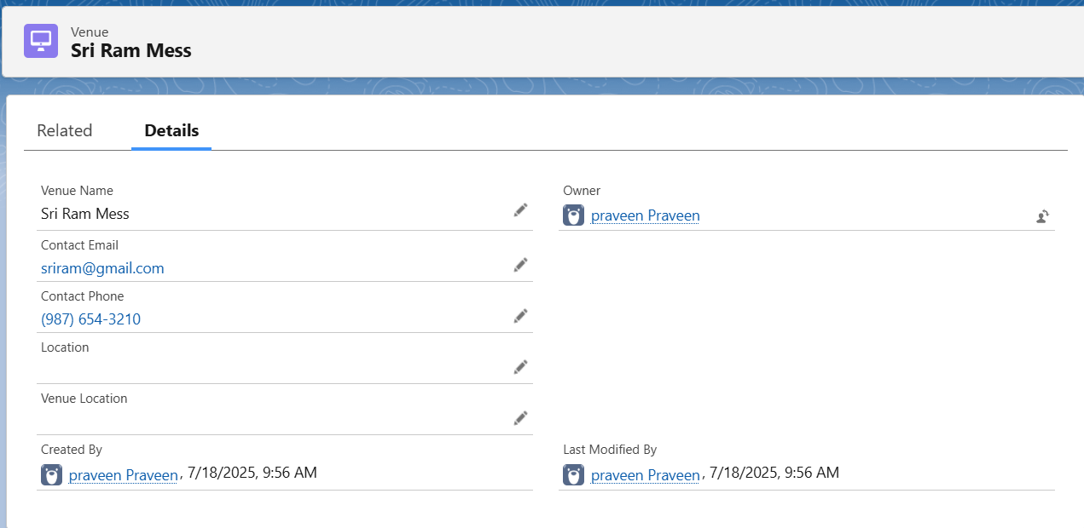

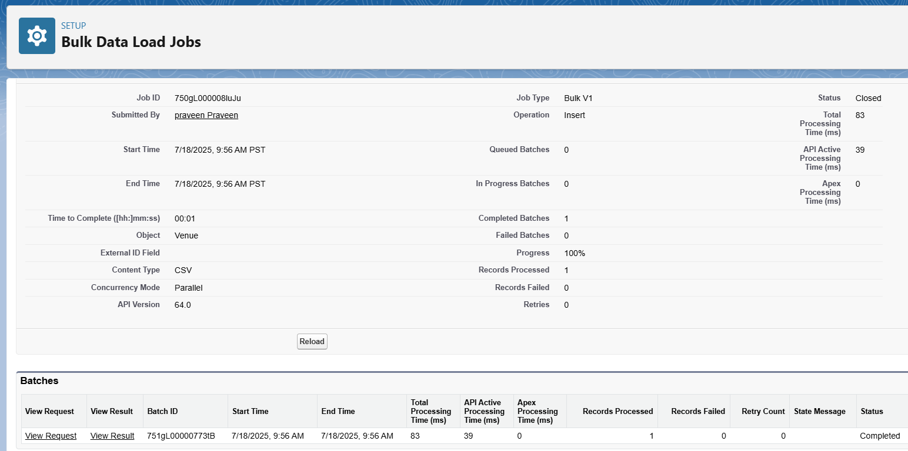

5.2 Ensuring Data Access and Security:

* Profiles:

Developed an NGO's Profile to control access for coordinators and volunteers so that they can only view and update the records appropriate to their work.

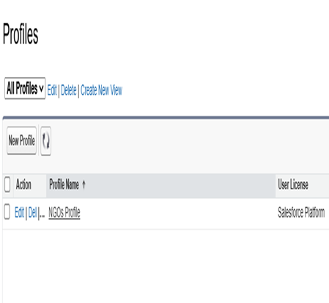

Sharing Rules:

* Set distance-based sharing rules on Drop-off Point records to share them with public groups by distance:
* Iksha group: Distance < 15 km
* NSS group: Distance = between 15 km and 30 km
* Street Cause group: Distance = between 30 km and 50 km
* This configuration ensures that volunteers and groups view only local drop-off points, improving operational effectiveness and data safety in FoodConnect

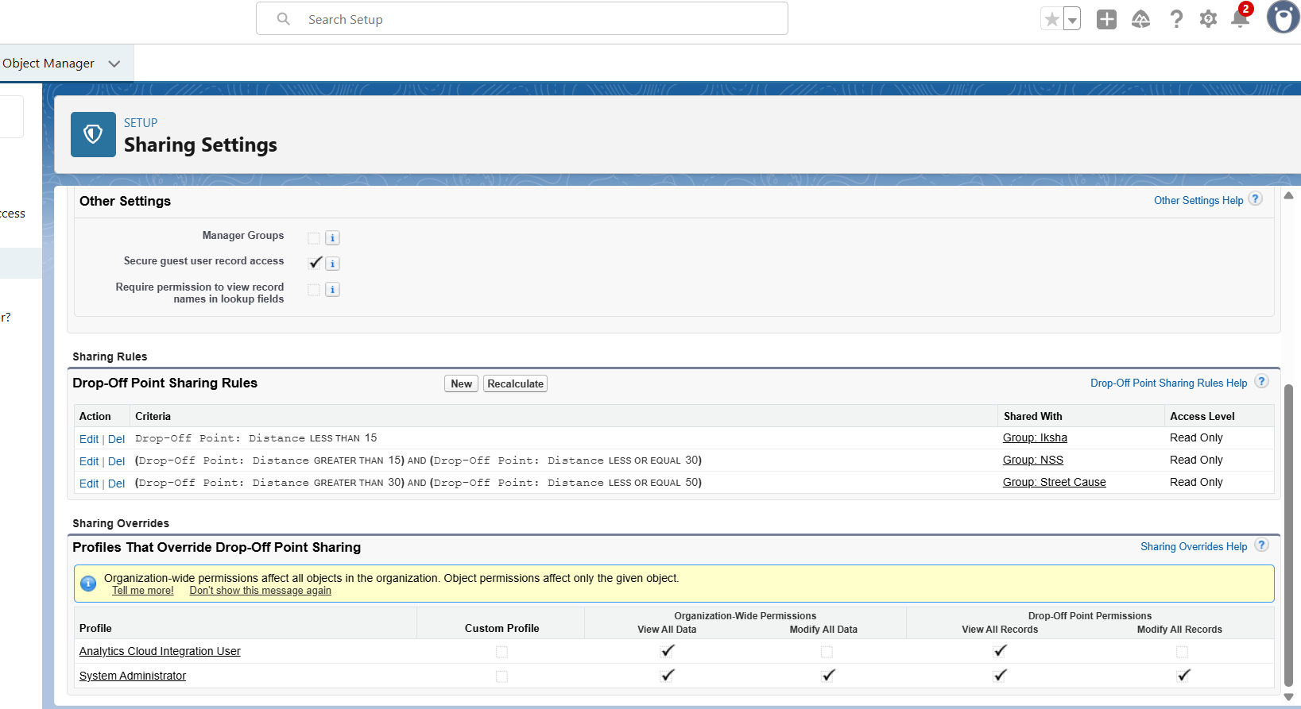

6. Phase V: Deployment, Documentation & Maintenance:

6.1 Deployment:

* Development and testing for the FoodConnect project were carried out directly within the Salesforce Developer Org. No independent deployment was carried out, nor was Change Set utilized, as the project was developed and proved out in the same environment.

6.2 Documentation:

* Features, flows, triggers, objects, and sharing rules were documented in a structured manner. Screenshots of each module and setup were created to maintain clarity and ease of readability for future purposes.

6.3 Maintenance:

* The system is maintained by:
* Periodically reviewing triggers and flows to make sure they are functioning as intended.
* Tracking errors with Debug Logs and Setup Audit Trail in Salesforce.
* Gathering user feedback to enhance layouts, reports, and processes, if necessary.
* Troubleshooting Method:
* During development, any problems like:
* Flows failing to create records properly
* Trigger logic errors were fixed by inspecting error messages, reviewing debug flow details, and fixing logic. Every fix was tested right away to verify correct functioning.

Phase 6: Conclusion:

* FoodConnect project was created to design a straightforward, efficient system to control leftover food distribution to poor and needy individuals. With Salesforce, the project simplified the process by:
* Registering the donor venues of leftover food.
* Automatically assigning work to volunteers for pickup and delivery.
* Monitoring drop-off locations and execution information efficiently.
* Applying automation, such as flows and triggers, to minimize manual effort.
* Setting up sharing rules so that only appropriate volunteers can view neighboring drop-off points.
* The project demonstrates how Salesforce may be employed outside of business CRM to address real-life social issues such as food wastage and hunger. It accelerates the donation and delivery process, making it more organized and transparent for both NGOs and the beneficiaries.
* In the future, FoodConnect can be made even more efficient by implementing WhatsApp notifications, AI-driven volunteer scheduling, and chatbot integration to increase its capabilities and accessibility.

