activity_sim.xml

activity_algorithms_list.xml

activity_main_drawer.xml

nav_header_main.xml

content_main.xml

NavigationView

app_bar_main.xml

activity_main.xml

MainActivity: Is the first screen loads on starting the app. The page UI should look like as below image.

SimView

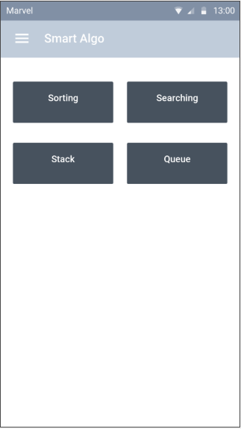

The buttons for different algorithms UI should be like with random colour gradient.

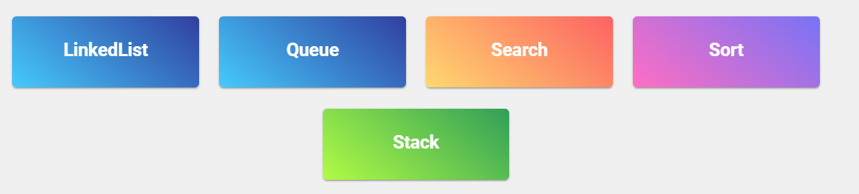

The list of categories should be taken from AlgorithmsData.Categories array. Please see the definition for AlgorithmsData, CategoryDetails and AlgorithmDetails.

The menu should contain

1. Icon of App
2. Title – Smart Algo
3. Subtitle – Master Algorithms and Data Structures Visually

At the header part of Menu.

The body part should contain,

1. Purchase All Algorithms – should perform purchase action TODO: Update details for purchase
2. Share the App – Should perform share to social media FB, Twitter, Google+, WhatsApp etc. TODO: Update more details
3. Rate App – Should perform rating of the app
4. Our Team – Should open a screen to contain our details like photo, qualification, profession, more.

On Selection of Category button MainActivity should start AlgorithmsList activity by passing index of the category from AlgorithmsData.Categories

AlgorithmListActivity: On starting of this activity should perform below actions by reading Algorithm details from AlgorithmsData.Categories by using index passed from MainActivity

1. Update the title to AlgorithmsData.Categories.Name
2. Populate a list with algorithms available for selected category by using AlgorithmsData.Categories.Algorithms.Name
3. For each list item display lock icon or unlock icon based on the settings from AlgorithmsData.Categories.Algorithms.IsLocked and if user not purchased all algorithms.

On selection of a item in the list this activity should start SimActivity by passing the class from AlgorithmsData.Categories.Algorithms.AlgorithmClass and name of the algorithm selected

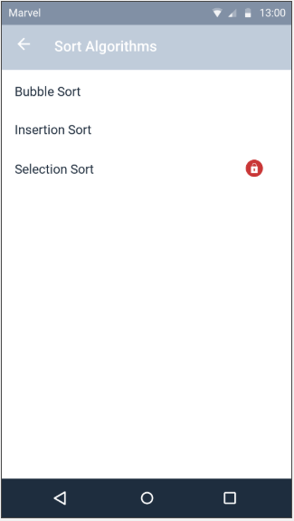

SimActivity – On starting of this activity should perform below actions by reading the passed.

1. Update the title

The UI for this page should be like.

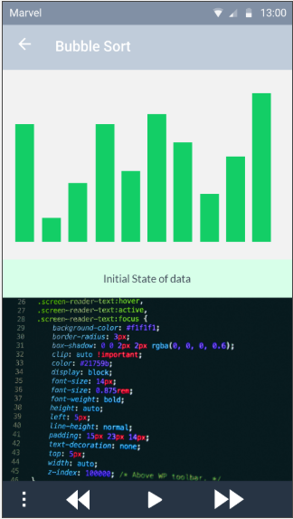 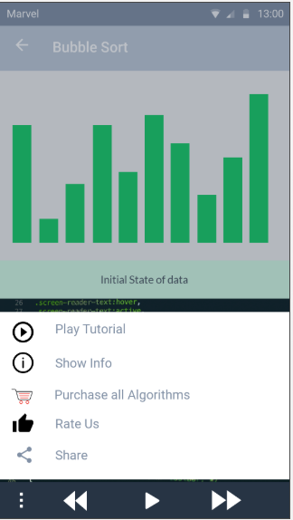

Perform the actions for Purchase All Algorithms, Rate Us and Share as per MainActivity.

TODO: Update details about Simulation Preparation, playing animation etc.