SARIMA

Vazão DE Camargos

Plotagem dos dados:

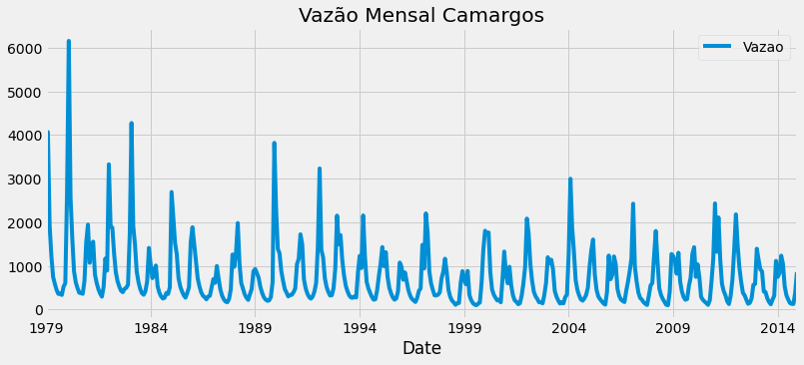

Amostra dos dados:

|  |  |
| --- | --- |
| Date | Vazao |
| 1979-01-01 | 3191 |
| 1979-02-01 | 4071 |
| 1979-03-01 | 1924 |
| 1979-04-01 | 1226 |
| 1979-05-01 | 745 |

Descrição dos dados:

|  |
| --- |
| Coluna: Vazão |
| count 432.000000 |
| mean 753.879630 |
| std 695.337121 |
| min 97.000000 |
| 25% 298.750000 |
| 50% 516.500000 |
| 75% 1013.000000 |
| max 6163.000000 |

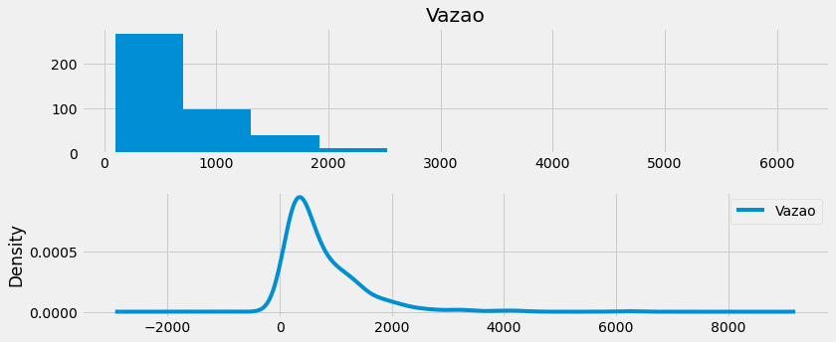

Decomposição dos dados:

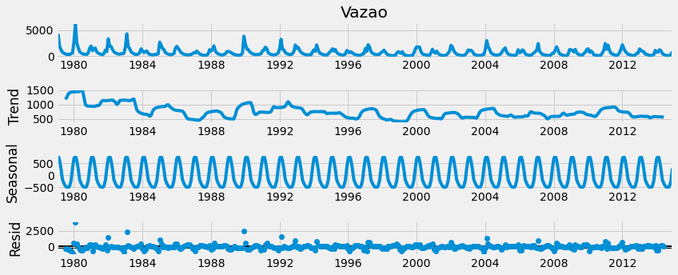

Componente Sazonal

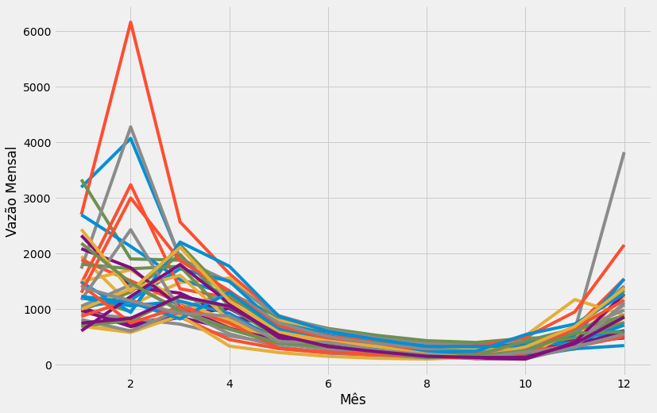

Autocorrelação( ACF E PACF)

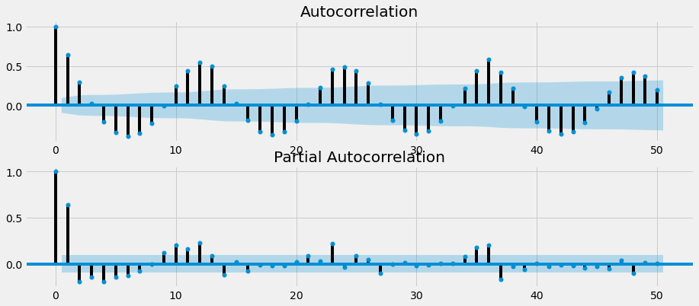

Média Móvel e Desvio Padrão

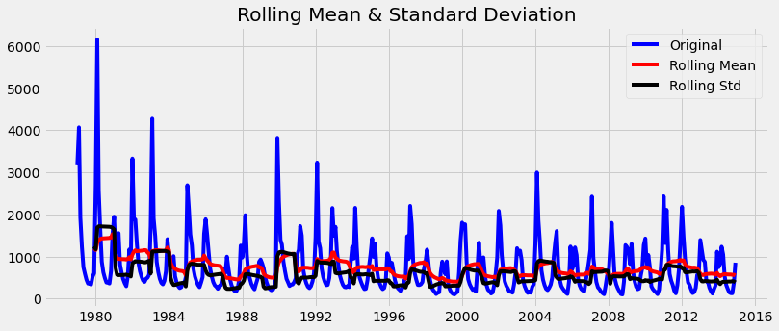

Resultados de Dick-Fuller:

Results of Dickey-Fuller Test:

Test Statistic -5.068400

p-value 0.000016

#Lags Used 13.000000

Number of Observations Used 418.000000

Critical Value (1%) -3.446091

Critical Value (5%) -2.868479

Critical Value (10%) -2.570466

**Teste de Dick-Fuller para dados de treino:**

Results of Dickey-Fuller Test:

Test Statistic -9.441342e+00

p-value 4.885395e-16

#Lags Used 1.700000e+01

Number of Observations Used 4.010000e+02

Critical Value (1%) -3.446763e+00

Critical Value (5%) -2.868775e+00

Critical Value (10%) -2.570624e+00

dtype: float64

Plotagem após tornar a série estacionária

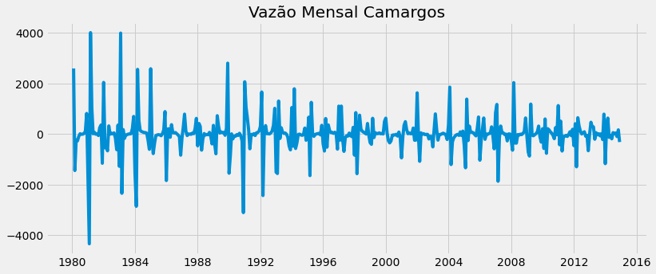

Autocorrelação( ACF E PACF)

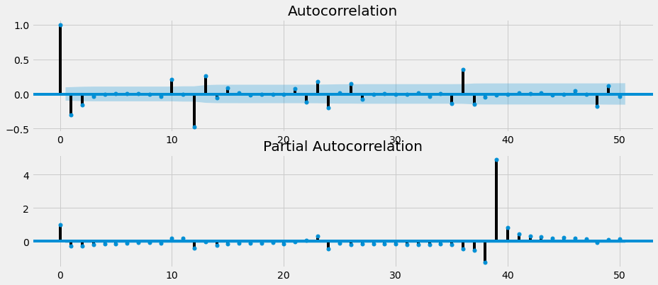

Ajuste de modelo usando todos os dados de Vazão

SARIMAX Results

Dep. Variable: y No. Observations: 432

Model: SARIMAX(5, 1, 0)x(2, 1, [1, 2], 12) Log Likelihood -3154.295

Date: Mon, 09 Nov 2020 AIC 6330.591

Time: 10:17:50 BIC 6375.007

Sample: 0 HQIC 6348.148

- 432

Covariance Type: opg

coef std err z P>|z| [0.025 0.975]

------------------------------------------------------------------------------

intercept 1.2109 17.076 0.071 0.943 -32.258 34.680

ar.L1 -0.4680 0.037 -12.525 0.000 -0.541 -0.395

ar.L2 -0.4282 0.053 -8.055 0.000 -0.532 -0.324

ar.L3 -0.3058 0.074 -4.127 0.000 -0.451 -0.161

ar.L4 -0.2305 0.080 -2.890 0.004 -0.387 -0.074

ar.L5 -0.1324 0.071 -1.877 0.061 -0.271 0.006

ar.S.L12 -0.7157 0.077 -9.320 0.000 -0.866 -0.565

ar.S.L24 -0.4734 0.037 -12.929 0.000 -0.545 -0.402

ma.S.L12 -0.1641 0.091 -1.804 0.071 -0.342 0.014

ma.S.L24 -0.1991 0.094 -2.115 0.034 -0.384 -0.015

sigma2 1.986e+05 6580.852 30.171 0.000 1.86e+05 2.11e+05

Ljung-Box (Q): 50.37 Jarque-Bera (JB): 2211.90

Prob(Q): 0.13 Prob(JB): 0.00

Heteroskedasticity (H): 0.41 Skew: 0.39

Prob(H) (two-sided): 0.00 Kurtosis: 14.23

Warnings:

[1] Covariance matrix calculated using the outer product of gradients (complex-step).

Plotagem de treino(azul) e testes(vermelho)

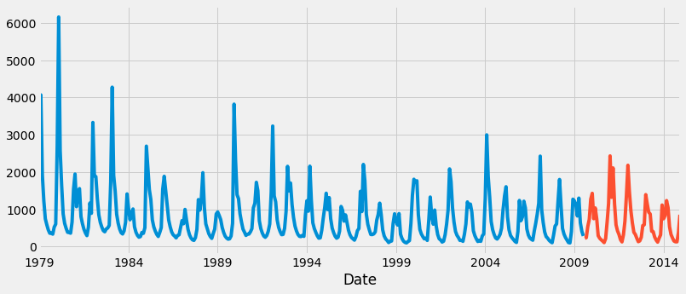

Ajuste de Modelo usando apenas dados de treino

SARIMAX Results

Dep. Variable: Vazao No. Observations: 367

Model: SARIMAX(1, 1, 0)x(0, 1, [1], 12) Log Likelihood -2735.042

Date: Mon, 09 Nov 2020 AIC 5476.084

Time: 09:47:44 BIC 5487.691

Sample: 01-01-1979 HQIC 5480.702

- 07-01-2009

Covariance Type: opg

coef std err z P>|z| [0.025 0.975]

------------------------------------------------------------------------------

ar.L1 -0.2684 0.026 -10.512 0.000 -0.318 -0.218

ma.S.L12 -0.9942 0.233 -4.274 0.000 -1.450 -0.538

sigma2 2.729e+05 6.2e+04 4.402 0.000 1.51e+05 3.94e+05

Ljung-Box (Q): 141.48 Jarque-Bera (JB): 651.57

Prob(Q): 0.00 Prob(JB): 0.00

Heteroskedasticity (H): 0.29 Skew: 0.29

Prob(H) (two-sided): 0.00 Kurtosis: 9.62

Diagnóstico do Modelo

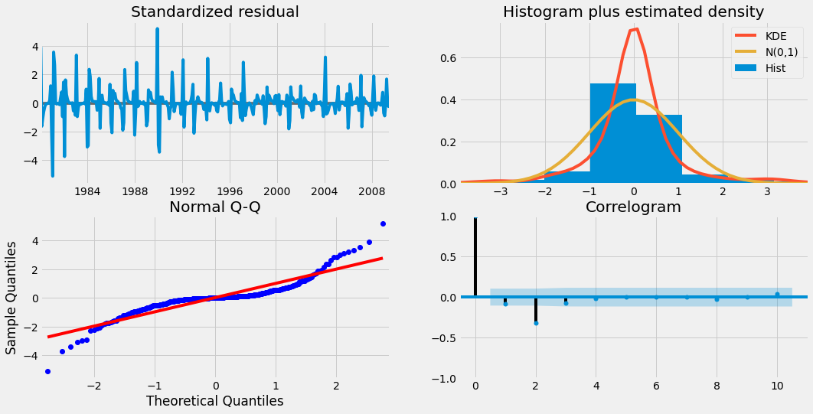

Plotagem de gráfico com dados previstos e dados de vazão

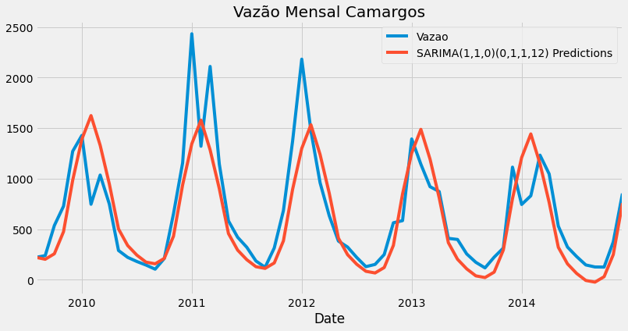

Comparação Previsto vs Esperado

**predicted=221.9649653, expected=222**

**predicted=203.0498783, expected=239**

**predicted=257.374235 , expected=537**

**predicted=475.869511 , expected=728**

**predicted=984.4157343, expected=1271**

**predicted=1390.19378 , expected=1428**

**predicted=1623.940046, expected=747**

**predicted=1329.797602, expected=1036**

**predicted=947.1899832, expected=749**

**predicted=503.0518693, expected=290**

**predicted=339.1264459, expected=222**

**predicted=244.289553 , expected=181**

**predicted=174.8917085, expected=146**

**predicted=158.2208325, expected=105**

**predicted=211.9429415, expected=211**

**predicted=430.5998344, expected=652**

**predicted=939.1026868, expected=1157**

**predicted=1344.892371, expected=2433**

**predicted=1578.635514, expected=1321**

**predicted=1284.493908, expected=2110**

**predicted=901.8860644, expected=1145**

**predicted=457.7480109, expected=583**

**predicted=293.8225713, expected=421**

**predicted=198.9856827, expected=322**

**predicted=129.5878371, expected=186**

**predicted=112.9169614, expected=124**

**predicted=166.6390703, expected=315**

**predicted=385.2959632, expected=685**

**predicted=893.7988156, expected=1371**

**predicted=1299.5885 , expected=2182**

**predicted=1533.331643, expected=1472**

**predicted=1239.190037, expected=960**

**predicted=856.5821932, expected=634**

**predicted=412.4441397, expected=383**

**predicted=248.5187001, expected=324**

**predicted=153.6818115, expected=221**

**predicted=84.28396595, expected=130**

**predicted=67.61309026, expected=152**

**predicted=121.3351991, expected=250**

**predicted=339.9920921, expected=564**

**predicted=848.4949445, expected=585**

**predicted=1254.284629, expected=1393**

**predicted=1488.027772, expected=1143**

**predicted=1193.886165, expected=921**

**predicted=811.2783221, expected=873**

**predicted=367.1402685, expected=410**

**predicted=203.2148289, expected=399**

**predicted=108.3779404, expected=256**

**predicted=38.98009477, expected=173**

**predicted=22.30921909, expected=118**

**predicted=76.03132796, expected=224**

**predicted=294.6882209, expected=314**

**predicted=803.1910733, expected=1114**

**predicted=1208.980757, expected=745**

**predicted=1442.723901, expected=831**

**predicted=1148.582294, expected=1233**

**predicted=765.9744509, expected=1047**

**predicted=321.8363973, expected=531**

**predicted=157.9109577, expected=324**

**predicted=63.07406919, expected=230**

**predicted=-6.323776401, expected=147**

**predicted=-22.99465209, expected=127**

**predicted=30.72745678, expected=126**

**predicted=249.3843497, expected=375**

**predicted=757.8872021, expected=853**

Avaliação de Resultados



