**Supplementary**

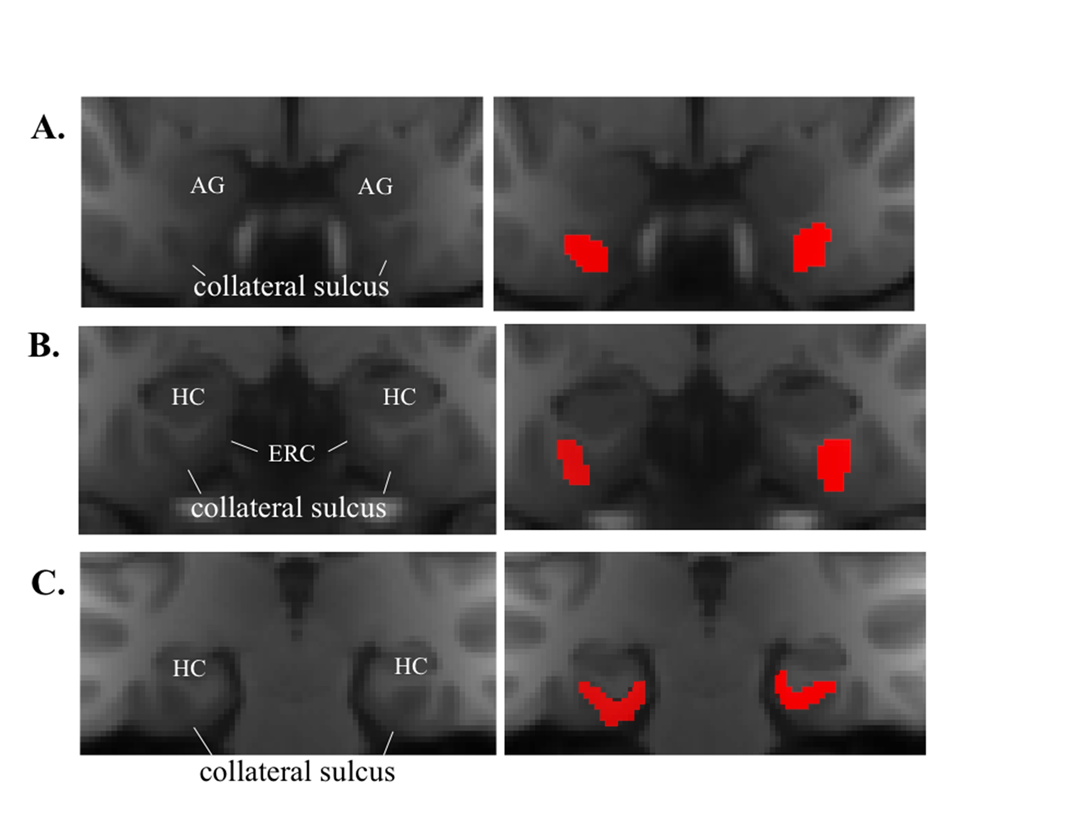

**Supplementary Figure 1. The PHG mask used in parcellation procedure.** The PHG mask was generated by manually tracing on the group-averaged MNI space MPRAGE image following previously- published guidelines (Insausti et al. 1998; Franko et al. 2012). The PHG mask contained gray matter voxels along the banks of the collateral sulcus. **A)** For coronal slices anterior to the onset of the ERC, the mask contained both the medial and lateral banks of the collateral sulcus. **B)** For slices containing the ERC, the mask contained the entire lateral bank of the collateral sulcus and extended to the midpoint of the medial bank. **C)** For slices posterior to the ERC, the mask included only the medial bank of the collateral sulcus and extended medially to the HC or to the calcarine sulcus. Masks are displayed at the resolution of the functional images (3.2 mm isotropic). AG: amygdala. HC: hippocampus

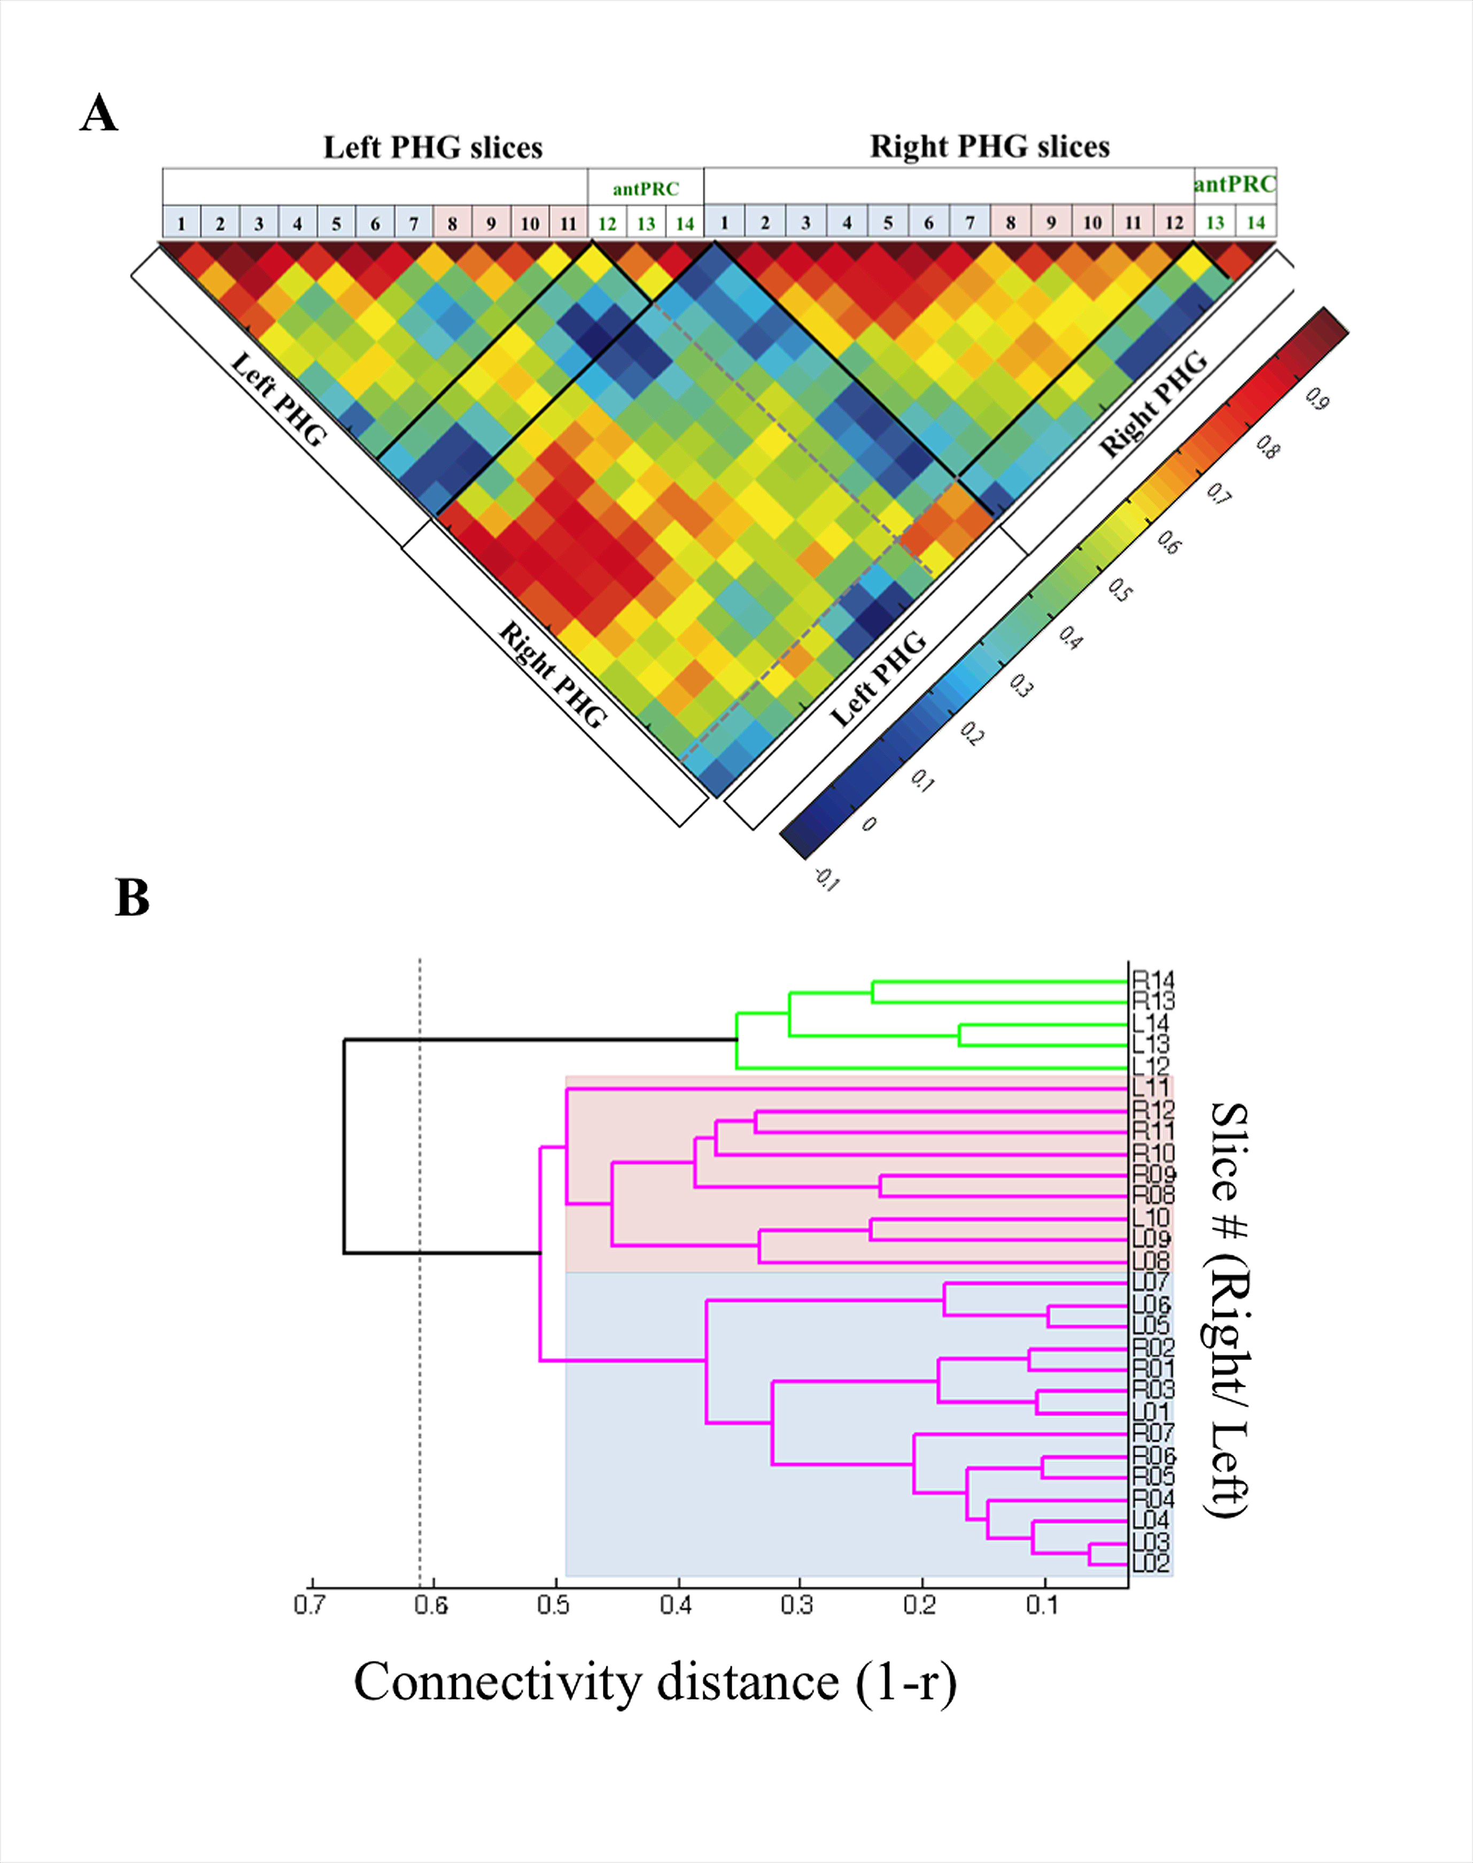**Supplementary Figure 2. Connectivity homogeneity matrices and dendrograms for the control PHG.** We applied the parcellation procedure to the control PHG mask, which included only the lateral half of the medial bank of the collateral sulcus (the part of the original PHG mask that was consistent across the entire longitudinal axis). The aim was to see whether this control region could be separated into clusters similar to what we found by using the full PHG mask.

**A)** The control PHG connectivity homogeneity matrix. The entries for each column/row in the matrix are connectivity similarity values (r) between a given slice and all other slices in the control PHG. Solid lines indicate significant clusters identified in the dendrogram and dashed lines show the connectivity similarity for homologous clusters across left and right hemisphere. In the matrix, the first 14 columns/rows contain the connectivity similarity values for each of the left control PHG coronal slice. The connectivity similarity values for right control PHG coronal slices start from the 15th column/row. Two significant clusters were identified in the control PHG area: control-antPRC (green) and control-postPHG (purple). The control-antPRC cluster consisted of the slices found in the antPRC cluster when using the full PHG mask. The rest of the control PHG was grouped into one cluster, the control-postPHG cluster. The boundary between control-antPRC and control-postPHG clusters corresponded to the boundary between antPRC and postPRC clusters in the original analysis. In the control-postPHG cluster, there are two major sub-clusters corresponded well to the PHC (blue) and postPRC (red) clusters identified when using full PHG mask. The only difference was that the control PHC cluster in the left hemisphere contained one more slice than the originally described PHC cluster. Boxes above the matrix contain slice numbers. Slices with blue background corresponded to the slices in the control-PHC cluster, corresponding to the cluster with blue background in the following dendrogram. Slices with red background corresponded to slices in the control- postPRC cluster, corresponding to the cluster with red background in the following dendrogram.

**B)** The control PHG dendrogram, showing the hierarchical relationships among coronal slices based on their connectivity distance. The x-axis is “connectivity distance” (1-r). The y-axis is the index of the coronal slice, which indicates the physical location of a given slice in a brain region. The numbers correspond to column/row number labeled on the connectivity homogeneity matrix. L stands for left hemisphere and R stands for right hemisphere. The dashed line on the dendrogram represent the connectivity distance threshold for the control PHG (1-r = 0.613, p< .05). Clusters to the right of the threshold are the two significant clusters, highlighted in different colors (control-antPRC: green, control-postPHG: purple). Red and blue background marked the two sub-clusters in the control-postPHG cluster. Although they were not significant clusters, the two clusters corresponded well to the PHC (blue) and postPRC (red) clusters found when using the full PHG mask.

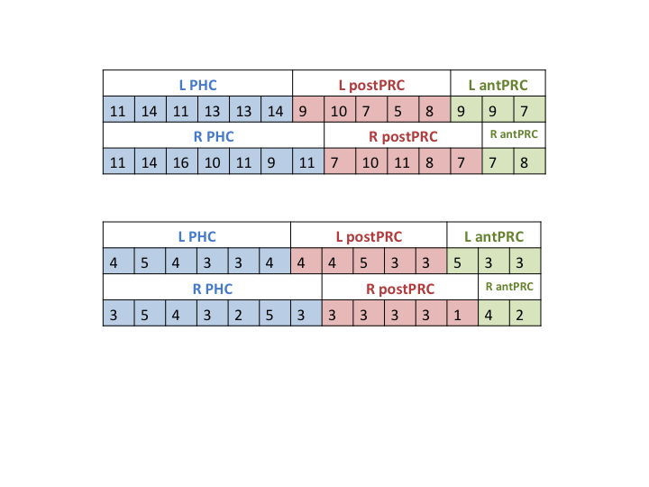

**Supplementary Figure 3. Number of voxels for each coronal slice in PHG.** One potential concern is that the parcellation procedure might have been biased by transitions in the number of voxels in each slice. The table shows the number of voxels for each slice and the clusters identified via the parcellation scheme. The slices in the PHC cluster are in blue, the slices in the postPRC cluster are in red, and the slices in antPRC cluster are in green. PHC includes more voxels than PRC, but this finding is fully consistent with the known anatomy of these two regions. Changes in the number of voxels for each PHG coronal slice did not correspond to boundaries among clusters. The number of voxels for each slice fluctuates within the range of 5 to 16 voxels. The mean number of voxels for a slice is 10. Transitions between clusters do not correspond to changes in numbers of voxels between slices.

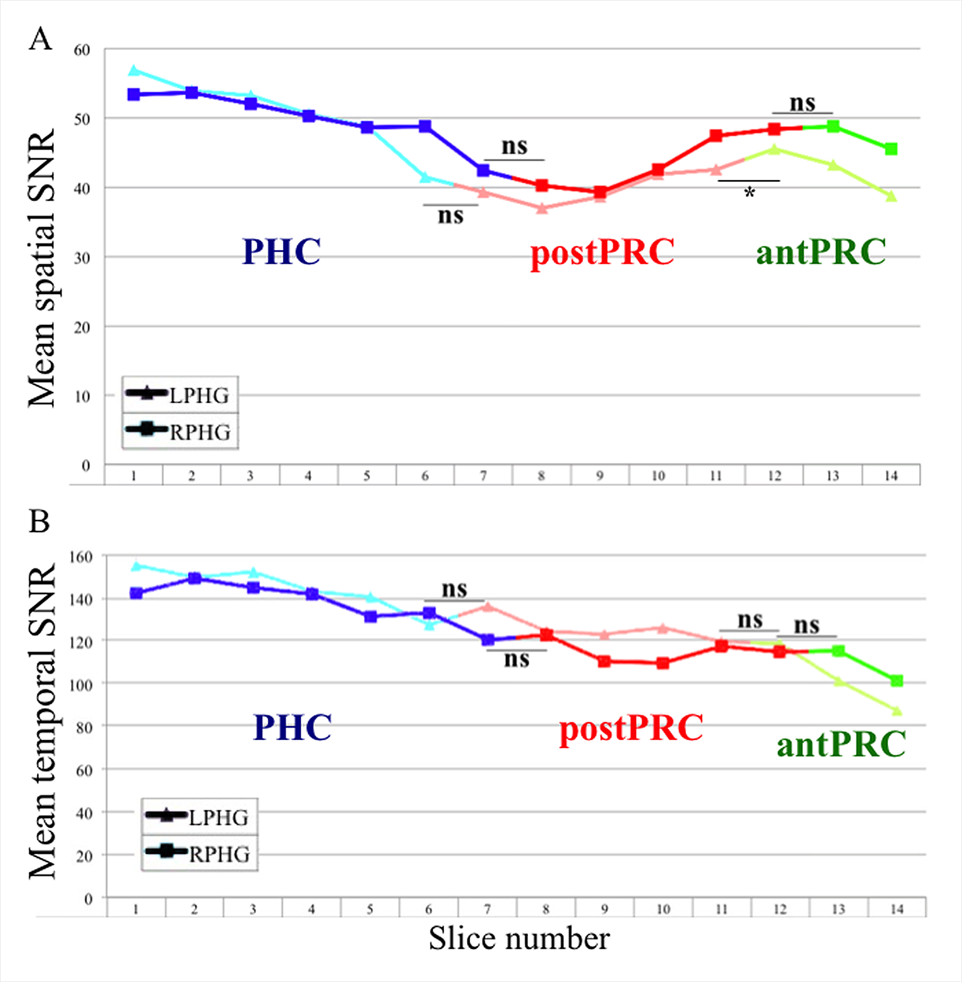

**Supplementary Figure 4. Mean spatial and temporal SNR for each coronal slice in the PHG.** Another concern was the impact of the susceptibility artifacts in the temporal lobes. To determine whether differences in signal quality could explain the pattern of results reported here, we calculated the mean spatial and temporal signal-to-noise ratio (SNR) for each coronal slice in the PHG. We then evaluated whether there were any transitions in SNR that corresponded to the observed transitions in functional connectivity. Specifically, we used paired t-tests to test whether SNR differed for slices adjacent to the cluster transitions. Points in the figure represent mean SNR for each slice. Boxes below the plot denote the slice number. Slice one represents the most posterior slice in the PHG and slice 14 is the most anterior slice in the PHG. Colors on the line represent three different clusters labeled below the line (PHC: blue; postPRC: red; antPRC: green). Left PHG is represented by triangle marks and right PHG is represented by square marks. **A)** Mean spatial SNR for each coronal slice in the left and right PHG. Spatial SNR did not differ for 3 out of the 4 pairs of slices adjacent to cluster transitions (ps > 0.05). The only significant difference was between the slices adjacent to the transition from left postPRC to antPRC (p = 0.012). **B)** Mean temporal SNR for each coronal slice in the left and right PHG. Temporal SNR did not differ for any of the pairs of slices adjacent to cluster transitions (ps > 0.05). Thus, it is unlikely that the present parcellation results were driven by differences in signal quality.