SALDRE/GLBCE on Centaurus

User Guide


Literature Number: TBD
April 2012

IMPORTANT NOTICE

Texas Instruments Incorporated and its subsidiaries (TI) reserve the right to make corrections, modifications, enhancements, improvements, and other changes to its products and services at any time and to discontinue any product or service without notice. Customers should obtain the latest relevant information before placing orders and should verify that such information is current and complete. All products are sold subject to TI’s terms and conditions of sale supplied at the time of order acknowledgment.
TI warrants performance of its hardware products to the specifications applicable at the time of sale in accordance with TI’s standard warranty. Testing and other quality control techniques are used to the extent TI deems necessary to support this warranty. Except where mandated by government requirements, testing of all parameters of each product is not necessarily performed.
TI assumes no liability for applications assistance or customer product design. Customers are responsible for their products and applications using TI components. To minimize the risks associated with customer products and applications, customers should provide adequate design and operating safeguards.
TI does not warrant or represent that any license, either express or implied, is granted under any TI patent right, copyright, mask work right, or other TI intellectual property right relating to any combination, machine, or process in which TI products or services are used. Information published by TI regarding third-party products or services does not constitute a license from TI to use such products or services or a warranty or endorsement thereof. Use of such information may require a license from a third party under the patents or other intellectual property of the third party, or a license from TI under the patents or other intellectual property of TI.
Reproduction of information in TI data books or data sheets is permissible only if reproduction is without alteration and is accompanied by all associated warranties, conditions, limitations, and notices. Reproduction of this information with alteration is an unfair and deceptive business practice. TI is not responsible or liable for such altered documentation.
Resale of TI products or services with statements different from or beyond the parameters stated by TI for that product or service voids all express and any implied warranties for the associated TI product or service and is an unfair and deceptive business practice. TI is not responsible or liable for any such statements.
Following are URLs where you can obtain information on other Texas Instruments products and application solutions:

Products |  | Applications
Amplifiers | amplifier.ti.com | Audio | www.ti.com/audio
Data Converters | dataconverter.ti.com | Automotive | www.ti.com/automotive
DSP | dsp.ti.com | Broadband | www.ti.com/broadband
Interface | interface.ti.com | Digital Control | www.ti.com/digitalcontrol
Logic | logic.ti.com | Military | www.ti.com/military
Power Mgmt | power.ti.com | Optical Networking | www.ti.com/opticalnetwork
Microcontrollers | microcontroller.ti.com | Security | www.ti.com/security
 |  | Telephony | www.ti.com/telephony
 |  | Video & Imaging | www.ti.com/video
 |  | Wireless | www.ti.com/wireless

Mailing Address: Texas Instruments
Post Office Box 655303 Dallas, Texas 75265

Copyright © 2010-12, Texas Instruments Incorporated

Preface
Read This First
About This Manual
The scene adaptive local dynamic range enhancement (SAL-DRE) aka Global and Local Brightness Contrast Enhancement (GLBCE) algorithm improves the dynamic range of a scene by adaptive tone mapping such that the contents in both the dark and bright regions are visible. The purpose of SAL-DRE is to modify the brightness/contrast of a video/image in such a way that it looks more similar to how a human would see the actual scene.

Intended Audience
This document is intended for system engineers who want to know how the algorithm has been integrated into the IPNC platform.
This document assumes that you are fluent in the C language, have a good working knowledge of Digital Signal Processing (DSP), digital signal processors, and DSP applications.
Related Documentation
You can use the following documents to supplement this user guide:
- TBD
Text Conventions
The following conventions are used in this document:
- Text inside back-quotes (‘‘) represents pseudo-code.
- Program source code, function and macro names, parameters, and command line commands are shown in a mono-spaced font.
- File names, paths are shown in italic.
Product Support
When contacting TI for support on this codec, please quote the product name (SALDRE algorithm on Centaurus) and version number. The version number of the codec is included in the Title of the Release Notes that accompanies this codec.
Trademarks
Code Composer Studio and eXpressDSP are trademarks of Texas Instruments.
All trademarks are the property of their respective owners.
Software Copyright
Software Copyright © 2006 Texas Instruments Inc.

Contents
Read This First iii
About This Manual iii
Intended Audience iii
Related Documentation iv
Text Conventions iv
Product Support iv
Trademarks v
Software Copyright v
Contents vi
1.1 Overview 1-1
1.2 Data flow 2-2
1.3 Execution flow 3-3
1.4 APIs 4-8
1.5 External dependencies 5-12
1.6 Quality tuning 6-12
1.6.1 Auto-exposure 7-13
1.6.2 Local flickering prevention 8-13
1.7 Performance considerations 9-13

Revision History
Version | Date | Comments
1.1 | April 19, 2012 | Initial document

This page is intentionally left blank

  - Overview
The scene adaptive local dynamic range enhancement (SAL-DRE) algorithm improves the dynamic range of a scene by adaptive tone mapping such that the contents in both the dark and bright regions are visible. The purpose of SAL-DRE is to modify the brightness/contrast of a video/image in such a way that it looks more similar to how a human would see the actual scene.
The dynamic range ratio of the scene in the figure below is 100 and the SAL-DRE algorithm enhances the dark regions while preserving the bright regions.
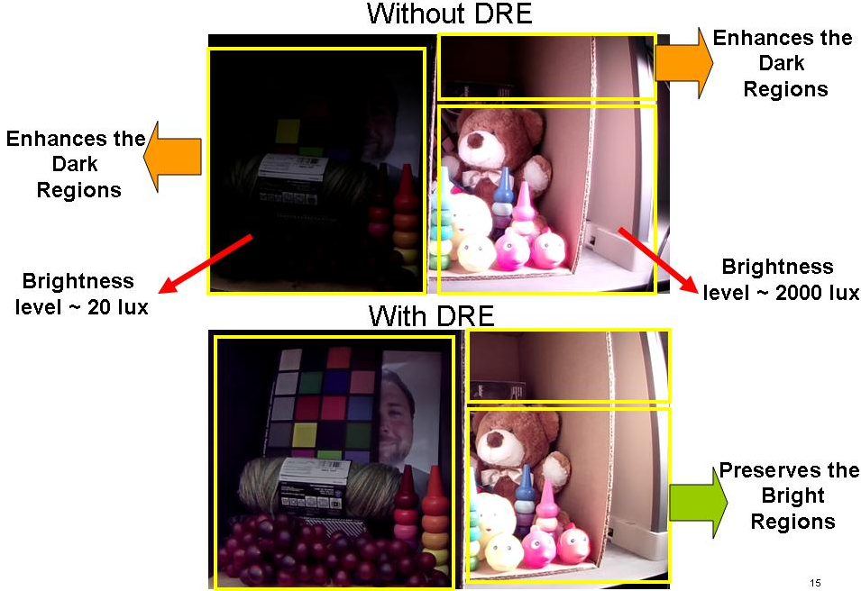

Examples of processed images through the SAL-DRE algorithm are shown below.

Unprocessed Processed
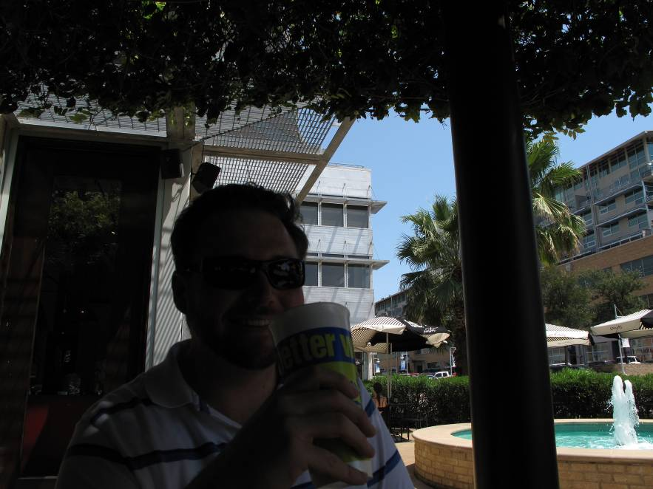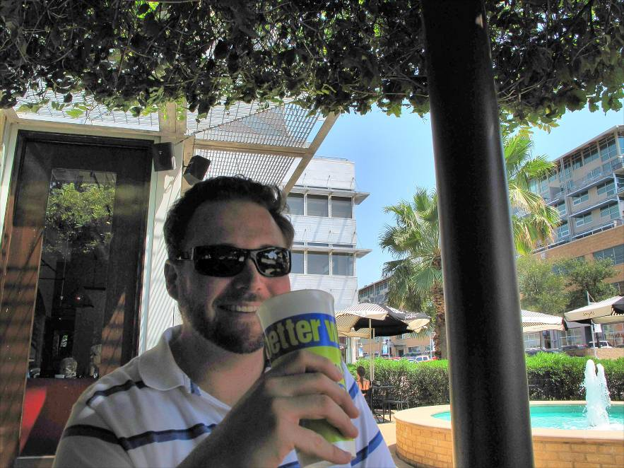



  - Data flow
The SALDRE algorithm must operate on raw data (BAYER) obtained by the ISIF. The capture data flow used must be ISIF->DDR->IPIPE depicted in the following figure:
Sensor
ISIF
H3A
DDR
IPIPE

DDR
DDR
BSC
RSZ2
VSTAB

2A
DDR
NF
(IMCOP)
DDR
SW OSD
1080p
AEWB control to
Sensor, IPIPE, ISIF
RSZ1
DDR
DDR
LDC
D1
Face Info
DDR
The SALDRE algorithm simply operates between the ISIF and IPIPE altering the data flow to: ISIF->DDR->SALDRE->DDR->IPIPE:

Sensor
ISIF
H3A
DDR
IPIPE

DDR
DDR
BSC
RSZ2
VSTAB

2A
DDR
NF
(IMCOP)
DDR
SW OSD

AEWB control to
Sensor, IPIPE, ISIF
RSZ1
DDR
DDR
LDC
Face Info
DDR
SALDRE
DDR
The IPNC can enable an alternate data flow ISIF->IPIPE which is to pass the output of the ISIF directly to the IPIPE. This data flow is the default one and consumes less DDR bandwidth. However it cannot be used in conjunction with SALDRE since there is no access to the raw data (the IPIPE outputs directly YUV data).
The latest release IPNC automatically switches to the ISIF->DDR->IPIPE data flow whenever the user enables SALDRE/GLBCE through the GUI. If SALDRE was previously disabled, the system restarts the AVServer in order to switch from the default ISIF->IPIPE data flow.

  - Execution flow
The SALDRE algorithm is implemented by the library iss/packages/psp/iss/alg/glbce/lib/release/iss_glbce.aem3.
The SALDRE algorithm works in the Embedded Vision Framework (EVF) version 1.1 or higher making the CPIS_xyz() calls.
Currently EVF1.3 version has been included and packaged along with ISS.

The library contains the following APIs:
1. CPIS_boxcar()
2. CPIS_glbce()
3. CPIS_setBestRoiAndProcBlockDim()
4. GLBCE_algConfig()
5. GLBCE_init()
6. GLBCE_run()
As it can be noted, first three functions needs the CPIS_init() to be called, before these function are called. CPIS_init() just needs to be called once during system initialization and currently done inside Iss_int(). On similar line CPIS_deInit() is called inside the Iss_deInit(). Out of these functions, last four function execute only on the M3, the other two use the SIMCOP hardware accelerators.
Among these functions it is the CPIS_glbce()which does the applying of GLBCE to capture frame and would be called every frame. Rest of the functions are called once in N Frames to generate the tonal curves taking the statistics of BoxCar data.
The overall integration of GLBCE into IPNC can studying the files \ipnc_rdk\ipnc_mcfw\mcfw\src_bios6\links_m3vpss\glbce\glbceLink_drv.c
and
\ipnc_rdk\ipnc_mcfw\mcfw\src_bios6\links_m3vpss\glbce\glbceLink_glbce.c .

  - APIs
Following are descriptions of the SALDRE APIs.

