1. You are developing an application that includes a class named Order. The application will store a collection of Order objects.
The collection must meet the following requirements:
• Use strongly typed members.
• Process Order objects in first-in-first-out order.
• Store values for each Order object.
• Use zero-based indices.
You need to use a collection type that meets the requirements.
Which collection type should you use?
- Queue<T>correct
- SortedList
- LinkedList<T>
- HashTable
- Array<T>

2. You are developing an application. The application calls a method that returns an array of integers named employeeIds. You define an integer variable named employeeIdToRemove and assign a value to it. You declare an array named filteredEmployeeIds.
You have the following requirements:
• Remove duplicate integers from the employeeIds array.
• Sort the array in order from the highest value to the lowest value.
• Remove the integer value stored in the employeeIdToRemove variable from the employeeIds array.
You need to create a LINQ query to meet the requirements.
Which code segment should you use?
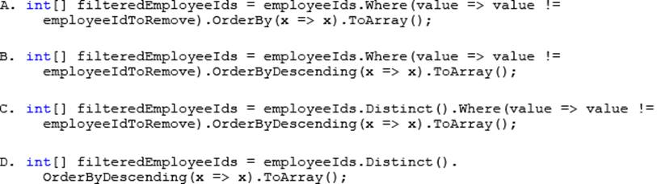
- Option A
- Option B
- Option C
- Option D

3. You are developing an application that uses the Microsoft ADO.NET Entity Framework to retrieve order information from a Microsoft SQL Server database.
The application includes the following code. (Line numbers are included for reference only.)
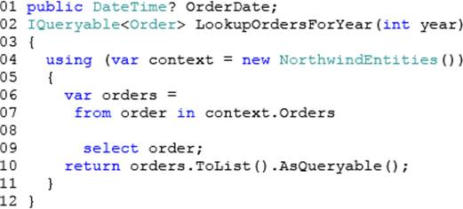
The application must meet the following requirements:
• Return only orders that have an OrderDate value other than null.
• Return only orders that were placed in the year specified in the OrderDate property or in a later year.
You need to ensure that the application meets the requirements.
Which code segment should you insert at line 08?
- Where order.OrderDate.Value != null && order.OrderDate.Value.Year > = year
- Where order.OrderDate.Value = = null && order.OrderDate.Value.Year = = year
- Where order.OrderDate.HasValue && order.OrderDate.Value.Year = = year
- Where order.OrderDate.Value.Year = = year

4. You are developing an application by using C#. The application includes an array of decimal values named loanAmounts.
You are developing a LINQ query to return the values from the array.
The query must return decimal values that are evenly divisible by two. The values must be sorted from the lowest value to the highest value.
You need to ensure that the query correctly returnsthe decimal values.
How should you complete the relevant code? 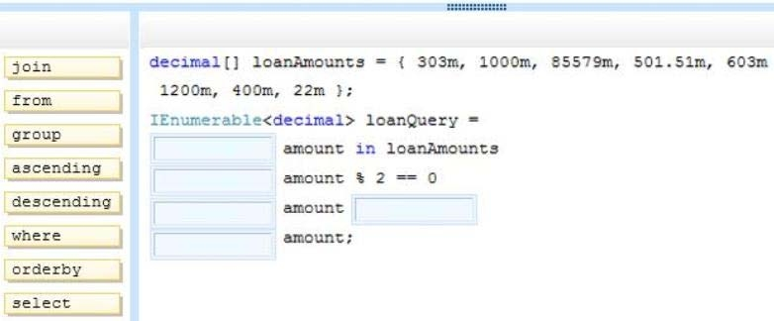

Write the complete query by using the options on the left-hand side.

5. An application receives JSON data in the following format:
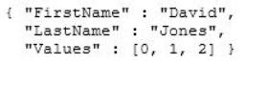
The application includes the following code segment. (Line numbers are included for reference only.)
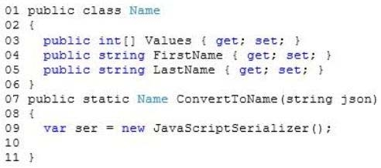
You need to ensure that the ConvertToName() method returns the JSON input string as a Name object.
Which code segment should you insert at line 10?
A. Return ser.ConvertToType<Name>(json);
B. Return ser.DeserializeObject(json);
C. Return ser.Deserialize<Name> (json) ;
D. Return (Name)ser.Serialize(json);

6. You are developing an application by using C#. The application includes the following code segment.
(Line numbers are included for reference only.)
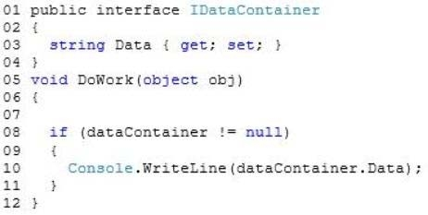
The DoWork() method must not throw any exceptions when converting the obj object to the IDataContainer interface or when accessing the Data property.
You need to meet the requirements.
Which code segment should you insert at line 07?

A. var dataContainer = (IDataContainer)obj;
B. dynamic dataContainer = obj;
C. var dataContainer = obj is IDataContainer;
D. var dataContainer = obj as IDataContainer;

7. You are creating an application that manages information about zoo animals. The application includes a class named Animal and a method named Save.
The Save () method must be strongly typed. It must allow only types inherited from the Animal class that uses a constructor that accepts no parameters.
You need to implement the Save () method.
Which code segment should you use?
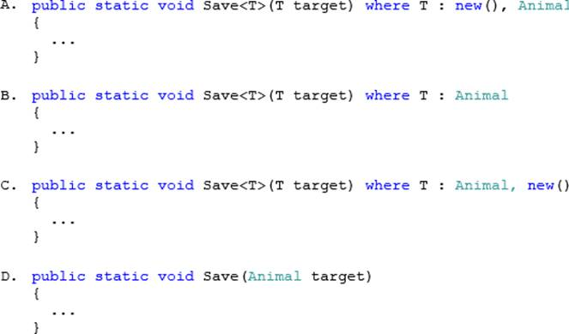
- Option A
- Option B
- Option C
- Option D

8. You are developing an application by using C#.
The application includes an object that performs a long running process.
You need to ensure that the garbage collector does not release the object's resources until the process completes.
Which garbage collector method should you use?
- ReRegisterForFinalize()
- SuppressFinalize()
- Collect()
- WaitForFullGCApproach()

9. You are implementing a method named Calculate that performs conversions between value types and reference types.
The following code segment implements the method. (Line numbers are included for reference only.)
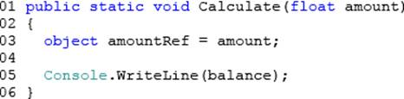
You need to ensure that the application does not throw exceptions on invalid conversions.
Which code segment should you insert at line 04?
- int balance = (int) (float)amountRef;
- int balance = (int)amountRef;
- int balance = amountRef;
- int balance = (int) (double) amountRef;

10. You use the Task.Run() method to launch a long-running data processing operation. The data processing operation often fails in times of heavy network congestion.
If the data processing operation fails, a second operation must clean up any results of the first operation.
You need to ensure that the second operation is invoked only if the data processing operation throws an unhandled exception.
What should you do?
- Create a TaskCompletionSource<T> object and call the TrySetException() method of the object.
- Create a task by calling the Task.ContinueWith() method.
- Examine the Task.Status property immediately after the call to the Task.Run() method.
- Create a task inside the existing Task.Run() method by using the AttachedToParent option.

11. You are modifying an application that processes leases.
The following code defines the Lease class. (Line numbers are included for reference only.)
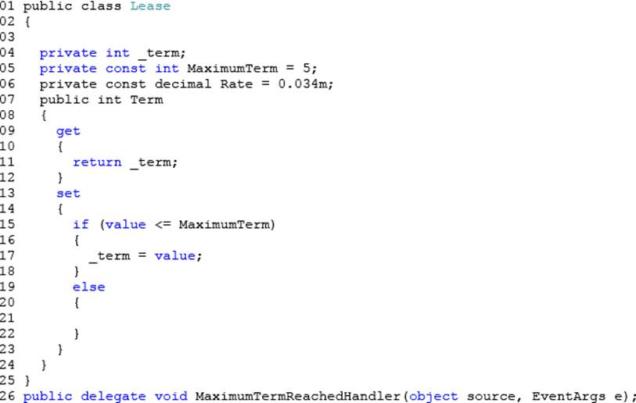
Leases are restricted to a maximum term of 5 years. The application must send a notification message if a lease request exceeds 5 years.
You need to implement the notification mechanism.
Which two actions should you perform? (Each correct answer presents part of the solution. Choose two.)
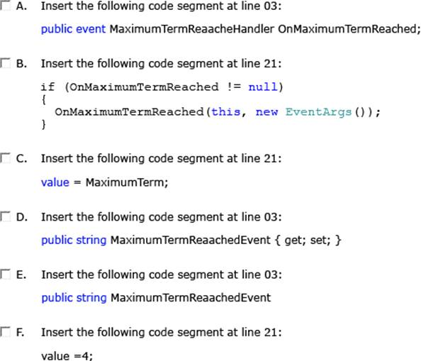

- Option A
- Option B
- Option C
- Option D
- Option E
- Option F

12. You are developing an application that uses structured exception handling. The application includes a class named ExceptionLogger.
The ExceptionLogger class implements a method named LogException by using the following code segment:
public static void LogException(Exception ex)
You have the following requirements:
• Log all exceptions by using the LogException() method of the ExceptionLogger class.
• Rethrow the original exception, including the entire exception stack.
You need to meet the requirements.
Which code segment should you use?
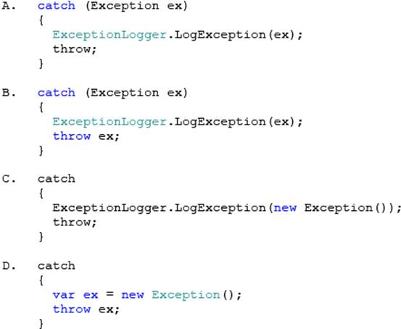
- Option A
- Option B
- Option C
- Option D

13. 5. You are developing an application that includes a class named UserTracker.
The application includes the following code segment. (Line numbers are included for reference only.)
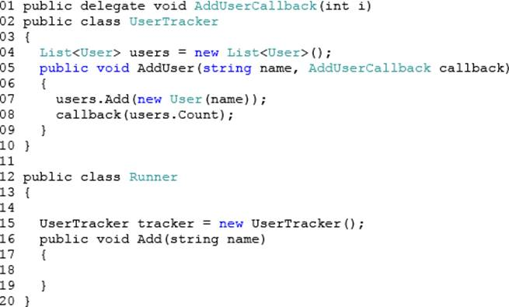
You need to add a user to the UserTracker instance.
What should you do?
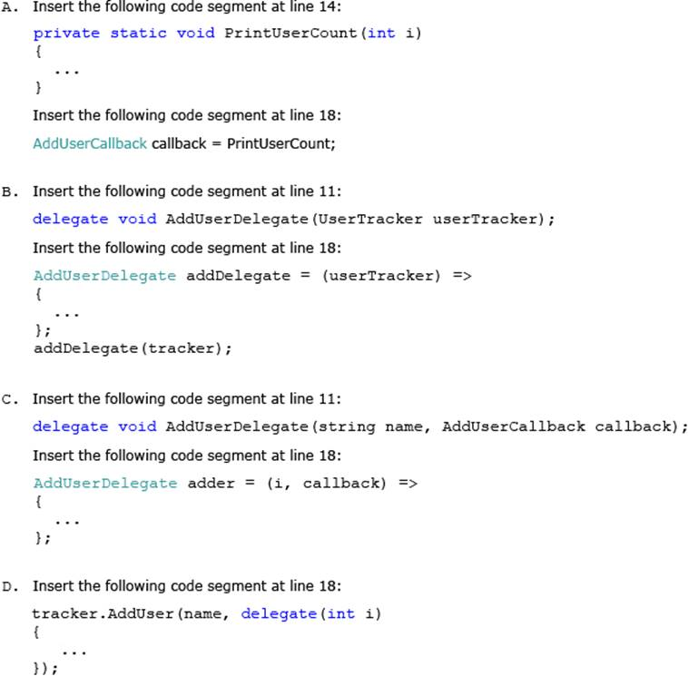
- Option A
- Option B
- Option C
- Option D

14. You are developing an application that includes a class named Kiosk. The Kiosk class includes a static
property named Catalog. The Kiosk class is defined by the following code segment. (Line numbers are
included for reference only.)
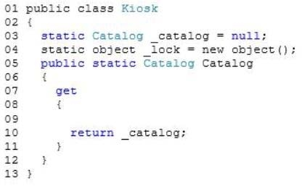
You have the following requirements:
-Initialize the _catalog field to a Catalog instance.
-Initialize the _catalog field only once.
-Ensure that the application code acquires a lock only when the _catalog object must be instantiated.
You need to meet the requirements.
Which three code segments should you insert in sequence at line 09? 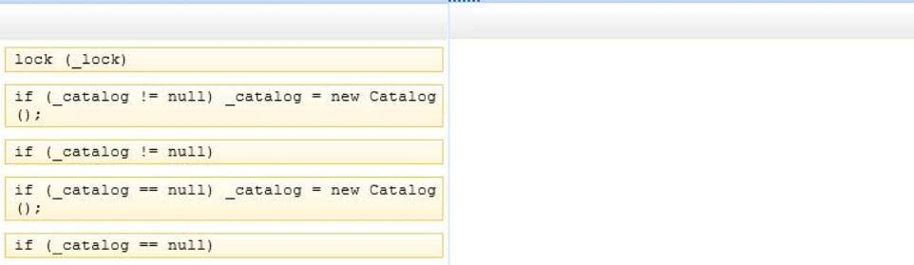

Write down the 3 lines of code in correct order from the above options.

15. You are developing a C# application that has a requirement to validate some string input data by using the Regex class.
The application includes a method named ContainsHyperlink. The ContainsHyperlink() method will verify the presence of a URI and surrounding markup.
The following code segment defines the ContainsHyperlink() method. (Line numbers are included for reference only.)
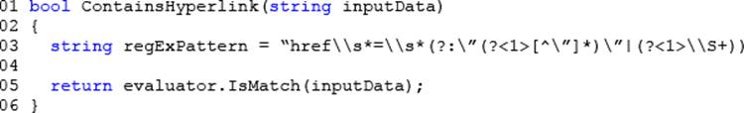
The expression patterns used for each validation function are constant.
You need to ensure that the expression syntax is evaluated only once when the Regex object is initially instantiated.
Which code segment should you insert at line 04?
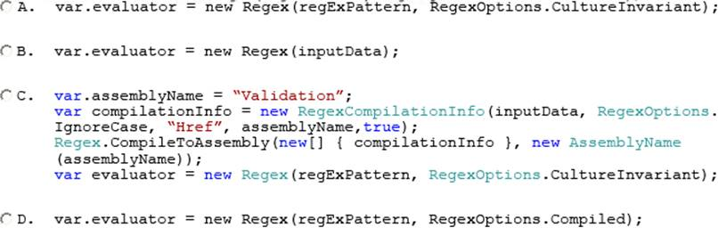
- Option A
- Option B
- Option C
- Option D

16. You are developing an application that will transmit large amounts of data between a client computer and a server.
You need to ensure the validity of the data by using a cryptographic hashing algorithm.
Which algorithm should you use?
- HMACSHA256correct
- RNGCryptoServiceProvider
- DES
- Aes

17. You are developing an application that accepts the input of dates from the user.
Users enter the date in their local format. The date entered by the user is stored in a string variable named inputDate. The valid date value must be placed in a DateTime variable named validatedDate.
You need to validate the entered date and convert it to Coordinated Universal Time (UTC). The code must not cause an exception to be thrown.
Which code segment should you use?
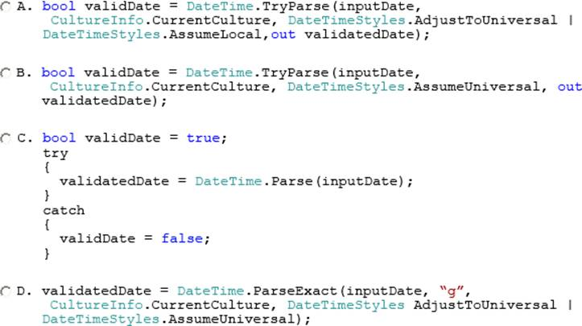
- Option A
- Option B
- Option C
- Option D

18. You are developing an application by using C#.
The application includes an object that performs a long running process.
You need to ensure that the garbage collector does not release the object's resources until the process completes.
Which garbage collector method should you use?
- WaitForFullGCComplete()
- WaitForFullGCApproach()
- KeepAlive()
- WaitForPendingFinalizers()

