Dataset Balance:
label
1 27983
0 27982

Visualizing predictions...


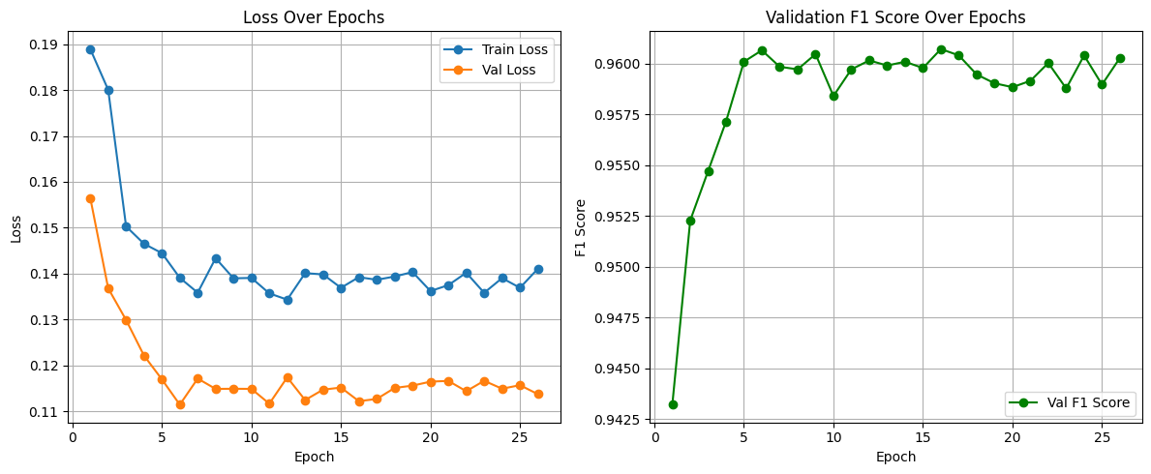
Evaluating on Train Set...
--- Train Performance ---
Accuracy: 0.9602
F1 Score: 0.9602

Classification Report:
precision recall f1-score support

0 0.96 0.96 0.96 27982
1 0.96 0.96 0.96 27983

accuracy 0.96 55965
macro avg 0.96 0.96 0.96 55965
weighted avg 0.96 0.96 0.96 55965

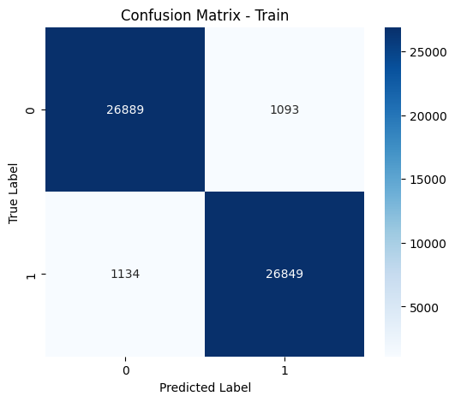
Evaluating on Validation Set...
--- Validation Performance ---
Accuracy: 0.9617
F1 Score: 0.9617

Classification Report:
precision recall f1-score support

0 0.96 0.96 0.96 7995
1 0.96 0.96 0.96 7995

accuracy 0.96 15990
macro avg 0.96 0.96 0.96 15990
weighted avg 0.96 0.96 0.96 15990

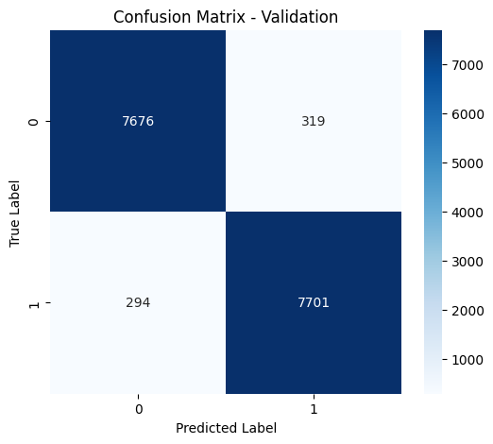
====================================================================================================

Evaluating on Test Set...
--- Test Performance ---
Accuracy: 0.9619
F1 Score: 0.9618

Classification Report:
precision recall f1-score support

0 0.97 0.96 0.96 3998
1 0.96 0.97 0.96 3997

accuracy 0.96 7995
macro avg 0.96 0.96 0.96 7995
weighted avg 0.96 0.96 0.96 7995

