Capstone Project: Proquest Data

## Setup:

# load necessary packages/libraries  
library(openxlsx)  
library(dplyr)  
library(stringr)  
library(ggplot2)  
library(knitr)  
library(tidyr)  
library(lemon)  
knit_print.data.frame <- lemon_print

# set working directory  
wd = getwd()  
setwd(wd)

# Clean and Combine Datasets

## Campus reports (BR2) 2014-2018

## Title  
## 2 A History of Japanese Buddhism (1)  
## 3 Adjectives : Formal analyses in syntax and semantics  
## 4 Advanced Nanomedicine and Nanobiotechnology  
## 5 Advances in Nanotechnology : Advances in Nanotechnology. Volume 3  
## 6 Against the Romance of Community  
## 7 Alternative Pre-MRNA Splicing : Theory and Protocols (1)  
## Publisher Platform Campus Year Book.DOI  
## 2 BRILL EBRARY UWEC 2014 10497350  
## 3 John Benjamins Publishing Company EBRARY UWEC 2014 10387194  
## 4 Nova Science Publishers, Inc. EBRARY UWEC 2014 10676679  
## 5 Nova Science Publishers, Inc. EBRARY UWEC 2014 10654802  
## 6 University of Minnesota Press EBRARY UWEC 2014 10151281  
## 7 John Wiley & Sons, Incorporated EBRARY UWEC 2014 10526571  
## Proprietary.Identifier ISBN ISSN Reporting.Period.Total Jan Feb  
## 2 NA 9781905246410 <NA> 2 0 0  
## 3 NA 9789027255365 <NA> 30 0 0  
## 4 NA 9781604564358 <NA> 1 0 0  
## 5 NA 9781616681616 21591490 1 0 0  
## 6 NA 9780816637959 <NA> 40 0 0  
## 7 NA 9783527326068 <NA> 48 0 0  
## Mar Apr May Jun Jul Aug Sep Oct Nov Dec  
## 2 0 0 0 0 0 0 0 0 0 2  
## 3 0 0 0 0 0 0 0 0 0 30  
## 4 0 0 0 0 0 0 1 0 0 0  
## 5 0 0 0 0 0 0 1 0 0 0  
## 6 0 0 0 0 0 0 0 0 40 0  
## 7 0 0 0 0 0 0 0 0 0 48

## Title Publisher Platform Campus   
## Length:158465 Length:158465 Length:158465 Length:158465   
## Class :character Class :character Class :character Class :character   
## Mode :character Mode :character Mode :character Mode :character   
##   
##   
##   
##   
## Year Book.DOI Proprietary.Identifier ISBN   
## Min. :2014 Min. : 2000648 Min. : 102745 Length:158465   
## 1st Qu.:2015 1st Qu.:10206628 1st Qu.: 1343436 Class :character   
## Median :2016 Median :10435247 Median :10048790 Mode :character   
## Mean :2016 Mean :10336941 Mean : 6287056   
## 3rd Qu.:2017 3rd Qu.:10627176 3rd Qu.:10468410   
## Max. :2018 Max. :11219602 Max. :80149351   
## NA's :1 NA's :124514 NA's :33951   
## ISSN Reporting.Period.Total Jan Feb   
## Length:158465 Min. : 1.00 Min. : 0.00 Min. : 0.00   
## Class :character 1st Qu.: 5.00 1st Qu.: 0.00 1st Qu.: 0.00   
## Mode :character Median : 13.00 Median : 0.00 Median : 0.00   
## Mean : 51.11 Mean : 10.42 Mean : 14.48   
## 3rd Qu.: 38.00 3rd Qu.: 0.00 3rd Qu.: 4.00   
## Max. :72266.00 Max. :3592.00 Max. :9303.00   
## NA's :116372 NA's :111184   
## Mar Apr May Jun   
## Min. : 0.00 Min. : 0.00 Min. : 0.00 Min. : 0.00   
## 1st Qu.: 0.00 1st Qu.: 0.00 1st Qu.: 0.00 1st Qu.: 0.00   
## Median : 0.00 Median : 0.00 Median : 0.00 Median : 0.00   
## Mean : 14.26 Mean : 16.59 Mean : 12.47 Mean : 8.94   
## 3rd Qu.: 6.00 3rd Qu.: 9.00 3rd Qu.: 4.00 3rd Qu.: 0.00   
## Max. :6642.00 Max. :14038.00 Max. :4668.00 Max. :4026.00   
## NA's :108824 NA's :105412 NA's :111245 NA's :118481   
## Jul Aug Sep Oct   
## Min. : 0.00 Min. : 0.0 Min. : 0.0 Min. : 0.00   
## 1st Qu.: 0.00 1st Qu.: 0.0 1st Qu.: 0.0 1st Qu.: 0.00   
## Median : 0.00 Median : 0.0 Median : 0.0 Median : 0.00   
## Mean : 9.78 Mean : 8.5 Mean : 18.7 Mean : 18.48   
## 3rd Qu.: 0.00 3rd Qu.: 0.0 3rd Qu.: 5.0 3rd Qu.: 10.00   
## Max. :3664.00 Max. :2774.0 Max. :29686.0 Max. :16916.00   
## NA's :118097 NA's :118618 NA's :112796 NA's :106123   
## Nov Dec   
## Min. : 0.00 Min. : 0.00   
## 1st Qu.: 0.00 1st Qu.: 0.00   
## Median : 0.00 Median : 0.00   
## Mean : 19.63 Mean : 16.25   
## 3rd Qu.: 12.00 3rd Qu.: 10.00   
## Max. :15450.00 Max. :13501.00   
## NA's :103977 NA's :108103

The proquest campus reports will be merged with other data using Book.DOI or Proprietary.Identifier later on. Let’s take a look at the number of NA’s for each column/variable as well as the observations that have NA values for both Book.DOI and Proprietary.Identifier.

sapply(proquest_df, function(x) sum(is.na(x)))

## Title Publisher Platform   
## 3 1 0   
## Campus Year Book.DOI   
## 1 1 124514   
## Proprietary.Identifier ISBN ISSN   
## 33951 2393 151686   
## Reporting.Period.Total Jan Feb   
## 0 116372 111184   
## Mar Apr May   
## 108824 105412 111245   
## Jun Jul Aug   
## 118481 118097 118618   
## Sep Oct Nov   
## 112796 106123 103977   
## Dec   
## 108103

dim(proquest_df[is.na(proquest_df$Book.DOI) & is.na(proquest_df$Proprietary.Identifier),])

## [1] 0 22

While Book.DOI is missing 124068 observations and Proprietary.Identifier is missing 33951 observations, no observations are missing values for both Book.DOI and Proprietary.Identifier. Proquest uses both these features interchangeably as “document ids” in other data sets, so either Book.DOI or Proprietary.Identifier should match the document id field(s) in other datasets.

Before moving on, unneeded variables or columns will be removed from the dataset.

proquest_df <- subset(proquest_df, select=-c(ISBN,ISSN))

## ProQuest Academic Complete (PQ AC) Dataset

This dataset contains the full list of subscribed titles through Proquest as of Dec 2020. The PQ AC data also provides the subject area that each title falls under.

# Load data  
full_subscribed_df <- read.xlsx("PQ_AC_FullList.xlsx")

The other columns/features that the dataset includes will not be helpful for the purposes of this analysis. A subset of full_subscribed_df with only relevant columns has been saved as susbscribed_df

subscribed_df <- subset(full_subscribed_df, select = c(DocumentID,SUBJECT))

Let’s take a look at what values are missing for our two columns/variables of interest

# Check number of NA/missing values in each column  
sapply(subscribed_df, function(x) sum(is.na(x)))

## DocumentID SUBJECT   
## 0 136

The PC AQ data and the campus reports will be merged on DocumentID from the PC AQ data set. There should be no issues merging data using DocumentID as it has no missing values. Subject has 136 missing values, but this is not a siginificant portion of the data (136/189298 or ~.09%) A column will be added with the all values as “subscribed”. This will differentiate subscribed titles from owned titles once the data is merged with the combined campus reports dataset (combined BR2 reports dataset).

subscribed_df$Ownership <- "subscribed"

## 

## Combine Campus Reports and PQ AC Data

### Combine Data Using Document.ID

Strip Book.DOI and Proprietar.Identifier from proquest_df and DocumentID from subscribed_df of all spaces and non-alphanumeric character for consitency.

proquest_df$Book.DOI <- as.character(proquest_df$Book.DOI)  
proquest_df$Book.DOI <- str_replace_all(proquest_df$Book.DOI, fixed(" "), "")  
proquest_df$Book.DOI <- str_replace_all(proquest_df$Book.DOI, "[^[:alnum:]]", "")  
  
proquest_df$Proprietary.Identifier <- as.character(proquest_df$Proprietary.Identifier)  
proquest_df$Proprietary.Identifier <- str_replace_all(proquest_df$Proprietary.Identifier, fixed(" "), "")  
proquest_df$Proprietary.Identifier <- str_replace_all(proquest_df$Proprietary.Identifier, "[^[:alnum:]]", "")  
  
subscribed_df$DocumentID <- str_replace_all(subscribed_df$DocumentID, fixed(" "), "")  
subscribed_df$DocumentID <- str_replace_all(subscribed_df$DocumentID, "[^[:alnum:]]", "")

In order to gain information about which titles are subscribed and which are acquired through subscription as well as information on what subject area subscribed titles fall under, the PQ AC or subscribed titles data set will be merged with the combined campus reports dataset (proquest_df) using DocumentID to match both Book.DOI and Proprietary.Identifier.

m1 <- merge(proquest_df,subscribed_df, by.x = c("Book.DOI"), by.y = "DocumentID", all.x = TRUE )  
m2 <- merge(m1, subscribed_df, by.x = c("Proprietary.Identifier"), by.y = "DocumentID", all.x = TRUE)

## Number of NA values is Ownership column after 1st merge: 158457

## Number of NA values is Ownership column after 2nd merge: 109650

### Combine Data Using Title

subscribed_df2 <- subset(full_subscribed_df, select = c(Title,SUBJECT))

Make titles in both proquest_df and subscribed_df all lowercase. Strip titles of any non-alphanumeric characters and spaces

proquest_df$Title <- tolower(proquest_df$Title)  
proquest_df$Title <- str_replace_all(proquest_df$Title, fixed(" "), "")  
proquest_df$Title <- str_replace_all(proquest_df$Title, "[^[:alnum:]]", "")  
  
subscribed_df2$Title <- tolower(subscribed_df2$Title)  
subscribed_df2$Title <- str_replace_all(subscribed_df2$Title, fixed(" "), "")  
subscribed_df2$Title <- str_replace_all(subscribed_df2$Title, "[^[:alnum:]]", "" )

Combine datasets using titles

subscribed_df2$Ownership <- "subscribed"  
m3 <- merge(proquest_df, subscribed_df2, by.x = "Title", by.y = "Title", all.x = TRUE)

length(which(is.na(m3$Ownership)))

## [1] 128069

### Merged Data Using the Optimal Method

There are less matches between the combined campus report data (proquest_df) and the PC AQ data using title to merge the data than when Book.Doi and Proprietary.Identification are used to match document.id. Therefore, matching on Book.Doi/Proprietary.Identification is preferred to matching on titles.

# Merge ownership and subject column duplicates from 2 merges  
m2$Ownership.y[!is.na(m2$Ownership.x)] <- "subscribed"  
m2$SUBJECT.y[!is.na(m2$SUBJECT.x)] <- m2$SUBJECT.x[!is.na(m2$SUBJECT.x)]  
  
# Remove duplicate columns and rename merged column  
pq_subscribed <- subset(m2,select = -c(SUBJECT.x,Ownership.x))  
names(pq_subscribed)[21] <- "Subject"  
names(pq_subscribed)[22] <- "Ownership"

Let’s take a look at the number of unique titles that were able to be identified as subscribed so far.

unique_titles <- distinct(pq_subscribed, pq_subscribed$Title, .keep_all=TRUE)  
summary(as.factor(unique_titles$Ownership))

## subscribed NA's   
## 28394 69794

## All Title Access UW System Data

This dataset contains all titles as of December 2020 that the UW library system has access to either through ownership, subscription, or other methods.

all_titles <- read.xlsx("Proquest_AllTitleAccess_UWSYS.xlsx", sheet = 1,startRow = 2,skipEmptyRows=TRUE, colNames = TRUE)

A subset of columns relevant to this analysis has been created and stored as all_titles.

all_titles <- subset(all_titles, select = c(Document.ID, ebrary.ID, Collection, Owned, Subscribed,Subject))

The variable Collection has “Subscription: Academic Complete” for titles that are subscribed. This should correspond to the titles in the PQ AC data examined previously. Some of the subscribed titles that were not able to be matched using the PQ AC data may be matched using the all titles data. In the all titles data, there are also columns labeled Owned and Subscribed. It looks like titles in the Collection “Subscription: Academic Complete” are also marked as subscribed (Yes) in the Subscribed column. Let’s double check.

levels(as.factor(all_titles$Collection))

## [1] "Subscription: Academic Complete"   
## [2] "Subscription: Academic Complete,Subscription: University Press Ebook Subscription"  
## [3] "Subscription: University Press Ebook Subscription"

collection <- all_titles[!is.na(all_titles$Collection),]  
levels(as.factor(collection$Subscribed))

## [1] "Yes"

Indeed, it looks like all titles with “Subscription: Academic Complete” also have the value “Yes” under the Subscribed column. The Collection column will be removed as the Collection and Subscribed column convey the same information.

#remove Collection column  
all_titles <- all_titles[,-3]

## number of NA's for Document.ID: 0

## number of NA's for ebaray.ID: 120349

Let’s take a look at the number of titles marked as Subscribed vs Owned in the all_titles data. Note, there are some rows that are marked “No” for both columns.

summary(as.factor(all_titles$Subscribed))

## No Yes   
## 851039 197535

summary(as.factor(all_titles$Owned))

## No Yes   
## 1048306 268

As expected, there is a very small number of owned titles. A smaller subset of all_titles is saved with only rows that have a value of “Yes” for either Subscribed or Ownership as there is no interest in titles that are neither owned or subscribed.

all_titles <- all_titles[all_titles$Owned =='Yes'|all_titles$Subscribed == 'Yes',]

Before merging the all_titles data with our previously merged campus reports and PQ AC data (pq_subscribed), Document.ID and ebrary-ID will be stripped of any spaces or non alphanumeric characters to remove any accidental/extra symbols or spaces that might be present.

all_titles$Document.ID <- as.character(all_titles$Document.ID)  
all_titles$Document.ID <- str_replace_all(all_titles$Document.ID, fixed(" "), "")  
all_titles$Document.ID <- str_replace_all(all_titles$Document.ID, "[^[:alnum:]]", "")  
  
all_titles$ebrary.ID <- as.character(all_titles$ebrary.ID)  
all_titles$ebrary.ID <- str_replace_all(all_titles$ebrary.ID, fixed(" "), "")  
all_titles$ebrary.ID <- str_replace_all(all_titles$ebrary.ID, "[^[:alnum:]]", "")

## 

## Combine Data

The columns Proprietary.Identifier and Book.DOI from the previously merged combined campus BR2 reports and PQ AC data (pq_subscribed) should match with either Document.ID or ebrary.ID in the all titles access dataset. All combinations of the foud columns will be used to merge on for the most compelte set of data possible. ### Merge on Document.ID and Proprietary.Identifier A subset of the all titles data with only non-NA values of Document.ID is created and stored as docID to be used for merging.

docID <- all_titles[!is.na(all_titles$Document.ID),]

pq_subscribed data is merged with doc_ID using Prorietary.Identifier and Document.ID so that all rows/observations of pq_subscribed are retained even if there is not a match between pq_subscribed Proprietary.Identifier and doc_Id Document.ID.

m4 <- merge(pq_subscribed, docID, by.x = "Proprietary.Identifier", by.y = "Document.ID", all.x = TRUE)  
head(m4)  
summary(m4)

Let’s take a look at the number of owned and subscribed titles that were able to be matched.

m4$Owned <- as.factor(m4$Owned)  
summary(m4$Owned)

## No Yes NA's   
## 48942 179 109344

m4$Subscribed <- as.factor(m4$Subscribed)  
summary(m4$Subscribed)

## No Yes NA's   
## 84 49037 109344

Titles that have “Yes” for Subscribed and Owned columns are assigned the “subscribed” and “owned” repsectively in the Ownership column. Duplicate subject area columns created during the merge are combined. Columns no longer needed are removed.

m4$Ownership[m4$Subscribed=="Yes" & !is.na(m4$Subscribed)] <- "subscribed"  
m4$Ownership[m4$Owned =="Yes" & !is.na(m4$Owned)] <- "owned"  
  
m4$Subject.x[!is.na(m4$Subject.y) & is.na(m4$Subject.x)] <- m4$Subject.y[!is.na(m4$Subject.y) & is.na(m4$Subject.x)]   
  
m4 <- subset(m4, select=-c(ebrary.ID, Subject.y, Owned, Subscribed))  
names(m4)[21] <- "Subject"  
  
head(m4)

Let’s take a look at the number of observations that still have not been assigned an ownership type.

## Number of NA values in Ownership column 109320

### 

### Merge on Document.ID and Book.DOI

Merge using Book.DOi and Document.ID

m5 <- merge(m4, docID, by.x = "Book.DOI", by.y = "Document.ID", all.x = TRUE)  
head(m5)

Let’s take a look at the number of new owned and subscribed titles that were identified from the merge.

m5$Owned <- as.factor(m5$Owned)  
summary(m5$Owned)

## No NA's   
## 9 158456

m5$Subscribed <- as.factor(m5$Subscribed)  
summary(m5$Subscribed)

## Yes NA's   
## 9 158456

Titles that have “Yes” for Subscribed and Owned columns are assigned the “subscribed” and “owned” repsectively in the Ownership column. Duplicate subject area columns created during the merge are combined. Columns no longer needed are removed.

m5$Ownership[m5$Subscribed=="Yes" & !is.na(m5$Subscribed)] <- "subscribed"  
m5$Ownership[m5$Owned =="Yes" & !is.na(m5$Owned)] <- "owned"  
  
m5$Subject.x[!is.na(m5$Subject.y) & is.na(m5$Subject.x)] <- m5$Subject.y[!is.na(m5$Subject.y) & is.na(m5$Subject.x)]   
  
m5 <- subset(m5, select=-c(ebrary.ID, Subject.y, Subscribed, Owned))  
names(m5)[21] <- "Subject"  
head(m5)

## Number of NA values in Ownership column 109319

### 

### Merge on ebrary.ID and Proprietary.Identifier.

A smaller subset of data with only non-NA values for ebrary.ID is created for merging using ebrary.ID.

ebrary <- all_titles[!is.na(all_titles$ebrary.ID),]

Merge using Proprietary.Identifier and ebrary.ID

m6 <- merge(m5, ebrary, by.x = "Proprietary.Identifier", by.y = "ebrary.ID", all.x = TRUE)  
head(m6)

Take a look at number of new owned and subscribed titles identified from this merge.

m6$Owned <- as.factor(m6$Owned)  
summary(m6$Owned)

## No Yes NA's   
## 55751 149 102565

m6$Subscribed <- as.factor(m6$Subscribed)  
summary(m6$Subscribed)

## No Yes NA's   
## 80 55820 102565

Titles that have “Yes” for Subscribed and Owned columns are assigned the “subscribed” and “owned” repsectively in the Ownership column. Duplicate subject area columns created during the merge are combined. Columns no longer needed are removed.

m6$Ownership[m6$Subscribed=="Yes" & !is.na(m6$Subscribed)] <- "subscribed"  
m6$Ownership[m6$Owned =="Yes" & !is.na(m6$Owned)] <- "owned"  
  
m6$Subject.x[!is.na(m6$Subject.y) & is.na(m6$Subject.x)] <- m6$Subject.y[!is.na(m6$Subject.y) & is.na(m6$Subject.x)]   
  
m6 <- subset(m6, select=-c(Document.ID, Subject.y, Owned, Subscribed))  
names(m6)[21] <- "Subject"  
head(m6)

Take a look at the number of rows that still have not been assigned an ownership type.

## Number of NA values in Ownership column 53436

### 

### Merge on ebrary.ID and Book.DOI

Merge using ebrary.ID and Book.DOI

m7 <- merge(m6, ebrary, by.x = "Book.DOI", by.y = "ebrary.ID", all.x = TRUE)  
head(m7)

Take a look at the number of new owned and subscribed titles identified from this merge

m7$Owned <- as.factor(m7$Owned)  
summary(m7$Owned)

## No Yes NA's   
## 29047 39 129379

m7$Subscribed <- as.factor(m7$Subscribed)  
summary(m7$Subscribed)

## No Yes NA's   
## 20 29066 129379

Titles that have “Yes” for Subscribed and Owned columns are assigned the “subscribed” and “owned” repsectively in the Ownership column. Duplicate subject area columns created during the merge are combined. Columns no longer needed are removed.

m7$Ownership[m7$Subscribed=="Yes" & !is.na(m7$Subscribed)] <- "subscribed"  
m7$Ownership[m7$Owned =="Yes" & !is.na(m7$Owned)] <- "owned"  
  
m7$Subject.x[!is.na(m7$Subject.y) & is.na(m7$Subject.x)] <- m7$Subject.y[!is.na(m7$Subject.y) & is.na(m7$Subject.x)]   
  
m7 <- subset(m7, select=-c(Document.ID, Subject.y, Subscribed, Owned))  
names(m7)[21] <- "Subject"  
head(m7)

Examine the number of titles that still have not been assigned an ownership type and the number of titles with no subject area.

cat("Number of NA values in Ownership column",length(which(is.na(m7$Ownership))),"\n")

## Number of NA values in Ownership column 24359

cat("Number of NA values in Subject column", length(which(is.na(m7$Subject))))

## Number of NA values in Subject column 24359

There are still 24359/158465 or ~15% of observations that were not matched using both the PQ AC data and UW system all access titles data and therefore do not have an ownership type assigned to them. These rows will be removed as we would only like to examine the usage of titles for which we are certain of the ownership type.

pq_df <- m7[!is.na(m7$Ownership), ]  
  
cols <- c("Campus", "Year", "Subject","Ownership")  
pq_df[cols] <- lapply(pq_df[cols], factor)  
summary(pq_df)

#Check that rows w/ NA values for Ownership have been removed  
sapply(pq_df, function(x) sum(is.na(x)))

## Book.DOI Proprietary.Identifier Title   
## 105020 29086 0   
## Publisher Platform Campus   
## 0 0 1   
## Year Reporting.Period.Total Jan   
## 1 0 98389   
## Feb Mar Apr   
## 93971 91935 88949   
## May Jun Jul   
## 93923 100138 99758   
## Aug Sep Oct   
## 100174 95339 89650   
## Nov Dec Subject   
## 87729 91325 0   
## Ownership   
## 0

It looks like there is one observation missing both Campus and Year. That row will be removed.

pq_df <- pq_df[!is.na(pq_df$Year), ]

## Combine Suject Categories

Next, subject area categories need to be combined before any analysis will be meaningful and interpretable as there are currently 2080 categories.

1.) All categories beginning with Agriculture were combined

2.) All categories beginning with Architecture were combined

3.) All categories beginning with Business/Management or Economics were combined

4.) All categories beginning with Computer Science/IT were combined

5.) All categories beginning with Education were combined

6.) All categories beginning with Engineering were combined

7.) Combine all categories beginning with Environmental Studies

8.) Combine all categories beginning with Fine Arts

9.) Combine all categories beginning with General Works/Reference, Military Science, or Museums as Reference/Other

10.) Combine all categories beginning with Geology/Travel as Travel

11.) combine all categories beginning with Health & Fitness or Health as Health/Fitness

12.) Combine all categories beginning with history

13.) Combine all categories beginning with Home Economics or House & Home as Home

14.) combine all categoreis beginning with Journalism or Publishing as Journalism/Publishing

15.) Combine all categories beginning with Language Arts

16.) Combine all categories beginning with Law or Policital Science as Law/Political Science

17.) Combine all categories beginning with library science

18.) Combine all categories beginning with literary criticism

19.) Combine all categories beginning with mathematics

20.) Combine all categories beginning with Medical, Medicine, or Nursing as Medical

21.) Combine all categories beginning with philosophy

22.) Combine all categories beginning with Psychology

23.) Combine all categoires beginning with Religion and Bibles as Religion

24.) Combine all categories beginning with Science

25.) Combine all categories beginning with Social Science

26.) Combine all categories beginnig with Sport & amp as Sport & Recreation

27.) combine all categories beginning with Tourism/Hospitality

28.) Combine Antiques & Collection, Art, Design, Photography, and and Fine Arts into Arts

29.) Combine Drama, Music, and Performing Arts into Performing Arts

30.) Combine Juvenile Fiction, Fiction, Juvenile Nonfiction, Young Adult Nonfiction, Humor, Biography & Autobiography, and Comics & Graphic Novels into Fiction/Nonfiction

31.) Combine Body, Mind & Spirit, Cooking, Crats & Hobbies, Family & Relationships, Games, Gardening, Self-Help, Pets, and Home into Sports & Recreation

32.) Combine Foreign Language Study, Philosophy, Library Science, True crime into Social Science

33.) Combine Travel, Transportaion, and Tourism/Hospitality into Travel/Tourism

34.) Combine Education and Study aids as Education

35.) combine Nature and Environmental Studies as Environmental Studies

36.) Combine Language Arts, Literary Criticism, Poetry,and Journalism/Publishing into Literary Criticism.

37.) Combine Reference and Non-Classifiable into Reference/Other

Let’s take a look at the categories after all combinations so far and the number of observations per category for our data

levels(pq_df$Subject)

## [1] "Agriculture" "Architecture" "Business/Economics"   
## [4] "ComputerScience/IT" "Tech/Engineering" "Reference/Other"   
## [7] "Health/Fitness" "History" "Law/Political Science"  
## [10] "Mathematics" "Medical" "Psychology"   
## [13] "Religion" "Science" "Sports & Recreation"   
## [16] "Arts" "Performing Arts" "Fiction/Nonfiction"   
## [19] "Social Science" "Travel/Tourism" "Education"   
## [22] "Environmental Studies" "Language Arts"

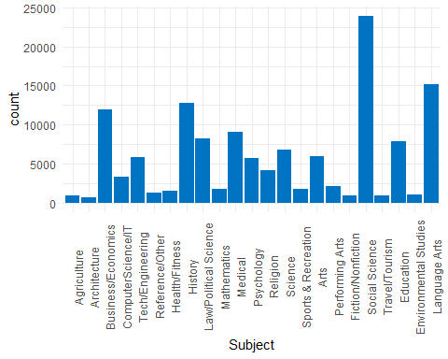

There are still too many categories (23) and there are very few titles that fall into some categories such as travel/tourism and environmental science. Some additional combinations will need to be done.

Additional Combinations:

* Combine Mathematics, Science, and Environmental Science into Math/Science
* Combine ComputerScience/IT and Tech/Engineering as Tech/Engineering
* Combine Architecture, Arts, and Performing Arts into Arts
* Combine Travel/Tourism with Business/Economics as Business/Economics
* Combine Health/Fitness and Medical as Health/Medicine
* Combine Fiction/Nonfiction with Language Arts as Language Arts
* Combine Agriculture withe Reference/Other

Resulting categories and distribution:

levels(pq_df$Subject)

## [1] "Business/Economics" "Tech/Engineering" "Reference/Other"   
## [4] "History" "Law/Political Science" "Psychology"   
## [7] "Religion" "Sports & Recreation" "Social Science"   
## [10] "Education" "Language Arts" "Math/Science"   
## [13] "Arts" "Health/Medicine"

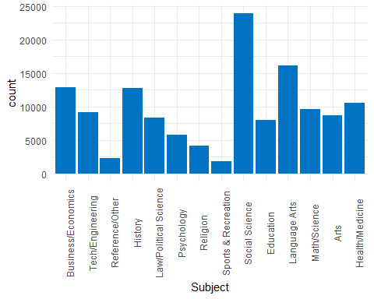

# Analysis

## Owned vs Subscribed Usage

Below are a plot and a table detailing the total number of uses per reporting period (year) for owned titles compared to subscribed titles for each unique campus, year, and title combination. The table includes percentage of use by ownership type.

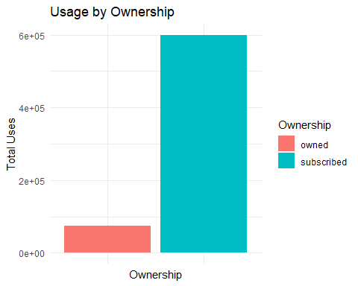

|  |  |  |
| --- | --- | --- |
| Ownership | Total_Uses | Percentage |
| owned | 74660 | 1.17 |
| subscribed | 6296654 | 98.83 |

## 

## Usage by Year

The following plot and table show the usage of all titles by year. The table includes percentage of use each year has recieved out of the 5 years considered.

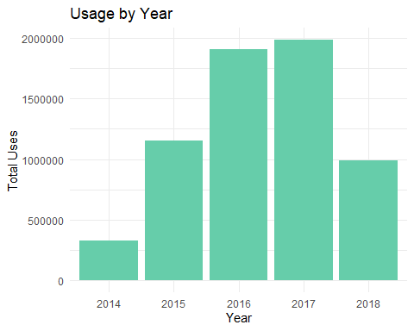

|  |  |  |
| --- | --- | --- |
| Year | Total_Uses | Percentage |
| 2014 | 328815 | 5.16 |
| 2015 | 1154994 | 18.13 |
| 2016 | 1911295 | 30.00 |
| 2017 | 1986135 | 31.17 |
| 2018 | 990075 | 15.54 |
|  |  |  |

### Subscribed Title Usage per Year

The following plot and table display the usage subscribed titles by year.

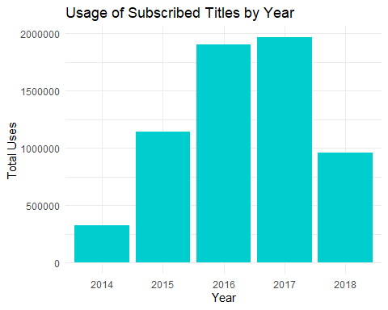

|  |  |  |
| --- | --- | --- |
| Year | Total_Uses | Percentage |
| 2014 | 325957 | 5.18 |
| 2015 | 1139196 | 18.09 |
| 2016 | 1903962 | 30.24 |
| 2017 | 1966215 | 31.23 |
| 2018 | 961324 | 15.27 |
|  |  |  |

### Owned Title Usage per Year

The following plot and table display the usage of owned titles by year.

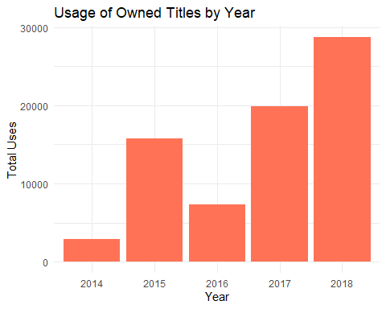

|  |  |  |
| --- | --- | --- |
| Year | Total_Uses | Percentage |
| 2014 | 325957 | 5.18 |
| 2015 | 1139196 | 18.09 |
| 2016 | 1903962 | 30.24 |
| 2017 | 1966215 | 31.23 |
| 2018 | 961324 | 15.27 |
|  |  |  |

## Usage by Campus

The following plot and table display the usage of titles by campus. The table also displays percentage of usage by campus.

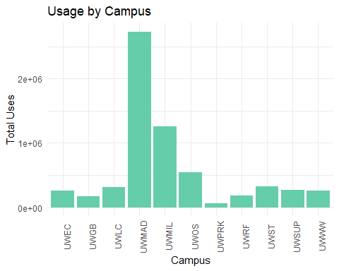

|  |  |  |
| --- | --- | --- |
| Campus | Total_Uses | Percentage |
| UWEC | 256181 | 4.02 |
| UWGB | 169127 | 2.65 |
| UWLC | 312853 | 4.91 |
| UWMAD | 2733382 | 42.90 |
| UWMIL | 1262491 | 19.82 |
| UWOS | 539113 | 8.46 |
| UWPRK | 60409 | 0.95 |
| UWRF | 186075 | 2.92 |
| UWST | 326585 | 5.13 |
| UWSUP | 271665 | 4.26 |
| UWWW | 253433 | 3.98 |

### Subscribed Title Usage by Campus

The following plot and table display the usage of subscribed titles by campus. The table also displays percentage of usage by campus.

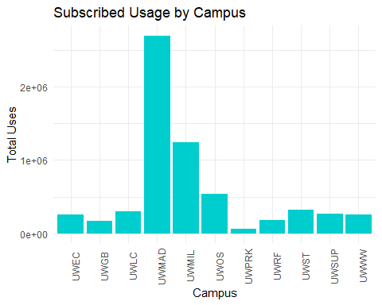

|  |  |  |
| --- | --- | --- |
| Campus | Total_Uses | Percentage |
| UWEC | 255202 | 4.05 |
| UWGB | 168897 | 2.68 |
| UWLC | 300446 | 4.77 |
| UWMAD | 2705109 | 42.96 |
| UWMIL | 1245087 | 19.77 |
| UWOS | 535966 | 8.51 |
| UWPRK | 60389 | 0.96 |
| UWRF | 180351 | 2.86 |
| UWST | 323412 | 5.14 |
| UWSUP | 271406 | 4.31 |
| UWWW | 250389 | 3.98 |

### Owned Title Usage by Campus

The following plot and table display the usage of subscribed titles by campus. The table also displays percentage of usage by campus.

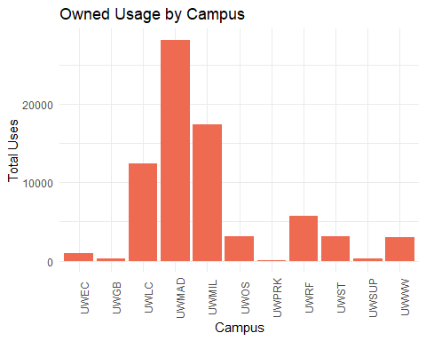

|  |  |  |
| --- | --- | --- |
| Campus | Total_Uses | Percentage |
| UWEC | 979 | 1.31 |
| UWGB | 230 | 0.31 |
| UWLC | 12407 | 16.62 |
| UWMAD | 28273 | 37.87 |
| UWMIL | 17404 | 23.31 |
| UWOS | 3147 | 4.22 |
| UWPRK | 20 | 0.03 |
| UWRF | 5724 | 7.67 |
| UWST | 3173 | 4.25 |
| UWSUP | 259 | 0.35 |
| UWWW | 3044 | 4.08 |

### Usage by Campus, Ownership, and Year

The following plots and tables break down the number of uses for owned titles and subscribed titles for each year by campus. 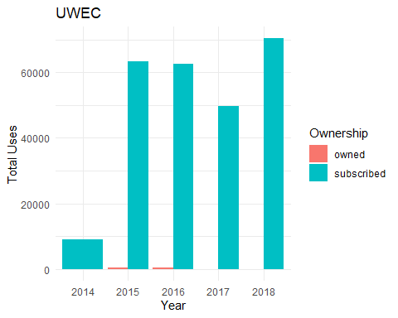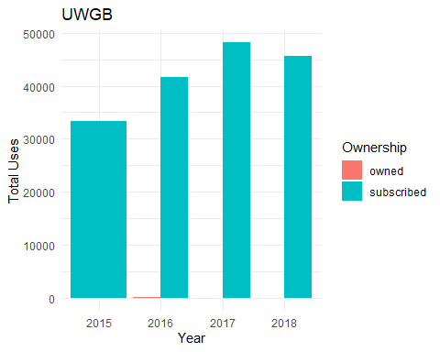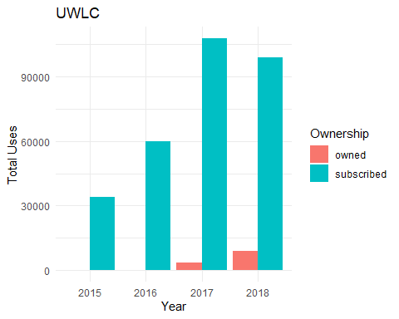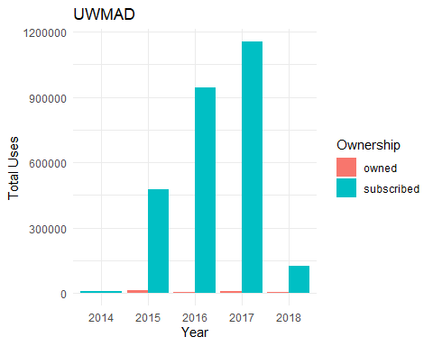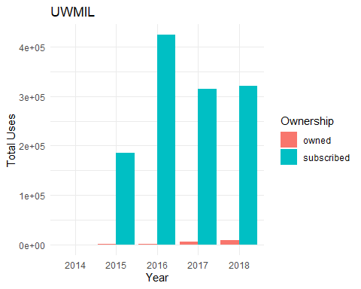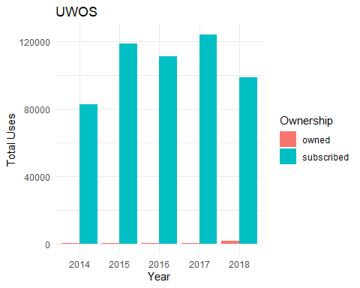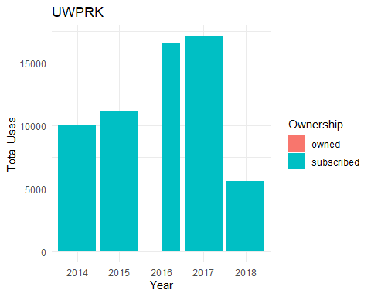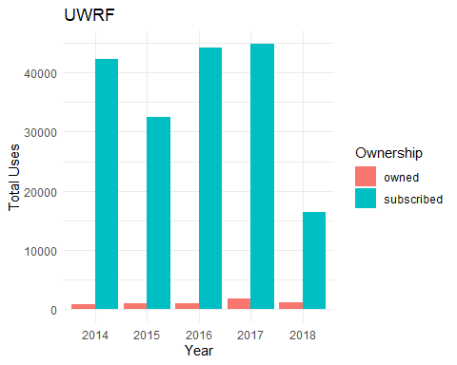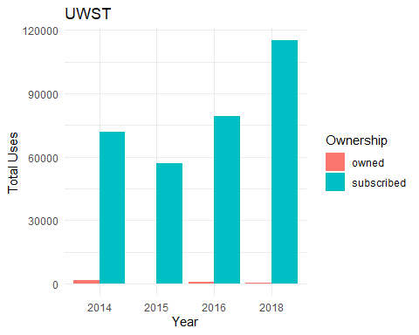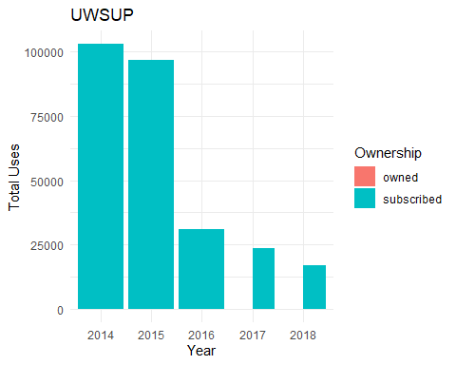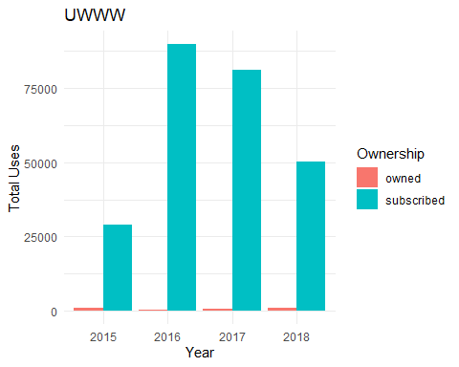

## [1] "UWEC"  
##   
##   
## |Year |Ownership | Total_Uses|  
## |:----|:----------|----------:|  
## |2014 |subscribed | 9123|  
## |2015 |owned | 412|  
## |2015 |subscribed | 63241|  
## |2016 |owned | 464|  
## |2016 |subscribed | 62655|  
## |2017 |owned | 1|  
## |2017 |subscribed | 49809|  
## |2018 |owned | 102|  
## |2018 |subscribed | 70374|  
## [1] "UWGB"  
##   
##   
## |Year |Ownership | Total_Uses|  
## |:----|:----------|----------:|  
## |2015 |subscribed | 33421|  
## |2016 |owned | 128|  
## |2016 |subscribed | 41698|  
## |2017 |owned | 73|  
## |2017 |subscribed | 48204|  
## |2018 |owned | 29|  
## |2018 |subscribed | 45574|  
## [1] "UWLC"  
##   
##   
## |Year |Ownership | Total_Uses|  
## |:----|:----------|----------:|  
## |2015 |owned | 51|  
## |2015 |subscribed | 33968|  
## |2016 |owned | 35|  
## |2016 |subscribed | 59809|  
## |2017 |owned | 3404|  
## |2017 |subscribed | 107769|  
## |2018 |owned | 8917|  
## |2018 |subscribed | 98900|  
## [1] "UWMAD"  
##   
##   
## |Year |Ownership | Total_Uses|  
## |:----|:----------|----------:|  
## |2014 |subscribed | 7015|  
## |2015 |owned | 11604|  
## |2015 |subscribed | 477601|  
## |2016 |owned | 2911|  
## |2016 |subscribed | 943245|  
## |2017 |owned | 7754|  
## |2017 |subscribed | 1154868|  
## |2018 |owned | 6004|  
## |2018 |subscribed | 122380|  
## [1] "UWMIL"  
##   
##   
## |Year |Ownership | Total_Uses|  
## |:----|:----------|----------:|  
## |2014 |subscribed | 44|  
## |2015 |owned | 899|  
## |2015 |subscribed | 185770|  
## |2016 |owned | 1420|  
## |2016 |subscribed | 423938|  
## |2017 |owned | 5839|  
## |2017 |subscribed | 314663|  
## |2018 |owned | 9246|  
## |2018 |subscribed | 320672|  
## [1] "UWOS"  
##   
##   
## |Year |Ownership | Total_Uses|  
## |:----|:----------|----------:|  
## |2014 |owned | 309|  
## |2014 |subscribed | 82601|  
## |2015 |owned | 598|  
## |2015 |subscribed | 118863|  
## |2016 |owned | 330|  
## |2016 |subscribed | 111462|  
## |2017 |owned | 268|  
## |2017 |subscribed | 124195|  
## |2018 |owned | 1642|  
## |2018 |subscribed | 98845|  
## [1] "UWPRK"  
##   
##   
## |Year |Ownership | Total_Uses|  
## |:----|:----------|----------:|  
## |2014 |subscribed | 10026|  
## |2015 |subscribed | 11091|  
## |2016 |owned | 20|  
## |2016 |subscribed | 16552|  
## |2017 |subscribed | 17125|  
## |2018 |subscribed | 5595|  
## [1] "UWRF"  
##   
##   
## |Year |Ownership | Total_Uses|  
## |:----|:----------|----------:|  
## |2014 |owned | 882|  
## |2014 |subscribed | 42304|  
## |2015 |owned | 1046|  
## |2015 |subscribed | 32447|  
## |2016 |owned | 912|  
## |2016 |subscribed | 44298|  
## |2017 |owned | 1700|  
## |2017 |subscribed | 44863|  
## |2018 |owned | 1184|  
## |2018 |subscribed | 16439|  
## [1] "UWST"  
##   
##   
## |Year |Ownership | Total_Uses|  
## |:----|:----------|----------:|  
## |2014 |owned | 1667|  
## |2014 |subscribed | 71815|  
## |2015 |owned | 128|  
## |2015 |subscribed | 56904|  
## |2016 |owned | 754|  
## |2016 |subscribed | 79491|  
## |2018 |owned | 624|  
## |2018 |subscribed | 115202|  
## [1] "UWSUP"  
##   
##   
## |Year |Ownership | Total_Uses|  
## |:----|:----------|----------:|  
## |2014 |subscribed | 103029|  
## |2015 |subscribed | 96759|  
## |2016 |subscribed | 30974|  
## |2017 |owned | 89|  
## |2017 |subscribed | 23673|  
## |2018 |owned | 170|  
## |2018 |subscribed | 16971|  
## [1] "UWWW"  
##   
##   
## |Year |Ownership | Total_Uses|  
## |:----|:----------|----------:|  
## |2015 |owned | 1060|  
## |2015 |subscribed | 29131|  
## |2016 |owned | 359|  
## |2016 |subscribed | 89840|  
## |2017 |owned | 792|  
## |2017 |subscribed | 81046|  
## |2018 |owned | 833|  
## |2018 |subscribed | 50372|

## 

## Usage by Subject Area

### Usage by Subject Area

The following plot and table show the usage of titles by subject area. The table also includes percentage of usage by subject

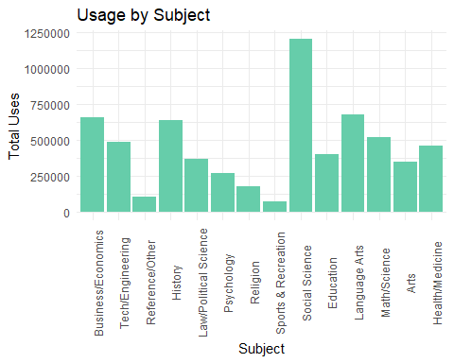

|  |  |  |
| --- | --- | --- |
| Subject | Total_Uses | Percentage |
| Business/Economics | 658774 | 10.34 |
| Tech/Engineering | 488392 | 7.67 |
| Reference/Other | 104963 | 1.65 |
| History | 634877 | 9.96 |
| Law/Political Science | 365232 | 5.73 |
| Psychology | 267087 | 4.19 |
| Religion | 177935 | 2.79 |
| Sports & Recreation | 74145 | 1.16 |
| Social Science | 1203219 | 18.88 |
| Education | 398350 | 6.25 |
| Language Arts | 674459 | 10.59 |
| Math/Science | 517991 | 8.13 |
| Arts | 348185 | 5.46 |
| Health/Medicine | 457705 | 7.18 |
|  |  |  |

### Subscribed Title Usage by Subject

The following plot and table display the usage of subscribed titles by subject area. The table also displays percentage of usage by subject.

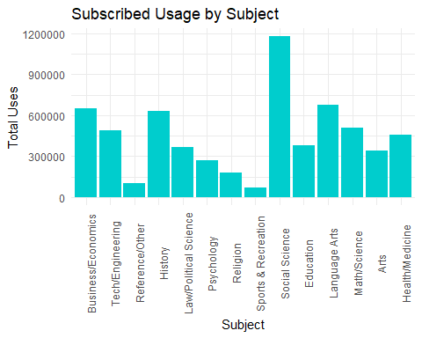

|  |  |  |
| --- | --- | --- |
| Campus | Total_Uses | Percentage |
| UWEC | 255202 | 4.05 |
| UWGB | 168897 | 2.68 |
| UWLC | 300446 | 4.77 |
| UWMAD | 2705109 | 42.96 |
| UWMIL | 1245087 | 19.77 |
| UWOS | 535966 | 8.51 |
| UWPRK | 60389 | 0.96 |
| UWRF | 180351 | 2.86 |
| UWST | 323412 | 5.14 |
| UWSUP | 271406 | 4.31 |
| UWWW | 250389 | 3.98 |

### Owned Title Usage by Subject

The following plot and table display the usage of subscribed titles by campus. The table also displays percentage of usage by campus.

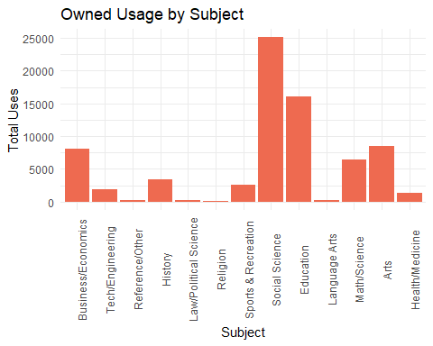

|  |  |  |
| --- | --- | --- |
| Subject | Total_Uses | Percentage |
| Business/Economics | 8072 | 10.81 |
| Tech/Engineering | 1963 | 2.63 |
| Reference/Other | 231 | 0.31 |
| History | 3460 | 4.63 |
| Law/Political Science | 295 | 0.40 |
| Religion | 172 | 0.23 |
| Sports & Recreation | 2624 | 3.51 |
| Social Science | 25118 | 33.64 |
| Education | 16116 | 21.59 |
| Language Arts | 309 | 0.41 |
| Math/Science | 6436 | 8.62 |
| Arts | 8467 | 11.34 |
| Health/Medicine | 1397 | 1.87 |

### Usage by Subject Area, Ownership, and Campus

The following plots and tables break down the number of uses for owned titles and subscribed titles for each subject area and campus. 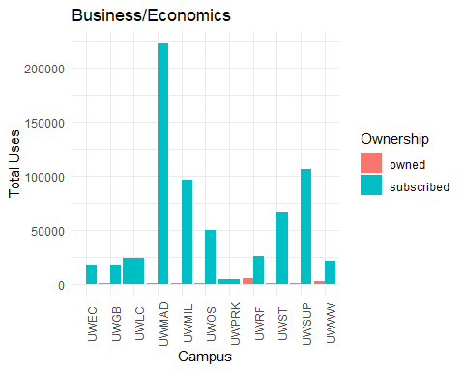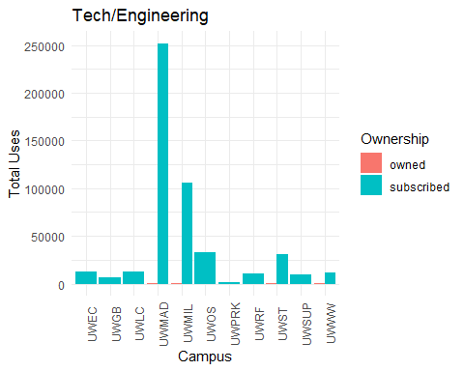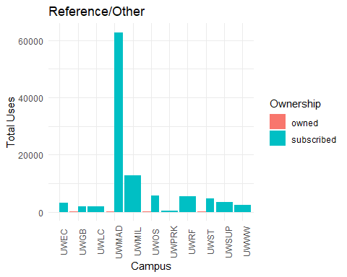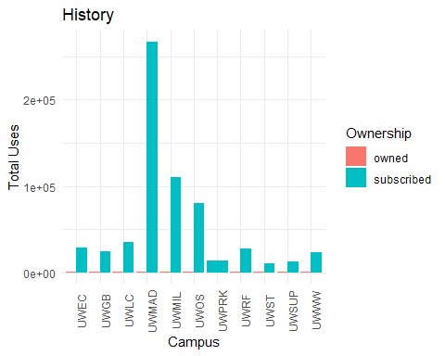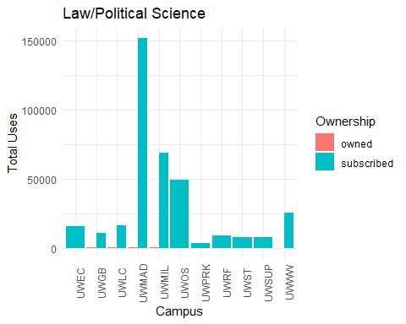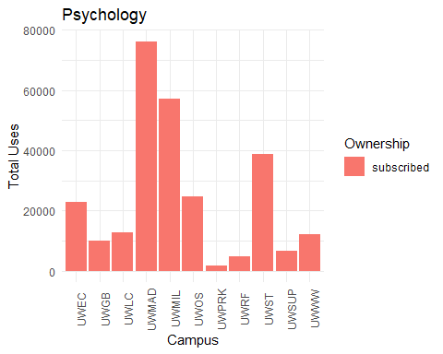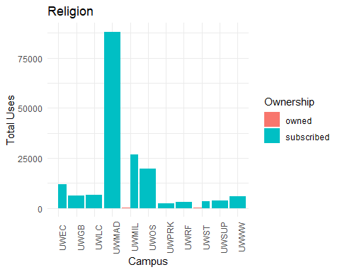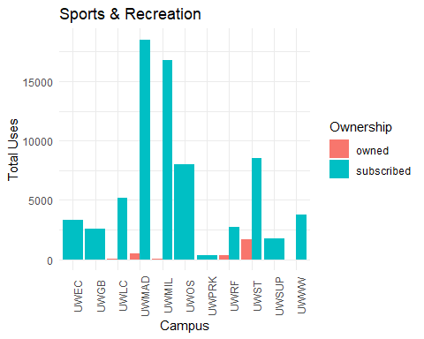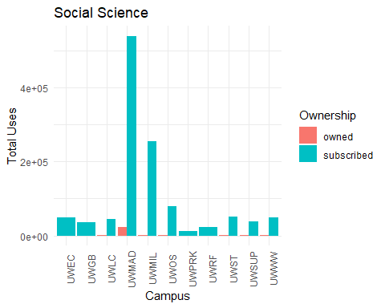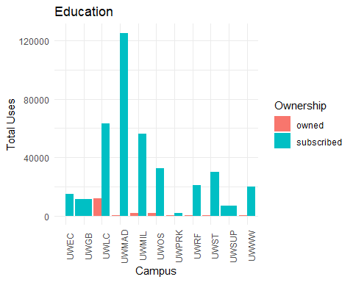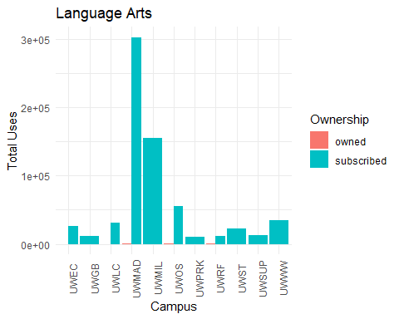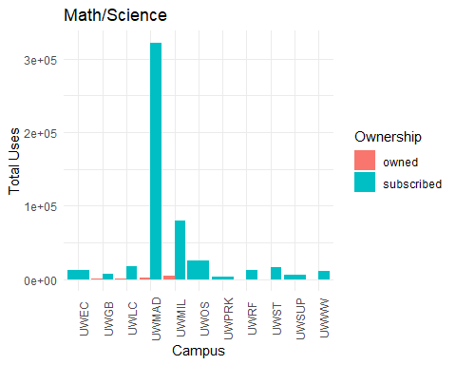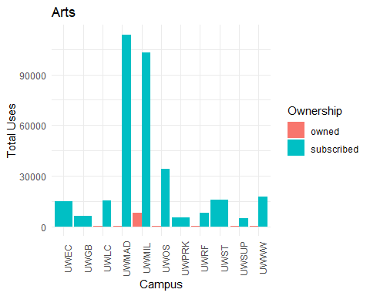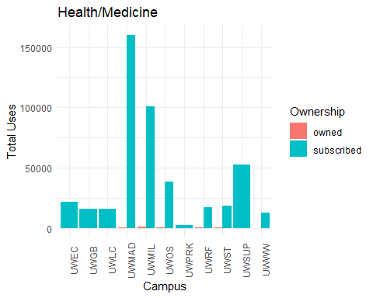

## [1] "Business/Economics"  
##   
##   
## |Campus |Ownership | Total_Uses|  
## |:------|:----------|----------:|  
## |UWEC |owned | 13|  
## |UWEC |subscribed | 17772|  
## |UWGB |owned | 37|  
## |UWGB |subscribed | 17303|  
## |UWLC |subscribed | 23389|  
## |UWMAD |owned | 147|  
## |UWMAD |subscribed | 222707|  
## |UWMIL |owned | 49|  
## |UWMIL |subscribed | 96131|  
## |UWOS |owned | 424|  
## |UWOS |subscribed | 50004|  
## |UWPRK |subscribed | 3767|  
## |UWRF |owned | 4739|  
## |UWRF |subscribed | 25720|  
## |UWST |owned | 24|  
## |UWST |subscribed | 66468|  
## |UWSUP |owned | 49|  
## |UWSUP |subscribed | 106082|  
## |UWWW |owned | 2590|  
## |UWWW |subscribed | 21359|  
## [1] "Tech/Engineering"  
##   
##   
## |Campus |Ownership | Total_Uses|  
## |:------|:----------|----------:|  
## |UWEC |subscribed | 12440|  
## |UWGB |subscribed | 6876|  
## |UWLC |subscribed | 12975|  
## |UWMAD |owned | 1012|  
## |UWMAD |subscribed | 251977|  
## |UWMIL |owned | 812|  
## |UWMIL |subscribed | 105795|  
## |UWOS |subscribed | 33025|  
## |UWPRK |subscribed | 1190|  
## |UWRF |subscribed | 10674|  
## |UWST |owned | 119|  
## |UWST |subscribed | 30451|  
## |UWSUP |subscribed | 9204|  
## |UWWW |owned | 20|  
## |UWWW |subscribed | 11822|  
## [1] "Reference/Other"  
##   
##   
## |Campus |Ownership | Total_Uses|  
## |:------|:----------|----------:|  
## |UWEC |owned | 1|  
## |UWEC |subscribed | 3108|  
## |UWGB |owned | 15|  
## |UWGB |subscribed | 1989|  
## |UWLC |subscribed | 1981|  
## |UWMAD |owned | 117|  
## |UWMAD |subscribed | 62834|  
## |UWMIL |subscribed | 12763|  
## |UWOS |owned | 25|  
## |UWOS |subscribed | 5671|  
## |UWPRK |subscribed | 504|  
## |UWRF |subscribed | 5391|  
## |UWST |owned | 73|  
## |UWST |subscribed | 4677|  
## |UWSUP |subscribed | 3497|  
## |UWWW |subscribed | 2317|  
## [1] "History"  
##   
##   
## |Campus |Ownership | Total_Uses|  
## |:------|:----------|----------:|  
## |UWEC |owned | 941|  
## |UWEC |subscribed | 28222|  
## |UWGB |owned | 118|  
## |UWGB |subscribed | 24627|  
## |UWLC |owned | 116|  
## |UWLC |subscribed | 34868|  
## |UWMAD |owned | 547|  
## |UWMAD |subscribed | 267655|  
## |UWMIL |owned | 1004|  
## |UWMIL |subscribed | 110225|  
## |UWOS |owned | 373|  
## |UWOS |subscribed | 80562|  
## |UWPRK |subscribed | 12963|  
## |UWRF |owned | 38|  
## |UWRF |subscribed | 26940|  
## |UWST |owned | 93|  
## |UWST |subscribed | 10178|  
## |UWSUP |owned | 114|  
## |UWSUP |subscribed | 12343|  
## |UWWW |owned | 116|  
## |UWWW |subscribed | 22834|  
## [1] "Law/Political Science"  
##   
##   
## |Campus |Ownership | Total_Uses|  
## |:------|:----------|----------:|  
## |UWEC |subscribed | 15556|  
## |UWGB |owned | 25|  
## |UWGB |subscribed | 10514|  
## |UWLC |owned | 41|  
## |UWLC |subscribed | 16120|  
## |UWMAD |owned | 187|  
## |UWMAD |subscribed | 152234|  
## |UWMIL |owned | 37|  
## |UWMIL |subscribed | 68642|  
## |UWOS |subscribed | 49232|  
## |UWPRK |subscribed | 3612|  
## |UWRF |subscribed | 8999|  
## |UWST |subscribed | 7563|  
## |UWSUP |subscribed | 7365|  
## |UWWW |owned | 5|  
## |UWWW |subscribed | 25100|  
## [1] "Psychology"  
##   
##   
## |Campus |Ownership | Total_Uses|  
## |:------|:----------|----------:|  
## |UWEC |subscribed | 22818|  
## |UWGB |subscribed | 9832|  
## |UWLC |subscribed | 12604|  
## |UWMAD |subscribed | 76265|  
## |UWMIL |subscribed | 57021|  
## |UWOS |subscribed | 24651|  
## |UWPRK |subscribed | 1571|  
## |UWRF |subscribed | 4814|  
## |UWST |subscribed | 38690|  
## |UWSUP |subscribed | 6602|  
## |UWWW |subscribed | 12219|  
## [1] "Religion"  
##   
##   
## |Campus |Ownership | Total_Uses|  
## |:------|:----------|----------:|  
## |UWEC |owned | 4|  
## |UWEC |subscribed | 11871|  
## |UWGB |subscribed | 6267|  
## |UWLC |subscribed | 6414|  
## |UWMAD |subscribed | 88068|  
## |UWMIL |owned | 78|  
## |UWMIL |subscribed | 26748|  
## |UWOS |subscribed | 19646|  
## |UWPRK |subscribed | 2351|  
## |UWRF |subscribed | 3183|  
## |UWST |owned | 90|  
## |UWST |subscribed | 3492|  
## |UWSUP |subscribed | 3771|  
## |UWWW |subscribed | 5952|  
## [1] "Sports & Recreation"  
##   
##   
## |Campus |Ownership | Total_Uses|  
## |:------|:----------|----------:|  
## |UWEC |subscribed | 3279|  
## |UWGB |subscribed | 2543|  
## |UWLC |owned | 61|  
## |UWLC |subscribed | 5151|  
## |UWMAD |owned | 491|  
## |UWMAD |subscribed | 18534|  
## |UWMIL |owned | 58|  
## |UWMIL |subscribed | 16784|  
## |UWOS |subscribed | 8034|  
## |UWPRK |subscribed | 326|  
## |UWRF |owned | 313|  
## |UWRF |subscribed | 2745|  
## |UWST |owned | 1700|  
## |UWST |subscribed | 8562|  
## |UWSUP |subscribed | 1785|  
## |UWWW |owned | 1|  
## |UWWW |subscribed | 3778|  
## [1] "Social Science"  
##   
##   
## |Campus |Ownership | Total_Uses|  
## |:------|:----------|----------:|  
## |UWEC |subscribed | 49459|  
## |UWGB |subscribed | 36398|  
## |UWLC |owned | 333|  
## |UWLC |subscribed | 44749|  
## |UWMAD |owned | 22950|  
## |UWMAD |subscribed | 540534|  
## |UWMIL |owned | 676|  
## |UWMIL |subscribed | 256047|  
## |UWOS |owned | 352|  
## |UWOS |subscribed | 80343|  
## |UWPRK |subscribed | 11945|  
## |UWRF |subscribed | 22295|  
## |UWST |owned | 632|  
## |UWST |subscribed | 50580|  
## |UWSUP |owned | 42|  
## |UWSUP |subscribed | 37056|  
## |UWWW |owned | 133|  
## |UWWW |subscribed | 48695|  
## [1] "Education"  
##   
##   
## |Campus |Ownership | Total_Uses|  
## |:------|:----------|----------:|  
## |UWEC |owned | 5|  
## |UWEC |subscribed | 14654|  
## |UWGB |subscribed | 11309|  
## |UWLC |owned | 11693|  
## |UWLC |subscribed | 63043|  
## |UWMAD |owned | 135|  
## |UWMAD |subscribed | 125387|  
## |UWMIL |owned | 2020|  
## |UWMIL |subscribed | 55978|  
## |UWOS |owned | 1612|  
## |UWOS |subscribed | 32402|  
## |UWPRK |owned | 20|  
## |UWPRK |subscribed | 1887|  
## |UWRF |owned | 169|  
## |UWRF |subscribed | 20797|  
## |UWST |owned | 415|  
## |UWST |subscribed | 29892|  
## |UWSUP |subscribed | 7041|  
## |UWWW |owned | 47|  
## |UWWW |subscribed | 19844|  
## [1] "Language Arts"  
##   
##   
## |Campus |Ownership | Total_Uses|  
## |:------|:----------|----------:|  
## |UWEC |owned | 15|  
## |UWEC |subscribed | 26552|  
## |UWGB |subscribed | 11609|  
## |UWLC |owned | 9|  
## |UWLC |subscribed | 30555|  
## |UWMAD |owned | 96|  
## |UWMAD |subscribed | 302765|  
## |UWMIL |subscribed | 154744|  
## |UWOS |owned | 111|  
## |UWOS |subscribed | 55236|  
## |UWPRK |subscribed | 9933|  
## |UWRF |owned | 78|  
## |UWRF |subscribed | 11559|  
## |UWST |subscribed | 23126|  
## |UWSUP |subscribed | 13024|  
## |UWWW |subscribed | 35047|  
## [1] "Math/Science"  
##   
##   
## |Campus |Ownership | Total_Uses|  
## |:------|:----------|----------:|  
## |UWEC |subscribed | 12560|  
## |UWGB |owned | 35|  
## |UWGB |subscribed | 7412|  
## |UWLC |owned | 38|  
## |UWLC |subscribed | 17242|  
## |UWMAD |owned | 2177|  
## |UWMAD |subscribed | 321935|  
## |UWMIL |owned | 4175|  
## |UWMIL |subscribed | 79948|  
## |UWOS |subscribed | 24776|  
## |UWPRK |subscribed | 2825|  
## |UWRF |owned | 8|  
## |UWRF |subscribed | 12049|  
## |UWST |owned | 2|  
## |UWST |subscribed | 15627|  
## |UWSUP |subscribed | 6299|  
## |UWWW |owned | 1|  
## |UWWW |subscribed | 10882|  
## [1] "Arts"  
##   
##   
## |Campus |Ownership | Total_Uses|  
## |:------|:----------|----------:|  
## |UWEC |subscribed | 15045|  
## |UWGB |subscribed | 6357|  
## |UWLC |owned | 116|  
## |UWLC |subscribed | 15362|  
## |UWMAD |owned | 196|  
## |UWMAD |subscribed | 113821|  
## |UWMIL |owned | 7832|  
## |UWMIL |subscribed | 103164|  
## |UWOS |owned | 125|  
## |UWOS |subscribed | 34231|  
## |UWPRK |subscribed | 5326|  
## |UWRF |owned | 15|  
## |UWRF |subscribed | 8191|  
## |UWST |subscribed | 15796|  
## |UWSUP |owned | 54|  
## |UWSUP |subscribed | 4656|  
## |UWWW |owned | 129|  
## |UWWW |subscribed | 17769|  
## [1] "Health/Medicine"  
##   
##   
## |Campus |Ownership | Total_Uses|  
## |:------|:----------|----------:|  
## |UWEC |subscribed | 21866|  
## |UWGB |subscribed | 15861|  
## |UWLC |subscribed | 15993|  
## |UWMAD |owned | 218|  
## |UWMAD |subscribed | 160393|  
## |UWMIL |owned | 663|  
## |UWMIL |subscribed | 101097|  
## |UWOS |owned | 125|  
## |UWOS |subscribed | 38153|  
## |UWPRK |subscribed | 2189|  
## |UWRF |owned | 364|  
## |UWRF |subscribed | 16994|  
## |UWST |owned | 25|  
## |UWST |subscribed | 18310|  
## |UWSUP |subscribed | 52681|  
## |UWWW |owned | 2|  
## |UWWW |subscribed | 12771|

### 

### Usage by Subject, Ownership, and Year

The following plots and tables show the total number of uses for owned compared to subscribed titles for each subject category and year. 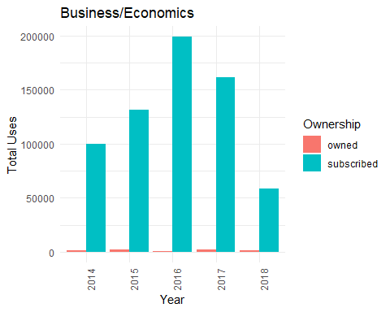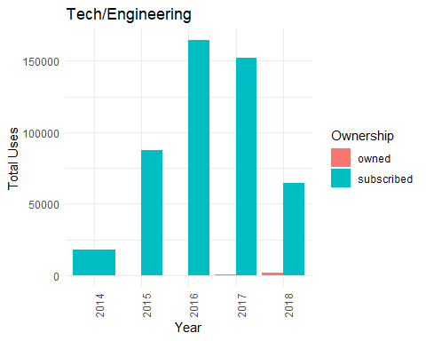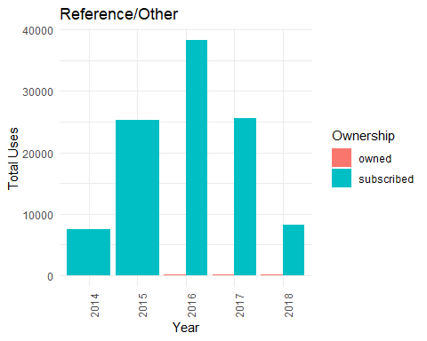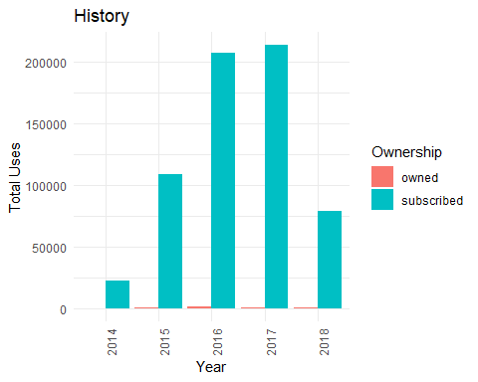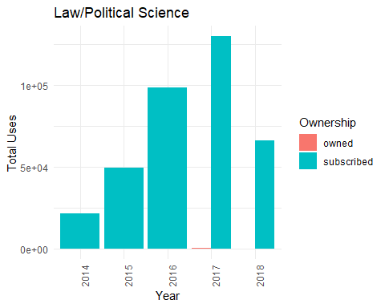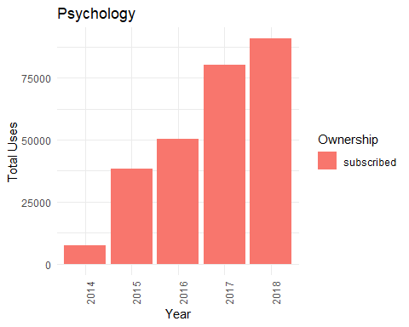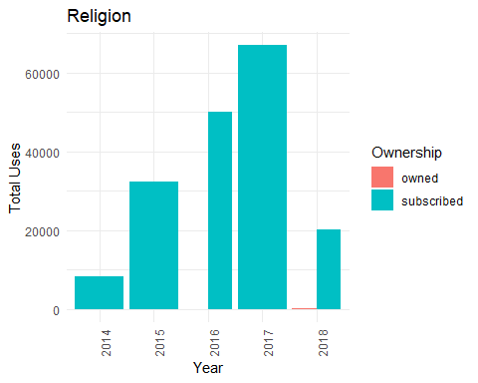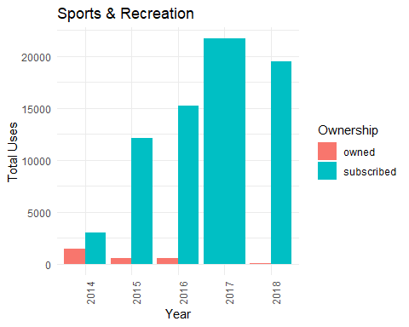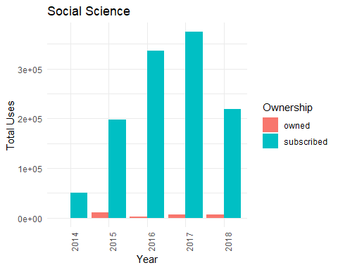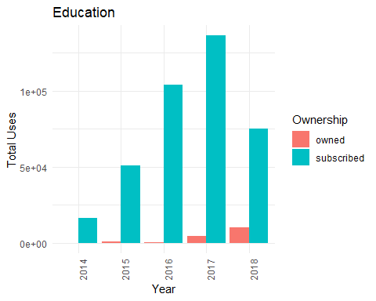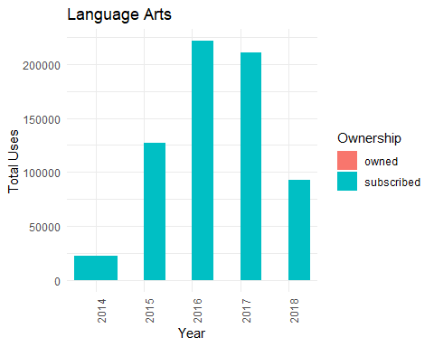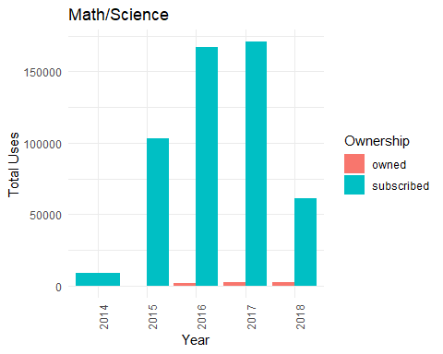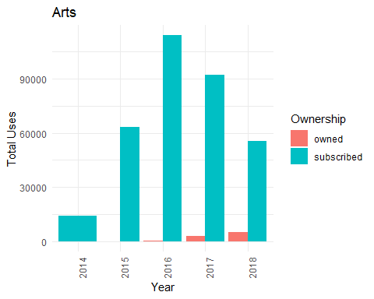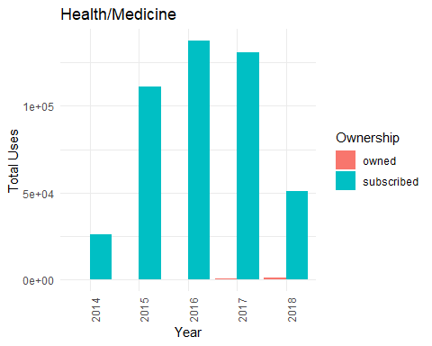

## [1] "Business/Economics"  
##   
##   
## |Year |Ownership | Total_Uses|  
## |:----|:----------|----------:|  
## |2014 |owned | 1122|  
## |2014 |subscribed | 100034|  
## |2015 |owned | 2186|  
## |2015 |subscribed | 131808|  
## |2016 |owned | 856|  
## |2016 |subscribed | 198989|  
## |2017 |owned | 2257|  
## |2017 |subscribed | 161596|  
## |2018 |owned | 1651|  
## |2018 |subscribed | 58275|  
## [1] "Tech/Engineering"  
##   
##   
## |Year |Ownership | Total_Uses|  
## |:----|:----------|----------:|  
## |2014 |subscribed | 17882|  
## |2015 |owned | 6|  
## |2015 |subscribed | 87609|  
## |2016 |owned | 6|  
## |2016 |subscribed | 164268|  
## |2017 |owned | 210|  
## |2017 |subscribed | 152204|  
## |2018 |owned | 1741|  
## |2018 |subscribed | 64466|  
## [1] "Reference/Other"  
##   
##   
## |Year |Ownership | Total_Uses|  
## |:----|:----------|----------:|  
## |2014 |subscribed | 7433|  
## |2015 |subscribed | 25228|  
## |2016 |owned | 43|  
## |2016 |subscribed | 38264|  
## |2017 |owned | 133|  
## |2017 |subscribed | 25617|  
## |2018 |owned | 55|  
## |2018 |subscribed | 8190|  
## [1] "History"  
##   
##   
## |Year |Ownership | Total_Uses|  
## |:----|:----------|----------:|  
## |2014 |owned | 50|  
## |2014 |subscribed | 22206|  
## |2015 |owned | 841|  
## |2015 |subscribed | 109124|  
## |2016 |owned | 1526|  
## |2016 |subscribed | 207287|  
## |2017 |owned | 450|  
## |2017 |subscribed | 213555|  
## |2018 |owned | 593|  
## |2018 |subscribed | 79245|  
## [1] "Law/Political Science"  
##   
##   
## |Year |Ownership | Total_Uses|  
## |:----|:----------|----------:|  
## |2014 |subscribed | 21566|  
## |2015 |subscribed | 49404|  
## |2016 |subscribed | 98561|  
## |2017 |owned | 230|  
## |2017 |subscribed | 129567|  
## |2018 |owned | 65|  
## |2018 |subscribed | 65839|  
## [1] "Psychology"  
##   
##   
## |Year |Ownership | Total_Uses|  
## |:----|:----------|----------:|  
## |2014 |subscribed | 7459|  
## |2015 |subscribed | 38398|  
## |2016 |subscribed | 50389|  
## |2017 |subscribed | 80146|  
## |2018 |subscribed | 90695|  
## [1] "Religion"  
##   
##   
## |Year |Ownership | Total_Uses|  
## |:----|:----------|----------:|  
## |2014 |subscribed | 8182|  
## |2015 |subscribed | 32451|  
## |2016 |owned | 4|  
## |2016 |subscribed | 50064|  
## |2017 |subscribed | 66979|  
## |2018 |owned | 168|  
## |2018 |subscribed | 20087|  
## [1] "Sports & Recreation"  
##   
##   
## |Year |Ownership | Total_Uses|  
## |:----|:----------|----------:|  
## |2014 |owned | 1495|  
## |2014 |subscribed | 3039|  
## |2015 |owned | 534|  
## |2015 |subscribed | 12085|  
## |2016 |owned | 538|  
## |2016 |subscribed | 15256|  
## |2017 |subscribed | 21674|  
## |2018 |owned | 57|  
## |2018 |subscribed | 19467|  
## [1] "Social Science"  
##   
##   
## |Year |Ownership | Total_Uses|  
## |:----|:----------|----------:|  
## |2014 |owned | 115|  
## |2014 |subscribed | 51186|  
## |2015 |owned | 10935|  
## |2015 |subscribed | 197168|  
## |2016 |owned | 1899|  
## |2016 |subscribed | 336609|  
## |2017 |owned | 6023|  
## |2017 |subscribed | 373895|  
## |2018 |owned | 6146|  
## |2018 |subscribed | 219243|  
## [1] "Education"  
##   
##   
## |Year |Ownership | Total_Uses|  
## |:----|:----------|----------:|  
## |2014 |owned | 75|  
## |2014 |subscribed | 16090|  
## |2015 |owned | 1084|  
## |2015 |subscribed | 51026|  
## |2016 |owned | 579|  
## |2016 |subscribed | 104012|  
## |2017 |owned | 4362|  
## |2017 |subscribed | 136129|  
## |2018 |owned | 10016|  
## |2018 |subscribed | 74977|  
## [1] "Language Arts"  
##   
##   
## |Year |Ownership | Total_Uses|  
## |:----|:----------|----------:|  
## |2014 |subscribed | 22037|  
## |2015 |owned | 13|  
## |2015 |subscribed | 126937|  
## |2016 |owned | 14|  
## |2016 |subscribed | 221282|  
## |2017 |owned | 81|  
## |2017 |subscribed | 210914|  
## |2018 |owned | 201|  
## |2018 |subscribed | 92980|  
## [1] "Math/Science"  
##   
##   
## |Year |Ownership | Total_Uses|  
## |:----|:----------|----------:|  
## |2014 |subscribed | 9001|  
## |2015 |owned | 121|  
## |2015 |subscribed | 103220|  
## |2016 |owned | 1492|  
## |2016 |subscribed | 167368|  
## |2017 |owned | 2683|  
## |2017 |subscribed | 170755|  
## |2018 |owned | 2140|  
## |2018 |subscribed | 61211|  
## [1] "Arts"  
##   
##   
## |Year |Ownership | Total_Uses|  
## |:----|:----------|----------:|  
## |2014 |subscribed | 14193|  
## |2015 |owned | 16|  
## |2015 |subscribed | 63333|  
## |2016 |owned | 332|  
## |2016 |subscribed | 114076|  
## |2017 |owned | 3113|  
## |2017 |subscribed | 92401|  
## |2018 |owned | 5006|  
## |2018 |subscribed | 55715|  
## [1] "Health/Medicine"  
##   
##   
## |Year |Ownership | Total_Uses|  
## |:----|:----------|----------:|  
## |2014 |owned | 1|  
## |2014 |subscribed | 25649|  
## |2015 |owned | 62|  
## |2015 |subscribed | 111405|  
## |2016 |owned | 44|  
## |2016 |subscribed | 137537|  
## |2017 |owned | 378|  
## |2017 |subscribed | 130783|  
## |2018 |owned | 912|  
## |2018 |subscribed | 50934|