Capstone Project: Wiley Data

## Setup:

#load necessary packages/libraries  
library(openxlsx)  
library(readr)  
library(dplyr)  
library(stringr)  
library(ggplot2)  
library(knitr)  
library(tidyr)  
library(lemon)  
knit_print.data.frame <- lemon_print

#set working directory  
wd = getwd()  
setwd(wd)

# Load and Combine Datasets

## Campus reports (BR2 and BR3) 2014-2018

#view summary of data frame and first few lines of data   
summary(wiley_df)

## Title Publisher Platform BookReport_Type   
## Length:66100 Length:66100 Length:66100 Length:66100   
## Class :character Class :character Class :character Class :character   
## Mode :character Mode :character Mode :character Mode :character   
##   
##   
##   
## Campus Year Book.DOI Proprietary.Identifier  
## Length:66100 Min. :2014 Length:66100 Length:66100   
## Class :character 1st Qu.:2015 Class :character Class :character   
## Mode :character Median :2016 Mode :character Mode :character   
## Mean :2016   
## 3rd Qu.:2017   
## Max. :2018   
## ISBN ISSN Reporting.Period.Total  
## Length:66100 Length:66100 Length:66100   
## Class :character Class :character Class :character   
## Mode :character Mode :character Mode :character   
##   
##   
##   
## Jan Feb Mar Apr   
## Length:66100 Length:66100 Length:66100 Length:66100   
## Class :character Class :character Class :character Class :character   
## Mode :character Mode :character Mode :character Mode :character   
##   
##   
##   
## Mar Jun Jul Aug   
## Length:66100 Length:66100 Length:66100 Length:66100   
## Class :character Class :character Class :character Class :character   
## Mode :character Mode :character Mode :character Mode :character   
##   
##   
##   
## Sep Oct Nov Dec   
## Length:66100 Length:66100 Length:66100 Length:66100   
## Class :character Class :character Class :character Class :character   
## Mode :character Mode :character Mode :character Mode :character   
##   
##   
##

head(wiley_df)

## Title Publisher  
## 2 4G Wireless Video Communications John Wiley and Sons  
## 3 A Companion to Ancient History John Wiley and Sons  
## 4 A Companion to Archaic Greece John Wiley and Sons  
## 5 A Companion to Bioethics: Second Edition John Wiley and Sons  
## 6 A Companion to Byzantium John Wiley and Sons  
## 7 A Companion to Cultural Resource Management John Wiley and Sons  
## Platform BookReport_Type Campus Year Book.DOI  
## 2 Wiley Online Library BR2 UWST 2014 10.1002/9780470745168  
## 3 Wiley Online Library BR2 UWST 2014 10.1002/9781444308372  
## 4 Wiley Online Library BR2 UWST 2014 10.1002/9781444308761  
## 5 Wiley Online Library BR2 UWST 2014 10.1002/9781444307818  
## 6 Wiley Online Library BR2 UWST 2014 10.1002/9781444320015  
## 7 Wiley Online Library BR2 UWST 2014 10.1002/9781444396065  
## Proprietary.Identifier ISBN ISSN Reporting.Period.Total Jan Feb  
## 2 BK 978-0-470-74516-8 <NA> 1 0 0  
## 3 BK 978-1-444-30837-2 <NA> 3 0 0  
## 4 BK 978-1-444-30876-1 <NA> 1 0 0  
## 5 BK 978-1-444-30781-8 <NA> 4 0 0  
## 6 BK 978-1-444-32001-5 <NA> 1 0 0  
## 7 BK 978-1-444-39606-5 <NA> 1 0 0  
## Mar Apr Mar Jun Jul Aug Sep Oct Nov Dec  
## 2 0 0 0 1 0 0 0 0 0 0  
## 3 0 0 0 0 0 0 0 2 1 0  
## 4 0 0 0 0 0 0 0 0 1 0  
## 5 0 0 0 0 0 0 0 0 3 1  
## 6 0 0 0 0 0 0 0 1 0 0  
## 7 0 0 0 0 0 0 1 0 0 0

### Data Cleaning

#rename misnamed column for May (Mar.1)  
names(wiley_df)

## [1] "Title" "BookReport_Type" "Campus"   
## [4] "Year" "ISBN" "Reporting.Period.Total"  
## [7] "Jan" "Feb" "Mar"   
## [10] "Apr" "Mar.1" "Jun"   
## [13] "Jul" "Aug" "Sep"   
## [16] "Oct" "Nov" "Dec"

names(wiley_df)[11] <- "May"  
names(wiley_df)

## [1] "Title" "BookReport_Type" "Campus"   
## [4] "Year" "ISBN" "Reporting.Period.Total"  
## [7] "Jan" "Feb" "Mar"   
## [10] "Apr" "May" "Jun"   
## [13] "Jul" "Aug" "Sep"   
## [16] "Oct" "Nov" "Dec"

#convert Campus to a factor variable (categories)  
wiley_df$Campus <- as.factor(wiley_df$Campus)  
  
#rename rows with misspelled campus UWBG to UWGB  
levels(wiley_df$Campus)

## [1] "UWBG" "UWEC" "UWGB" "UWLC" "UWMAD" "UWMIL" "UWOS" "UWPLT" "UWPRK"  
## [10] "UWRF" "UWSP" "UWST" "UWSUP" "UWWW"

levels(wiley_df$Campus)[1] <- "UWGB"  
levels(wiley_df$Campus)

## [1] "UWGB" "UWEC" "UWLC" "UWMAD" "UWMIL" "UWOS" "UWPLT" "UWPRK" "UWRF"   
## [10] "UWSP" "UWST" "UWSUP" "UWWW"

#convert Title, BookReport_Type, Campus, and Year to factor variables   
wiley_df[,c(1:4)] <- lapply(wiley_df[,c(1:4)],as.factor)  
  
#convert Reporting.Period.Total and all Months (Jan-Dec) to numeric variables  
wiley_df[,6:18] <- lapply(wiley_df[,6:18],as.numeric)

Take a look at numer of NA/missing values in each column:

## Title BookReport_Type Campus   
## 19 0 0   
## Year ISBN Reporting.Period.Total   
## 0 37 19   
## Jan Feb Mar   
## 19 19 19   
## Apr May Jun   
## 19 19 19   
## Jul Aug Sep   
## 19 19 19   
## Oct Nov Dec   
## 19 19 19

It looks like almost all columns have 19 NA values. It is likely these are observation where are all columns/variables are missing values. Let’s take a look to make sure this is the case.

## Title NA's: 4195 5195 6195 7195 8195 15557 16557 17557 24930 25930 26930 27930 28930 38993 39993 40993 41993 42993 43993

## Reporting.Period.Total NA's: 4195 5195 6195 7195 8195 15557 16557 17557 24930 25930 26930 27930 28930 38993 39993 40993 41993 42993 43993

## Jan NA's: 4195 5195 6195 7195 8195 15557 16557 17557 24930 25930 26930 27930 28930 38993 39993 40993 41993 42993 43993

Indeed, it looks like the 19 NA values present in most columns of the data have the same index. These rows will be removed as they do not hold value for variables that are necessary to the analysis.

#remove rows with NA values   
na_indices <- which(is.na(wiley_df$Jan))  
  
wiley_df <- wiley_df[-c(na_indices),]

wiley_df will be merged with other dataframes later on to gain information on which titles are subscribed vs owned as well as which the subject categories of titles. ISBNs will be used to merge data frames. It is necessary to examine the number of NA/missing values there are for the ISBN column as well as the Titles column in wiley_df to determine whether it is a good idea to merge using ISBNs. If too many ISBNs are missing, it may be necessary to merge using a combination of ISBNs and Titles. Merging using title matching should be avoided if possible as titles may contain different spellings, inclusion of editions, differing symbols, and other minor variations that may cause titles to mismatch.

## NA Titles: 0

## NA ISBNs: 4311 4336 4342 5560 8219 8371 14159 14883 14885 14891 15341 15687 17193 17196 17197 17199 17411 17514

## Number of NA ISBNs: 18

There are only 18 observations (out of 66081) with missing NA values. It looks like it will be fine to merge on ISBN only based on an examination of the campus reports data. The inital data contained 66100 observation, so far 19 rows that were all NA values have been removed. The 18 rows with NA values for ISBN will also be removed as there will be enough data to work with without these data points.

#remove rows where ISBN is na  
wiley_df <- wiley_df[complete.cases(wiley_df$ISBN),]

## 

## System Owned Titles Report

The UW system all title access data for Wiley contains all titles that the UW system has access to through Wiley. Titles with a license end date of year 2099 are owned titles. This will be used to determine which titles in the combined BR2 and BR3 data are owned titles.

#read in data set of all owned Wiley titles  
owned_full <- read.xlsx("WileyAllTitleAccessUWSYS.xlsx", sheet = 1, startRow = 7, skipEmptyRows = TRUE, colNames = TRUE)  
summary(owned_full)

## Publication.Type Journal.Code Title DOI   
## Length:24944 Length:24944 Length:24944 Length:24944   
## Class :character Class :character Class :character Class :character   
## Mode :character Mode :character Mode :character Mode :character   
##   
##   
##   
##   
## Author Print.ISSN Online.ISSN Print.ISBN   
## Length:24944 Length:24944 Length:24944 Min. :9.780e+12   
## Class :character Class :character Class :character 1st Qu.:9.780e+12   
## Mode :character Mode :character Mode :character Median :9.781e+12   
## Mean :9.781e+12   
## 3rd Qu.:9.781e+12   
## Max. :9.789e+12   
## NA's :2382   
## Online.ISBN Homepage.URL List.of.Issues.URL Open.URL   
## Min. :9.780e+12 Length:24944 Length:24944 Length:24944   
## 1st Qu.:9.780e+12 Class :character Class :character Class :character   
## Median :9.781e+12 Mode :character Mode :character Mode :character   
## Mean :9.781e+12   
## 3rd Qu.:9.781e+12   
## Max. :9.784e+12   
## NA's :1972   
## Online.Publication.Date Journal.Start.Year Journal.End.Year Back.File.End.Year  
## Min. :2001 Min. :1790 Min. :1839 Min. :1878   
## 1st Qu.:2008 1st Qu.:1974 1st Qu.:2010 1st Qu.:1995   
## Median :2012 Median :1990 Median :2020 Median :1996   
## Mean :2012 Mean :1983 Mean :2012 Mean :1996   
## 3rd Qu.:2015 3rd Qu.:2000 3rd Qu.:2020 3rd Qu.:1996   
## Max. :2020 Max. :2016 Max. :2020 Max. :2006   
## NA's :1973 NA's :22972 NA's :22972 NA's :23635   
## Front.File.Start.Year Content.Start.Date Content.End.Date License.Start.Date  
## Min. :1879 Min. :1997 Min. :2015 Length:24944   
## 1st Qu.:1996 1st Qu.:1997 1st Qu.:2015 Class :character   
## Median :1997 Median :1997 Median :2015 Mode :character   
## Mean :1997 Mean :1997 Mean :2015   
## 3rd Qu.:1997 3rd Qu.:1997 3rd Qu.:2015   
## Max. :2007 Max. :1997 Max. :2015   
## NA's :23635 NA's :22972 NA's :22972   
## License.End.Date  
## Min. :2021   
## 1st Qu.:2021   
## Median :2021   
## Mean :2039   
## 3rd Qu.:2021   
## Max. :2099   
##

#create subset of data with only columns relevant to the analysis  
owned_df <- subset( owned_full, select = c(Title, Print.ISBN, Online.ISBN, License.Start.Date, License.End.Date))

Print.ISBN and Online.ISBN have been converted to character variables, and the year each title is purchase has been extracted from License.Start.Date and stored as Purchase.Year

#convert Print.ISBN and Online.ISBN to character  
owned_df[,c(2,3)] <- lapply(owned_df[,c(2,3)], as.character)  
  
#create new column with purchase year base on License.Start.Date  
owned_df$Purchase.Year <- format(as.Date(owned_df$License.Start.Date, format="%Y-%m-%d"),"%Y")  
  
#convert License.End.Year and Purchase.Year to factor variables  
owned_df[,c(5,6)] <- lapply(owned_df[,c(5,6)], as.factor)

An ownership column has been created to tag titles with a License.End.Date of 2099 as owned titles.

owned_df$Ownership <- "subscribed"  
owned_df$Ownership[owned_df$License.End.Date == "2099"] <- "owned"  
  
owned_df$Ownership <- as.factor(owned_df$Ownership)  
summary(owned_df)

## Title Print.ISBN Online.ISBN License.Start.Date  
## Length:24944 Length:24944 Length:24944 Length:24944   
## Class :character Class :character Class :character Class :character   
## Mode :character Mode :character Mode :character Mode :character   
##   
##   
##   
##   
## License.End.Date Purchase.Year Ownership   
## 2021:19283 2015: 1619 owned : 5661   
## 2099: 5661 2016: 434 subscribed:19283   
## 2017: 358   
## 2018: 62   
## 2019: 745   
## 2020:19754   
## NA's: 1972

License.Start.Date and License.End.Date will be removed from the data as the necessary information has been extracted and stored in new columns.

## NA Titles: 0

## Number of NA Print.ISBNs: 2382

## Number of NA Online.ISBNs: 1972

## [1] 1972

1972 observations out of 24944 total observations (about 8%) have NA values for both ISBN types.

The combined campus reports (BR2 and BR3) data will be merged with the all titles access data using ISBN to match both print.ISBN and online.ISBN. Titles will not be matched on due to minor variations such as inclusions of edition, minor spelling differences, and so on causing titles not to match when they should. Matching on titles does not improve results by much (see commented out chunks). Before doing any merging, any spaces and non alphanumeric characters are removed from all ISBN fields that will be used for merging as a precaution.

#remove dashes from wiley_df ISBN to match owned_df ISBN's  
wiley_df$ISBN <- gsub("-", "", wiley_df$ISBN)  
  
#remove any spaces and non-alphanumeric characters from ISBNs in wiley_df  
#or use str_replace_all(x, "[[:punct:]]", "") to remove punctuation   
wiley_df$ISBN <- str_replace_all(wiley_df$ISBN, fixed(" "), "")  
wiley_df$ISNB <- str_replace_all(wiley_df$ISBN, "[^[:alnum:]]", "")  
  
#convert owned_df PrintISBN to character type   
owned_df$Print.ISBN <- as.character(owned_df$Print.ISBN)  
  
#remove any spaces and non-alphanumeric characters from Print.ISBN in owned_df  
owned_df$Print.ISBN <- str_replace_all(owned_df$Print.ISBN, fixed(" "), "")  
owned_df$Print.ISBN <- str_replace_all(owned_df$Print.ISBN, "[^[:alnum:]]", "")  
  
#convert owned_df Online.ISBN to character type   
owned_df$Online.ISBN <- as.character(owned_df$Online.ISBN)  
  
#remove any spaces and non-alphanumeric characters from Print.ISBN in owned_df  
owned_df$Online.ISBN <- str_replace_all(owned_df$Online.ISBN, fixed(" "), "")  
owned_df$Online.ISBN <- str_replace_all(owned_df$Online.ISBN, "[^[:alnum:]]", "")

Titles in both wiley_df and owned_df will be made all lowercase, and titles will be stripped of any non-alphanumeric characters and spaces in attempts to make titles that should match as similar as possible.

### 1st merge:

The first merge will merge the combined campus reports (wiley_df) using ISBN with the all titles access reports (owned_df) using Online.ISBN.

# Merge wiley_df and owned_df on Online.ISBN  
merge_df <-merge(wiley_df,owned_df, by.x = "ISBN", by.y = "Online.ISBN", all.x = TRUE)  
  
#remove duplicate columns from merging  
merge_df <- subset(merge_df, select = -c(ISNB, Title.y, Print.ISBN))  
names(merge_df)[2] <- "Title"  
  
cat("Number of NA values in ownership column after 1st merge:", length(which(is.na(merge_df$Ownership))))

## Number of NA values in ownership column after 1st merge: 7849

### 2nd merge:

The second merge will merge the combined campus reports (wiley_df) using ISBN with the all titles access reports (owned_df) using Print.ISBN.

#merge 1st merged data frame with owned_df on Print.ISBN  
owned_subscribed_df<- merge(merge_df, owned_df, by.x = "ISBN", by.y = "Print.ISBN", all.x = TRUE )  
  
#assign value of "owned" to titles that are tagged as owned in ownership.y column from the 2nd merge  
owned_subscribed_df$Ownership.x[!is.na(owned_subscribed_df$Ownership.y) & is.na(owned_subscribed_df$Ownership.x)] <- owned_subscribed_df$Ownership.y[!is.na(owned_subscribed_df$Ownership.y) & is.na(owned_subscribed_df$Ownership.x)]  
  
#combine two purchase.year columns   
owned_subscribed_df$Purchase.Year.x[!is.na(owned_subscribed_df$Purchase.Year.y) & is.na(owned_subscribed_df$Purchase.Year.x)] <- owned_subscribed_df$Purchase.Year.y[!is.na(owned_subscribed_df$Purchase.Year.y) & is.na(owned_subscribed_df$Purchase.Year.x)]  
  
#remove duplicate columns  
owned_subscribed_df <- subset(owned_subscribed_df, select = -c(Title.y, Online.ISBN, Purchase.Year.y, Ownership.y))  
  
#rename columns with .x or .y added due to merging  
names(owned_subscribed_df)[2] <- "Title"  
names(owned_subscribed_df)[19] <- "Purchase.Year"  
names(owned_subscribed_df)[20] <- "Ownership"  
  
cat("Number of NA values in ownership column after 2nd merge:", length(which(is.na(owned_subscribed_df$Ownership))))

## Number of NA values in ownership column after 2nd merge: 6468

After merging twice, there are still 6468 NA values in the Ownership column. This is not surprising as the combined campuse data includes BR3 reports which are titles where access was denied. The all titles access report only includes accessible titles, so it is not surprising that there is a rather large amount of titles that do not match up. BR3 data is included to cover titles that should be accessible, but were not able to be accessed due to reasons outside of ownership/subscription.

#test_df <- merge(owned_subscribed_df, owned_df, by.x = "Title", by.y = "Title", all.x=TRUE)  
  
#test_df$Ownership.x[!is.na(test_df$Ownership.x) & is.na(test_df$Ownership.x)] <- test_df$Ownership[!is.na(test_df$Ownership.x) & is.na(test_df$Ownership.x)]  
  
#cat("Number of NA values in ownership column after 3rd merge:", length(which(is.na(test_df$Ownership.x))))

Before moving on, let’s take a look at the number of unique titles for each ownership type as well as the number of NA titles. NA titles are titles in the combine campus reports (BR2 and BR3 for all campuses) that were not found in the system all access titles report. This makes sense as BR3 reports titles that were attempted to be accessed but not accessible.

#convert ownership column to factor type variable  
owned_subscribed_df$Ownership <- as.factor(owned_subscribed_df$Ownership)  
  
#take a look at number of unique owned vs subscribed titles  
unique_titles <- distinct(owned_subscribed_df, owned_subscribed_df$ISBN, .keep_all=TRUE)  
summary(as.factor(unique_titles$Ownership))

## owned subscribed NA's   
## 3712 13713 1070

## 

## Subject Categories

The Wiley order form data contains all titles that can be purchased or subscribed to through Wiley. This data includes what subject area each title falls under. The previously owned_subscribed_df will be combined with the order form data to obtain subject area categories.

# Read in Wiley Ebook Order Form data  
orderForm_df = read.csv("WileyEbookOrderForm.csv", skip=2, header=T)  
summary(orderForm_df)

## X.for.Title.Selected OTF.or.SUB Author Title   
## Mode:logical Length:22868 Length:22868 Length:22868   
## NA's:22868 Class :character Class :character Class :character   
## Mode :character Mode :character Mode :character   
##   
##   
##   
##   
## Print.ISBN10 O.Book.ISBN10 E.Book.ISBN10 Print.ISBN13   
## Length:22868 Length:22868 Length:22868 Length:22868   
## Class :character Class :character Class :character Class :character   
## Mode :character Mode :character Mode :character Mode :character   
##   
##   
##   
##   
## O.Book.ISBN13 E.Book.ISBN13 Main.Subject.Category  
## Min. :9.780e+12 Min. :9.780e+12 Length:22868   
## 1st Qu.:9.780e+12 1st Qu.:9.780e+12 Class :character   
## Median :9.781e+12 Median :9.781e+12 Mode :character   
## Mean :9.781e+12 Mean :9.781e+12   
## 3rd Qu.:9.781e+12 3rd Qu.:9.781e+12   
## Max. :9.784e+12 Max. :9.784e+12   
## NA's :2813   
## Specialized.Subject.Area OCLC Online.Book.Price..US..  
## Length:22868 Min. :0.000e+00 Min. : 0.00   
## Class :character 1st Qu.:2.644e+08 1st Qu.: 97.95   
## Mode :character Median :7.646e+08 Median : 143.95   
## Mean :1.060e+09 Mean : 163.40   
## 3rd Qu.:8.974e+08 3rd Qu.: 200.00   
## Max. :9.781e+12 Max. :3659.75   
##   
## URL.on.Wiley.Online.Library Online.Availability.Date Online.Availability.Year  
## Length:22868 Length:22868 Min. :2001   
## Class :character Class :character 1st Qu.:2008   
## Mode :character Mode :character Median :2012   
## Mean :2012   
## 3rd Qu.:2015   
## Max. :2020   
##   
## Print.Publication...Date Print.Publication...Year Language   
## Length:22868 Min. : 0 Length:22868   
## Class :character 1st Qu.:2006 Class :character   
## Mode :character Median :2011 Mode :character   
## Mean :2009   
## 3rd Qu.:2015   
## Max. :2024   
## NA's :17   
## Print.Price Page.Count Sales.Model.One.time Sales.Model.Subscription  
## Min. : 0.0 Min. : 1 Length:22868 Length:22868   
## 1st Qu.: 90.0 1st Qu.: 270 Class :character Class :character   
## Median : 142.5 Median : 361 Mode :character Mode :character   
## Mean : 159.9 Mean : 411   
## 3rd Qu.: 200.0 3rd Qu.: 505   
## Max. :2922.5 Max. :5006   
##   
## Online.Series Online.Series.Description Online.Backvolume   
## Min. : 6 Length:22868 Length:22868   
## 1st Qu.:2007 Class :character Class :character   
## Median :2658 Mode :character Mode :character   
## Mean :3640   
## 3rd Qu.:5165   
## Max. :9891   
## NA's :13505   
## Business.Group Imprint Comment   
## Length:22868 Length:22868 Length:22868   
## Class :character Class :character Class :character   
## Mode :character Mode :character Mode :character   
##   
##   
##   
##

A subset of the data with only relevant columns/variables will be used

# Create subset of data with only relevant variables  
orderForm_df <- subset(orderForm_df, select = c(8,9,10,11))

O-Book.ISBN13 is the ISBN that matches the ISBN from our merged data set owned_subscribed_df. However, some ISBNs seem to match Print.ISBN13 and E-book.ISBN13 too. All three ISBN’s will be stripped of any punctuation and spaces then used to merge on for the most complete set of data possible.

# Remove any spaces and non alphanumeric characters present in Print.ISBN13, O-Book.ISBN13, and E-Book.ISBN13  
orderForm_df$Print.ISBN13 <- str_replace_all(orderForm_df$Print.ISBN13 , fixed(" "), "")  
orderForm_df$Print.ISBN13 <- str_replace_all(orderForm_df$Print.ISBN13 , "[^[:alnum:]]", "")  
  
orderForm_df$O.Book.ISBN13 <- str_replace_all(orderForm_df$O.Book.ISBN13 , fixed(" "), "")  
orderForm_df$O.Book.ISBN13 <- str_replace_all(orderForm_df$O.Book.ISBN13 , "[^[:alnum:]]", "")  
  
orderForm_df$E.Book.ISBN13 <- str_replace_all(orderForm_df$E.Book.ISBN13 , fixed(" "), "")  
orderForm_df$E.Book.ISBN13 <- str_replace_all(orderForm_df$E.Book.ISBN13 , "[^[:alnum:]]", "")

## Number of Print.ISBN13 NAs: 0

## O-Book.ISBN13 NA's: 0

## Number of E-Book.ISBN13 NA's: 2813

## Number of Main.Subject.Category NA's: 0

The data is looking good so far. There are no missing values for O-Book ISBN (the ISBN most owned_subscribed_df ISBNs should match), Print ISBN ,or for Main.Subject.Category (the main variable of interest).

### 

### 1st merge

The first merge will combine owned_subscribed_df with the order form data using O-Book.ISBN13.

# merge on ISBN in owned_subscribed_df and O-Book.ISBN13 in orderForm_df  
merge_df2 <-merge(owned_subscribed_df, orderForm_df, by.x = "ISBN", by.y = "O.Book.ISBN13", all.x = TRUE)

## Number of NA values in Main.Subject.Category column after 1st merge: 8363

### 2nd merge

It looks like there are quite a few missing values in Main.Subject.Category after the first merge. Let’s see if merging on another ISBN type will help. The second merge will combine owned_subscribed_df with the order form data using E-Book.ISBN13.

# Merge again on E-Book.ISBN13  
merge_df3 <- merge(merge_df2, orderForm_df, by.x = "ISBN", by.y = "E.Book.ISBN13", all.x = TRUE)  
  
# assign none NA values in merged columns to NA values in original data frame (merge_df2) columns  
merge_df3$Main.Subject.Category.x[!is.na(merge_df3$Main.Subject.Category.y) & is.na(merge_df3$Main.Subject.Category.x)] <- merge_df3$Main.Subject.Category.y[!is.na(merge_df3$Main.Subject.Category.y)& is.na(merge_df3$Main.Subject.Category.x)]

## Number of NA values in Main.Subject.Category column after 2nd merge: 8363

Duplicate columns from merging are deleted, and Main.Subject.Category is renamed to Subject to be more concise.

# Remove duplicate and unneeded columns   
merge_df3 <- subset(merge_df3, select = -c(21,22,24:26))  
names(merge_df3)[21] <- "Subject"

### 

### 3rd merge

Merging using e-ISBN13 did not seem to help at all. There is still the same number of missing values for Main.Subject.Category as before. One final merge will be done using Print.ISBN13.

#merge again on Print.ISBN13  
full_df<- merge(merge_df3, orderForm_df, by.x = "ISBN", by.y = "Print.ISBN13", all.x = TRUE)  
  
#assign none NA values in Main.Subject.Category to NA values in original data frame (merge_df3) Subject colum   
full_df$Subject[!is.na(full_df$Main.Subject.Category)] <- full_df$Main.Subject.Category[!is.na(full_df$Main.Subject.Category)]  
  
#convert Subject to factor variable  
full_df$Subject <- as.factor(full_df$Subject)

## Number of NA values in Subject column after 3rd merge: 6992

Using Print.ISBN13 helped a little. There are 6992 missing values now(compared to 8363 before). Columns that were duplicated during merging are removed as they do not provide any additional/needed information.

# Remove unneeded/duplicate columns  
full_df <- subset(full_df, select = -c(22:24))

NA values in the Ownership and subject category access will be labeled as “no_access”. This represents titles that were not present in the all access titles form due to the University of Wisconsin campuses being denied access and titles that were not able to be matched for the given data.

full_df$Ownership <- as.character(full_df$Ownership)  
full_df$Ownership[is.na(full_df$Ownership)] <- "no_access"  
full_df$Ownership <- as.factor(full_df$Ownership)  
  
full_df$Subject <- as.character(full_df$Subject)  
full_df$Subject[is.na(full_df$Subject)] <- "no_access"  
full_df$Subject <- as.factor(full_df$Subject)

# 

# Analysis

## Owned vs Subscribed

### Usage by Ownership

Below are a plot and a table detailing the total number of uses per reporting period (year) for owned titles compared to subscribed titles for each unique campus, year, and title combination. The table includes percentage of use by ownership type.

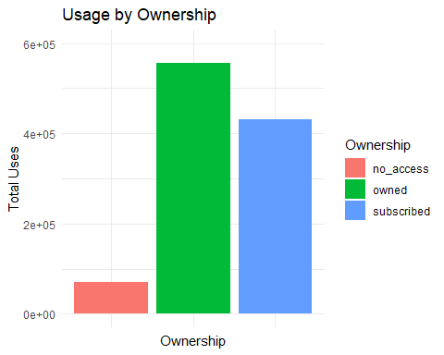

|  |  |  |
| --- | --- | --- |
| Ownership | Total_Uses | Percentage |
| no_access | 69420 | 6.56 |
| owned | 556540 | 52.62 |
| subscribed | 431608 | 40.81 |
|  |  |  |

## Year by Year Comparison

### Usage by Year

The following plot and table display the total number of title uses by year. The table also displays percentage of usage per year. This summary is cumulative meaning titles are not summed by the year of purchase. Titles were given a value of “owned” based off of the license end date in the UW system all access titles report which gives a list of all titles the UW system has access to as of October 2020. This summary of usage simply accounts for the number of usages owned and subscribed titles the UW system has access to in 2020 got for each year 2014-2018. Note, the same title may be counted multiple times in a year if it was accessed by multiple campuses.

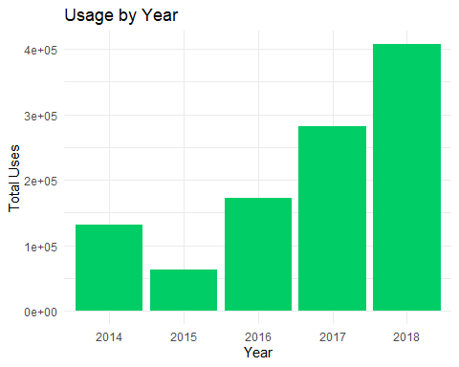

|  |  |  |
| --- | --- | --- |
| Year | Total_Uses | Percentage |
| 2014 | 132142 | 12.49 |
| 2015 | 63051 | 5.96 |
| 2016 | 172782 | 16.34 |
| 2017 | 282347 | 26.70 |
| 2018 | 407246 | 38.51 |

### Usage by Year and Ownership: Cumulative

The following plot and table summarizes the total number of owned titles compared to subscribed titles by year. The table includes percentage of use by ownership type per year. 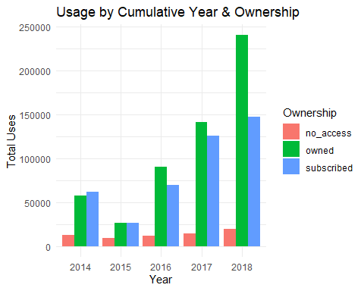

|  |  |  |  |
| --- | --- | --- | --- |
| Year | Ownership | Total_Uses | Percentage |
| 2014 | no_access | 12669 | 9.59 |
| 2014 | owned | 57777 | 43.72 |
| 2014 | subscribed | 61696 | 46.69 |
| 2015 | no_access | 9803 | 15.55 |
| 2015 | owned | 26951 | 42.74 |
| 2015 | subscribed | 26297 | 41.71 |
| 2016 | no_access | 12432 | 7.20 |
| 2016 | owned | 90281 | 52.25 |
| 2016 | subscribed | 70069 | 40.55 |
| 2017 | no_access | 15036 | 5.33 |
| 2017 | owned | 141249 | 50.03 |
| 2017 | subscribed | 126062 | 44.65 |
| 2018 | no_access | 19480 | 4.78 |
| 2018 | owned | 240282 | 59.00 |
| 2018 | subscribed | 147484 | 36.21 |

### Owned Titles Usage by Purchase Year: Non-Cumulative

The following plot and table give a summary of owned titles only. The table includes percentage of owned titles usage by year. These summaries represent the number uses for owned titles based on the year of purchase from 2015-2020. Note that 2020 data was not complete as the data was collected in October, and 2020 usage may look much lower than it actually is.

A dataset including only owned titles will be used to visualize and summarized owned title usage.

owned <- full_df[full_df$Ownership=="owned",]

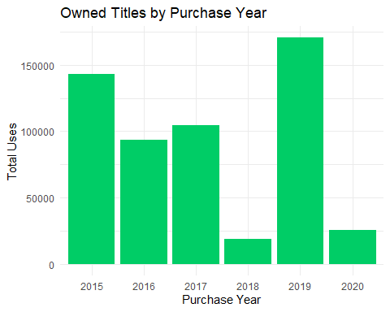

|  |  |  |
| --- | --- | --- |
| Purchase.Year | Total_Uses | Percentage |
| 2015 | 143262 | 25.74 |
| 2016 | 93573 | 16.81 |
| 2017 | 104595 | 18.79 |
| 2018 | 18765 | 3.37 |
| 2019 | 170560 | 30.65 |
| 2020 | 25785 | 4.63 |

All subscribed titles have a urchase year of 2020 as seen below, so there is nothing further to explore.

|  |  |
| --- | --- |
| Purchase.Year | Total_Uses |
| 2020 | 431608 |
|  |  |

## Campus Comparison

### Usage by Campus

The following plot and table display the total number of title uses by campus. The table also displays percentage of usage per campus. 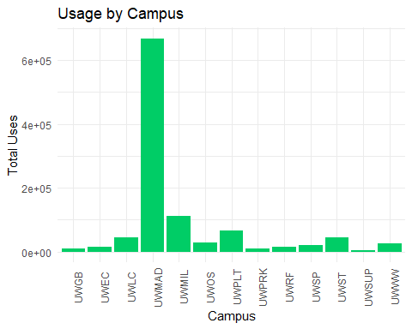

|  |  |  |
| --- | --- | --- |
| Campus | Total_Uses | Percentage |
| UWGB | 9563 | 0.90 |
| UWEC | 15808 | 1.49 |
| UWLC | 43674 | 4.13 |
| UWMAD | 668451 | 63.21 |
| UWMIL | 110496 | 10.45 |
| UWOS | 27507 | 2.60 |
| UWPLT | 65809 | 6.22 |
| UWPRK | 8422 | 0.80 |
| UWRF | 14075 | 1.33 |
| UWSP | 19922 | 1.88 |
| UWST | 43188 | 4.08 |
| UWSUP | 3942 | 0.37 |
| UWWW | 26711 | 2.53 |
|  |  |  |

### Usage by Campus and Ownership

The following plot and table depict the total number of uses for owned titles compared to subscribed titles by Campus. The table also includes percentage of usage by ownership type each year

. 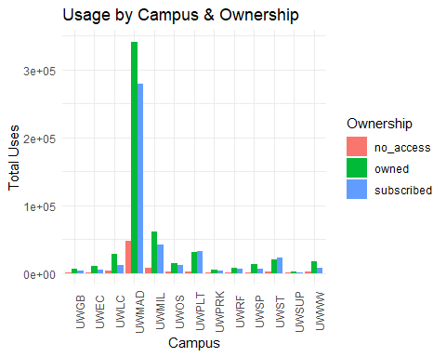

|  |  |  |
| --- | --- | --- |
| Campus | Total_Uses | Percentage |
| UWGB | 9563 | 0.90 |
| UWEC | 15808 | 1.49 |
| UWLC | 43674 | 4.13 |
| UWMAD | 668451 | 63.21 |
| UWMIL | 110496 | 10.45 |
| UWOS | 27507 | 2.60 |
| UWPLT | 65809 | 6.22 |
| UWPRK | 8422 | 0.80 |
| UWRF | 14075 | 1.33 |
| UWSP | 19922 | 1.88 |
| UWST | 43188 | 4.08 |
| UWSUP | 3942 | 0.37 |
| UWWW | 26711 | 2.53 |
|  |  |  |

### Usage by Ownership, Campus, and Year: Cumulative

The following plots and tables break down the number of uses for owned titles and subscribed titles for each year by campus. 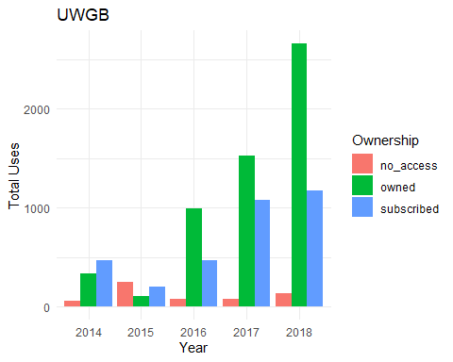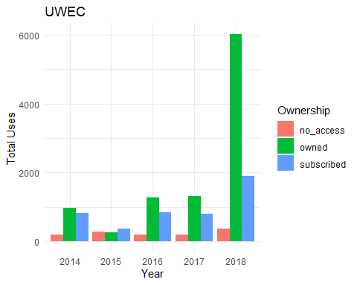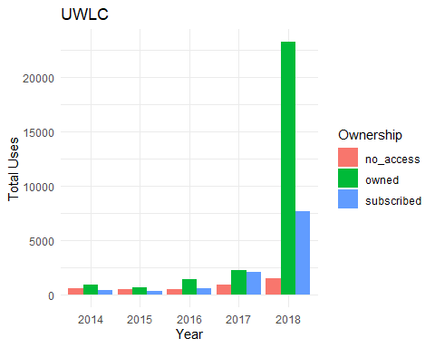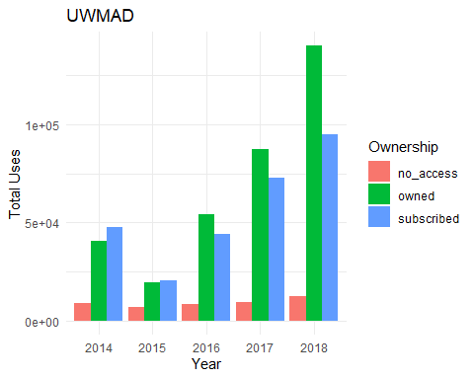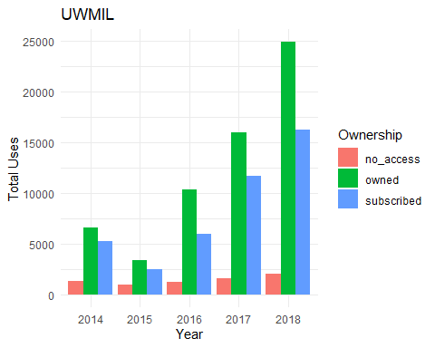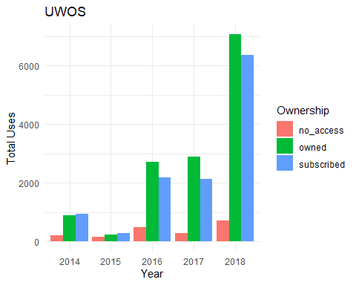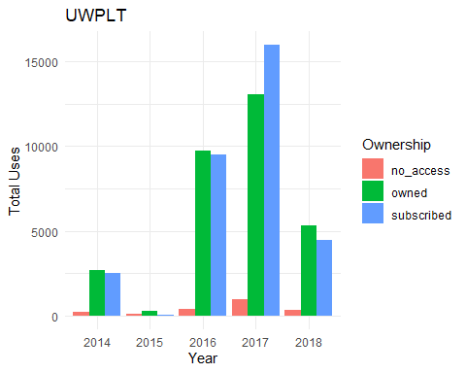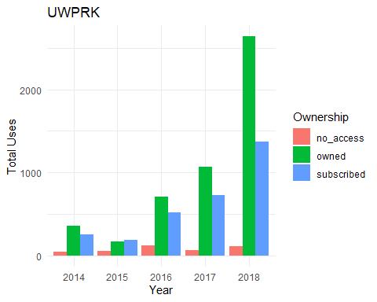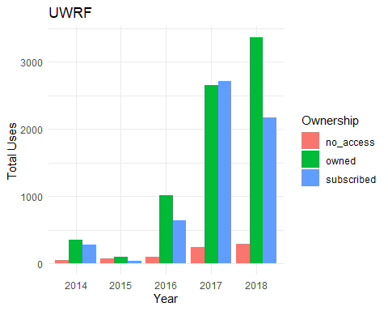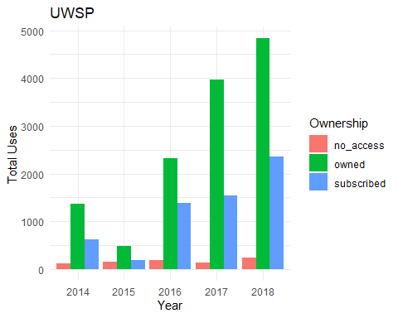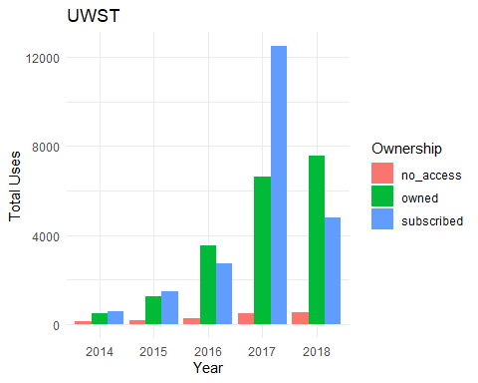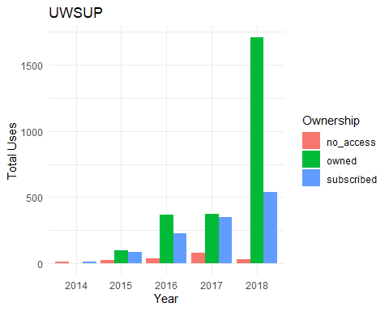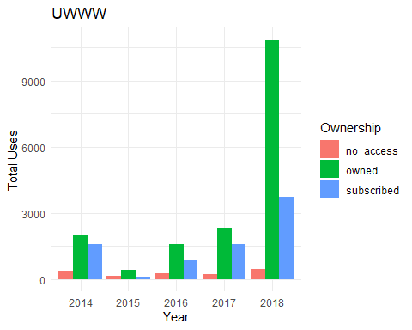

## [1] "UWGB"  
##   
##   
## |Year |Ownership | Total_Uses|  
## |:----|:----------|----------:|  
## |2014 |no_access | 53|  
## |2014 |owned | 337|  
## |2014 |subscribed | 463|  
## |2015 |no_access | 251|  
## |2015 |owned | 102|  
## |2015 |subscribed | 197|  
## |2016 |no_access | 72|  
## |2016 |owned | 988|  
## |2016 |subscribed | 465|  
## |2017 |no_access | 80|  
## |2017 |owned | 1522|  
## |2017 |subscribed | 1074|  
## |2018 |no_access | 131|  
## |2018 |owned | 2659|  
## |2018 |subscribed | 1169|  
## [1] "UWEC"  
##   
##   
## |Year |Ownership | Total_Uses|  
## |:----|:----------|----------:|  
## |2014 |no_access | 198|  
## |2014 |owned | 975|  
## |2014 |subscribed | 819|  
## |2015 |no_access | 289|  
## |2015 |owned | 249|  
## |2015 |subscribed | 364|  
## |2016 |no_access | 195|  
## |2016 |owned | 1277|  
## |2016 |subscribed | 852|  
## |2017 |no_access | 203|  
## |2017 |owned | 1307|  
## |2017 |subscribed | 800|  
## |2018 |no_access | 359|  
## |2018 |owned | 6024|  
## |2018 |subscribed | 1897|  
## [1] "UWLC"  
##   
##   
## |Year |Ownership | Total_Uses|  
## |:----|:----------|----------:|  
## |2014 |no_access | 600|  
## |2014 |owned | 892|  
## |2014 |subscribed | 404|  
## |2015 |no_access | 499|  
## |2015 |owned | 693|  
## |2015 |subscribed | 341|  
## |2016 |no_access | 491|  
## |2016 |owned | 1430|  
## |2016 |subscribed | 595|  
## |2017 |no_access | 933|  
## |2017 |owned | 2264|  
## |2017 |subscribed | 2084|  
## |2018 |no_access | 1476|  
## |2018 |owned | 23288|  
## |2018 |subscribed | 7684|  
## [1] "UWMAD"  
##   
##   
## |Year |Ownership | Total_Uses|  
## |:----|:----------|----------:|  
## |2014 |no_access | 9274|  
## |2014 |owned | 40759|  
## |2014 |subscribed | 47898|  
## |2015 |no_access | 6842|  
## |2015 |owned | 19412|  
## |2015 |subscribed | 20441|  
## |2016 |no_access | 8562|  
## |2016 |owned | 54211|  
## |2016 |subscribed | 44038|  
## |2017 |no_access | 9665|  
## |2017 |owned | 87151|  
## |2017 |subscribed | 72801|  
## |2018 |no_access | 12767|  
## |2018 |owned | 140004|  
## |2018 |subscribed | 94626|  
## [1] "UWMIL"  
##   
##   
## |Year |Ownership | Total_Uses|  
## |:----|:----------|----------:|  
## |2014 |no_access | 1343|  
## |2014 |owned | 6652|  
## |2014 |subscribed | 5282|  
## |2015 |no_access | 1019|  
## |2015 |owned | 3420|  
## |2015 |subscribed | 2482|  
## |2016 |no_access | 1227|  
## |2016 |owned | 10349|  
## |2016 |subscribed | 6014|  
## |2017 |no_access | 1650|  
## |2017 |owned | 16020|  
## |2017 |subscribed | 11731|  
## |2018 |no_access | 2062|  
## |2018 |owned | 24938|  
## |2018 |subscribed | 16307|  
## [1] "UWOS"  
##   
##   
## |Year |Ownership | Total_Uses|  
## |:----|:----------|----------:|  
## |2014 |no_access | 193|  
## |2014 |owned | 886|  
## |2014 |subscribed | 934|  
## |2015 |no_access | 162|  
## |2015 |owned | 229|  
## |2015 |subscribed | 289|  
## |2016 |no_access | 479|  
## |2016 |owned | 2712|  
## |2016 |subscribed | 2183|  
## |2017 |no_access | 279|  
## |2017 |owned | 2879|  
## |2017 |subscribed | 2139|  
## |2018 |no_access | 705|  
## |2018 |owned | 7072|  
## |2018 |subscribed | 6366|  
## [1] "UWPLT"  
##   
##   
## |Year |Ownership | Total_Uses|  
## |:----|:----------|----------:|  
## |2014 |no_access | 218|  
## |2014 |owned | 2684|  
## |2014 |subscribed | 2540|  
## |2015 |no_access | 102|  
## |2015 |owned | 311|  
## |2015 |subscribed | 86|  
## |2016 |no_access | 424|  
## |2016 |owned | 9756|  
## |2016 |subscribed | 9511|  
## |2017 |no_access | 970|  
## |2017 |owned | 13074|  
## |2017 |subscribed | 15979|  
## |2018 |no_access | 331|  
## |2018 |owned | 5340|  
## |2018 |subscribed | 4483|  
## [1] "UWPRK"  
##   
##   
## |Year |Ownership | Total_Uses|  
## |:----|:----------|----------:|  
## |2014 |no_access | 48|  
## |2014 |owned | 364|  
## |2014 |subscribed | 251|  
## |2015 |no_access | 57|  
## |2015 |owned | 175|  
## |2015 |subscribed | 185|  
## |2016 |no_access | 119|  
## |2016 |owned | 710|  
## |2016 |subscribed | 517|  
## |2017 |no_access | 65|  
## |2017 |owned | 1073|  
## |2017 |subscribed | 732|  
## |2018 |no_access | 111|  
## |2018 |owned | 2639|  
## |2018 |subscribed | 1376|  
## [1] "UWRF"  
##   
##   
## |Year |Ownership | Total_Uses|  
## |:----|:----------|----------:|  
## |2014 |no_access | 54|  
## |2014 |owned | 353|  
## |2014 |subscribed | 274|  
## |2015 |no_access | 71|  
## |2015 |owned | 91|  
## |2015 |subscribed | 37|  
## |2016 |no_access | 91|  
## |2016 |owned | 1019|  
## |2016 |subscribed | 640|  
## |2017 |no_access | 236|  
## |2017 |owned | 2659|  
## |2017 |subscribed | 2719|  
## |2018 |no_access | 295|  
## |2018 |owned | 3365|  
## |2018 |subscribed | 2171|  
## [1] "UWSP"  
##   
##   
## |Year |Ownership | Total_Uses|  
## |:----|:----------|----------:|  
## |2014 |no_access | 121|  
## |2014 |owned | 1363|  
## |2014 |subscribed | 630|  
## |2015 |no_access | 161|  
## |2015 |owned | 478|  
## |2015 |subscribed | 191|  
## |2016 |no_access | 193|  
## |2016 |owned | 2324|  
## |2016 |subscribed | 1384|  
## |2017 |no_access | 136|  
## |2017 |owned | 3967|  
## |2017 |subscribed | 1546|  
## |2018 |no_access | 239|  
## |2018 |owned | 4836|  
## |2018 |subscribed | 2353|  
## [1] "UWST"  
##   
##   
## |Year |Ownership | Total_Uses|  
## |:----|:----------|----------:|  
## |2014 |no_access | 151|  
## |2014 |owned | 492|  
## |2014 |subscribed | 585|  
## |2015 |no_access | 180|  
## |2015 |owned | 1254|  
## |2015 |subscribed | 1482|  
## |2016 |no_access | 281|  
## |2016 |owned | 3529|  
## |2016 |subscribed | 2747|  
## |2017 |no_access | 507|  
## |2017 |owned | 6614|  
## |2017 |subscribed | 12500|  
## |2018 |no_access | 525|  
## |2018 |owned | 7562|  
## |2018 |subscribed | 4779|  
## [1] "UWSUP"  
##   
##   
## |Year |Ownership | Total_Uses|  
## |:----|:----------|----------:|  
## |2014 |no_access | 14|  
## |2014 |owned | 3|  
## |2014 |subscribed | 10|  
## |2015 |no_access | 24|  
## |2015 |owned | 96|  
## |2015 |subscribed | 86|  
## |2016 |no_access | 37|  
## |2016 |owned | 368|  
## |2016 |subscribed | 225|  
## |2017 |no_access | 82|  
## |2017 |owned | 375|  
## |2017 |subscribed | 349|  
## |2018 |no_access | 29|  
## |2018 |owned | 1708|  
## |2018 |subscribed | 536|  
## [1] "UWWW"  
##   
##   
## |Year |Ownership | Total_Uses|  
## |:----|:----------|----------:|  
## |2014 |no_access | 402|  
## |2014 |owned | 2017|  
## |2014 |subscribed | 1606|  
## |2015 |no_access | 146|  
## |2015 |owned | 441|  
## |2015 |subscribed | 116|  
## |2016 |no_access | 261|  
## |2016 |owned | 1608|  
## |2016 |subscribed | 898|  
## |2017 |no_access | 230|  
## |2017 |owned | 2344|  
## |2017 |subscribed | 1608|  
## |2018 |no_access | 450|  
## |2018 |owned | 10847|  
## |2018 |subscribed | 3737|

### Owned Titles Usage by Campus and Purchase Year: Non-cumulative

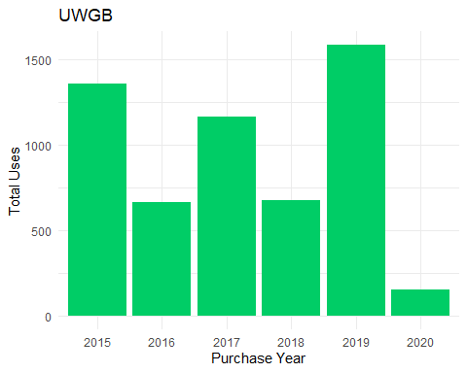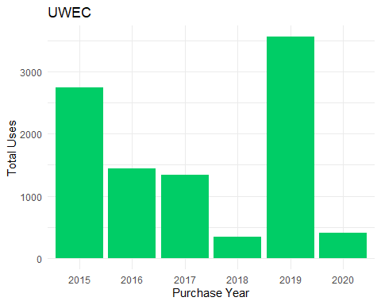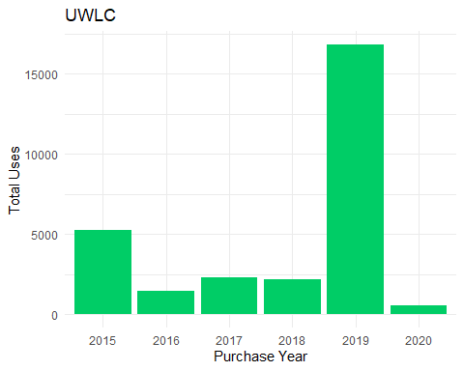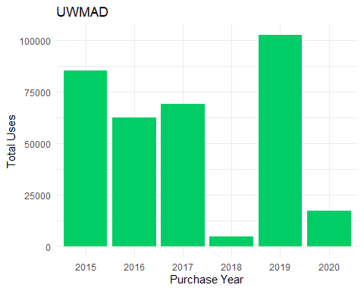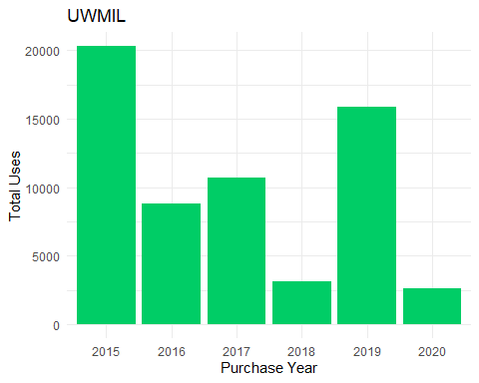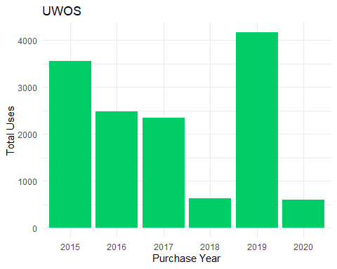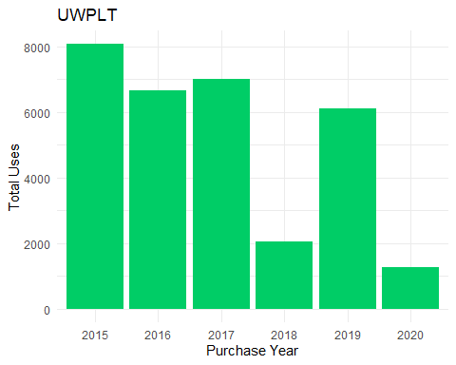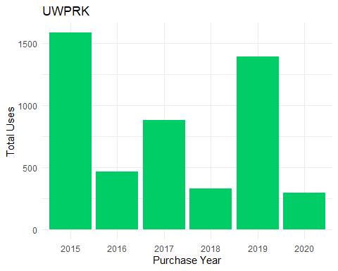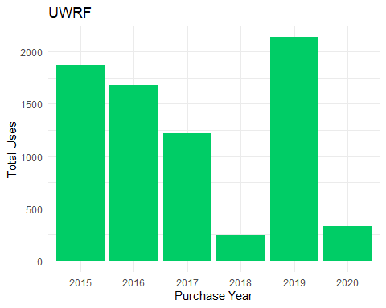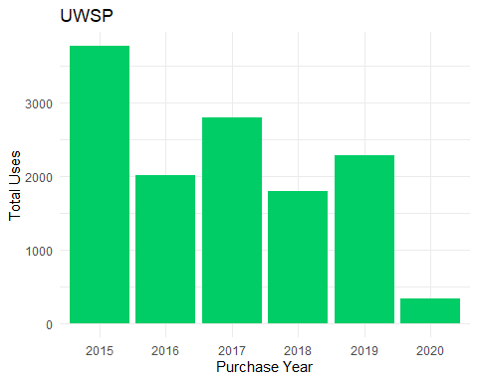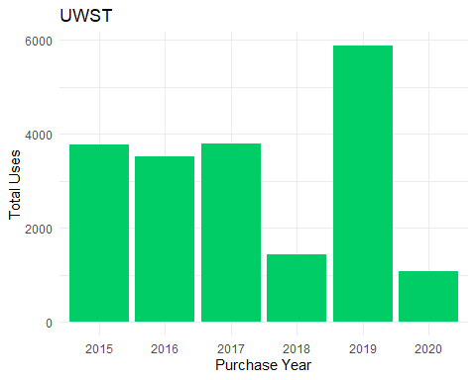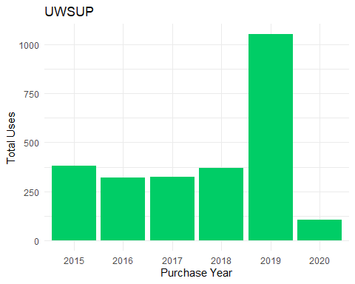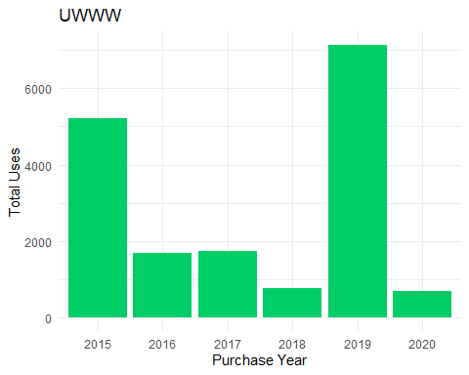

## [1] "UWGB"  
##   
##   
## |Purchase.Year | Total_Uses|  
## |:-------------|----------:|  
## |2015 | 1360|  
## |2016 | 664|  
## |2017 | 1165|  
## |2018 | 677|  
## |2019 | 1587|  
## |2020 | 155|  
## [1] "UWEC"  
##   
##   
## |Purchase.Year | Total_Uses|  
## |:-------------|----------:|  
## |2015 | 2741|  
## |2016 | 1445|  
## |2017 | 1334|  
## |2018 | 349|  
## |2019 | 3557|  
## |2020 | 406|  
## [1] "UWLC"  
##   
##   
## |Purchase.Year | Total_Uses|  
## |:-------------|----------:|  
## |2015 | 5260|  
## |2016 | 1439|  
## |2017 | 2289|  
## |2018 | 2198|  
## |2019 | 16830|  
## |2020 | 551|  
## [1] "UWMAD"  
##   
##   
## |Purchase.Year | Total_Uses|  
## |:-------------|----------:|  
## |2015 | 85359|  
## |2016 | 62418|  
## |2017 | 69001|  
## |2018 | 4812|  
## |2019 | 102553|  
## |2020 | 17394|  
## [1] "UWMIL"  
##   
##   
## |Purchase.Year | Total_Uses|  
## |:-------------|----------:|  
## |2015 | 20317|  
## |2016 | 8783|  
## |2017 | 10708|  
## |2018 | 3103|  
## |2019 | 15874|  
## |2020 | 2594|  
## [1] "UWOS"  
##   
##   
## |Purchase.Year | Total_Uses|  
## |:-------------|----------:|  
## |2015 | 3557|  
## |2016 | 2485|  
## |2017 | 2343|  
## |2018 | 631|  
## |2019 | 4170|  
## |2020 | 592|  
## [1] "UWPLT"  
##   
##   
## |Purchase.Year | Total_Uses|  
## |:-------------|----------:|  
## |2015 | 8074|  
## |2016 | 6658|  
## |2017 | 6996|  
## |2018 | 2057|  
## |2019 | 6113|  
## |2020 | 1267|  
## [1] "UWPRK"  
##   
##   
## |Purchase.Year | Total_Uses|  
## |:-------------|----------:|  
## |2015 | 1587|  
## |2016 | 466|  
## |2017 | 884|  
## |2018 | 332|  
## |2019 | 1396|  
## |2020 | 296|  
## [1] "UWRF"  
##   
##   
## |Purchase.Year | Total_Uses|  
## |:-------------|----------:|  
## |2015 | 1872|  
## |2016 | 1677|  
## |2017 | 1220|  
## |2018 | 248|  
## |2019 | 2139|  
## |2020 | 331|  
## [1] "UWSP"  
##   
##   
## |Purchase.Year | Total_Uses|  
## |:-------------|----------:|  
## |2015 | 3763|  
## |2016 | 2016|  
## |2017 | 2790|  
## |2018 | 1788|  
## |2019 | 2278|  
## |2020 | 333|  
## [1] "UWST"  
##   
##   
## |Purchase.Year | Total_Uses|  
## |:-------------|----------:|  
## |2015 | 3771|  
## |2016 | 3510|  
## |2017 | 3796|  
## |2018 | 1425|  
## |2019 | 5878|  
## |2020 | 1071|  
## [1] "UWSUP"  
##   
##   
## |Purchase.Year | Total_Uses|  
## |:-------------|----------:|  
## |2015 | 380|  
## |2016 | 320|  
## |2017 | 323|  
## |2018 | 368|  
## |2019 | 1052|  
## |2020 | 107|  
## [1] "UWWW"  
##   
##   
## |Purchase.Year | Total_Uses|  
## |:-------------|----------:|  
## |2015 | 5221|  
## |2016 | 1692|  
## |2017 | 1746|  
## |2018 | 777|  
## |2019 | 7133|  
## |2020 | 688|

## Subject Area Analysis

### Usage by Subject Area

The following plot and table show the usage of titles by subject area. The table also includes percentage of usage by subject 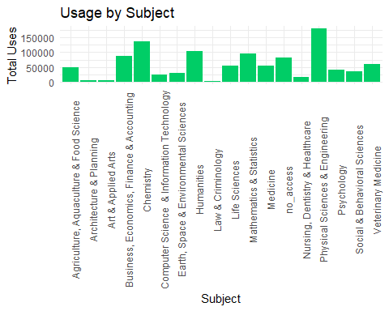

|  |  |  |
| --- | --- | --- |
| Subject | Total_Uses | Percentage |
| Agriculture, Aquaculture & Food Science | 48566 | 4.59 |
| Architecture & Planning | 3893 | 0.37 |
| Art & Applied Arts | 4784 | 0.45 |
| Business, Economics, Finance & Accounting | 87124 | 8.24 |
| Chemistry | 136698 | 12.93 |
| Computer Science & Information Technology | 24748 | 2.34 |
| Earth, Space & Environmental Sciences | 28186 | 2.67 |
| Humanities | 103438 | 9.78 |
| Law & Criminology | 3297 | 0.31 |
| Life Sciences | 55632 | 5.26 |
| Mathematics & Statistics | 94562 | 8.94 |
| Medicine | 53925 | 5.10 |
| no_access | 82300 | 7.78 |
| Nursing, Dentistry & Healthcare | 14612 | 1.38 |
| Physical Sciences & Engineering | 180412 | 17.06 |
| Psychology | 39304 | 3.72 |
| Social & Behavioral Sciences | 35527 | 3.36 |
| Veterinary Medicine | 60560 | 5.73 |

### Subject Area Usage by Ownership

The plot and table show the total uses for owned vs subscribed titles by subject area. The table shows percentage of usage by ownership type for each subject. 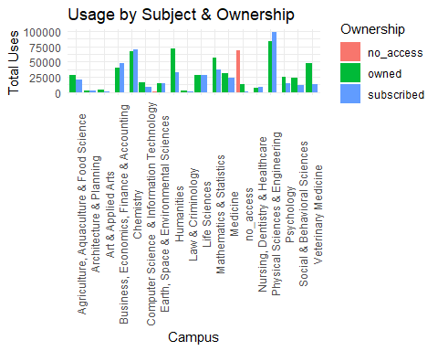

|  |  |  |  |
| --- | --- | --- | --- |
| Subject | Ownership | Total_Uses | Percentage |
| Agriculture, Aquaculture & Food Science | owned | 28139 | 57.94 |
| Agriculture, Aquaculture & Food Science | subscribed | 20427 | 42.06 |
| Architecture & Planning | owned | 1952 | 50.14 |
| Architecture & Planning | subscribed | 1941 | 49.86 |
| Art & Applied Arts | owned | 3940 | 82.36 |
| Art & Applied Arts | subscribed | 844 | 17.64 |
| Business, Economics, Finance & Accounting | no_access | 31 | 0.04 |
| Business, Economics, Finance & Accounting | owned | 39666 | 45.53 |
| Business, Economics, Finance & Accounting | subscribed | 47427 | 54.44 |
| Chemistry | no_access | 157 | 0.11 |
| Chemistry | owned | 66752 | 48.83 |
| Chemistry | subscribed | 69789 | 51.05 |
| Computer Science & Information Technology | owned | 16466 | 66.53 |
| Computer Science & Information Technology | subscribed | 8282 | 33.47 |
| Earth, Space & Environmental Sciences | no_access | 309 | 1.10 |
| Earth, Space & Environmental Sciences | owned | 13961 | 49.53 |
| Earth, Space & Environmental Sciences | subscribed | 13916 | 49.37 |
| Humanities | no_access | 199 | 0.19 |
| Humanities | owned | 70684 | 68.33 |
| Humanities | subscribed | 32555 | 31.47 |
| Law & Criminology | owned | 1850 | 56.11 |
| Law & Criminology | subscribed | 1447 | 43.89 |
| Life Sciences | owned | 27293 | 49.06 |
| Life Sciences | subscribed | 28339 | 50.94 |
| Mathematics & Statistics | no_access | 172 | 0.18 |
| Mathematics & Statistics | owned | 56850 | 60.12 |
| Mathematics & Statistics | subscribed | 37540 | 39.70 |
| Medicine | owned | 30563 | 56.68 |
| Medicine | subscribed | 23362 | 43.32 |
| no_access | no_access | 68499 | 83.23 |
| no_access | owned | 13428 | 16.32 |
| no_access | subscribed | 373 | 0.45 |
| Nursing, Dentistry & Healthcare | no_access | 1 | 0.01 |
| Nursing, Dentistry & Healthcare | owned | 6475 | 44.31 |
| Nursing, Dentistry & Healthcare | subscribed | 8136 | 55.68 |
| Physical Sciences & Engineering | no_access | 47 | 0.03 |
| Physical Sciences & Engineering | owned | 82693 | 45.84 |
| Physical Sciences & Engineering | subscribed | 97672 | 54.14 |
| Psychology | no_access | 5 | 0.01 |
| Psychology | owned | 24575 | 62.53 |
| Psychology | subscribed | 14724 | 37.46 |
| Social & Behavioral Sciences | owned | 23783 | 66.94 |
| Social & Behavioral Sciences | subscribed | 11744 | 33.06 |
| Veterinary Medicine | owned | 47470 | 78.39 |
| Veterinary Medicine | subscribed | 13090 | 21.61 |

### Subject Area Usage by Campus

The following plots and tables break down the number of uses for owned titles and subscribed titles for each subject area and campus. 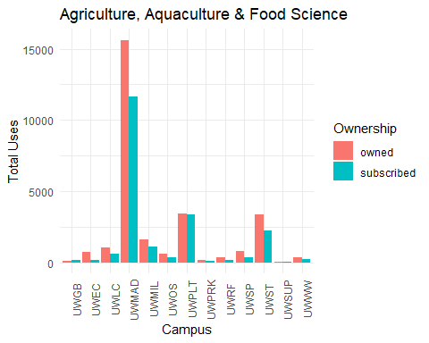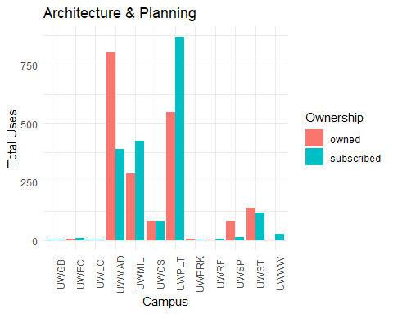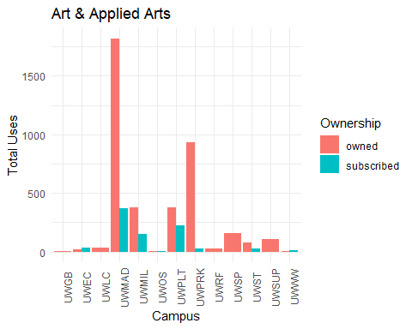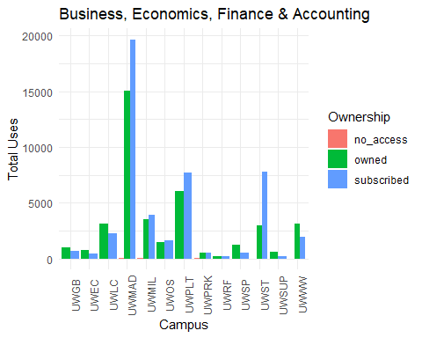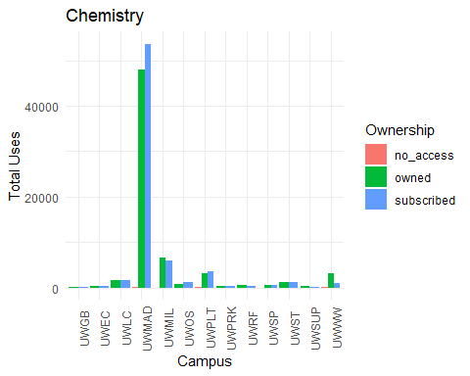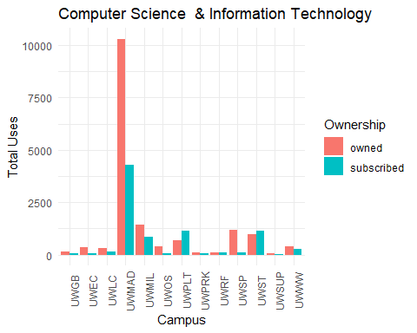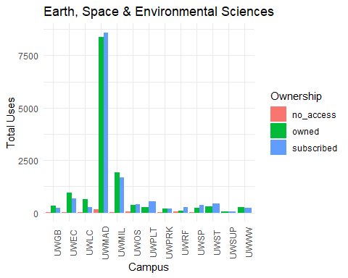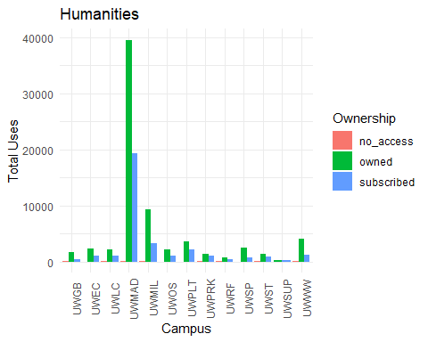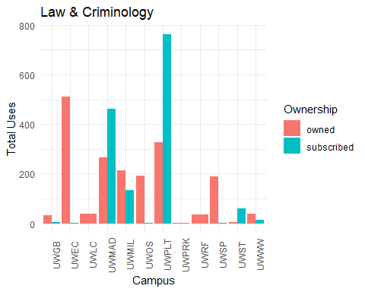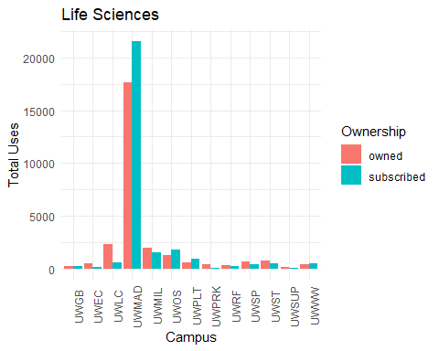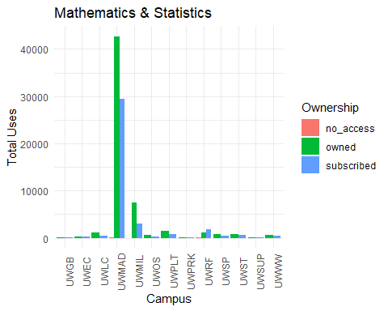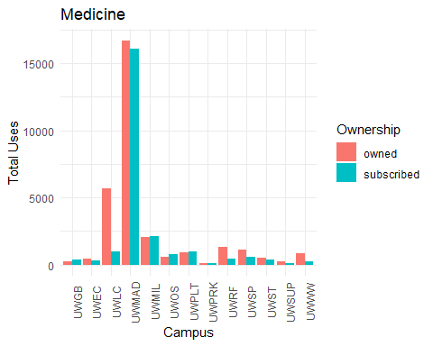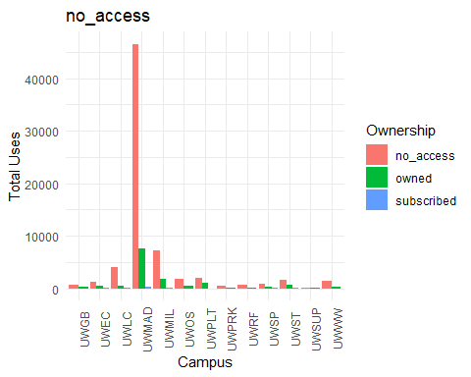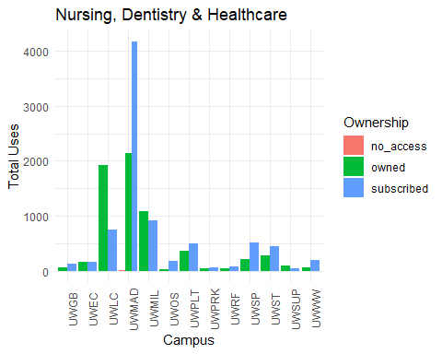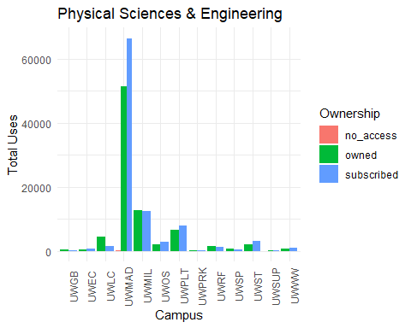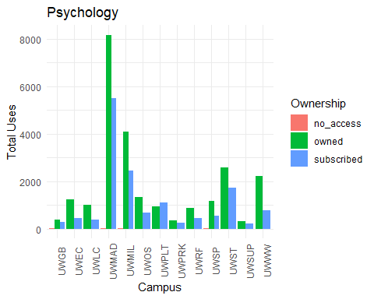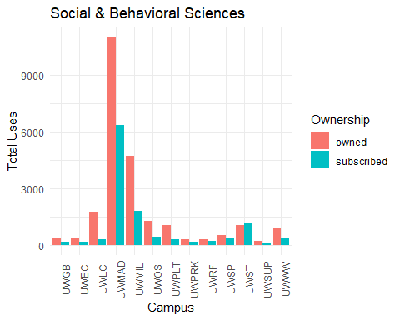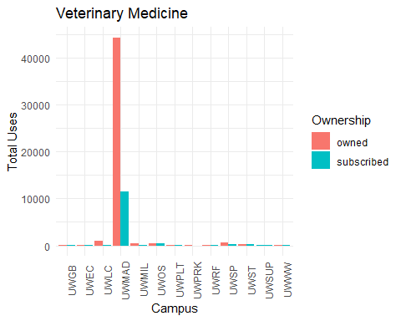

## [1] "Agriculture, Aquaculture & Food Science"  
##   
##   
## |Campus |Ownership | Total_Uses|  
## |:------|:----------|----------:|  
## |UWGB |owned | 87|  
## |UWGB |subscribed | 174|  
## |UWEC |owned | 752|  
## |UWEC |subscribed | 131|  
## |UWLC |owned | 1053|  
## |UWLC |subscribed | 595|  
## |UWMAD |owned | 15633|  
## |UWMAD |subscribed | 11623|  
## |UWMIL |owned | 1604|  
## |UWMIL |subscribed | 1094|  
## |UWOS |owned | 593|  
## |UWOS |subscribed | 364|  
## |UWPLT |owned | 3396|  
## |UWPLT |subscribed | 3346|  
## |UWPRK |owned | 148|  
## |UWPRK |subscribed | 64|  
## |UWRF |owned | 348|  
## |UWRF |subscribed | 177|  
## |UWSP |owned | 814|  
## |UWSP |subscribed | 350|  
## |UWST |owned | 3335|  
## |UWST |subscribed | 2244|  
## |UWSUP |owned | 15|  
## |UWSUP |subscribed | 49|  
## |UWWW |owned | 361|  
## |UWWW |subscribed | 216|  
## [1] "Architecture & Planning"  
##   
##   
## |Campus |Ownership | Total_Uses|  
## |:------|:----------|----------:|  
## |UWGB |subscribed | 2|  
## |UWEC |owned | 6|  
## |UWEC |subscribed | 8|  
## |UWLC |subscribed | 1|  
## |UWMAD |owned | 804|  
## |UWMAD |subscribed | 391|  
## |UWMIL |owned | 286|  
## |UWMIL |subscribed | 424|  
## |UWOS |owned | 82|  
## |UWOS |subscribed | 82|  
## |UWPLT |owned | 546|  
## |UWPLT |subscribed | 871|  
## |UWPRK |owned | 7|  
## |UWPRK |subscribed | 1|  
## |UWRF |owned | 1|  
## |UWRF |subscribed | 4|  
## |UWSP |owned | 81|  
## |UWSP |subscribed | 14|  
## |UWST |owned | 137|  
## |UWST |subscribed | 118|  
## |UWWW |owned | 2|  
## |UWWW |subscribed | 25|  
## [1] "Art & Applied Arts"  
##   
##   
## |Campus |Ownership | Total_Uses|  
## |:------|:----------|----------:|  
## |UWGB |owned | 1|  
## |UWEC |owned | 15|  
## |UWEC |subscribed | 32|  
## |UWLC |owned | 33|  
## |UWMAD |owned | 1821|  
## |UWMAD |subscribed | 367|  
## |UWMIL |owned | 378|  
## |UWMIL |subscribed | 152|  
## |UWOS |owned | 7|  
## |UWOS |subscribed | 4|  
## |UWPLT |owned | 379|  
## |UWPLT |subscribed | 225|  
## |UWPRK |owned | 936|  
## |UWPRK |subscribed | 24|  
## |UWRF |owned | 29|  
## |UWSP |owned | 157|  
## |UWST |owned | 78|  
## |UWST |subscribed | 27|  
## |UWSUP |owned | 103|  
## |UWWW |owned | 3|  
## |UWWW |subscribed | 13|  
## [1] "Business, Economics, Finance & Accounting"  
##   
##   
## |Campus |Ownership | Total_Uses|  
## |:------|:----------|----------:|  
## |UWGB |owned | 1012|  
## |UWGB |subscribed | 696|  
## |UWEC |owned | 724|  
## |UWEC |subscribed | 400|  
## |UWLC |owned | 3132|  
## |UWLC |subscribed | 2238|  
## |UWMAD |no_access | 22|  
## |UWMAD |owned | 15070|  
## |UWMAD |subscribed | 19676|  
## |UWMIL |no_access | 4|  
## |UWMIL |owned | 3498|  
## |UWMIL |subscribed | 3910|  
## |UWOS |owned | 1471|  
## |UWOS |subscribed | 1623|  
## |UWPLT |owned | 6068|  
## |UWPLT |subscribed | 7734|  
## |UWPRK |no_access | 3|  
## |UWPRK |owned | 532|  
## |UWPRK |subscribed | 481|  
## |UWRF |owned | 234|  
## |UWRF |subscribed | 212|  
## |UWSP |owned | 1233|  
## |UWSP |subscribed | 537|  
## |UWST |no_access | 1|  
## |UWST |owned | 2974|  
## |UWST |subscribed | 7800|  
## |UWSUP |owned | 556|  
## |UWSUP |subscribed | 214|  
## |UWWW |no_access | 1|  
## |UWWW |owned | 3162|  
## |UWWW |subscribed | 1906|  
## [1] "Chemistry"  
##   
##   
## |Campus |Ownership | Total_Uses|  
## |:------|:----------|----------:|  
## |UWGB |owned | 128|  
## |UWGB |subscribed | 218|  
## |UWEC |owned | 395|  
## |UWEC |subscribed | 327|  
## |UWLC |owned | 1591|  
## |UWLC |subscribed | 1703|  
## |UWMAD |no_access | 95|  
## |UWMAD |owned | 47923|  
## |UWMAD |subscribed | 53707|  
## |UWMIL |no_access | 2|  
## |UWMIL |owned | 6589|  
## |UWMIL |subscribed | 5889|  
## |UWOS |owned | 824|  
## |UWOS |subscribed | 1144|  
## |UWPLT |no_access | 40|  
## |UWPLT |owned | 3207|  
## |UWPLT |subscribed | 3491|  
## |UWPRK |owned | 244|  
## |UWPRK |subscribed | 314|  
## |UWRF |owned | 449|  
## |UWRF |subscribed | 288|  
## |UWSP |no_access | 1|  
## |UWSP |owned | 642|  
## |UWSP |subscribed | 543|  
## |UWST |owned | 1293|  
## |UWST |subscribed | 1266|  
## |UWSUP |owned | 336|  
## |UWSUP |subscribed | 30|  
## |UWWW |no_access | 19|  
## |UWWW |owned | 3131|  
## |UWWW |subscribed | 869|  
## [1] "Computer Science & Information Technology"  
##   
##   
## |Campus |Ownership | Total_Uses|  
## |:------|:----------|----------:|  
## |UWGB |owned | 136|  
## |UWGB |subscribed | 50|  
## |UWEC |owned | 364|  
## |UWEC |subscribed | 55|  
## |UWLC |owned | 308|  
## |UWLC |subscribed | 163|  
## |UWMAD |owned | 10308|  
## |UWMAD |subscribed | 4275|  
## |UWMIL |owned | 1436|  
## |UWMIL |subscribed | 834|  
## |UWOS |owned | 402|  
## |UWOS |subscribed | 75|  
## |UWPLT |owned | 681|  
## |UWPLT |subscribed | 1126|  
## |UWPRK |owned | 112|  
## |UWPRK |subscribed | 60|  
## |UWRF |owned | 117|  
## |UWRF |subscribed | 84|  
## |UWSP |owned | 1189|  
## |UWSP |subscribed | 123|  
## |UWST |owned | 960|  
## |UWST |subscribed | 1147|  
## |UWSUP |owned | 56|  
## |UWSUP |subscribed | 29|  
## |UWWW |owned | 397|  
## |UWWW |subscribed | 261|  
## [1] "Earth, Space & Environmental Sciences"  
##   
##   
## |Campus |Ownership | Total_Uses|  
## |:------|:----------|----------:|  
## |UWGB |no_access | 4|  
## |UWGB |owned | 326|  
## |UWGB |subscribed | 216|  
## |UWEC |no_access | 1|  
## |UWEC |owned | 964|  
## |UWEC |subscribed | 685|  
## |UWLC |no_access | 1|  
## |UWLC |owned | 655|  
## |UWLC |subscribed | 273|  
## |UWMAD |no_access | 156|  
## |UWMAD |owned | 8372|  
## |UWMAD |subscribed | 8598|  
## |UWMIL |no_access | 29|  
## |UWMIL |owned | 1922|  
## |UWMIL |subscribed | 1667|  
## |UWOS |no_access | 67|  
## |UWOS |owned | 375|  
## |UWOS |subscribed | 392|  
## |UWPLT |owned | 263|  
## |UWPLT |subscribed | 549|  
## |UWPRK |no_access | 1|  
## |UWPRK |owned | 174|  
## |UWPRK |subscribed | 201|  
## |UWRF |no_access | 48|  
## |UWRF |owned | 94|  
## |UWRF |subscribed | 273|  
## |UWSP |no_access | 2|  
## |UWSP |owned | 227|  
## |UWSP |subscribed | 363|  
## |UWST |owned | 278|  
## |UWST |subscribed | 416|  
## |UWSUP |owned | 40|  
## |UWSUP |subscribed | 59|  
## |UWWW |owned | 271|  
## |UWWW |subscribed | 224|  
## [1] "Humanities"  
##   
##   
## |Campus |Ownership | Total_Uses|  
## |:------|:----------|----------:|  
## |UWGB |no_access | 3|  
## |UWGB |owned | 1633|  
## |UWGB |subscribed | 423|  
## |UWEC |no_access | 2|  
## |UWEC |owned | 2255|  
## |UWEC |subscribed | 1013|  
## |UWLC |no_access | 7|  
## |UWLC |owned | 2152|  
## |UWLC |subscribed | 1069|  
## |UWMAD |no_access | 57|  
## |UWMAD |owned | 39541|  
## |UWMAD |subscribed | 19287|  
## |UWMIL |no_access | 9|  
## |UWMIL |owned | 9244|  
## |UWMIL |subscribed | 3275|  
## |UWOS |no_access | 1|  
## |UWOS |owned | 2101|  
## |UWOS |subscribed | 1035|  
## |UWPLT |no_access | 1|  
## |UWPLT |owned | 3501|  
## |UWPLT |subscribed | 2138|  
## |UWPRK |no_access | 13|  
## |UWPRK |owned | 1349|  
## |UWPRK |subscribed | 1098|  
## |UWRF |no_access | 56|  
## |UWRF |owned | 676|  
## |UWRF |subscribed | 382|  
## |UWSP |no_access | 1|  
## |UWSP |owned | 2474|  
## |UWSP |subscribed | 643|  
## |UWST |no_access | 46|  
## |UWST |owned | 1361|  
## |UWST |subscribed | 889|  
## |UWSUP |owned | 318|  
## |UWSUP |subscribed | 162|  
## |UWWW |no_access | 3|  
## |UWWW |owned | 4079|  
## |UWWW |subscribed | 1141|  
## [1] "Law & Criminology"  
##   
##   
## |Campus |Ownership | Total_Uses|  
## |:------|:----------|----------:|  
## |UWGB |owned | 32|  
## |UWGB |subscribed | 6|  
## |UWEC |owned | 512|  
## |UWEC |subscribed | 1|  
## |UWLC |owned | 38|  
## |UWMAD |owned | 267|  
## |UWMAD |subscribed | 462|  
## |UWMIL |owned | 214|  
## |UWMIL |subscribed | 135|  
## |UWOS |owned | 192|  
## |UWOS |subscribed | 1|  
## |UWPLT |owned | 326|  
## |UWPLT |subscribed | 764|  
## |UWPRK |owned | 3|  
## |UWRF |owned | 34|  
## |UWSP |owned | 189|  
## |UWSP |subscribed | 3|  
## |UWST |owned | 6|  
## |UWST |subscribed | 61|  
## |UWWW |owned | 37|  
## |UWWW |subscribed | 14|  
## [1] "Life Sciences"  
##   
##   
## |Campus |Ownership | Total_Uses|  
## |:------|:----------|----------:|  
## |UWGB |owned | 250|  
## |UWGB |subscribed | 241|  
## |UWEC |owned | 515|  
## |UWEC |subscribed | 143|  
## |UWLC |owned | 2323|  
## |UWLC |subscribed | 576|  
## |UWMAD |owned | 17692|  
## |UWMAD |subscribed | 21590|  
## |UWMIL |owned | 1968|  
## |UWMIL |subscribed | 1481|  
## |UWOS |owned | 1287|  
## |UWOS |subscribed | 1751|  
## |UWPLT |owned | 536|  
## |UWPLT |subscribed | 941|  
## |UWPRK |owned | 418|  
## |UWPRK |subscribed | 76|  
## |UWRF |owned | 286|  
## |UWRF |subscribed | 206|  
## |UWSP |owned | 672|  
## |UWSP |subscribed | 403|  
## |UWST |owned | 775|  
## |UWST |subscribed | 452|  
## |UWSUP |owned | 142|  
## |UWSUP |subscribed | 23|  
## |UWWW |owned | 429|  
## |UWWW |subscribed | 456|  
## [1] "Mathematics & Statistics"  
##   
##   
## |Campus |Ownership | Total_Uses|  
## |:------|:----------|----------:|  
## |UWGB |owned | 122|  
## |UWGB |subscribed | 131|  
## |UWEC |owned | 185|  
## |UWEC |subscribed | 191|  
## |UWLC |owned | 1033|  
## |UWLC |subscribed | 471|  
## |UWMAD |no_access | 154|  
## |UWMAD |owned | 42716|  
## |UWMAD |subscribed | 29347|  
## |UWMIL |no_access | 2|  
## |UWMIL |owned | 7542|  
## |UWMIL |subscribed | 2952|  
## |UWOS |owned | 550|  
## |UWOS |subscribed | 275|  
## |UWPLT |owned | 1379|  
## |UWPLT |subscribed | 699|  
## |UWPRK |owned | 78|  
## |UWPRK |subscribed | 42|  
## |UWRF |no_access | 16|  
## |UWRF |owned | 1061|  
## |UWRF |subscribed | 1830|  
## |UWSP |owned | 719|  
## |UWSP |subscribed | 377|  
## |UWST |owned | 829|  
## |UWST |subscribed | 672|  
## |UWSUP |owned | 42|  
## |UWSUP |subscribed | 121|  
## |UWWW |owned | 594|  
## |UWWW |subscribed | 432|  
## [1] "Medicine"  
##   
##   
## |Campus |Ownership | Total_Uses|  
## |:------|:----------|----------:|  
## |UWGB |owned | 233|  
## |UWGB |subscribed | 348|  
## |UWEC |owned | 445|  
## |UWEC |subscribed | 331|  
## |UWLC |owned | 5651|  
## |UWLC |subscribed | 947|  
## |UWMAD |owned | 16715|  
## |UWMAD |subscribed | 16064|  
## |UWMIL |owned | 2051|  
## |UWMIL |subscribed | 2111|  
## |UWOS |owned | 546|  
## |UWOS |subscribed | 803|  
## |UWPLT |owned | 904|  
## |UWPLT |subscribed | 952|  
## |UWPRK |owned | 83|  
## |UWPRK |subscribed | 78|  
## |UWRF |owned | 1283|  
## |UWRF |subscribed | 425|  
## |UWSP |owned | 1076|  
## |UWSP |subscribed | 597|  
## |UWST |owned | 516|  
## |UWST |subscribed | 381|  
## |UWSUP |owned | 235|  
## |UWSUP |subscribed | 82|  
## |UWWW |owned | 825|  
## |UWWW |subscribed | 243|  
## [1] "no_access"  
##   
##   
## |Campus |Ownership | Total_Uses|  
## |:------|:----------|----------:|  
## |UWGB |no_access | 579|  
## |UWGB |owned | 267|  
## |UWEC |no_access | 1241|  
## |UWEC |owned | 434|  
## |UWEC |subscribed | 5|  
## |UWLC |no_access | 3991|  
## |UWLC |owned | 543|  
## |UWLC |subscribed | 7|  
## |UWMAD |no_access | 46578|  
## |UWMAD |owned | 7530|  
## |UWMAD |subscribed | 304|  
## |UWMIL |no_access | 7253|  
## |UWMIL |owned | 1798|  
## |UWMIL |subscribed | 22|  
## |UWOS |no_access | 1750|  
## |UWOS |owned | 407|  
## |UWPLT |no_access | 2004|  
## |UWPLT |owned | 946|  
## |UWPLT |subscribed | 2|  
## |UWPRK |no_access | 383|  
## |UWPRK |owned | 44|  
## |UWRF |no_access | 627|  
## |UWRF |owned | 107|  
## |UWSP |no_access | 845|  
## |UWSP |owned | 377|  
## |UWSP |subscribed | 29|  
## |UWST |no_access | 1597|  
## |UWST |owned | 719|  
## |UWST |subscribed | 4|  
## |UWSUP |no_access | 185|  
## |UWSUP |owned | 14|  
## |UWWW |no_access | 1466|  
## |UWWW |owned | 242|  
## [1] "Nursing, Dentistry & Healthcare"  
##   
##   
## |Campus |Ownership | Total_Uses|  
## |:------|:----------|----------:|  
## |UWGB |owned | 56|  
## |UWGB |subscribed | 134|  
## |UWEC |owned | 153|  
## |UWEC |subscribed | 168|  
## |UWLC |owned | 1919|  
## |UWLC |subscribed | 747|  
## |UWMAD |no_access | 1|  
## |UWMAD |owned | 2138|  
## |UWMAD |subscribed | 4182|  
## |UWMIL |owned | 1083|  
## |UWMIL |subscribed | 908|  
## |UWOS |owned | 33|  
## |UWOS |subscribed | 172|  
## |UWPLT |owned | 359|  
## |UWPLT |subscribed | 494|  
## |UWPRK |owned | 36|  
## |UWPRK |subscribed | 63|  
## |UWRF |owned | 44|  
## |UWRF |subscribed | 69|  
## |UWSP |owned | 213|  
## |UWSP |subscribed | 515|  
## |UWST |owned | 284|  
## |UWST |subscribed | 442|  
## |UWSUP |owned | 96|  
## |UWSUP |subscribed | 45|  
## |UWWW |owned | 61|  
## |UWWW |subscribed | 197|  
## [1] "Physical Sciences & Engineering"  
##   
##   
## |Campus |Ownership | Total_Uses|  
## |:------|:----------|----------:|  
## |UWGB |owned | 446|  
## |UWGB |subscribed | 235|  
## |UWEC |owned | 447|  
## |UWEC |subscribed | 571|  
## |UWLC |owned | 4476|  
## |UWLC |subscribed | 1509|  
## |UWMAD |no_access | 46|  
## |UWMAD |owned | 51438|  
## |UWMAD |subscribed | 66510|  
## |UWMIL |owned | 12577|  
## |UWMIL |subscribed | 12553|  
## |UWOS |owned | 1909|  
## |UWOS |subscribed | 2725|  
## |UWPLT |owned | 6608|  
## |UWPLT |subscribed | 7764|  
## |UWPRK |owned | 164|  
## |UWPRK |subscribed | 171|  
## |UWRF |owned | 1415|  
## |UWRF |subscribed | 1108|  
## |UWSP |owned | 589|  
## |UWSP |subscribed | 483|  
## |UWST |owned | 1981|  
## |UWST |subscribed | 3107|  
## |UWSUP |no_access | 1|  
## |UWSUP |owned | 94|  
## |UWSUP |subscribed | 108|  
## |UWWW |owned | 549|  
## |UWWW |subscribed | 828|  
## [1] "Psychology"  
##   
##   
## |Campus |Ownership | Total_Uses|  
## |:------|:----------|----------:|  
## |UWGB |no_access | 1|  
## |UWGB |owned | 371|  
## |UWGB |subscribed | 273|  
## |UWEC |owned | 1242|  
## |UWEC |subscribed | 435|  
## |UWLC |owned | 986|  
## |UWLC |subscribed | 387|  
## |UWMAD |no_access | 1|  
## |UWMAD |owned | 8173|  
## |UWMAD |subscribed | 5487|  
## |UWMIL |no_access | 2|  
## |UWMIL |owned | 4090|  
## |UWMIL |subscribed | 2454|  
## |UWOS |owned | 1317|  
## |UWOS |subscribed | 660|  
## |UWPLT |owned | 920|  
## |UWPLT |subscribed | 1092|  
## |UWPRK |owned | 333|  
## |UWPRK |subscribed | 237|  
## |UWRF |owned | 882|  
## |UWRF |subscribed | 443|  
## |UWSP |no_access | 1|  
## |UWSP |owned | 1174|  
## |UWSP |subscribed | 555|  
## |UWST |owned | 2562|  
## |UWST |subscribed | 1712|  
## |UWSUP |owned | 324|  
## |UWSUP |subscribed | 202|  
## |UWWW |owned | 2201|  
## |UWWW |subscribed | 787|  
## [1] "Social & Behavioral Sciences"  
##   
##   
## |Campus |Ownership | Total_Uses|  
## |:------|:----------|----------:|  
## |UWGB |owned | 394|  
## |UWGB |subscribed | 174|  
## |UWEC |owned | 374|  
## |UWEC |subscribed | 166|  
## |UWLC |owned | 1753|  
## |UWLC |subscribed | 310|  
## |UWMAD |owned | 11005|  
## |UWMAD |subscribed | 6351|  
## |UWMIL |owned | 4720|  
## |UWMIL |subscribed | 1803|  
## |UWOS |owned | 1269|  
## |UWOS |subscribed | 433|  
## |UWPLT |owned | 1051|  
## |UWPLT |subscribed | 273|  
## |UWPRK |owned | 280|  
## |UWPRK |subscribed | 150|  
## |UWRF |owned | 294|  
## |UWRF |subscribed | 210|  
## |UWSP |owned | 516|  
## |UWSP |subscribed | 318|  
## |UWST |owned | 1050|  
## |UWST |subscribed | 1157|  
## |UWSUP |owned | 179|  
## |UWSUP |subscribed | 51|  
## |UWWW |owned | 898|  
## |UWWW |subscribed | 348|  
## [1] "Veterinary Medicine"  
##   
##   
## |Campus |Ownership | Total_Uses|  
## |:------|:----------|----------:|  
## |UWGB |owned | 114|  
## |UWGB |subscribed | 47|  
## |UWEC |owned | 50|  
## |UWEC |subscribed | 70|  
## |UWLC |owned | 921|  
## |UWLC |subscribed | 112|  
## |UWMAD |owned | 44391|  
## |UWMAD |subscribed | 11583|  
## |UWMIL |owned | 379|  
## |UWMIL |subscribed | 152|  
## |UWOS |owned | 413|  
## |UWOS |subscribed | 372|  
## |UWPLT |owned | 95|  
## |UWPLT |subscribed | 138|  
## |UWPRK |owned | 20|  
## |UWPRK |subscribed | 1|  
## |UWRF |owned | 133|  
## |UWRF |subscribed | 130|  
## |UWSP |owned | 626|  
## |UWSP |subscribed | 251|  
## |UWST |owned | 313|  
## |UWST |subscribed | 198|  
## |UWSUP |subscribed | 31|  
## |UWWW |owned | 15|  
## |UWWW |subscribed | 5|

### 

### Subject Area Usage by Year:Cumulative

The following demonstrates the total number of uses for owned compared to subscribed titles for each subject category and year (cumulative) .

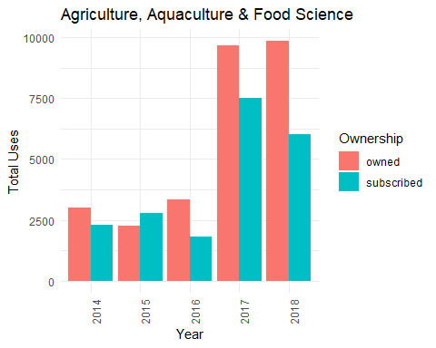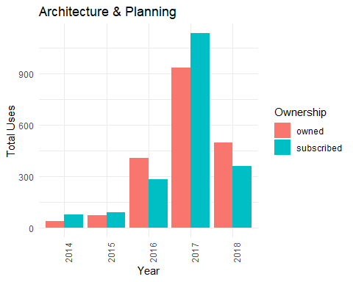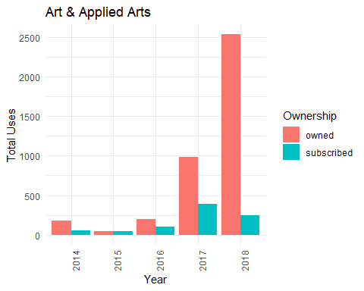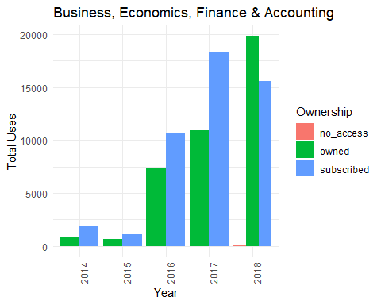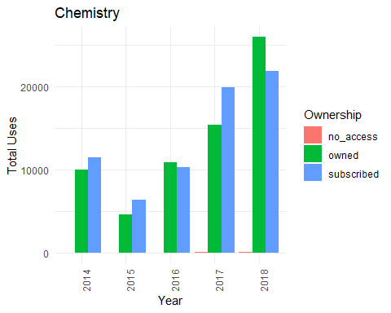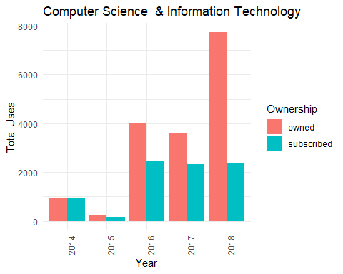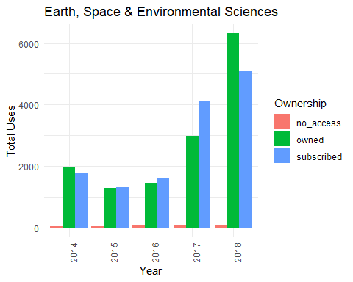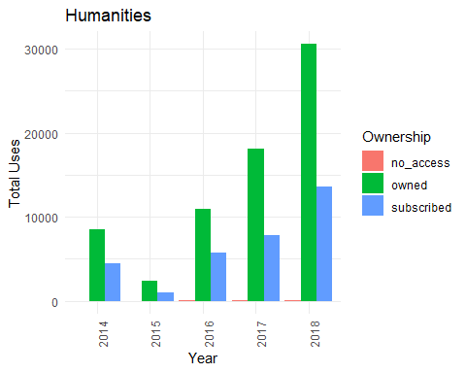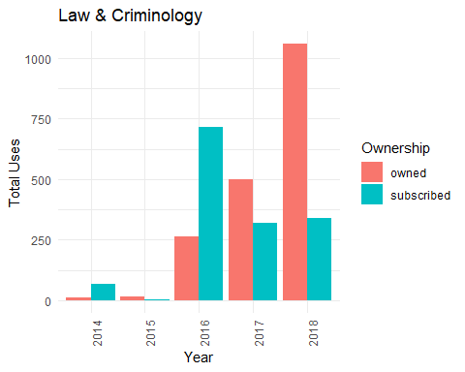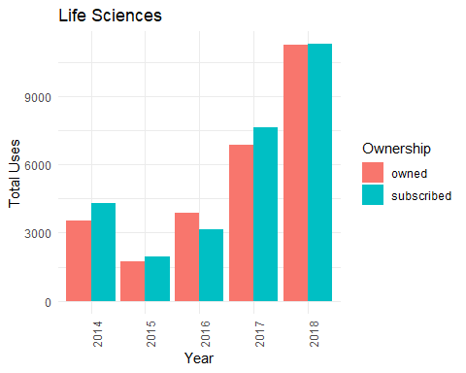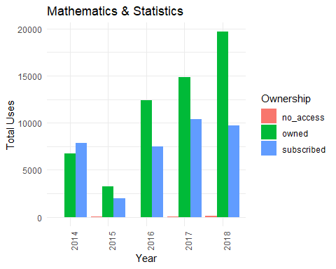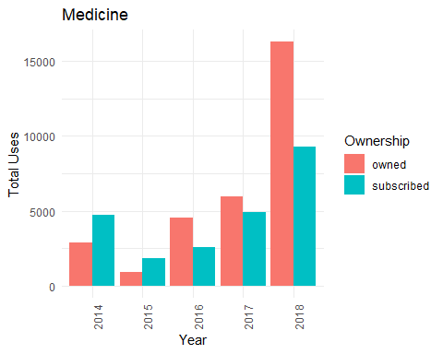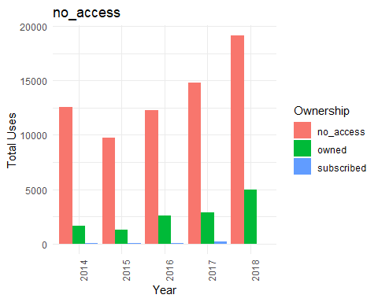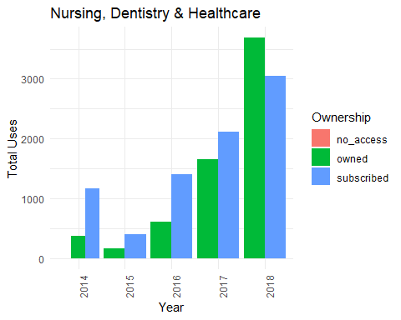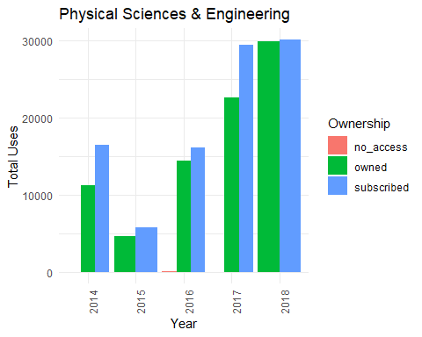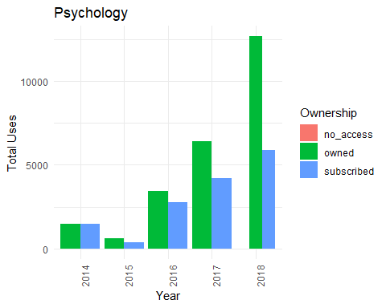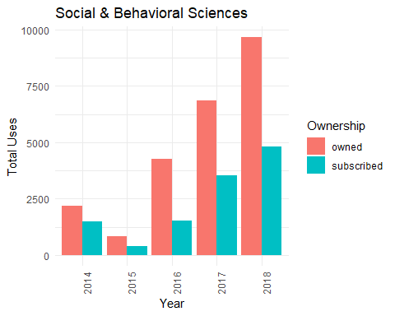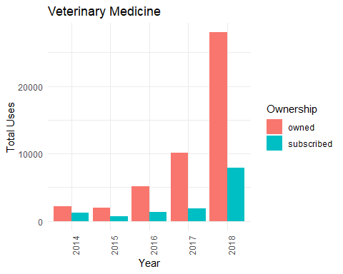

## [1] "Agriculture, Aquaculture & Food Science"  
##   
##   
## |Year |Ownership | Total_Uses|  
## |:----|:----------|----------:|  
## |2014 |owned | 3003|  
## |2014 |subscribed | 2307|  
## |2015 |owned | 2268|  
## |2015 |subscribed | 2766|  
## |2016 |owned | 3352|  
## |2016 |subscribed | 1809|  
## |2017 |owned | 9680|  
## |2017 |subscribed | 7512|  
## |2018 |owned | 9836|  
## |2018 |subscribed | 6033|  
## [1] "Architecture & Planning"  
##   
##   
## |Year |Ownership | Total_Uses|  
## |:----|:----------|----------:|  
## |2014 |owned | 36|  
## |2014 |subscribed | 78|  
## |2015 |owned | 74|  
## |2015 |subscribed | 87|  
## |2016 |owned | 409|  
## |2016 |subscribed | 282|  
## |2017 |owned | 935|  
## |2017 |subscribed | 1136|  
## |2018 |owned | 498|  
## |2018 |subscribed | 358|  
## [1] "Art & Applied Arts"  
##   
##   
## |Year |Ownership | Total_Uses|  
## |:----|:----------|----------:|  
## |2014 |owned | 181|  
## |2014 |subscribed | 59|  
## |2015 |owned | 45|  
## |2015 |subscribed | 41|  
## |2016 |owned | 201|  
## |2016 |subscribed | 107|  
## |2017 |owned | 980|  
## |2017 |subscribed | 389|  
## |2018 |owned | 2533|  
## |2018 |subscribed | 248|  
## [1] "Business, Economics, Finance & Accounting"  
##   
##   
## |Year |Ownership | Total_Uses|  
## |:----|:----------|----------:|  
## |2014 |owned | 892|  
## |2014 |subscribed | 1844|  
## |2015 |owned | 633|  
## |2015 |subscribed | 1093|  
## |2016 |owned | 7374|  
## |2016 |subscribed | 10681|  
## |2017 |owned | 10941|  
## |2017 |subscribed | 18260|  
## |2018 |no_access | 31|  
## |2018 |owned | 19826|  
## |2018 |subscribed | 15549|  
## [1] "Chemistry"  
##   
##   
## |Year |Ownership | Total_Uses|  
## |:----|:----------|----------:|  
## |2014 |no_access | 13|  
## |2014 |owned | 9976|  
## |2014 |subscribed | 11422|  
## |2015 |no_access | 1|  
## |2015 |owned | 4582|  
## |2015 |subscribed | 6333|  
## |2016 |no_access | 17|  
## |2016 |owned | 10899|  
## |2016 |subscribed | 10234|  
## |2017 |no_access | 58|  
## |2017 |owned | 15340|  
## |2017 |subscribed | 19917|  
## |2018 |no_access | 68|  
## |2018 |owned | 25955|  
## |2018 |subscribed | 21883|  
## [1] "Computer Science & Information Technology"  
##   
##   
## |Year |Ownership | Total_Uses|  
## |:----|:----------|----------:|  
## |2014 |owned | 917|  
## |2014 |subscribed | 917|  
## |2015 |owned | 243|  
## |2015 |subscribed | 162|  
## |2016 |owned | 3999|  
## |2016 |subscribed | 2488|  
## |2017 |owned | 3586|  
## |2017 |subscribed | 2317|  
## |2018 |owned | 7721|  
## |2018 |subscribed | 2398|  
## [1] "Earth, Space & Environmental Sciences"  
##   
##   
## |Year |Ownership | Total_Uses|  
## |:----|:----------|----------:|  
## |2014 |no_access | 36|  
## |2014 |owned | 1947|  
## |2014 |subscribed | 1774|  
## |2015 |no_access | 44|  
## |2015 |owned | 1272|  
## |2015 |subscribed | 1333|  
## |2016 |no_access | 66|  
## |2016 |owned | 1441|  
## |2016 |subscribed | 1618|  
## |2017 |no_access | 92|  
## |2017 |owned | 2986|  
## |2017 |subscribed | 4112|  
## |2018 |no_access | 71|  
## |2018 |owned | 6315|  
## |2018 |subscribed | 5079|  
## [1] "Humanities"  
##   
##   
## |Year |Ownership | Total_Uses|  
## |:----|:----------|----------:|  
## |2014 |no_access | 19|  
## |2014 |owned | 8555|  
## |2014 |subscribed | 4469|  
## |2015 |no_access | 1|  
## |2015 |owned | 2395|  
## |2015 |subscribed | 969|  
## |2016 |no_access | 41|  
## |2016 |owned | 11009|  
## |2016 |subscribed | 5694|  
## |2017 |no_access | 55|  
## |2017 |owned | 18161|  
## |2017 |subscribed | 7836|  
## |2018 |no_access | 83|  
## |2018 |owned | 30564|  
## |2018 |subscribed | 13587|  
## [1] "Law & Criminology"  
##   
##   
## |Year |Ownership | Total_Uses|  
## |:----|:----------|----------:|  
## |2014 |owned | 9|  
## |2014 |subscribed | 68|  
## |2015 |owned | 16|  
## |2015 |subscribed | 4|  
## |2016 |owned | 265|  
## |2016 |subscribed | 717|  
## |2017 |owned | 501|  
## |2017 |subscribed | 320|  
## |2018 |owned | 1059|  
## |2018 |subscribed | 338|  
## [1] "Life Sciences"  
##   
##   
## |Year |Ownership | Total_Uses|  
## |:----|:----------|----------:|  
## |2014 |owned | 3537|  
## |2014 |subscribed | 4316|  
## |2015 |owned | 1757|  
## |2015 |subscribed | 1961|  
## |2016 |owned | 3892|  
## |2016 |subscribed | 3154|  
## |2017 |owned | 6870|  
## |2017 |subscribed | 7628|  
## |2018 |owned | 11237|  
## |2018 |subscribed | 11280|  
## [1] "Mathematics & Statistics"  
##   
##   
## |Year |Ownership | Total_Uses|  
## |:----|:----------|----------:|  
## |2014 |no_access | 4|  
## |2014 |owned | 6783|  
## |2014 |subscribed | 7896|  
## |2015 |no_access | 36|  
## |2015 |owned | 3220|  
## |2015 |subscribed | 2018|  
## |2016 |no_access | 2|  
## |2016 |owned | 12364|  
## |2016 |subscribed | 7504|  
## |2017 |no_access | 28|  
## |2017 |owned | 14826|  
## |2017 |subscribed | 10396|  
## |2018 |no_access | 102|  
## |2018 |owned | 19657|  
## |2018 |subscribed | 9726|  
## [1] "Medicine"  
##   
##   
## |Year |Ownership | Total_Uses|  
## |:----|:----------|----------:|  
## |2014 |owned | 2852|  
## |2014 |subscribed | 4746|  
## |2015 |owned | 937|  
## |2015 |subscribed | 1848|  
## |2016 |owned | 4543|  
## |2016 |subscribed | 2549|  
## |2017 |owned | 5953|  
## |2017 |subscribed | 4924|  
## |2018 |owned | 16278|  
## |2018 |subscribed | 9295|  
## [1] "no_access"  
##   
##   
## |Year |Ownership | Total_Uses|  
## |:----|:----------|----------:|  
## |2014 |no_access | 12593|  
## |2014 |owned | 1660|  
## |2014 |subscribed | 55|  
## |2015 |no_access | 9721|  
## |2015 |owned | 1303|  
## |2015 |subscribed | 35|  
## |2016 |no_access | 12267|  
## |2016 |owned | 2597|  
## |2016 |subscribed | 80|  
## |2017 |no_access | 14798|  
## |2017 |owned | 2889|  
## |2017 |subscribed | 192|  
## |2018 |no_access | 19120|  
## |2018 |owned | 4979|  
## |2018 |subscribed | 11|  
## [1] "Nursing, Dentistry & Healthcare"  
##   
##   
## |Year |Ownership | Total_Uses|  
## |:----|:----------|----------:|  
## |2014 |no_access | 1|  
## |2014 |owned | 366|  
## |2014 |subscribed | 1162|  
## |2015 |owned | 160|  
## |2015 |subscribed | 403|  
## |2016 |owned | 605|  
## |2016 |subscribed | 1408|  
## |2017 |owned | 1660|  
## |2017 |subscribed | 2118|  
## |2018 |owned | 3684|  
## |2018 |subscribed | 3045|  
## [1] "Physical Sciences & Engineering"  
##   
##   
## |Year |Ownership | Total_Uses|  
## |:----|:----------|----------:|  
## |2014 |no_access | 3|  
## |2014 |owned | 11190|  
## |2014 |subscribed | 16397|  
## |2015 |owned | 4648|  
## |2015 |subscribed | 5746|  
## |2016 |no_access | 39|  
## |2016 |owned | 14429|  
## |2016 |subscribed | 16090|  
## |2017 |no_access | 5|  
## |2017 |owned | 22567|  
## |2017 |subscribed | 29417|  
## |2018 |owned | 29859|  
## |2018 |subscribed | 30022|  
## [1] "Psychology"  
##   
##   
## |Year |Ownership | Total_Uses|  
## |:----|:----------|----------:|  
## |2014 |owned | 1470|  
## |2014 |subscribed | 1492|  
## |2015 |owned | 615|  
## |2015 |subscribed | 367|  
## |2016 |owned | 3432|  
## |2016 |subscribed | 2785|  
## |2017 |owned | 6401|  
## |2017 |subscribed | 4223|  
## |2018 |no_access | 5|  
## |2018 |owned | 12657|  
## |2018 |subscribed | 5857|  
## [1] "Social & Behavioral Sciences"  
##   
##   
## |Year |Ownership | Total_Uses|  
## |:----|:----------|----------:|  
## |2014 |owned | 2175|  
## |2014 |subscribed | 1475|  
## |2015 |owned | 839|  
## |2015 |subscribed | 397|  
## |2016 |owned | 4271|  
## |2016 |subscribed | 1540|  
## |2017 |owned | 6844|  
## |2017 |subscribed | 3515|  
## |2018 |owned | 9654|  
## |2018 |subscribed | 4817|  
## [1] "Veterinary Medicine"  
##   
##   
## |Year |Ownership | Total_Uses|  
## |:----|:----------|----------:|  
## |2014 |owned | 2228|  
## |2014 |subscribed | 1219|  
## |2015 |owned | 1944|  
## |2015 |subscribed | 734|  
## |2016 |owned | 5199|  
## |2016 |subscribed | 1329|  
## |2017 |owned | 10129|  
## |2017 |subscribed | 1850|  
## |2018 |owned | 27970|  
## |2018 |subscribed | 7958|

### 

### Owned Titles Usage by Subject and Purchase Year: Non-cumulative

The following plots and tables show the number of uses for only owned titles grouped by purchase year.

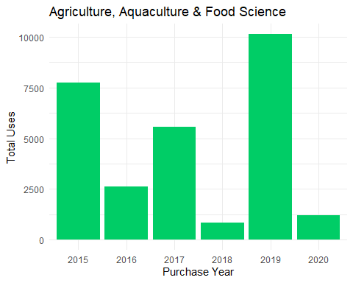 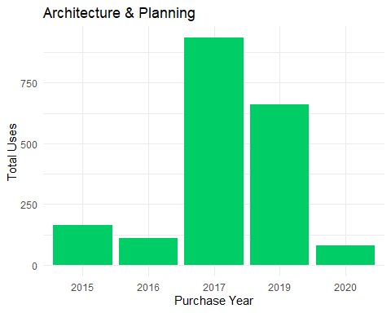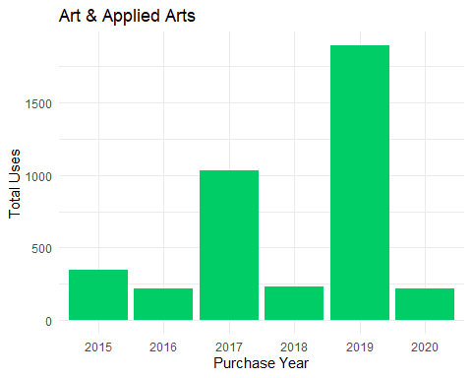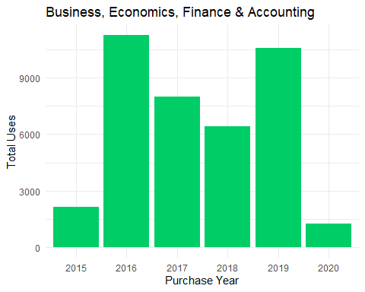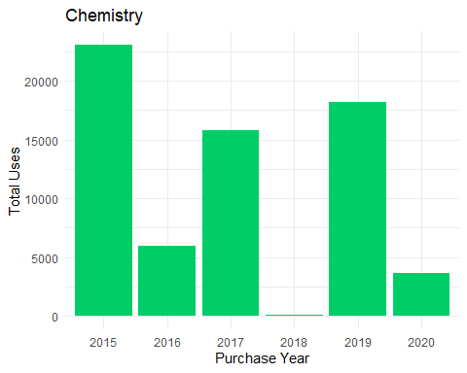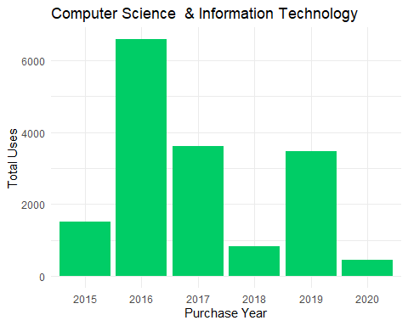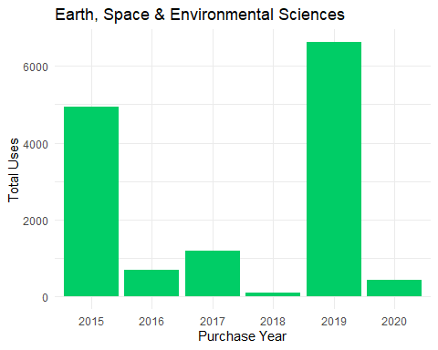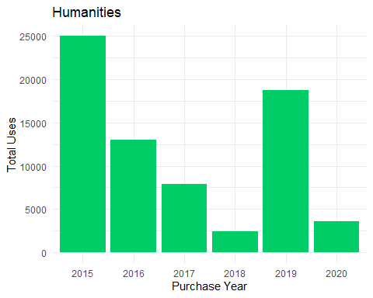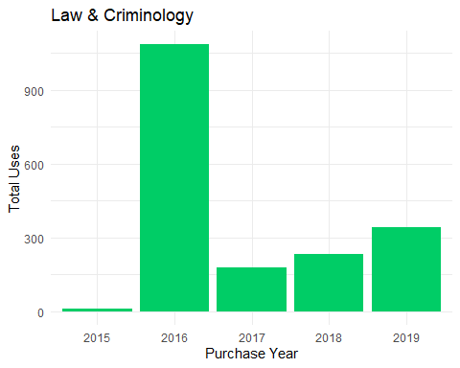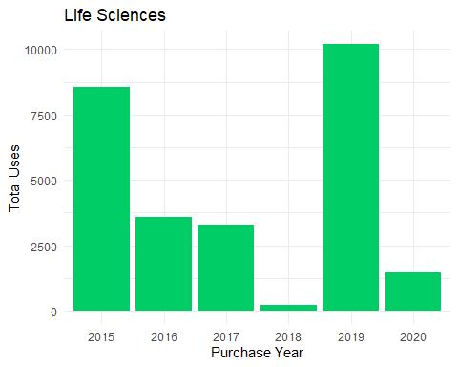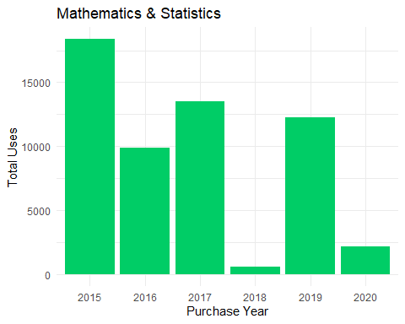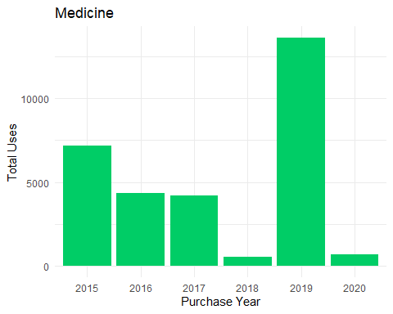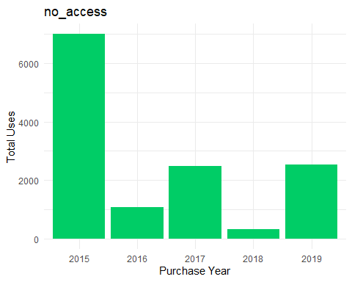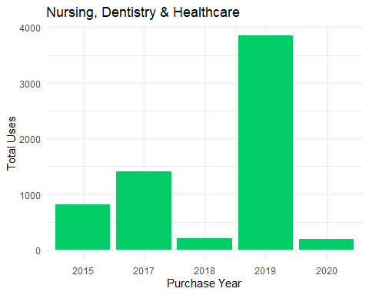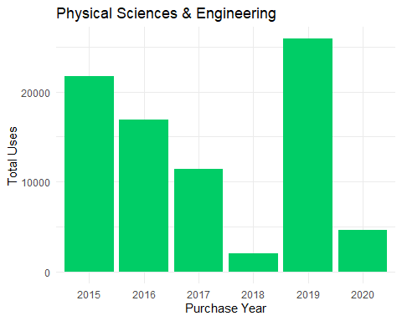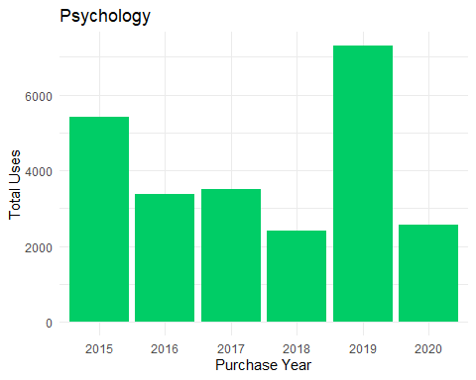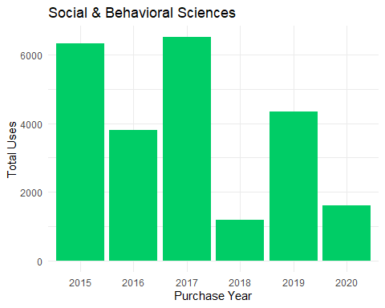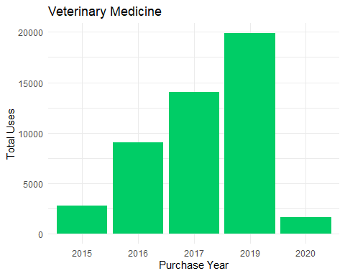

## [1] "Agriculture, Aquaculture & Food Science"  
##   
##   
## |Subject |Purchase.Year | Total_Uses|  
## |:---------------------------------------|:-------------|----------:|  
## |Agriculture, Aquaculture & Food Science |2015 | 7732|  
## |Agriculture, Aquaculture & Food Science |2016 | 2632|  
## |Agriculture, Aquaculture & Food Science |2017 | 5564|  
## |Agriculture, Aquaculture & Food Science |2018 | 854|  
## |Agriculture, Aquaculture & Food Science |2019 | 10143|  
## |Agriculture, Aquaculture & Food Science |2020 | 1214|  
## [1] "Architecture & Planning"  
##   
##   
## |Subject |Purchase.Year | Total_Uses|  
## |:-----------------------|:-------------|----------:|  
## |Architecture & Planning |2015 | 164|  
## |Architecture & Planning |2016 | 111|  
## |Architecture & Planning |2017 | 935|  
## |Architecture & Planning |2019 | 660|  
## |Architecture & Planning |2020 | 82|  
## [1] "Art & Applied Arts"  
##   
##   
## |Subject |Purchase.Year | Total_Uses|  
## |:------------------|:-------------|----------:|  
## |Art & Applied Arts |2015 | 349|  
## |Art & Applied Arts |2016 | 214|  
## |Art & Applied Arts |2017 | 1033|  
## |Art & Applied Arts |2018 | 234|  
## |Art & Applied Arts |2019 | 1894|  
## |Art & Applied Arts |2020 | 216|  
## [1] "Business, Economics, Finance & Accounting"  
##   
##   
## |Subject |Purchase.Year | Total_Uses|  
## |:-----------------------------------------|:-------------|----------:|  
## |Business, Economics, Finance & Accounting |2015 | 2156|  
## |Business, Economics, Finance & Accounting |2016 | 11257|  
## |Business, Economics, Finance & Accounting |2017 | 8007|  
## |Business, Economics, Finance & Accounting |2018 | 6423|  
## |Business, Economics, Finance & Accounting |2019 | 10579|  
## |Business, Economics, Finance & Accounting |2020 | 1244|  
## [1] "Chemistry"  
##   
##   
## |Subject |Purchase.Year | Total_Uses|  
## |:---------|:-------------|----------:|  
## |Chemistry |2015 | 23076|  
## |Chemistry |2016 | 5936|  
## |Chemistry |2017 | 15778|  
## |Chemistry |2018 | 103|  
## |Chemistry |2019 | 18193|  
## |Chemistry |2020 | 3666|  
## [1] "Computer Science & Information Technology"  
##   
##   
## |Subject |Purchase.Year | Total_Uses|  
## |:------------------------------------------|:-------------|----------:|  
## |Computer Science & Information Technology |2015 | 1515|  
## |Computer Science & Information Technology |2016 | 6584|  
## |Computer Science & Information Technology |2017 | 3620|  
## |Computer Science & Information Technology |2018 | 823|  
## |Computer Science & Information Technology |2019 | 3471|  
## |Computer Science & Information Technology |2020 | 453|  
## [1] "Earth, Space & Environmental Sciences"  
##   
##   
## |Subject |Purchase.Year | Total_Uses|  
## |:-------------------------------------|:-------------|----------:|  
## |Earth, Space & Environmental Sciences |2015 | 4942|  
## |Earth, Space & Environmental Sciences |2016 | 696|  
## |Earth, Space & Environmental Sciences |2017 | 1191|  
## |Earth, Space & Environmental Sciences |2018 | 93|  
## |Earth, Space & Environmental Sciences |2019 | 6622|  
## |Earth, Space & Environmental Sciences |2020 | 417|  
## [1] "Humanities"  
##   
##   
## |Subject |Purchase.Year | Total_Uses|  
## |:----------|:-------------|----------:|  
## |Humanities |2015 | 25035|  
## |Humanities |2016 | 13024|  
## |Humanities |2017 | 7867|  
## |Humanities |2018 | 2427|  
## |Humanities |2019 | 18777|  
## |Humanities |2020 | 3554|  
## [1] "Law & Criminology"  
##   
##   
## |Subject |Purchase.Year | Total_Uses|  
## |:-----------------|:-------------|----------:|  
## |Law & Criminology |2015 | 10|  
## |Law & Criminology |2016 | 1086|  
## |Law & Criminology |2017 | 178|  
## |Law & Criminology |2018 | 235|  
## |Law & Criminology |2019 | 341|  
## [1] "Life Sciences"  
##   
##   
## |Subject |Purchase.Year | Total_Uses|  
## |:-------------|:-------------|----------:|  
## |Life Sciences |2015 | 8567|  
## |Life Sciences |2016 | 3587|  
## |Life Sciences |2017 | 3281|  
## |Life Sciences |2018 | 215|  
## |Life Sciences |2019 | 10198|  
## |Life Sciences |2020 | 1445|  
## [1] "Mathematics & Statistics"  
##   
##   
## |Subject |Purchase.Year | Total_Uses|  
## |:------------------------|:-------------|----------:|  
## |Mathematics & Statistics |2015 | 18390|  
## |Mathematics & Statistics |2016 | 9871|  
## |Mathematics & Statistics |2017 | 13521|  
## |Mathematics & Statistics |2018 | 624|  
## |Mathematics & Statistics |2019 | 12283|  
## |Mathematics & Statistics |2020 | 2161|  
## [1] "Medicine"  
##   
##   
## |Subject |Purchase.Year | Total_Uses|  
## |:--------|:-------------|----------:|  
## |Medicine |2015 | 7199|  
## |Medicine |2016 | 4321|  
## |Medicine |2017 | 4204|  
## |Medicine |2018 | 555|  
## |Medicine |2019 | 13614|  
## |Medicine |2020 | 670|  
## [1] "no_access"  
##   
##   
## |Subject |Purchase.Year | Total_Uses|  
## |:---------|:-------------|----------:|  
## |no_access |2015 | 6996|  
## |no_access |2016 | 1089|  
## |no_access |2017 | 2487|  
## |no_access |2018 | 331|  
## |no_access |2019 | 2525|  
## [1] "Nursing, Dentistry & Healthcare"  
##   
##   
## |Subject |Purchase.Year | Total_Uses|  
## |:-------------------------------|:-------------|----------:|  
## |Nursing, Dentistry & Healthcare |2015 | 814|  
## |Nursing, Dentistry & Healthcare |2017 | 1407|  
## |Nursing, Dentistry & Healthcare |2018 | 203|  
## |Nursing, Dentistry & Healthcare |2019 | 3853|  
## |Nursing, Dentistry & Healthcare |2020 | 198|  
## [1] "Physical Sciences & Engineering"  
##   
##   
## |Subject |Purchase.Year | Total_Uses|  
## |:-------------------------------|:-------------|----------:|  
## |Physical Sciences & Engineering |2015 | 21753|  
## |Physical Sciences & Engineering |2016 | 16933|  
## |Physical Sciences & Engineering |2017 | 11450|  
## |Physical Sciences & Engineering |2018 | 2055|  
## |Physical Sciences & Engineering |2019 | 25893|  
## |Physical Sciences & Engineering |2020 | 4609|  
## [1] "Psychology"  
##   
##   
## |Subject |Purchase.Year | Total_Uses|  
## |:----------|:-------------|----------:|  
## |Psychology |2015 | 5416|  
## |Psychology |2016 | 3375|  
## |Psychology |2017 | 3508|  
## |Psychology |2018 | 2408|  
## |Psychology |2019 | 7296|  
## |Psychology |2020 | 2572|  
## [1] "Social & Behavioral Sciences"  
##   
##   
## |Subject |Purchase.Year | Total_Uses|  
## |:----------------------------|:-------------|----------:|  
## |Social & Behavioral Sciences |2015 | 6332|  
## |Social & Behavioral Sciences |2016 | 3805|  
## |Social & Behavioral Sciences |2017 | 6511|  
## |Social & Behavioral Sciences |2018 | 1182|  
## |Social & Behavioral Sciences |2019 | 4336|  
## |Social & Behavioral Sciences |2020 | 1617|  
## [1] "Veterinary Medicine"  
##   
##   
## |Subject |Purchase.Year | Total_Uses|  
## |:-------------------|:-------------|----------:|  
## |Veterinary Medicine |2015 | 2816|  
## |Veterinary Medicine |2016 | 9052|  
## |Veterinary Medicine |2017 | 14053|  
## |Veterinary Medicine |2019 | 19882|  
## |Veterinary Medicine |2020 | 1667|

### Owned Titles Usage by Subject and Campus

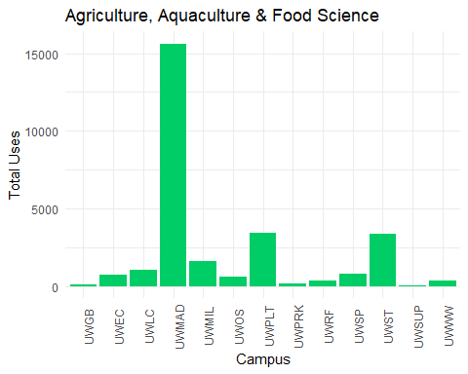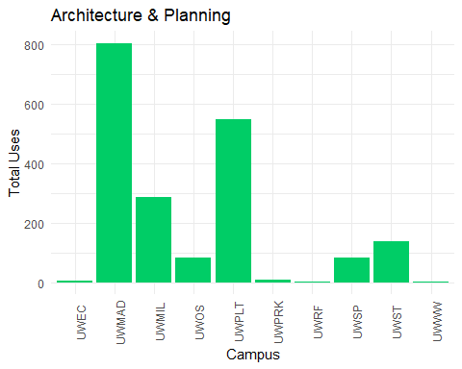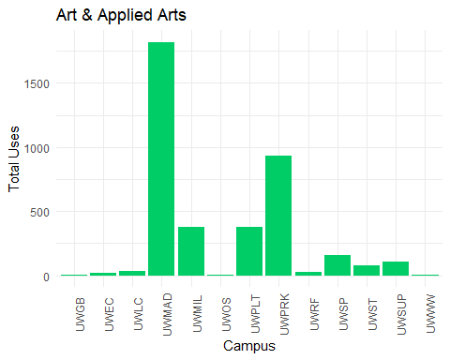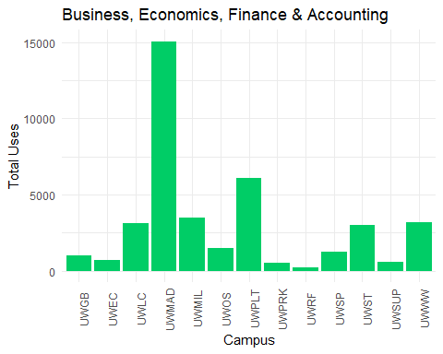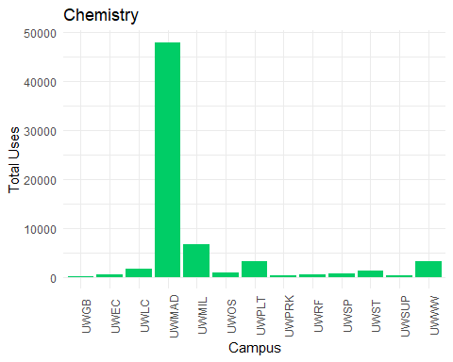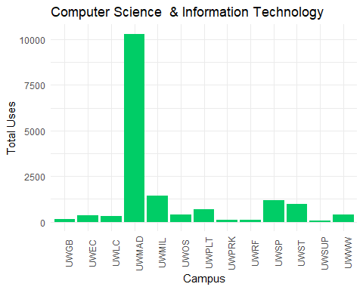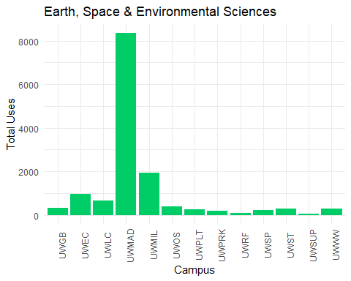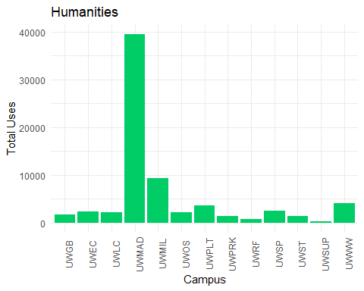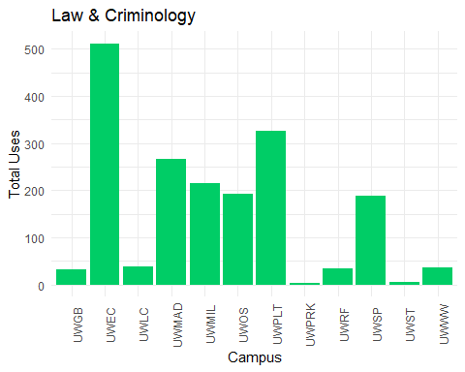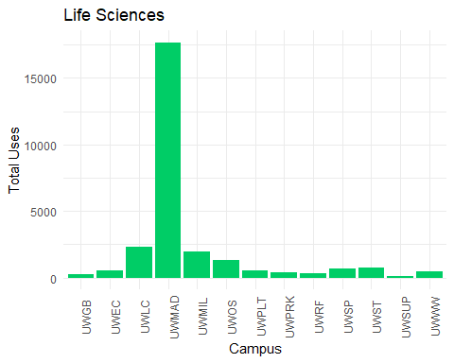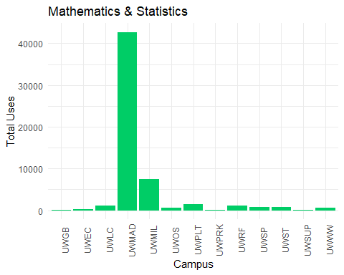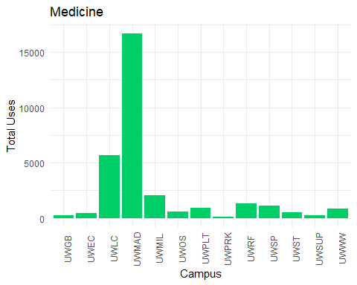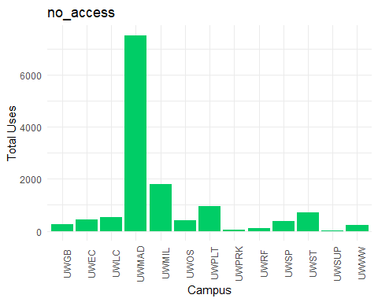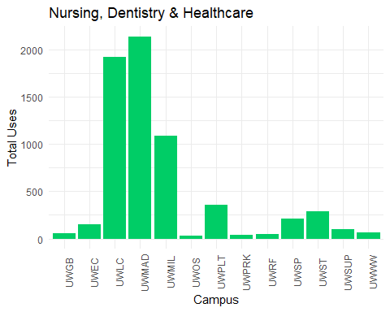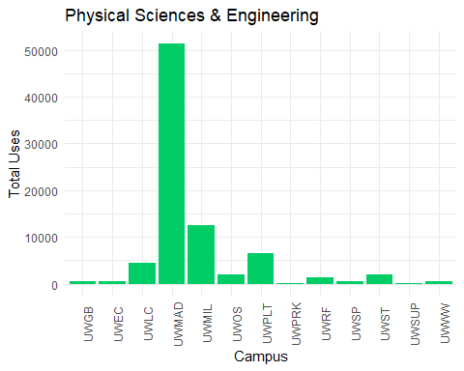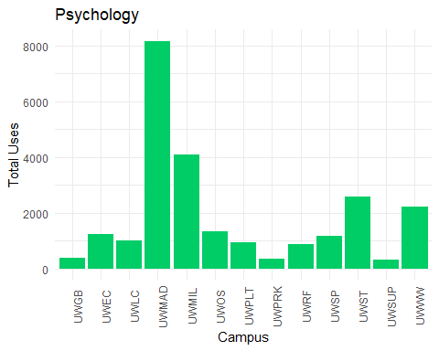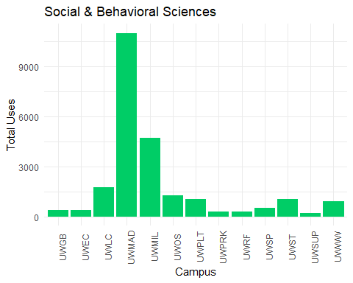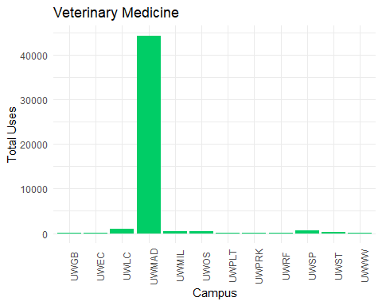

## [1] "Agriculture, Aquaculture & Food Science"  
##   
##   
## |Subject |Campus | Total_Uses|  
## |:---------------------------------------|:------|----------:|  
## |Agriculture, Aquaculture & Food Science |UWGB | 87|  
## |Agriculture, Aquaculture & Food Science |UWEC | 752|  
## |Agriculture, Aquaculture & Food Science |UWLC | 1053|  
## |Agriculture, Aquaculture & Food Science |UWMAD | 15633|  
## |Agriculture, Aquaculture & Food Science |UWMIL | 1604|  
## |Agriculture, Aquaculture & Food Science |UWOS | 593|  
## |Agriculture, Aquaculture & Food Science |UWPLT | 3396|  
## |Agriculture, Aquaculture & Food Science |UWPRK | 148|  
## |Agriculture, Aquaculture & Food Science |UWRF | 348|  
## |Agriculture, Aquaculture & Food Science |UWSP | 814|  
## |Agriculture, Aquaculture & Food Science |UWST | 3335|  
## |Agriculture, Aquaculture & Food Science |UWSUP | 15|  
## |Agriculture, Aquaculture & Food Science |UWWW | 361|  
## [1] "Architecture & Planning"  
##   
##   
## |Subject |Campus | Total_Uses|  
## |:-----------------------|:------|----------:|  
## |Architecture & Planning |UWEC | 6|  
## |Architecture & Planning |UWMAD | 804|  
## |Architecture & Planning |UWMIL | 286|  
## |Architecture & Planning |UWOS | 82|  
## |Architecture & Planning |UWPLT | 546|  
## |Architecture & Planning |UWPRK | 7|  
## |Architecture & Planning |UWRF | 1|  
## |Architecture & Planning |UWSP | 81|  
## |Architecture & Planning |UWST | 137|  
## |Architecture & Planning |UWWW | 2|  
## [1] "Art & Applied Arts"  
##   
##   
## |Subject |Campus | Total_Uses|  
## |:------------------|:------|----------:|  
## |Art & Applied Arts |UWGB | 1|  
## |Art & Applied Arts |UWEC | 15|  
## |Art & Applied Arts |UWLC | 33|  
## |Art & Applied Arts |UWMAD | 1821|  
## |Art & Applied Arts |UWMIL | 378|  
## |Art & Applied Arts |UWOS | 7|  
## |Art & Applied Arts |UWPLT | 379|  
## |Art & Applied Arts |UWPRK | 936|  
## |Art & Applied Arts |UWRF | 29|  
## |Art & Applied Arts |UWSP | 157|  
## |Art & Applied Arts |UWST | 78|  
## |Art & Applied Arts |UWSUP | 103|  
## |Art & Applied Arts |UWWW | 3|  
## [1] "Business, Economics, Finance & Accounting"  
##   
##   
## |Subject |Campus | Total_Uses|  
## |:-----------------------------------------|:------|----------:|  
## |Business, Economics, Finance & Accounting |UWGB | 1012|  
## |Business, Economics, Finance & Accounting |UWEC | 724|  
## |Business, Economics, Finance & Accounting |UWLC | 3132|  
## |Business, Economics, Finance & Accounting |UWMAD | 15070|  
## |Business, Economics, Finance & Accounting |UWMIL | 3498|  
## |Business, Economics, Finance & Accounting |UWOS | 1471|  
## |Business, Economics, Finance & Accounting |UWPLT | 6068|  
## |Business, Economics, Finance & Accounting |UWPRK | 532|  
## |Business, Economics, Finance & Accounting |UWRF | 234|  
## |Business, Economics, Finance & Accounting |UWSP | 1233|  
## |Business, Economics, Finance & Accounting |UWST | 2974|  
## |Business, Economics, Finance & Accounting |UWSUP | 556|  
## |Business, Economics, Finance & Accounting |UWWW | 3162|  
## [1] "Chemistry"  
##   
##   
## |Subject |Campus | Total_Uses|  
## |:---------|:------|----------:|  
## |Chemistry |UWGB | 128|  
## |Chemistry |UWEC | 395|  
## |Chemistry |UWLC | 1591|  
## |Chemistry |UWMAD | 47923|  
## |Chemistry |UWMIL | 6589|  
## |Chemistry |UWOS | 824|  
## |Chemistry |UWPLT | 3207|  
## |Chemistry |UWPRK | 244|  
## |Chemistry |UWRF | 449|  
## |Chemistry |UWSP | 642|  
## |Chemistry |UWST | 1293|  
## |Chemistry |UWSUP | 336|  
## |Chemistry |UWWW | 3131|  
## [1] "Computer Science & Information Technology"  
##   
##   
## |Subject |Campus | Total_Uses|  
## |:------------------------------------------|:------|----------:|  
## |Computer Science & Information Technology |UWGB | 136|  
## |Computer Science & Information Technology |UWEC | 364|  
## |Computer Science & Information Technology |UWLC | 308|  
## |Computer Science & Information Technology |UWMAD | 10308|  
## |Computer Science & Information Technology |UWMIL | 1436|  
## |Computer Science & Information Technology |UWOS | 402|  
## |Computer Science & Information Technology |UWPLT | 681|  
## |Computer Science & Information Technology |UWPRK | 112|  
## |Computer Science & Information Technology |UWRF | 117|  
## |Computer Science & Information Technology |UWSP | 1189|  
## |Computer Science & Information Technology |UWST | 960|  
## |Computer Science & Information Technology |UWSUP | 56|  
## |Computer Science & Information Technology |UWWW | 397|  
## [1] "Earth, Space & Environmental Sciences"  
##   
##   
## |Subject |Campus | Total_Uses|  
## |:-------------------------------------|:------|----------:|  
## |Earth, Space & Environmental Sciences |UWGB | 326|  
## |Earth, Space & Environmental Sciences |UWEC | 964|  
## |Earth, Space & Environmental Sciences |UWLC | 655|  
## |Earth, Space & Environmental Sciences |UWMAD | 8372|  
## |Earth, Space & Environmental Sciences |UWMIL | 1922|  
## |Earth, Space & Environmental Sciences |UWOS | 375|  
## |Earth, Space & Environmental Sciences |UWPLT | 263|  
## |Earth, Space & Environmental Sciences |UWPRK | 174|  
## |Earth, Space & Environmental Sciences |UWRF | 94|  
## |Earth, Space & Environmental Sciences |UWSP | 227|  
## |Earth, Space & Environmental Sciences |UWST | 278|  
## |Earth, Space & Environmental Sciences |UWSUP | 40|  
## |Earth, Space & Environmental Sciences |UWWW | 271|  
## [1] "Humanities"  
##   
##   
## |Subject |Campus | Total_Uses|  
## |:----------|:------|----------:|  
## |Humanities |UWGB | 1633|  
## |Humanities |UWEC | 2255|  
## |Humanities |UWLC | 2152|  
## |Humanities |UWMAD | 39541|  
## |Humanities |UWMIL | 9244|  
## |Humanities |UWOS | 2101|  
## |Humanities |UWPLT | 3501|  
## |Humanities |UWPRK | 1349|  
## |Humanities |UWRF | 676|  
## |Humanities |UWSP | 2474|  
## |Humanities |UWST | 1361|  
## |Humanities |UWSUP | 318|  
## |Humanities |UWWW | 4079|  
## [1] "Law & Criminology"  
##   
##   
## |Subject |Campus | Total_Uses|  
## |:-----------------|:------|----------:|  
## |Law & Criminology |UWGB | 32|  
## |Law & Criminology |UWEC | 512|  
## |Law & Criminology |UWLC | 38|  
## |Law & Criminology |UWMAD | 267|  
## |Law & Criminology |UWMIL | 214|  
## |Law & Criminology |UWOS | 192|  
## |Law & Criminology |UWPLT | 326|  
## |Law & Criminology |UWPRK | 3|  
## |Law & Criminology |UWRF | 34|  
## |Law & Criminology |UWSP | 189|  
## |Law & Criminology |UWST | 6|  
## |Law & Criminology |UWWW | 37|  
## [1] "Life Sciences"  
##   
##   
## |Subject |Campus | Total_Uses|  
## |:-------------|:------|----------:|  
## |Life Sciences |UWGB | 250|  
## |Life Sciences |UWEC | 515|  
## |Life Sciences |UWLC | 2323|  
## |Life Sciences |UWMAD | 17692|  
## |Life Sciences |UWMIL | 1968|  
## |Life Sciences |UWOS | 1287|  
## |Life Sciences |UWPLT | 536|  
## |Life Sciences |UWPRK | 418|  
## |Life Sciences |UWRF | 286|  
## |Life Sciences |UWSP | 672|  
## |Life Sciences |UWST | 775|  
## |Life Sciences |UWSUP | 142|  
## |Life Sciences |UWWW | 429|  
## [1] "Mathematics & Statistics"  
##   
##   
## |Subject |Campus | Total_Uses|  
## |:------------------------|:------|----------:|  
## |Mathematics & Statistics |UWGB | 122|  
## |Mathematics & Statistics |UWEC | 185|  
## |Mathematics & Statistics |UWLC | 1033|  
## |Mathematics & Statistics |UWMAD | 42716|  
## |Mathematics & Statistics |UWMIL | 7542|  
## |Mathematics & Statistics |UWOS | 550|  
## |Mathematics & Statistics |UWPLT | 1379|  
## |Mathematics & Statistics |UWPRK | 78|  
## |Mathematics & Statistics |UWRF | 1061|  
## |Mathematics & Statistics |UWSP | 719|  
## |Mathematics & Statistics |UWST | 829|  
## |Mathematics & Statistics |UWSUP | 42|  
## |Mathematics & Statistics |UWWW | 594|  
## [1] "Medicine"  
##   
##   
## |Subject |Campus | Total_Uses|  
## |:--------|:------|----------:|  
## |Medicine |UWGB | 233|  
## |Medicine |UWEC | 445|  
## |Medicine |UWLC | 5651|  
## |Medicine |UWMAD | 16715|  
## |Medicine |UWMIL | 2051|  
## |Medicine |UWOS | 546|  
## |Medicine |UWPLT | 904|  
## |Medicine |UWPRK | 83|  
## |Medicine |UWRF | 1283|  
## |Medicine |UWSP | 1076|  
## |Medicine |UWST | 516|  
## |Medicine |UWSUP | 235|  
## |Medicine |UWWW | 825|  
## [1] "no_access"  
##   
##   
## |Subject |Campus | Total_Uses|  
## |:---------|:------|----------:|  
## |no_access |UWGB | 267|  
## |no_access |UWEC | 434|  
## |no_access |UWLC | 543|  
## |no_access |UWMAD | 7530|  
## |no_access |UWMIL | 1798|  
## |no_access |UWOS | 407|  
## |no_access |UWPLT | 946|  
## |no_access |UWPRK | 44|  
## |no_access |UWRF | 107|  
## |no_access |UWSP | 377|  
## |no_access |UWST | 719|  
## |no_access |UWSUP | 14|  
## |no_access |UWWW | 242|  
## [1] "Nursing, Dentistry & Healthcare"  
##   
##   
## |Subject |Campus | Total_Uses|  
## |:-------------------------------|:------|----------:|  
## |Nursing, Dentistry & Healthcare |UWGB | 56|  
## |Nursing, Dentistry & Healthcare |UWEC | 153|  
## |Nursing, Dentistry & Healthcare |UWLC | 1919|  
## |Nursing, Dentistry & Healthcare |UWMAD | 2138|  
## |Nursing, Dentistry & Healthcare |UWMIL | 1083|  
## |Nursing, Dentistry & Healthcare |UWOS | 33|  
## |Nursing, Dentistry & Healthcare |UWPLT | 359|  
## |Nursing, Dentistry & Healthcare |UWPRK | 36|  
## |Nursing, Dentistry & Healthcare |UWRF | 44|  
## |Nursing, Dentistry & Healthcare |UWSP | 213|  
## |Nursing, Dentistry & Healthcare |UWST | 284|  
## |Nursing, Dentistry & Healthcare |UWSUP | 96|  
## |Nursing, Dentistry & Healthcare |UWWW | 61|  
## [1] "Physical Sciences & Engineering"  
##   
##   
## |Subject |Campus | Total_Uses|  
## |:-------------------------------|:------|----------:|  
## |Physical Sciences & Engineering |UWGB | 446|  
## |Physical Sciences & Engineering |UWEC | 447|  
## |Physical Sciences & Engineering |UWLC | 4476|  
## |Physical Sciences & Engineering |UWMAD | 51438|  
## |Physical Sciences & Engineering |UWMIL | 12577|  
## |Physical Sciences & Engineering |UWOS | 1909|  
## |Physical Sciences & Engineering |UWPLT | 6608|  
## |Physical Sciences & Engineering |UWPRK | 164|  
## |Physical Sciences & Engineering |UWRF | 1415|  
## |Physical Sciences & Engineering |UWSP | 589|  
## |Physical Sciences & Engineering |UWST | 1981|  
## |Physical Sciences & Engineering |UWSUP | 94|  
## |Physical Sciences & Engineering |UWWW | 549|  
## [1] "Psychology"  
##   
##   
## |Subject |Campus | Total_Uses|  
## |:----------|:------|----------:|  
## |Psychology |UWGB | 371|  
## |Psychology |UWEC | 1242|  
## |Psychology |UWLC | 986|  
## |Psychology |UWMAD | 8173|  
## |Psychology |UWMIL | 4090|  
## |Psychology |UWOS | 1317|  
## |Psychology |UWPLT | 920|  
## |Psychology |UWPRK | 333|  
## |Psychology |UWRF | 882|  
## |Psychology |UWSP | 1174|  
## |Psychology |UWST | 2562|  
## |Psychology |UWSUP | 324|  
## |Psychology |UWWW | 2201|  
## [1] "Social & Behavioral Sciences"  
##   
##   
## |Subject |Campus | Total_Uses|  
## |:----------------------------|:------|----------:|  
## |Social & Behavioral Sciences |UWGB | 394|  
## |Social & Behavioral Sciences |UWEC | 374|  
## |Social & Behavioral Sciences |UWLC | 1753|  
## |Social & Behavioral Sciences |UWMAD | 11005|  
## |Social & Behavioral Sciences |UWMIL | 4720|  
## |Social & Behavioral Sciences |UWOS | 1269|  
## |Social & Behavioral Sciences |UWPLT | 1051|  
## |Social & Behavioral Sciences |UWPRK | 280|  
## |Social & Behavioral Sciences |UWRF | 294|  
## |Social & Behavioral Sciences |UWSP | 516|  
## |Social & Behavioral Sciences |UWST | 1050|  
## |Social & Behavioral Sciences |UWSUP | 179|  
## |Social & Behavioral Sciences |UWWW | 898|  
## [1] "Veterinary Medicine"  
##   
##   
## |Subject |Campus | Total_Uses|  
## |:-------------------|:------|----------:|  
## |Veterinary Medicine |UWGB | 114|  
## |Veterinary Medicine |UWEC | 50|  
## |Veterinary Medicine |UWLC | 921|  
## |Veterinary Medicine |UWMAD | 44391|  
## |Veterinary Medicine |UWMIL | 379|  
## |Veterinary Medicine |UWOS | 413|  
## |Veterinary Medicine |UWPLT | 95|  
## |Veterinary Medicine |UWPRK | 20|  
## |Veterinary Medicine |UWRF | 133|  
## |Veterinary Medicine |UWSP | 626|  
## |Veterinary Medicine |UWST | 313|  
## |Veterinary Medicine |UWWW | 15|