Feature Bagging for Author Attribution
François-Marie Giraud and Thierry Artières

LIP6, Université Pierre et Marie Curie (UPMC)
giraudf@poleia.lip6.fr, thierry.artieres@lip6.fr

Extended Abstract A key issue in author attribution and verification lies in feature definition and selection, which motivated many studies [4], [2]. One conclusion is that despite many efforts to build smart features [1] very simple ones such as counts (or tfidf like features) of words and/or of character n-grams are commonly used. Moreover feature selection is performed using simple criterion such as choosing the most frequent words and character ngrams. Finally, simple classifiers such as linear SVM have been shown to perform well with above features and such simple systems appear to be difficult to outperform [2]. Besides, as it has been observed in the context of text processing with log linear models it may appear that learning rich models on few training data may yield a form of undertraining [5] where some relevant features are not fully taken into account by the model after training. This may happen when a number of features (not necessarily many) are sufficient, alone, for perfect discrimination of the training samples. In that case learning may focus on learning good weights for few of these relevant features while neglecting remaining relevant features. Then if only the neglected features occur in a test sample it will be misclassified.
We argue this often occurs in authorship attribution tasks. We observed on many datasets that SVMs working on occurrence counts of words easily reach 100% accuracy on the training set. Moreover preliminary experiments yield thinking there is actually some kind of undertraining in SVMs learned on authorship attribution tasks. Figure 1 put in evidence some interesting facts. As may be seen the performance of classifiers exploiting only few features is very high on the training set when using the most frequent features and when using all features while it reaches a ceiling on the test set. Also using few random features contain useful information for discriminating between authors as may be seen on the right figure. At the end one may expect that SVMs do not necessarily fully exploit all discriminative features since only few of them may allow reaching 100% accuracy on the training set, while there exist a number of discriminative features that could improve generalization.
Many methods have been proposed for combining classifiers working on different subsets of features, such as co-training, boosting, bagging, etc [6], [5]. In a first attempt we investigated simple methods relying on a majority vote decision process with a number of SVM classifier trained on many (hundreds to thousands) random subsets of few (tens to hundreds) features Preliminary results show significative improvement over a single SVM classifier exploiting all the features. To go further we built on the work of [3] who suggested that an author’s witting style is characterized by a limited number of discriminative features and more importantly by the way the classifer performance behaves (i.e. drops) when most important features (having large weights after SVM learning) are iteratively removed. We designed a method that is inspired by this work and exploits weak SVM classifiers learned on
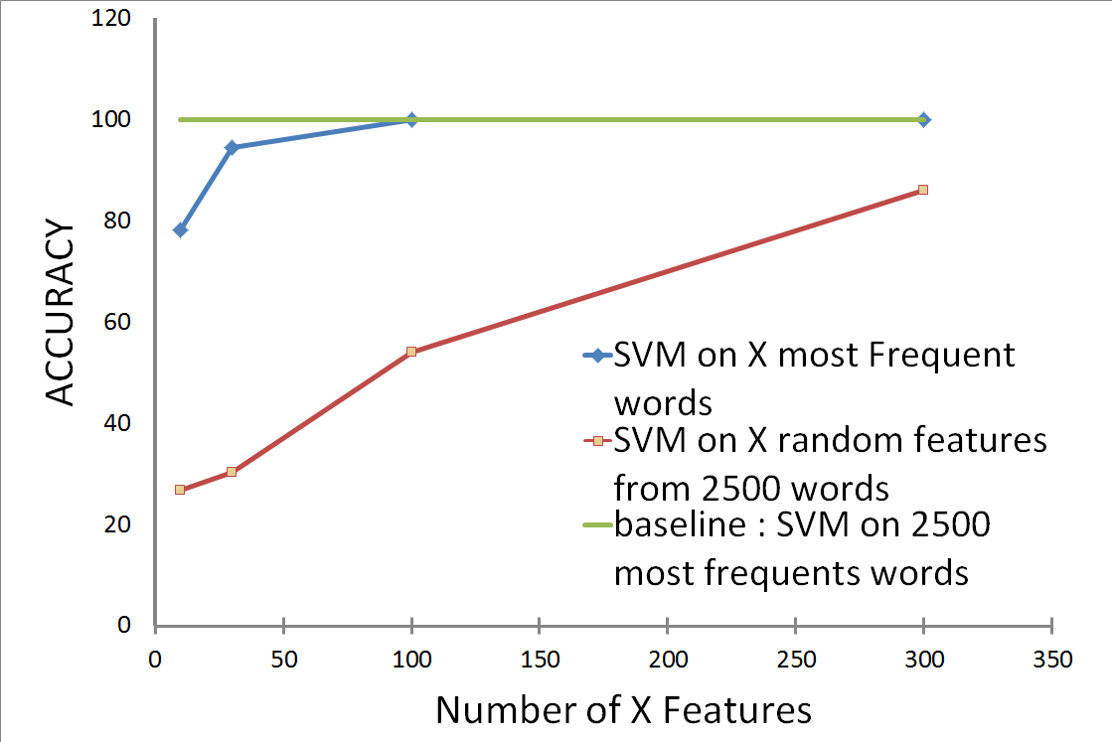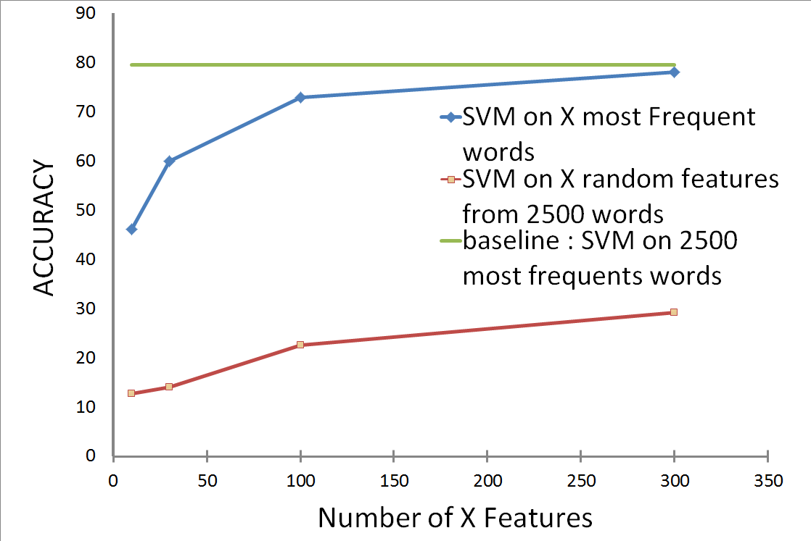

Figure 1. Accuracy (on a 9 authors dataset [2]) on training (left) and test (right) data of linear SVMs when selecting (randomly or the most frequent) a subset of K features among 2500 features (K 2 [10; 300]). Accuracy of a SVM using all 2500 features is given for comparison.

random subsets of features. Consider an author classification problem with N classes and documents are represented by d-dimensional feature vectors. The system we propose is a two stage system. In a first stage we learn K linear SVMs exploiting random subsets of the d original features as before. These classifiers are learned to affect a document to one of the N authors. Then we build a new (a second stage) dataset. For any author i 2 [1;N] and for any document, we build a new d-dimensional feature vector (we call this a profile) whose jth component is the proportion of classifiers (among the N classifiers that exploit feature j) that predict author i. At this point, each document in the train and the validation corpus correspond to N profiles, one for every author. Based on this new dataset we learn a new classifier (a linear SVM) to discriminate between positive examples (profiles that are built for the actual author) and negative examples.
When classifying a test document we first run the set of K classifers and build N d-dimensional feature vectors as above. We take the final decision based on the second stage SVM classifier that is run on these N second stage feature vectors (looking for the highest score). Note that this approach may be used for author classification as well as for verification provided documents from a number of alternate authors is available.

References
- Kim, S., Kim, H., Weninger, T., Han, J., Kim, H.D.: Authorship classification: a
discriminative syntactic tree mining approach. In: SIGIR (2011)
- Koppel, M., Schler, J., Argamon, S.: Computational methods in authorship attribution. Journal of the American Society for Information Science and Technology 60(1) (2009)
- Koppel, M., Schler, J., Bonchek-Dokow, E.: Measuring differentiability: unmasking pseudonymous authors. Journal of Machine Learning Research (2007)
- Stamatatos, E.: A survey of modern authorship attribution methods. Journal of the American Society for Information Science and Technology 60(3), 538–556 (2009)
- Sutton, C., Sindelar, M., Mccallum, A.: Feature bagging: Preventing weight undertraining in structured discriminative learning. Tech. rep., CIIR (2005)
- Viola, P., Jones, M.: Rapid object detection using a boosted cascade of simple features. In:Computer Vision and Pattern Recognition, 2001

