IR-based k-Nearest Neighbor Approach for Identifying Abnormal Chat Users
Notebook for PAN at CLEF 2012
In-Su Kang¹, Chul-Kyu Kim¹, Shin-Jae Kang², Seung-Hoon Na³

¹Kyungsung University, South Korea
²Daegu University, South Korea
³Electronics and Telecommunications Research Institute, South Korea
¹dbaisk@ks.ac.kr, ¹ckkim@ks.ac.kr, ²sjkang@daegu.ac.kr, ³seunghoonna@gmail.com
Abstract. This paper addresses a task of automatically identifying abnormal chat users where training data is given as a collection of chat messages from both abnormal and normal users. We employ a k-NN classification based on an IR technique. A document is constructed in per-conversation for each user by concatenating his/her messages in a conversation. A query is constructed for a new user in the same way. A k-NN classification is then performed using top retrieved documents in response to the query.
1 Introduction
A chat user has his/her intended goals when taking part in chatting with others. This paper addresses a task of identifying such goals of a chat user. Our assumption is that strong clues for inferring their intended goals may commonly appear in chat messages of similar users. Based on this assumption, we represent a chat user as a document comprising his/her chat messages in a specific conversation and then identify chat users with abnormal goals by finding chat user documents with similar goals. We employ an information retrieval (IR) technique to discern such documents. In a training step, we prepare an IR system by indexing a collection of chat logs with chat-user goals marked either ‘abnormal’ or not. Given an unseen chat user, its chat messages are collected to formulate a query to be submitted to the IR system, and its chat goal is automatically classified using top-retrieved documents to which a k-NN approach is applied.
2 Method
A chat conversation can be viewed as a set of one or more user documents each of which consists of sentences from a particular user of the conversation. The training conversations are thus converted into a collection of user documents which is indexed using an information retrieval (IR) system. Given a test conversation, it is divided similarly into documents {q_{i}} each of which is then submitted as a query to the IR system to retrieve a set R={d₁, …, d_{k}} of its highly related k training documents. For each q_{i}, the following k-nearest neighbor classifier (Tan, 2005) is then used to determine whether q_{i} is uttered from a sexual predator (SP) or not:

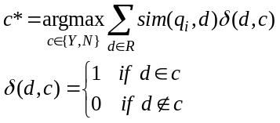
where Y and N indicate SP class and non-SP class respectively, and sim(⋅,⋅) is a query-document similarity score from the IR system.
3 Evaluation Results and Discussion
To evaluate the performance of our IR-based k-NN classifier and to find the best parameter value for the number k of top-retrieved documents, 5-fold cross-validation was performed on the training set. Apache Lucene was employed for the IR system. Without stop-words removal and stemming, all 1-gram and 2-gram terms were used for index terms, where only rare terms with frequencies less than 3 were removed. For retrieval, the Lucene’s default retrieval formula was used.

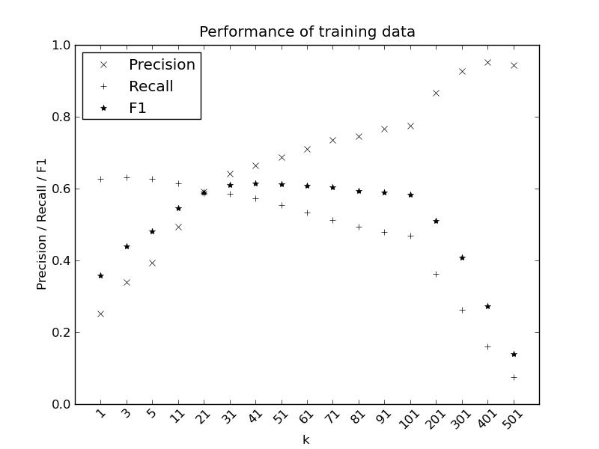
Figure 1. 5-fold cross-validation for training data.
Figure 1 shows cross-validation performance of train data for different k values. Based on the result shown in Figure 1, we chose k values 31 and 41 to submit two official runs. The better performance of our official runs was reported as 0.2140, 0.7960, and 0.3373, respectively for precision, recall, and F1. However, it was found that in our official runs, roughly a half of the test set was missed when preparing run submissions. So, we have fixed the error and have reiterated the same experiment. Figure 2 presents our revised result.

As Figures 1-2 show, the best k values for k-NN classifier are significantly different between training and test data, and this is the main reason for the poor performance in this year’s SPI task. Using a robust value for k was indeed important in our approach; when we used k values which are optimal for both training and test data, the proposed method showed more than 60% and 70% in F1, respectively for training and test data.
Overall, our current use of k-NN classifier was not very successful in obtaining a good performance. We believe that this is because our current approach is not so matured with a lot of further explorations remaining. In the future, we will further examine the effect using document similarity on the same task by focusing on finding a robust range for k and using more advanced IR similarity functions, and so on.

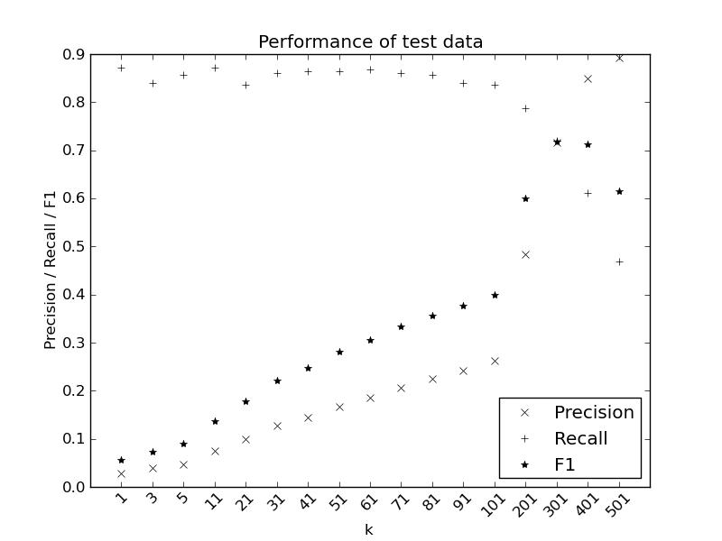
Figure 2. Performance for test data.

References
- Songbo Tan. (2005). Neighbor-weighted K-nearest neighbor for unbalanced text corpus. Expert Systems with Applications, 28(4): 667-671.

http://lucene.apache.org/core/

