**LAB06**

1. <http://127.0.0.1:8080/>

2. <http://127.0.0.1:8080/ITD>

3. <http://127.0.0.1:8080/IMI>

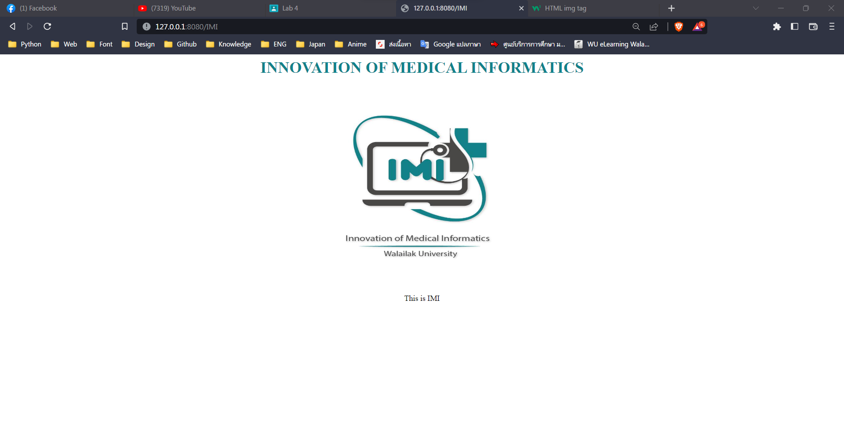

4. <http://127.0.0.1:8080/DCM>

5. <http://127.0.0.1:8080/DCA>

6. <http://127.0.0.1:8080/MTA>

