Enhancing Socio-Emotional Functioning of Adults with Disabilities:
Evaluation of an Experiential Intervention in a Day Care Facility
[Author information removed for double-anonymous peer review]

Abstract
Background: Adults with intellectual and psychosocial disabilities have limited access to structured socio-emotional development programs in community care settings.
Method: A three-phase longitudinal design evaluated an arts-based socio-emotional program over three months in a Day Care Center (n = 30 adults). Data were collected from beneficiary self-reports, trainer/educator assessments, and independent observer ratings using a 10-item Likert-scale instrument.
Results: Significant improvements were observed across all evaluator sources. Beneficiary self-reports showed the largest effect (d = 2.45, p < .001), followed by the independent observer (d = 1.65) and trainers/educators (d = 1.35). Friedman tests confirmed significant longitudinal change across phases (p < .001).
Conclusions: A holistic experiential program can substantially improve emotion recognition, cooperation, group participation, and well-being among adults with disabilities in Day Care settings, supporting social inclusion and quality of life.

Keywords: social-emotional learning; emotional intelligence; adults with disabilities; day care centers; group interventions; social inclusion; program evaluation

Lay Summary
- Adults with intellectual and psychosocial disabilities attending a Day Care Center showed substantial improvements in socio-emotional skills—including emotion recognition, cooperation, and group participation—following a structured arts-based intervention.
- Improvements were consistently confirmed by three independent sources: the participants themselves, their trainers/educators, and an independent observer, strengthening the reliability of the findings.
- The intervention combined theatre, music, movement, ceramics, and narrative dialogue within a group-based format, offering a replicable and documented model for Day Care services supporting adults with disabilities.
- These findings support the integration of arts-based socio-emotional programs in Day Care settings as a pathway to enhanced emotional well-being, social inclusion, and quality of life for adults with disabilities.

1. Introduction
Socio-emotional functioning constitutes a fundamental factor for the quality of life, empowerment, and social inclusion of persons with disabilities. Contemporary international literature recognizes that skills such as emotion recognition and expression, self-regulation, social awareness, empathy, and cooperation form a critical basis for participation in social, educational, and occupational contexts (CASEL, 2020; Weissberg et al., 2015). Emotional intelligence, as conceptualized by Goleman (1995), has also been identified as an important factor associated with well-being, resilience, and successful interpersonal relationships.
In the context of Day Care Centers (DCCs), which provide structured daily support to adults with intellectual and psychosocial difficulties, the development of socio-emotional skills becomes particularly important. DCCs combine education, care, psychosocial support, and social inclusion, offering beneficiaries opportunities to develop stable social relationships, autonomy-related skills, and self-esteem (Westmore et al., 2024).
The theoretical basis of this study draws on socio-cultural, group-based, and relational approaches to learning and development. Vygotsky's theory emphasizes the role of social interaction as a driving force of learning (Vygotsky, 1978), supporting the need for interventions that promote cooperation, dialogue, and experiential engagement. Similarly, Yalom and Leszcz (2005) highlight the therapeutic value of group processes, particularly in enhancing empathy, authentic expression, and emotional connectedness among participants. These principles are especially relevant for adults with disabilities, whose socio-emotional development is strongly influenced by their participation in safe and supportive social environments (Shogren et al., 2017).
The effectiveness of group interventions cannot be explained solely by the content of the activities, but also by group dynamics and the quality of interpersonal relationships developed within the group. Research on group therapy indicates that group cohesion is a strong predictor of positive therapeutic outcomes (Burlingame et al., 2011). Cohesion is associated with feelings of safety, trust, and acceptance, which facilitate authentic emotional expression and active participation. Moreover, the therapeutic relationship has been identified as a critical factor of change across different intervention models (Norcross & Lambert, 2018; Wampold & Imel, 2015).
Emotional safety and the experience of acceptance are essential preconditions for the development of socio-emotional skills. Attachment theory suggests that a secure base enables individuals to explore, express themselves, and experiment with new behaviors without fear of rejection (Bowlby, 1988). In group contexts, this secure-base function may operate collectively, allowing the group to function as a space of emotional containment and experiential processing. Interpersonal neurobiology further supports the idea that emotional regulation develops through relationships and social interaction (Siegel, 2012; Schore, 2012).
Despite the theoretical and empirical importance of socio-emotional development, important gaps remain in the literature. Most studies focus on children and adolescents in school contexts (Durlak et al., 2011; Humphrey, 2013; Oberle et al., 2019), whereas research concerning adults in day care settings remains limited. Existing studies on social skills and community participation among adults with intellectual disabilities report positive outcomes (Hall et al., 2009; Verdonschot et al., 2009); however, they rarely combine a multi-phase longitudinal design with multiple sources of evaluation, such as beneficiaries, trainers, and independent observers.
The present study addresses these gaps by systematically evaluating a holistic, experiential socio-emotional empowerment program implemented in a DCC setting. Its contribution is fivefold. First, it examines a structured intervention in a day care context, which remains underexplored in the literature. Second, it uses three independent sources of evaluation: beneficiary self-reports, trainer/educator assessments, and independent observer ratings. Third, it adopts a three-phase longitudinal design, allowing the analysis of change over time. Fourth, it combines statistical significance testing with effect-size estimation and trajectory analysis. Fifth, it connects theory and practice by integrating Social and Emotional Learning (SEL), emotional intelligence, socio-cultural learning theory, and group therapeutic factors.
A further contribution of this study lies in the arts-based nature of the intervention. The program, entitled 'The Universe Within Us,' included experiential practices such as theatrical expression, music, movement, symbolic object creation, and narrative activities. These practices aimed to cultivate SEL-related skills through symbolic, embodied, and interpersonal learning. Arts-based approaches have been described as particularly valuable for groups with complex support needs, as they allow expression, participation, and meaning-making beyond purely verbal modes of communication (Leavy, 2015; Stickley & Clift, 2018).
Based on the international literature and the theoretical framework of SEL, the present study adopts a conceptual model organized around three interrelated dimensions: social interaction and communication skills, socio-emotional well-being and emotional regulation, and active participation within the group. The model assumes that a systematic, experiential, and group-based intervention can activate mechanisms of change such as safe emotional expression, group cohesion, social reinforcement, and gradual internalization of socio-emotional skills. These mechanisms are expected to lead to improvements in the socio-emotional functioning of the beneficiaries.
Accordingly, the study formulates the following hypotheses:
- The intervention will be associated with statistically significant improvement in socio-emotional functioning between Phase A and Phase C.
- Improvement will be observed across all three independent sources of evaluation: beneficiaries, trainers/educators, and the independent observer.
- The trajectory of change will be progressive and statistically significant across consecutive phases.

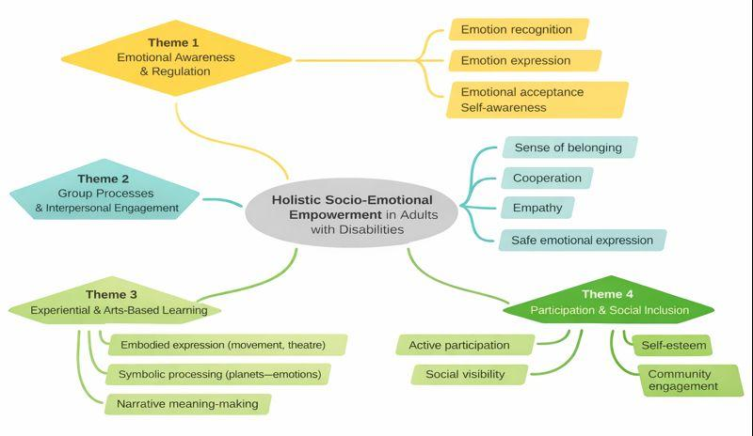
Figure 1. Conceptual model of the intervention and mechanisms of change.

Figure 1 presents the conceptual model of the intervention and the proposed mechanisms of empowerment.

2. Background
Earlier approaches in the field often focused primarily on functional training or behavioral compliance (Emerson, 2001), with limited attention to the emotional, relational, and participatory dimensions of adult life with disability. These approaches, while effective in addressing specific behavioral targets, have been criticized for their narrow scope, their tendency to treat adults with disabilities as passive recipients of intervention, and their failure to address broader psychosocial needs such as belonging, identity, and self-determination (McNaughton & Häusler, 2025; Witwer et al., 2022). More recent research has therefore shifted toward interventions that promote self-awareness, emotional regulation, belonging, participation, and inclusion in community and group contexts, recognizing that socio-emotional competencies are not peripheral but central to quality of life and meaningful social participation.
Giummarra et al. (2022) provide a broad synthesis of interventions targeting social and community participation among adults with autism spectrum disorder, intellectual disability, and psychosocial disability. Their findings suggest that experiential participation, safe social contexts, and stable group involvement are associated with improvements in social functioning, self-esteem, and emotional well-being. Nevertheless, the review relies exclusively on secondary synthesis without primary data collection, does not employ standardized outcome measures across studies, and lacks longitudinal follow-up, limiting the comparability and generalizability of findings across different service settings.
Littlewood et al. (2018) examined emotion regulation strategies used by adults with mild intellectual disability in everyday social interactions. Their findings indicate that participants often develop informal and experience-based regulation strategies through social interaction. This supports the need for interventions embedded in real social contexts rather than isolated instructional settings. However, the qualitative design of the study precludes quantitative effectiveness measurement, and the exclusive focus on mild intellectual disability limits applicability to populations with more complex support needs.
Jacob et al. (2022) systematically reviewed interventions aiming to improve social skills in individuals with intellectual disability. The reviewed strategies included peer tutoring, video modelling, and play-based emotional regulation interventions. Although many interventions showed positive outcomes, the authors highlighted the lack of integrated programs combining multiple SEL-related skills within a longitudinal evaluation design. A further limitation concerns the diversity of measurement instruments across reviewed studies, which impedes the synthesis of comparable effect sizes and the identification of common mechanisms of change.
In therapeutic intervention research, Vanutelli et al. (2023) examined the use of elements of Dialectical Behavior Therapy (DBT) for enhancing emotion regulation in individuals with intellectual disability. Although their sample mainly involved adolescents and young adults, their findings indicate that structured and experiential interventions may improve emotion recognition and regulation, supporting the adaptation of such models to adult populations. The primary limitation of this work lies in its restricted generalizability to adult populations in community care settings, as well as the absence of a multi-source evaluation design that could triangulate findings across different perspectives.
Recent work has also emphasized the heterogeneity of psychological interventions for adults with intellectual disability. Witwer et al. (2022) argue that many interventions lack a clear theoretical framework and systematic evaluation, making it difficult to identify which components drive positive outcomes. Similarly, McNaughton and Häusler (2025) emphasize that meaningful social participation among adults with developmental disabilities requires interventions that strengthen voice, agency, participation, and belonging, rather than focusing only on isolated skill acquisition. Both contributions, however, remain theoretical in nature and do not provide empirical data on intervention effectiveness, which limits their direct applicability to evidence-based practice.
At the cognitive level, Okafor et al. (2025) link cognitive processing speed with emotion regulation in adults with intellectual disability. This finding suggests that interventions relying exclusively on verbal processing may be limited. It also strengthens the rationale for experiential and multimodal interventions that use bodily, symbolic, emotional, and interpersonal forms of engagement. A notable challenge in this line of research, however, is the absence of an intervention component: the study establishes a neuropsychological association but does not test whether targeted programs can modify these processes in applied settings.
From a theoretical perspective, Sappok et al. (2022) propose a social neuroscience framework for understanding socio-emotional development in individuals with intellectual disability. Their work emphasizes that emotional processing and social behavior are shaped through ongoing interaction with the environment. This framework is directly relevant to group-based and community-embedded interventions. However, as a theoretical analysis without empirical intervention data, the framework requires further validation through applied studies that test its predictions in real-world care contexts.
Finally, Parsakia et al. (2024) examined experiences of community participation among adults with intellectual disability. Their findings indicate that participation, acceptance, and emotional safety are central indicators of successful inclusion, often more important than isolated functional skills. Despite the richness of the qualitative data, the study does not include quantitative measures of socio-emotional outcomes, nor does it evaluate a structured intervention, leaving open the question of how these experiential conditions can be systematically cultivated in day care settings.
Overall, the literature suggests that interventions targeting socio-emotional functioning in adults with disabilities are more effective when they are experiential, multimodal, socially embedded, and evaluated through longitudinal and multi-source designs. However, there remains a clear gap in structured programs that combine these characteristics within day care settings. The present intervention, entitled 'The Universe Within Us,' responds to this gap by adopting a holistic, arts-based, community-oriented SEL approach for adults with disabilities in a DCC context. Table 1 summarizes selected studies and highlights the differentiation of the present research.

Table 1
Categorization of Related Studies and Differentiation of the Present Research
Study | Population | Intervention / Focus | Theoretical Framework | Design | Evaluation | Main Limitations
Giummarra et al. (2022) | Adults ≥18 yrs with intellectual disabilities, ASD, and psychosocial disabilities; 57 reviews covering 522 studies | Social and community participation | Participatory inclusion and well-being | Umbrella review | Secondary synthesis | No primary data; heterogeneous outcome measures; limited longitudinal follow-up
Littlewood et al. (2018) | n = 11 adults with mild intellectual disabilities; age not reported | Emotion regulation in everyday life | Experiential approach | Qualitative study | Semi-structured interviews | No quantitative effectiveness measurement; limited to mild intellectual disabilities only
Jacob et al. (2022) | Children and adolescents with intellectual disabilities across 10 studies (n ranging from 3 to 296; age range: 7–19 yrs) | Social skills interventions | Behavioral and social theories | Systematic review | Diverse instruments | Heterogeneous measures; lack of unified theoretical framework; limited adult representation
Vanutelli et al. (2023) | n = 8 adults with intellectual disabilities; emotional skills training during COVID-19 | Emotional competencies training | Educational and experiential approach | Pilot intervention study | Pre–post assessment (quantitative and qualitative) | Very small sample; limited generalizability; no control group
Witwer et al. (2022) | N/A — theoretical analysis; adults with intellectual disabilities (reviewed literature) | Psychological interventions | Diverse frameworks | Scoping review | Secondary analysis | No primary sample; lack of comparable evaluations across interventions
McNaughton & Häusler (2025) | N/A — theoretical article; adults with developmental disabilities | Social participation and agency | Participatory models | Theoretical article | Not applicable | No empirical data; findings not directly testable without primary research
Okafor et al. (2025) | Adults with intellectual disabilities; neuropsychological assessment sample | Cognitive processing speed and emotion regulation | Neurocognitive approach | Quantitative study | Neuropsychological tests | No intervention component; associational findings only
Sappok et al. (2022) | N/A — theoretical analysis; people with intellectual disabilities (conceptual framework) | Socio-emotional development | Social neuroscience | Theoretical analysis | Not applicable | No primary sample; framework requires empirical validation in applied settings
Parsakia et al. (2024) | Adults with intellectual disabilities; qualitative community sample | Community participation | Phenomenological approach | Qualitative study | Thematic analysis | No quantitative outcome measures; no structured intervention evaluated
Present study | n = 30 adults with intellectual and psychosocial disabilities in a DCC (mean age: 36.8 yrs, SD = 10.0; complete longitudinal sample) | Holistic arts-based SEL intervention | SEL, EI, Vygotsky, Yalom | Three-phase longitudinal design | Three-source evaluation (self-report, educators, independent observer) and effect sizes | No control group; single-site study; tool not formally validated

3. Method

3.1 Study Setup
The study was conducted at a Day Care Center providing educational and psychosocial programs for adults with intellectual and psychosocial difficulties. A total of 30 adult beneficiaries participated in the study. All participants attended the daily program systematically and had the capacity, or supported capacity, to provide consent. Informed consent was obtained from all participants or their legal guardians prior to inclusion in the study.
Thirty adults participated in the study (20 men and 10 women), with a mean age of 36.8 years (SD = 10.0, range: 21–56 years). Twenty-two participants (73.3%) had an intellectual disability, five (16.7%) had psychosocial disabilities without intellectual disability, two (6.7%) had autism spectrum disorder without intellectual disability, and one participant (3.3%) had a physical disability without intellectual disability. Although JARID's primary focus is intellectual disability, participants with psychosocial, autism spectrum, or physical disabilities were included as they attend the same Day Care program and share comparable support needs within this community setting. Demographic and clinical characteristics are summarised in Table 2.
Complete data were available for all participants across the three measurement phases. Therefore, the statistical analysis was conducted on complete cases without excluding any beneficiary. In addition, two trainers/educators who worked daily with the beneficiaries participated in the evaluation process. For each beneficiary, the mean score of the two trainers was calculated and used as a single trainer-based evaluation score in the statistical analyses. One independent observer with experience in special education also participated in the assessment process.

Table 2
Demographic and Clinical Characteristics of Participants (N = 30)
Variable | Value
Age, mean ± SD (years) | 36.8 ± 10.0
Age range (years) | 21–56
Male, n (%) | 20 (66.7%)
Female, n (%) | 10 (33.3%)
Disability type
Intellectual disability, n (%) | 22 (73.3%)
Psychosocial disability without intellectual disability, n (%) | 5 (16.7%)
Autism spectrum disorder without intellectual disability, n (%) | 2 (6.7%)
Physical disability without intellectual disability, n (%) | 1 (3.3%)

3.2 Research Design
The study followed a three-phase longitudinal design over a period of three months. Each month corresponded to one evaluation phase. Phase A was conducted at the beginning of the program, Phase B at the end of the first month of implementation, and Phase C after the completion of the intervention. These three consecutive measurements enabled the assessment of both immediate and progressive effects of the intervention, while Phase B served as an intermediate observation point.

3.3 Intervention Description
The intervention was implemented over a period of three months, comprising approximately 36 structured sessions in total, with three sessions per week, each lasting between 45 and 60 minutes. Sessions were conducted in small groups of 6 to 10 participants and followed a consistent structure: an opening warm-up activity, a core experiential task (artistic, theatrical, or movement-based), and a closing reflective dialogue. The weekly schedule remained stable throughout the implementation period to provide predictability and emotional safety. The psychologist-psychotherapist facilitating the sessions held a postgraduate qualification in psychotherapy and had prior experience working with adults with intellectual and psychosocial disabilities. No formal fidelity checklist was applied; however, session consistency was maintained through a fixed activity protocol developed prior to implementation.
The intervention was holistic and experiential in nature. It was organized around activities involving emotion recognition and expression, empathy exercises, collaborative tasks, and group processes. The intervention was theoretically informed by SEL (CASEL, 2020), emotional intelligence (Goleman, 1995), Vygotsky's socio-cultural theory (Vygotsky, 1978), and Yalom's therapeutic factors of group work (Yalom & Leszcz, 2005).
The structure of the program remained stable throughout the implementation period. Weekly activities were conducted in small groups and included goal setting, repeated experiential patterns, and structured opportunities for social interaction. The intervention was implemented with the continuous presence of a psychologist-psychotherapist, who supported the emotional safety of the group, facilitated expression, and strengthened interpersonal understanding among participants. This role extended beyond instructional guidance and contributed to the development of therapeutic alliance and group cohesion, both of which are recognized as important mechanisms of change (Norcross & Lambert, 2018; Burlingame et al., 2011).
The intervention was embedded in the arts-based experiential program entitled 'The Universe Within Us.' The program aimed to enhance the recognition, expression, and acceptance of emotions through multimodal artistic processes. It included:
- theatrical exercises and role-play activities;
- movement and bodily expression;
- music and original song composition;
- ceramics and visual creation;
- construction of “emotion-planets”;
- group dialogue and empathy-based discussions.
Each beneficiary participated in the creation of symbolic planets, each representing a different emotion. This process promoted symbolism, self-expression, and embodied emotional processing, in line with principles of arts-based interventions (Malchiodi, 2020; Goldstein et al., 2017; Hinz, 2009). The program culminated in a music-theatre performance at a public amphitheatre, with the participation of kindergartens and primary schools. This public presentation aimed to enhance self-esteem, social visibility, and community inclusion, consistent with the international framework of community arts inclusion (Nicholson, 2005; White, 2013).

3.4 Assessment Instrument
Socio-emotional functioning was assessed using a structured instrument consisting of 10 indicators rated on a five-point Likert scale, ranging from 1 (not at all) to 5 (very much). The instrument was designed to assess core SEL-related dimensions, including:
- emotion expression;
- emotion recognition;
- emotion acceptance;
- self-awareness;
- sense of belonging to the group;
- cooperation;
- creativity and enjoyment;
- active participation;
- well-being and self-esteem;
- overall evaluation.
The same indicator system was adapted into three distinct formulations in order to capture different temporal perspectives. Phase A reflected the participant's general self-perception before the intervention. Phase B assessed the experience of the specific session and intermediate progress. Phase C assessed the perceived overall effect of the program. This threefold structure strengthened content validity and allowed the measurement of both general characteristics and intervention-related change.
The instrument demonstrated satisfactory to high internal consistency, with Cronbach's alpha values ranging from 0.84 to 0.95 across evaluator categories, as shown in Table 3.

Table 3
Internal Consistency of the Assessment Instrument
Evaluator Category | Cronbach's α
Beneficiaries | 0.84
Trainers/Educators | 0.95
Independent observer | 0.88

The assessment instrument was developed specifically for this study by the lead researcher and psychologist-psychotherapist responsible for the intervention, drawing on the five core competency domains of the CASEL SEL framework (CASEL, 2020) and established theoretical frameworks of emotional intelligence (Goleman, 1995). Item generation followed a content-driven approach: each indicator was mapped onto a specific SEL dimension (emotion recognition, self-regulation, cooperation, group belonging, and well-being), and linguistic accessibility was prioritized to accommodate the cognitive and communicative characteristics of the target population. The instrument was reviewed by two special education professionals prior to administration and minor wording adjustments were made based on their feedback. No formal pilot study was conducted prior to the main data collection. Internal consistency served as the primary reliability indicator, while convergence across three independent evaluator sources provided supplementary support for content validity. Nevertheless, the absence of formal psychometric validation (factor analysis, convergent validity) remains a limitation that future research should address.

3.5 Statistical Analysis
The statistical analysis combined descriptive and inferential techniques. First, means, standard deviations, and 95% confidence intervals were calculated for each phase and evaluator category. To examine the effectiveness of the intervention, paired-sample t-tests were applied by comparing Phase A and Phase C scores for each evaluator category (Student, 1908). Effect sizes were calculated using Cohen's d with corresponding confidence intervals (Cohen, 1988).
The longitudinal trajectory of scores across the three phases was examined graphically and statistically. Boxplots and violin plots were used to visualize the distribution of values before and after the intervention, while a trajectory plot was used to illustrate the evolution of mean scores across phases.
All analyses were conducted using Python 3.11, with the pandas, SciPy, and Matplotlib libraries. The level of statistical significance was set at α = .05. Prior to the application of parametric tests, the normality of the difference scores was examined using the Shapiro–Wilk test. For the evaluator category in which normality was not confirmed, namely the independent observer ratings (W = 0.904, p = .011), the Wilcoxon signed-rank test was additionally applied as a confirmatory non-parametric test.
For the extended analysis of change across the three phases, the Friedman test was used. Pairwise comparisons between Phase A–Phase B, Phase B–Phase C, and Phase A–Phase C were conducted using Bonferroni-corrected paired t-tests, with an adjusted significance threshold of α_adj = .017. Given the sample size and the applied nature of the study, these tests were preferred over more complex mixed-effects models, which require larger samples for reliable estimation.
The analysis code is openly available at a public repository (URL blinded for review).

4. Results

4.1 Descriptive Statistics and Distributional Patterns
Descriptive statistics for socio-emotional functioning scores across phases and evaluator categories are presented in Table 4. A consistent increase in mean scores was observed from Phase A to Phase C across all evaluator categories, indicating progressive improvement during the intervention. The relatively narrow 95% confidence intervals suggest stability in the estimates.

Table 4
Descriptive Statistics of Socio-Emotional Functioning Scores by Phase and Evaluator Category
Evaluator | Phase | Mean | SD | 95% CI Lower | 95% CI Upper
Beneficiaries | A | 3.24 | 0.62 | 3.02 | 3.46
Beneficiaries | B | 3.71 | 0.62 | 3.49 | 3.93
Beneficiaries | C | 4.75 | 0.18 | 4.69 | 4.82
Trainers/Educators | A | 2.85 | 0.55 | 2.66 | 3.05
Trainers/Educators | B | 3.30 | 0.42 | 3.15 | 3.45
Trainers/Educators | C | 3.56 | 0.30 | 3.45 | 3.67
Independent observer | A | 2.17 | 0.32 | 2.06 | 2.29
Independent observer | B | 2.47 | 0.31 | 2.36 | 2.58
Independent observer | C | 2.60 | 0.26 | 2.50 | 2.69

The graphical representation of scores before and after the intervention is presented in Figures 2 and 3. The boxplots indicate a clear and systematic upward shift in central tendency from Phase A to Phase C across all evaluator categories. For beneficiaries, the median increased substantially, while the interquartile range decreased, suggesting greater homogeneity in socio-emotional functioning after the completion of the program.
For trainers/educators, the boxplots also reveal an increase in median scores and a reduction of extreme values, reflecting both overall improvement and more stable evaluations of beneficiary behavior. The independent observer showed a similar upward pattern, with Phase C scores occupying a higher area of the scale compared with Phase A. Overall, the boxplots suggest that improvement was not limited to mean scores, but affected the broader distribution of values.

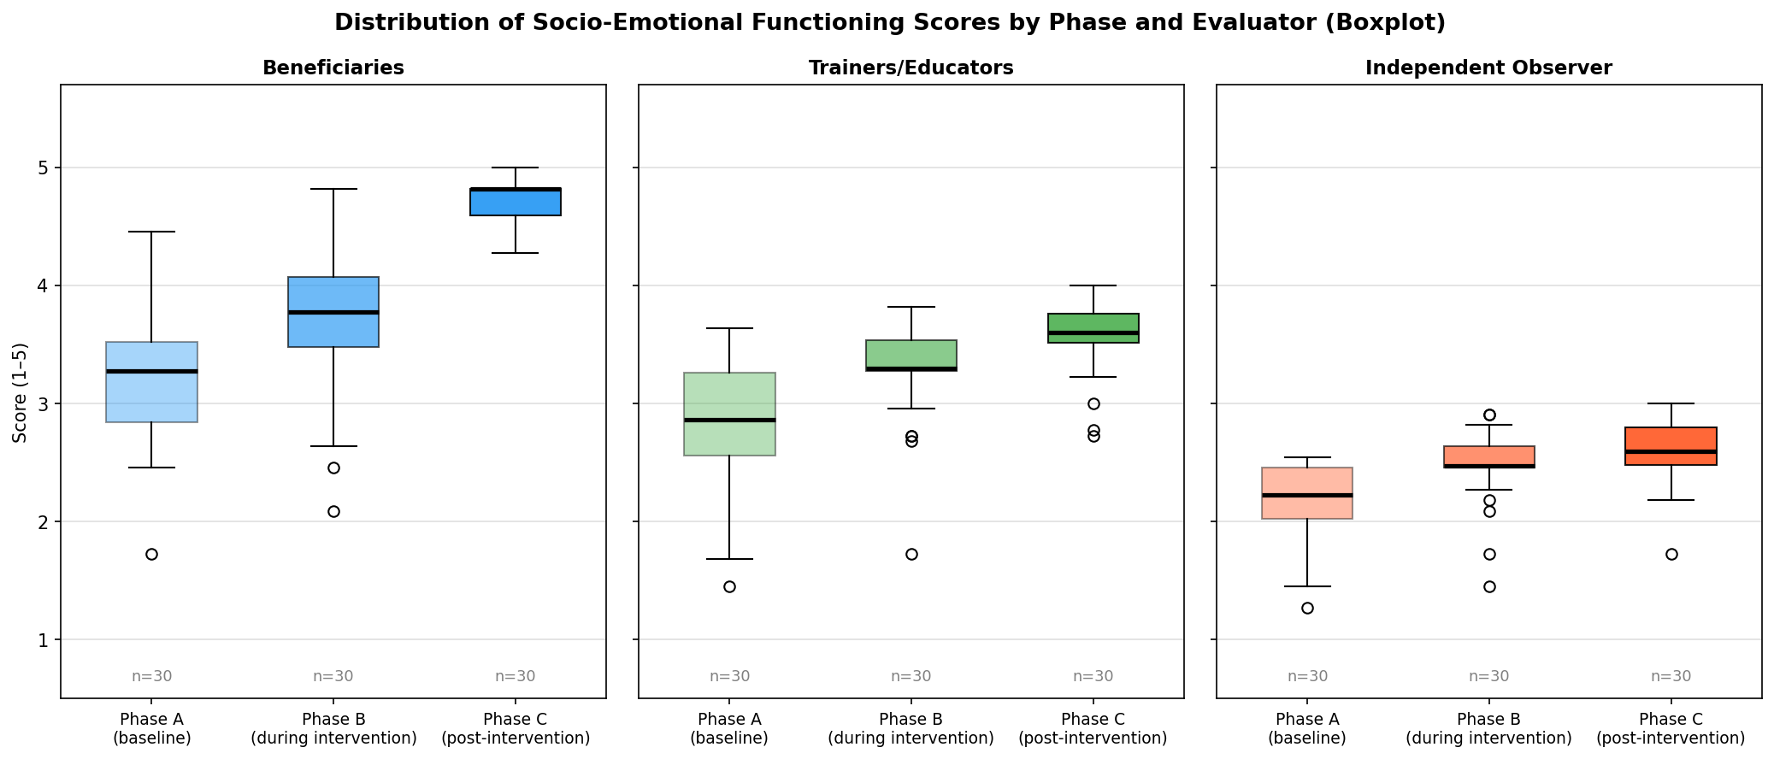
Figure 2. Boxplots of socio-emotional functioning scores in Phases A and C across evaluator categories.

The violin plots provide a more detailed view of score distributions across Phases A and C. Phase A was characterized by a concentration of observations around lower scores, whereas Phase C showed a clear shift toward higher values. The distribution in Phase C appeared more concentrated around positive functioning levels, suggesting that improvement was broadly distributed across participants rather than restricted to a small subgroup.

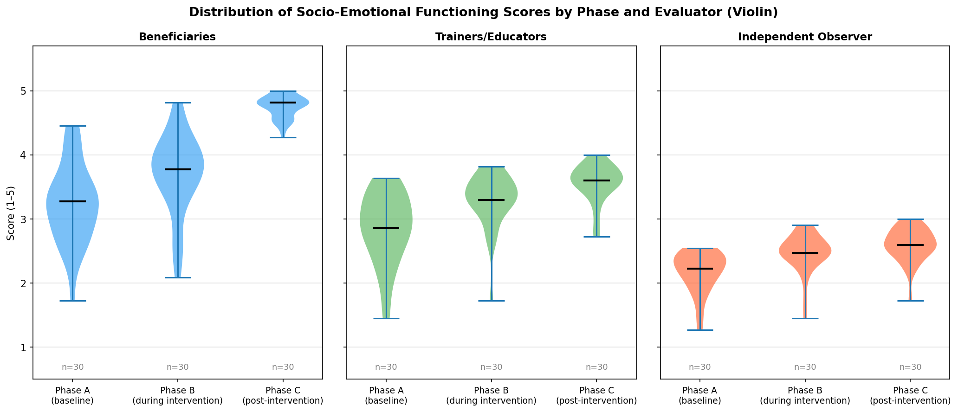
Figure 3. Violin plots of score distributions in Phases A and C.

4.2 Effect Sizes and Hypothesis Testing
The results of paired-sample t-tests comparing Phase A and Phase C are presented in Table 5. All evaluator categories showed statistically significant improvement from Phase A to Phase C. The largest effect was observed in beneficiary self-reports (d = 2.45, 95% CI [1.73, 3.16]), followed by the independent observer ratings (d = 1.65, 95% CI [1.10, 2.20]) and trainer/educator ratings (d = 1.35, 95% CI [0.86, 1.85]). These values indicate large to very large effects.

Table 5
Paired-Sample Tests Between Phase A and Phase C and Effect Sizes
Evaluator | Mean Δ | t | df | p | Cohen's d | 95% CI for d
Beneficiaries | +1.52 | −13.41 | 29 | < .001 | 2.45 | [1.73, 3.16]
Trainers/Educators | +0.71 | −7.40 | 29 | < .001 | 1.35 | [0.86, 1.85]
Independent observer | +0.42 | −9.05 | 29 | < .001 | 1.65 | [1.10, 2.20]

The corresponding forest plot is presented in Figure 4. All effect-size estimates were positioned clearly to the right of the zero-effect line, supporting the presence of statistically significant and practically meaningful improvement across all three sources of evaluation.

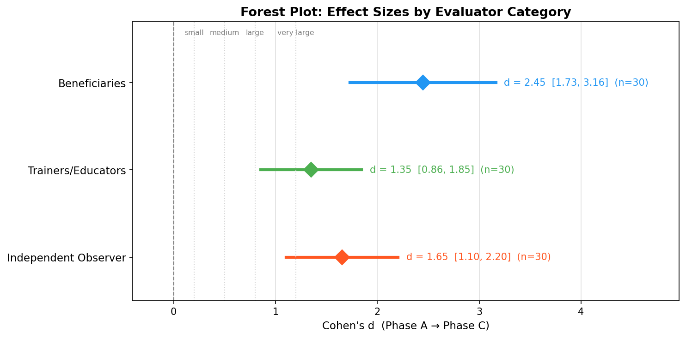
Figure 4. Forest plot of Cohen's d effect sizes across evaluator categories.

Prior to the application of parametric tests, the normality of difference scores between Phase C and Phase A was examined using the Shapiro–Wilk test. The assumption of normality was supported for beneficiaries (W = 0.945, p = .121) and trainers/educators (W = 0.950, p = .172). For the independent observer, normality was not confirmed (W = 0.904, p = .011); therefore, the Wilcoxon signed-rank test was additionally applied and confirmed the statistical significance of the change (W = 0, p < .001).
The Friedman test indicated statistically significant longitudinal change across the three phases for all evaluator categories: beneficiaries, χ² = 44.86, p < .001; trainers/educators, χ² = 44.67, p < .001; and independent observer, χ² = 40.27, p < .001. Pairwise comparisons using Bonferroni-corrected paired t-tests, with an adjusted threshold of α_adj = .017, showed that each phase differed significantly from the next for all evaluator categories, with all p < .003.
The very large effect size observed in beneficiary self-reports (d = 2.45) warrants cautious interpretation. Given the pilot nature of the study, the small sample size (n = 30), and the absence of a control condition, formal sensitivity analyses (e.g., influence analyses or bootstrapped effect estimates) were not conducted. The observed magnitude is likely influenced by a combination of genuine change, ceiling effects in Phase C (M = 4.75, SD = 0.18), social desirability bias inherent in self-report measures, and possible response-shift bias. The convergence of findings across the two external evaluator categories — trainers/educators (d = 1.35) and the independent observer (d = 1.65) — provides partial evidence that the improvement is not solely attributable to self-report inflation, though it does not eliminate these alternative explanations.

4.3 Longitudinal Trajectory
The evolution of mean scores across the three phases is shown in Figure 5. A consistent pattern of progressive improvement was observed across all evaluator categories. Beneficiaries showed the steepest upward trajectory, with a notable increase from Phase A to Phase B and further improvement from Phase B to Phase C. This suggests that the intervention began to produce measurable benefits during the early stages of implementation and that these benefits were strengthened over time.
Trainer/educator ratings also increased steadily, although in a more gradual manner. This may reflect the perspective of professionals who observe beneficiaries in daily routines and tend to provide more conservative evaluations of behavioral change. The independent observer showed a similar positive trajectory, further supporting the objectivity and consistency of the findings.

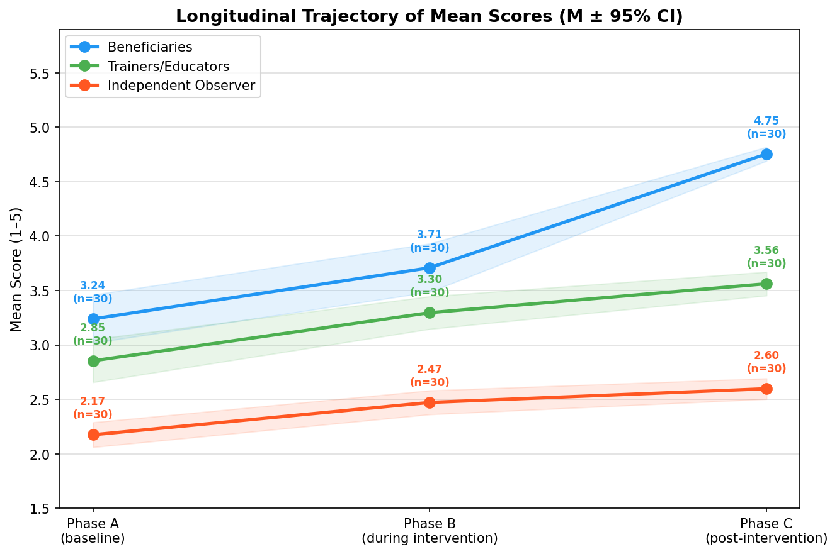
Figure 5. Longitudinal trajectory of mean scores across Phases A, B, and C.

Overall, the results indicate that the intervention was associated with significant improvement in emotion recognition, cooperation, group participation, and broader socio-emotional functioning. The convergence of findings across beneficiaries, trainers/educators, and the independent observer provides cross-source support for the effectiveness of the experiential socio-emotional intervention in a DCC setting.

5. Discussion
The findings of the present study indicate that the structured experiential socio-emotional intervention was associated with statistically significant and practically meaningful improvements in the socio-emotional functioning of adult beneficiaries attending the Day Care Center. The steady increase in mean scores across all three measurement phases, together with the large effect sizes observed across evaluator groups, suggests that the program substantially enhanced skills related to emotional recognition, cooperation, expression, group participation, and positive interpersonal interaction.
The marked improvement reported by beneficiaries themselves (d = 2.45) is consistent with previous studies showing that participation in stable, safe, and structured group activities may enhance self-perception, confidence, and social engagement among adults with disabilities (Hall et al., 2009; Verdonschot et al., 2009). The increase in self-reported functioning may reflect greater self-awareness and a more positive internal experience, both of which are central dimensions of emotional intelligence as conceptualized by Goleman (1995).
Trainers and educators also reported significant improvement (d = 1.35), with a pattern of change broadly parallel to that observed in self-reports. Although professionals often evaluate functioning more conservatively due to continuous exposure to everyday behavioral challenges, the convergence in trajectories strengthens confidence in the consistency of the findings.
Importantly, the independent observer, who had no prior relational involvement with participants, also identified substantial gains (d = 1.65). Agreement across the three sources of evaluation represents one of the strongest methodological contributions of the present study. In disability research, ratings may be influenced by familiarity effects, expectancy bias, or relational dynamics. Therefore, cross-source convergence enhances internal validity and reduces the likelihood that the findings merely reflect rater-specific perceptions.
From a theoretical perspective, the findings align closely with the framework of SEL. CASEL emphasizes that competencies such as self-awareness, self-management, empathy, relationship skills, and responsible decision-making are strengthened through repeated participation in structured and emotionally supportive learning environments (CASEL, 2020; Weissberg et al., 2015). The intervention implemented in the present study was explicitly designed around these principles, suggesting that SEL-informed approaches may also be highly relevant beyond school settings and into adult disability services.
The results are also consistent with group-process theory. Yalom and Leszcz argue that therapeutic factors such as universality, interpersonal learning, group cohesion, emotional catharsis, and hope are central mechanisms of change in group contexts (Yalom & Leszcz, 2005). The repeated small-group format of the intervention likely facilitated these processes. Participants were given opportunities to share experiences, express emotions, collaborate creatively, and experience belonging within a psychologically safe collective environment.
In addition, the findings support growing evidence suggesting that arts-based interventions can function as powerful vehicles for socio-emotional development, particularly among populations with communication, cognitive, or psychosocial support needs (Stickley & Clift, 2018; Leavy, 2015). The program 'The Universe Within Us' combined theatre, music, movement, symbolic creation, and narrative dialogue. Such multimodal methods may be especially effective because they enable expression beyond purely verbal communication, allowing embodied, symbolic, and relational forms of meaning-making.
Transformative learning theory may also help interpret the findings. Mezirow (2000) proposed that emotionally meaningful experiences can stimulate perspective transformation and personal growth. The strong participant engagement observed during the intervention suggests that creative and emotionally resonant experiences may have facilitated reflection, identity development, and new patterns of social participation.
From a developmental standpoint, the results also resonate with Vygotsky's socio-cultural theory, according to which learning emerges through guided participation and social interaction (Vygotsky, 1978). As participants became more familiar with the structure and expectations of the program, they may have increasingly benefited from scaffolded participation within their zone of proximal development. This may explain the progressive gains observed across phases rather than a short-term isolated improvement.
Another plausible mechanism concerns belongingness and social identity. Group membership and positive shared identity have been shown to improve well-being and resilience through what has been described as the 'social cure' process (Haslam et al., 2018). In the present intervention, participants repeatedly engaged in collaborative creative experiences, public performance, and shared symbolic production, all of which may have strengthened identity, cohesion, and perceived social value.
The magnitude of change observed in the present study appears larger than that reported in many previous interventions targeting social skills or participation in adults with disabilities, where small-to-moderate effects are more common (Hall et al., 2009; Verdonschot et al., 2009). This may indicate that holistic interventions combining emotional safety, experiential learning, creative expression, and stable group processes generate synergistic effects beyond narrowly skills-based approaches.
The findings may also be interpreted within the Quality of Life framework proposed for persons with intellectual disabilities. Schalock and colleagues identify emotional well-being, interpersonal relations, self-determination, social inclusion, and personal development as central quality-of-life domains (Schalock et al., 2010). Improvements in emotional expression, cooperation, group belonging, and active participation suggest that the intervention may have contributed not only to isolated competencies but to broader psychosocial quality-of-life dimensions.
Similarly, supported participation in community and relational contexts has been identified as a key pathway to inclusion (Bigby, 2015). The public performance component of the intervention, involving schools and the local community, may have strengthened visibility, dignity, and reciprocal social recognition, extending the impact beyond the internal group setting.
The present study was conducted within a specific cultural and institutional context. While this context is representative of community-based disability services in Southern Europe, caution is warranted when generalizing findings to other national systems. DCCs in different countries may vary considerably in terms of staffing ratios, program duration, participant characteristics, and available resources. Nevertheless, the core principles underlying the intervention — experiential learning, group cohesion, arts-based expression, and structured emotional safety — are not context-specific and have been documented as effective across diverse service settings internationally (Giummarra et al., 2022; Leavy, 2015). Future replications in different national and cultural contexts would strengthen the external validity of these findings.

5.1 Limitations
Despite the strength and consistency of the findings, several limitations should be acknowledged. First, the study was conducted in a single Day Care Center without a control group. Consequently, causal attribution should be made cautiously, as maturation effects, seasonal influences, or Hawthorne effects cannot be excluded.
Second, the very large effect sizes, particularly in beneficiary self-reports, should be interpreted conservatively. Possible inflating factors include social desirability bias, ceiling effects in the final phase, expectancy effects, response-shift bias, and regression to the mean.
Third, although the instrument demonstrated satisfactory internal consistency, it has not yet undergone full psychometric validation (e.g., factor structure, convergent validity, discriminant validity). Fourth, the sample size, while adequate for within-subject analyses, remains modest for subgroup comparisons or moderator analyses.
Fifth, inter-rater reliability between the two trainers/educators was not formally assessed. The mean of their scores was used as a composite rating, but the absence of an intraclass correlation coefficient or equivalent measure limits the precision of the trainer-based evaluation component.
Finally, intervention fidelity was not formally measured through observational checklists or adherence protocols, which limits precision regarding replicability across settings.

5.2 Future Directions
Future research may strengthen the evidence base in several ways. Replication across multiple Day Care Centers or similar disability-service settings would improve external validity. Randomized or quasi-experimental designs with comparison groups would allow stronger causal inference.
Long-term follow-up assessments are also needed to determine whether gains are sustained after program completion. Future studies may further integrate physiological indicators of emotional regulation, such as heart-rate variability or stress biomarkers, to complement behavioral outcomes.
In addition, mixed-methods designs incorporating qualitative interviews with beneficiaries, families, and staff could offer deeper insight into lived experience and mechanisms of change. Finally, future psychometric validation of the assessment instrument would support broader use in disability-service evaluation and intervention research. Specifically, exploratory and confirmatory factor analyses should be conducted to examine the factor structure of the instrument, while test-retest reliability studies would provide evidence of measurement stability over time.

6. Conclusion
The present study provides preliminary but consistent evidence that a holistic and experiential socio-emotional empowerment program may produce notable and promising improvements in the emotional and social functioning of adults with disabilities within a day care setting. The consistent upward trajectory of scores across the three evaluation phases, combined with large effect sizes and substantial agreement among beneficiaries, trainers, and an independent observer, suggests that the intervention was associated with improvements through mechanisms of experiential learning, group cohesion, relational support, and guided emotional expression.
The findings are consistent with contemporary theoretical frameworks of SEL, emotional intelligence, and socio-cultural learning theory. They support the view that adults with disabilities are capable of developing and strengthening complex psychosocial competencies when they participate in structured, emotionally safe, and socially meaningful environments.
The contribution of the present study is twofold. First, it offers an empirically informed intervention model that may be adapted and replicated in other Day Care Centers and community-based disability services. Second, it enriches the international literature with evidence from a field in which rigorous empirical research remains comparatively limited, particularly regarding adult populations in non-institutional support settings.
Methodologically, the study demonstrates the value of combining longitudinal multi-phase assessment with multiple evaluator perspectives. The convergence of findings across self-reports, professional ratings, and independent observation strengthens confidence in the robustness of the results and offers a useful framework for future applied evaluation studies.
The practical implications are also noteworthy. Services supporting adults with disabilities may benefit from integrating programs that cultivate emotional awareness, interpersonal connection, cooperative participation, and creative expression. Such interventions may function not only as educational tools, but also as pathways to empowerment, autonomy, psychological well-being, and community inclusion.
The findings also align with broader policy directions, including the European Disability Rights Strategy 2021–2030, which promotes community-based models of care that enhance participation, independence, dignity, and equal opportunities.
Overall, the present study highlights that adults with disabilities possess substantial developmental potential when provided with appropriate structure, sustained support, and meaningful opportunities for learning and participation. Investing in such environments is therefore not merely a service innovation, but a matter of social justice, human development, and inclusive citizenship.

Author Contributions
[Author contributions are provided on the separate title page — blinded for double-anonymous peer review.]

Conflict of Interest Disclosure
The authors declare no conflict of interest.

Ethics Approval Statement
This study was conducted as an evaluation of an arts-based socio-emotional program delivered within the context of an existing Day Care Center service. As the study constituted an evaluation of a program that formed part of the facility's regular provision rather than an experimental clinical intervention, formal ethics committee review was not required under applicable national guidelines. The study was conducted in accordance with the ethical principles of the Declaration of Helsinki. All participants, or their legal guardians where applicable, were informed about the evaluation purpose and provided voluntary consent prior to inclusion. Participant anonymity and confidentiality were maintained throughout.

Data Availability Statement
The analysis code used in this study is available at a public repository (URL blinded for review). The dataset is available from the corresponding author upon reasonable request.

Funding Statement
This research received no external grant funding. The study was conducted with the institutional support of the Day Care Center [name blinded for review], which provided the research setting, access to participants, and staff time throughout the implementation and evaluation of the program.

Acknowledgements
[Acknowledgements blinded for double-anonymous review.]

References
Bigby, C. (2015). Supported decision-making in Australia: A work in progress. Journal of Policy and Practice in Intellectual Disabilities, 12(4), 248–257.
Bowlby, J. (1988). A secure base: Parent-child attachment and healthy human development. Basic Books.
Burlingame, G. M., McClendon, D. T., & Alonso, J. (2011). Cohesion in group therapy. Psychotherapy, 48(1), 34–42.
CASEL. (2020). CASEL's SEL framework: What are the core competency areas and where are they promoted? Collaborative for Academic, Social, and Emotional Learning.
Cohen, J. (1988). Statistical power analysis for the behavioral sciences (2nd ed.). Lawrence Erlbaum Associates.
Durlak, J. A., Weissberg, R. P., Dymnicki, A. B., Taylor, R. D., & Schellinger, K. B. (2011). The impact of enhancing students' social and emotional learning: A meta-analysis of school-based universal interventions. Child Development, 82(1), 405–432.
Emerson, E. (2001). Challenging behaviour: Analysis and intervention in people with severe intellectual disabilities (2nd ed.). Cambridge University Press.
Giummarra, M. J., Kelly, G., Kaur, H., Haslam, R., & Georgiou-Karistianis, N. (2022). Social and community participation interventions for adults with disability: An umbrella review. Disability and Rehabilitation, 44(18), 5199–5218.
Goldstein, T. R., Lerner, M. D., & Winner, E. (2017). Arts-based interventions for social cognition in children. Journal of Applied Developmental Psychology, 53, 1–15.
Goleman, D. (1995). Emotional intelligence. Bantam Books.
Hall, E., Krahn, G. L., Horner-Johnson, W., & Lamb, G. (2009). Examining functional content in widely used health-related quality of life scales. Rehabilitation Psychology, 54(2), 156–164.
Haslam, S. A., Jetten, J., Cruwys, T., Dingle, G. A., & Haslam, C. (2018). The new psychology of health: Unlocking the social cure. Routledge.
Hinz, L. D. (2009). Expressive therapies continuum: A framework for using art in therapy. Routledge.
Humphrey, N. (2013). Social and emotional learning: A critical appraisal. SAGE.
Jacob, U. S., Olisaemeka, A. N., & Edozie, I. S. (2022). Social skills interventions for children and adults with intellectual disability: A systematic review. International Journal of Development and Sustainability, 11(3), 88–102.
Leavy, P. (2015). Method meets art: Arts-based research practice (2nd ed.). Guilford Press.
Littlewood, M., Dagnan, D., & Rodgers, J. (2018). Exploring the emotion regulation strategies of adults with intellectual disabilities using the cognitive emotion regulation questionnaire. International Journal of Developmental Disabilities, 64(4–5), 280–287.
Malchiodi, C. A. (2020). Trauma and expressive arts therapy: Brain, body, and imagination in the healing process. Guilford Press.
McNaughton, D., & Häusler, A. (2025). Promoting social participation and belonging for adults with developmental disabilities. Journal of Developmental and Physical Disabilities, 37(1), 1–18.
Mezirow, J. (2000). Learning as transformation: Critical perspectives on a theory in progress. Jossey-Bass.
Nicholson, H. (2005). Applied drama: The gift of theatre. Palgrave Macmillan.
Norcross, J. C., & Lambert, M. J. (Eds.). (2018). Psychotherapy relationships that work (3rd ed.). Oxford University Press.
Oberle, E., Domitrovich, C. E., Meyers, D. C., & Weissberg, R. P. (2019). Establishing systemic social and emotional learning approaches in schools: A framework for schoolwide implementation. Cambridge Journal of Education, 46(3), 277–297.
Okafor, E., Haefner, J., & Schoenberg, M. R. (2025). Cognitive processing speed and emotion regulation in adults with intellectual disability. Research in Developmental Disabilities, 148, 104712.
Parsakia, K., Rostami, M., & Zamiri, A. (2024). Lived experiences of community participation among adults with intellectual disability: A phenomenological study. Journal of Intellectual Disabilities, 28(2), 345–362.
Sappok, T., Budde, B., & Bölte, S. (2022). The social brain in intellectual disability: A social neuroscience perspective. Frontiers in Psychiatry, 13, 877090.
Schalock, R. L., Borthwick-Duffy, S. A., Bradley, V. J., Buntinx, W. H., Coulter, D. L., Craig, E. M., ... & Yeager, M. H. (2010). Intellectual disability: Definition, classification, and systems of supports (11th ed.). American Association on Intellectual and Developmental Disabilities.
Schore, A. N. (2012). The science of the art of psychotherapy. Norton.
Shogren, K. A., Wehmeyer, M. L., & Lane, K. L. (2017). Supported decision-making: Mapping to positive psychology outcomes. Inclusion, 5(2), 66–78.
Siegel, D. J. (2012). The developing mind: How relationships and the brain interact to shape who we are (2nd ed.). Guilford Press.
Stickley, T., & Clift, S. (Eds.). (2018). Arts, health and wellbeing: A theoretical inquiry for practice. Cambridge Scholars Publishing.
Student [W. S. Gosset]. (1908). The probable error of a mean. Biometrika, 6(1), 1–25.
Vanutelli, M. E., Gatti, L., Angioletti, L., & Balconi, M. (2023). Emotional competencies training in adults with intellectual disabilities during COVID-19: A pilot study. Frontiers in Psychology, 14, 1098765.
Verdonschot, M. M., de Witte, L. P., Reichrath, E., Buntinx, W. H., & Curfs, L. M. (2009). Community participation of people with an intellectual disability: A review of empirical findings. Journal of Intellectual Disability Research, 53(4), 303–318.
Vygotsky, L. S. (1978). Mind in society: The development of higher psychological processes. Harvard University Press.
Wampold, B. E., & Imel, Z. E. (2015). The great psychotherapy debate: The evidence for what makes psychotherapy work (2nd ed.). Routledge.
Weissberg, R. P., Durlak, J. A., Domitrovich, C. E., & Gullotta, T. P. (Eds.). (2015). Social and emotional learning: Past, present, and future. In J. A. Durlak, C. E. Domitrovich, R. P. Weissberg, & T. P. Gullotta (Eds.), Handbook of social and emotional learning (pp. 3–19). Guilford Press.
Westmore, K., Bigby, C., & Douglas, J. (2024). Day services for adults with intellectual disability: A scoping review. Journal of Applied Research in Intellectual Disabilities, 37(1), e13166.
White, M. (2013). Arts development in community health: A social tonic. Radcliffe.
Witwer, A. N., Lecavalier, L., & Norris, M. (2022). Psychological interventions for adults with intellectual disability: A scoping review. Journal of Mental Health Research in Intellectual Disabilities, 15(3), 201–228.
Yalom, I. D., & Leszcz, M. (2005). The theory and practice of group psychotherapy (5th ed.). Basic Books.

Day Care Centers are facilities providing organized daily care, education, social inclusion, and support services for adults with disabilities, operating within a legislative framework for disability services. Their objectives include enhancing autonomy, developing skills, promoting social participation, and relieving families, through individualized and group-based psychosocial and functional support programs.
An educational practice in which an individual is supported in learning or developing skills by a peer with similar characteristics or experiences, relying on social interaction and peer reinforcement.
A technique in which the individual observes video-recorded behavioral models and is prompted to replicate them, particularly effective as it reduces language demands and strengthens observational learning.

