**ASP.NET PAGE LIFE CYCLE**

When user send request using .aspx page in browser.

1. First request goes to the web server and it will check which ISAPI extension is requesting to the server.

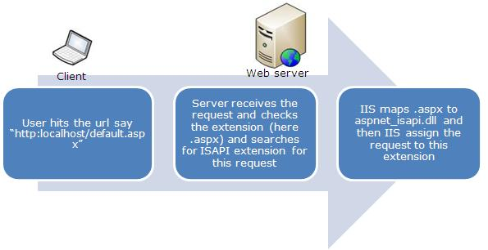

1. The request goes to the aspnet_isapi.dll for processing your application. Then it will check if request is coming first time or not.
2. If request is coming for the first time, then application manager will create application domain where application runs.

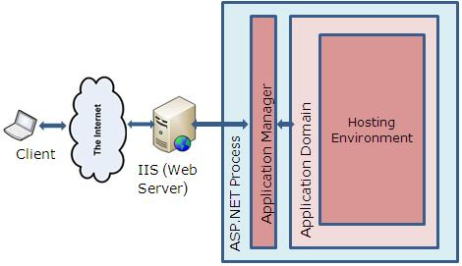

1. Asp.net creates objects like HttpContext, HttpRequest, HttpResponse.
2. HttpContext – holds the objects to the specific application request as HttpRequest and HttpResponse.
3. HttpRequest – contains information regarding the current request like cookies and browser information.
4. HttpResponse - containts the response that is sent to client.
5. Then application is started by creating the object of HttpApplication class.

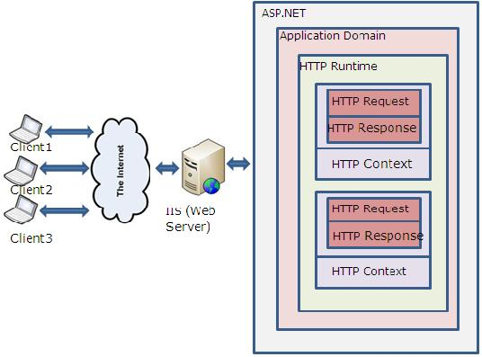

1. Then HttpApplication class starts processing the request.
2. First will call global.asax – handle application level event or methods.
3. Then will call page life cycle.

**ASP.Net Page Life Cycle during first request**

1. **Page Object Created** – HttpRequest and HttpResponse objects.
2. **Page_ PreInit Event** – to change Master Page and Theme of the page.
3. **Page_Init Event** – all the controls of the page initialized. Developers can change the properties of a control in this event.
4. **Page_Init Complete** – perform different operations to complete the initialization.
5. **Page_PreLoad Event** – performing operations on page.
6. **Page_Load Event** – load all the controls and their children controls. Write Database logic, filling the Dropdown list control.
7. **Page_Load Complete** – loading all other controls.
8. **Page_PreRender** – making final changes to the page properties or control properties.
9. **Page_Save State Complete Event** – before this event, ViewState created for the controls and page is saved with Key-Value pair. It is saved in a Hidden-Field.
10. **Page_Render Method** –
11. **Page_unLoad Event** – unload all the controls and then page.

**ASP.Net Page Life Cycle after post back**

1. **Page_LoadState Event** – during the round trip, client to server and server to client, asp.net maintain the state of the controls and the page. Load After Page_Init Complete event.
2. **Page_ProcessPostData Event** –
3. **Server Control Event** – events of the controls. Load after Page_Load Event.