**Week 1**

|  |  |
| --- | --- |
| **Meals** | **What To Eat** |
| Early Morning (6:30 – 7:30 a.m) | 1 cup fenugreek soaked water |
| Breakfast (7:30 – 8:30 p.m) | 4 idlis with 1 cup sambar and ¼ cup coconut chutney + 1 cup green tea + 4 almonds |
| Mid-Morning (10:00 – 10:30 a.m) | 1 cup milk/soy milk or fruit juice |
| Lunch (12:30 – 1:00 p.m) | 3 rotis + 1 serving white rice + 1 cup dal + ½ cup mixed vegetable curry or chicken curry + 1 cup salad + 1 cup buttermilk (after 20 minutes) |
| Post Lunch (3:30 – 4:00 p.m) | 1 cup moong bean sprouts, 15 peanuts with salt pepper and lemon to taste Or 1 cup cucumber and carrot slices |
| Dinner (7:00 – 7:30 p.m) | 3 rotis + ½ cup mixed vegetable curry / chickpeas / fish + ½ cup yogurt + ½ cup salad + 1 cup warm milk with a pinch of turmeric before bed |

**Total Calories –** 1509

**Benefits –** Fenugreek seed water in the morning helps boost metabolism and helps flush out toxins. Veggies, fruits, legumes, dairy, etc. will help prevent fat absorption and storage.

**Tip –** Avoid consuming too much oil. Though ghee is good for health, avoid it for a few days.

##### **How You Will Feel By the End of Week 1**

If you adhere to the plan, you will see a significant difference in your appearance. That’s because, in the first few days, you will lose water weight and a healthy eating habit will prevent bloating. Therefore, you will weigh less and feel light and happy. But remember, if you give up now, you will not be able to lose fat – which is the main goal. So, let’s find out what you must eat in the second week of 1500-calorie Indian diet plan for weight loss.

### Week 2

|  |  |
| --- | --- |
| **Meals** | **What To Eat** |
| Early Morning (6:30 – 7:30 a.m) | 1 cup fenugreek soaked water |
| Breakfast (7:30 – 8:30 p.m) | 2 moong daal chillas + 1 cup green tea + 4 almonds |
| Mid-Morning (10:00 – 10:30 a.m) | 1 cup seasonal fruits |
| Lunch (12:30 – 1:00 p.m) | 3 rotis + 1 serving of rice + 1 cup vegetable curry + 1 cup salad + 1 cup yogurt |
| Post Lunch (3:30 – 4:00 p.m) | 1 cup coconut water + ½ cup grapes/watermelon |
| Dinner (7:00 – 7:30 p.m) | 2 rotis + ½ cup mushroom/tofu/chicken curry + ½ cup blanched spinach/broccoli + 1 cup warm milk with a pinch of turmeric before bed |

**Total Calories –** 1497

**Benefits –** Moong daal chillas are loaded with protein, seasonal fruits will provide your body with the essential vitamins and minerals, coconut water is rich in natural electrolytes, and blanched spinach or broccoli is a great source of vitamin C and dietary fiber, which also helps to boost the immune system.

**Tip –** Do not throw away the soft spinach stem or the crunchy broccoli stalk as inedible. Wash them and slice off ½ an inch of the broccoli stalk or the soft spinach leaf stem. The rest you can use as these parts of the veggies are highly nutritious.

##### **How You Will Feel By the End of Week 2**

By the end of week 2, you will start to burn fat. You will start feeling better as all your digestion problems, gastritis problems, and weak immunity problems will slowly start to vanish. You will love your new lifestyle and will look forward to week 3.

### Week 3

|  |  |
| --- | --- |
| **Meals** | **What To Eat** |
| Early Morning (6:30 – 7:30 a.m) | 1 cup water with juice of ½ a lime |
| Breakfast (7:30 – 8:30 p.m) | 1 cup vegetable oats + 1 cup green tea + 4 almonds/walnut |
| Mid-Morning (10:00 – 10:30 a.m) | 1 boiled egg and 1 kiwi Or 1 cup freshly pressed fruit juice |
| Lunch (12:30 – 1:00 p.m) | 2 servings of white rice + 1 roti (with or without ghee) + 1 cup rajma/ fish curry + 1 cup salad + 1 cup buttermilk |
| Post Lunch (3:30 – 4:00 p.m) | 1 cup green tea + 1 multigrain biscuit |
| Dinner (7:00 – 7:30 p.m) | 3 rotis + ½ cup daal + 1 cup vegetable or chicken stew + ½ cup salad + 1 piece of dark chocolate + 1 cup warm milk before bed |

**Total Calories –** 1536

**Benefits –** Not warm, not cold, drink room temperature water with lime juice to flush out toxins. Vegetable oats are healthy and keep you full for a longer duration. A whole boiled egg is loaded with water soluble and fat soluble vitamins, essential amino acids, and protein. There is nothing wrong in consuming white rice if you eat a lot of different types of veggies, fruits etc. to lower the glycemic index. A piece of dark chocolate (80% or more cocoa) will keep your sweet cravings at bay.

**Tip –** On this week, let Saturday be your cheat day. You can consume 2000 calories instead of 1500 calories.

##### **How You Will Feel By the End of Week 3**

By the end of week three, you will weigh at least 5 pounds less and will be more proactive. Your attention span will also increase. Having a cheat day will also improve your mood and determination to complete the 4th week of the Indian diet plan for weight loss.

### Week 4

|  |  |
| --- | --- |
| **Meals** | **What To Eat** |
| Early Morning (6:30 – 7:30 a.m) | 1 cup water with juice of ½ a lime |
| Breakfast (7:30 – 8:30 p.m) | ½ cup vegetable upma + 1 cup milk / green tea + 2 almonds |
| Mid Morning (10:00 – 10:30 a.m) | 1 cup seasonal fruits |
| Lunch (12:30 – 1:00 p.m) | 3 rotis + 1 cup vegetable curry + 1 cup lentil/beans + ½ cup salad + ½ cup yogurt |
| Post Lunch (3:30 – 4:00 p.m) | 1 cup coconut water or freshly pressed fruit juice or green tea |
| Dinner (7:00 – 7:30 p.m) | 1 roti + 1 serving of brown rice + 1 cup daal/fish/chicken/mushroom + ½ cup boiled vegetables + 1 cup warm milk before bed |

**Total Calories –** 1486

**Benefits –** By consuming more veggies and fruits, you will prevent weight gain, and it will also make you feel good about yourself. The basic meals will provide you with protein, minerals, good carbs, vitamins, and healthy fats.

**Tip –** Try to consume at least 5 different types of veggies and 3 different types of fruits per day.

##### **How You Will Feel By the End of Week 4**

Good job! You adhered to the plan and can clearly see the results for yourself. You look much slimmer, you are more active, and you are proud of yourself. But this diet plan is incomplete! Why? Well, if you consume 1500 calories and sit all day (which most of us do – be it at home, office, or while traveling), you are not going to lose weight. You must exercise. Here is a sample exercise plan for you.

#### But this diet plan is incomplete! Why? Well, if you consume 1500 calories and sit all day (which most of us do – be it at home, office, or while traveling), you are not going to lose weight. You must exercise. Here is a sample exercise plan.

### Exercise Plan

1. Head tilt - 1 set of 10 reps

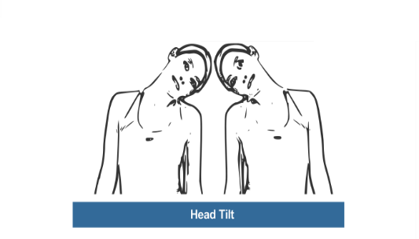 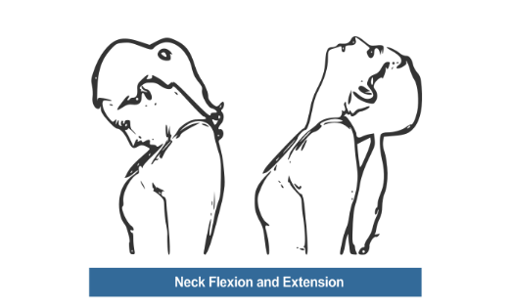

1. Neck rotations – 1 set of 10 reps

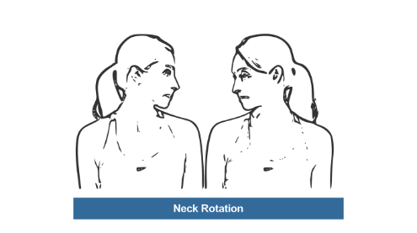

1. Shoulder rotations – 1 set of 10 reps

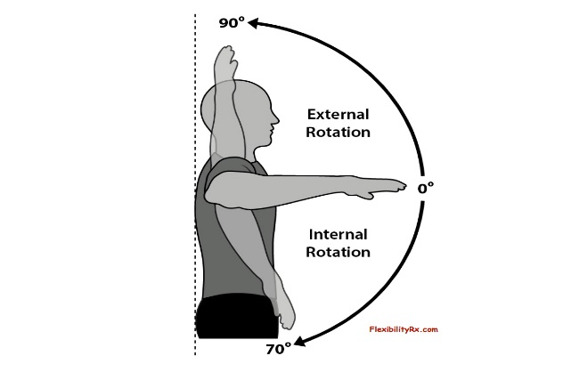 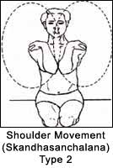

1. Arm circles – 1 set of 10 reps

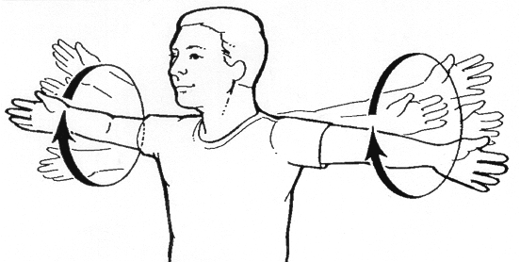

1. Wrist rotations – 1 set of 10 reps

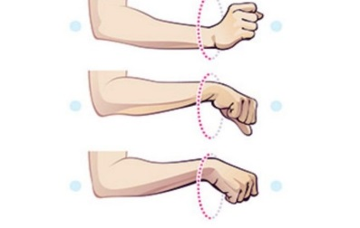

1. Waist rotations – 1 set of 10 reps

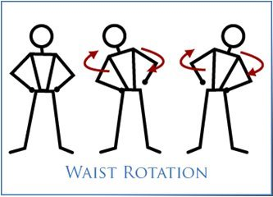

1. Ankle rotation – 1 set of 10 reps

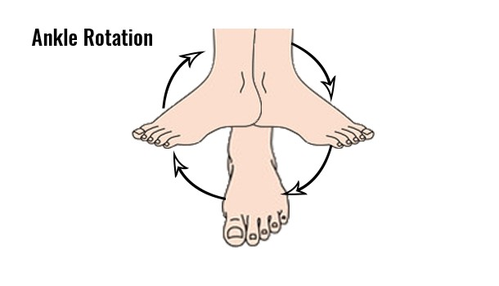

1. Spot jogging – 5 minutes

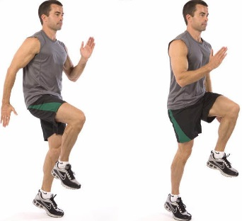

1. Jumping jacks – 2 sets of 20 reps



1. Side Lunges – 1 set of 15 reps

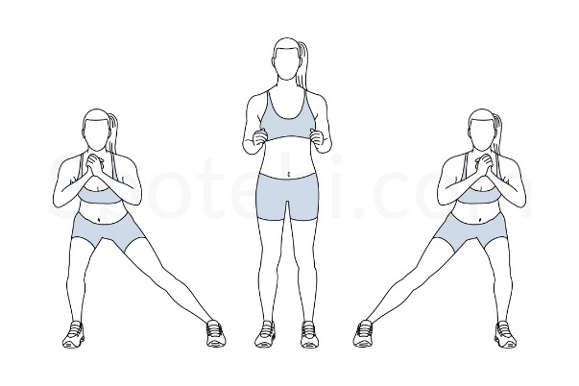

1. Forward bend – 1 set of 10 reps



1. Standing side crunches – 2 sets of 10 reps



1. Russian twist – 2 sets of 20 reps



1. Crunches – 3 sets of 10 reps

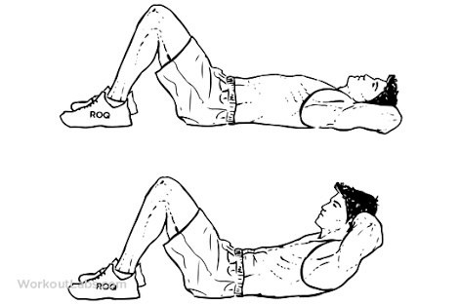

1. Full Squat – 2 sets of 10 reps

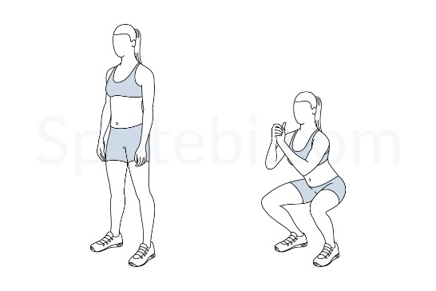

1. Explosive forward lunges – 2 sets of 10 reps

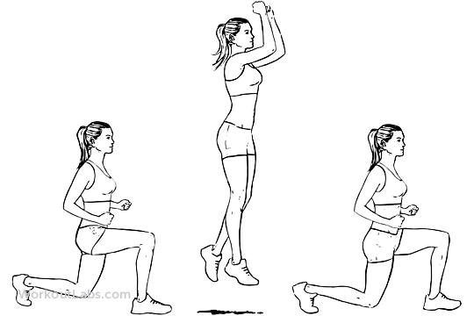

1. Burpees – 1 set of 10 reps

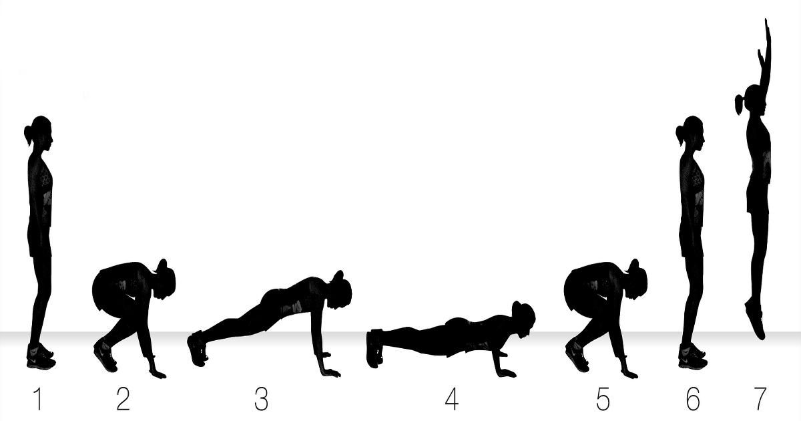

1. Sit-ups – 1 set of 10 reps

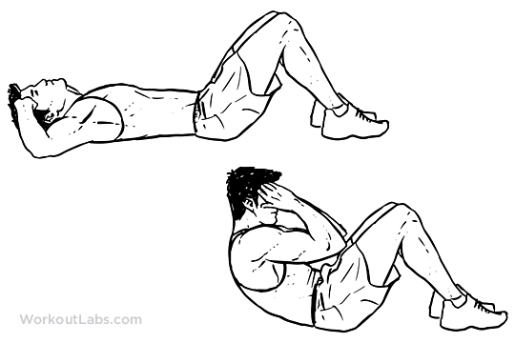

1. Bicep curls (5 lb weights) – 2 sets of 10 reps

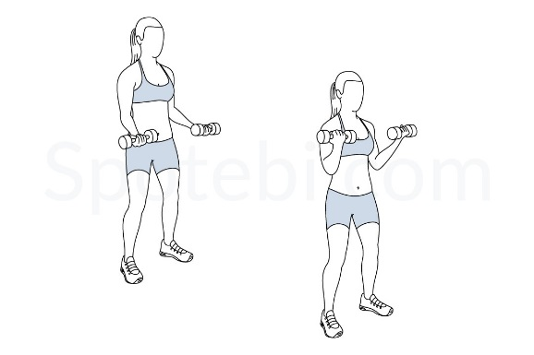

1. Tricep dips – 2 sets of 5 reps

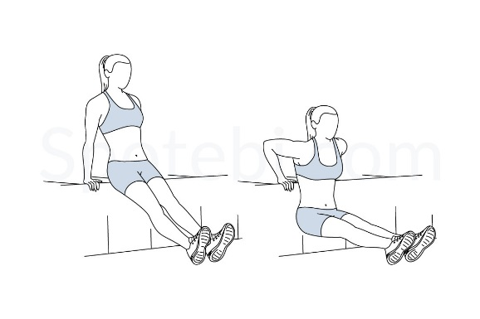

1. Push-ups – 2 sets of 10 reps



1. Lying leg circles – 1 set of 10 reps

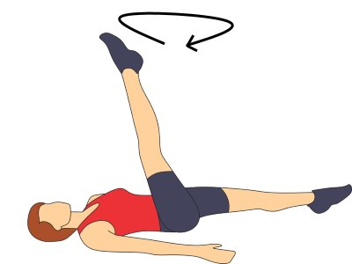

1. Horizontal kicks – 1 set of 10 reps



1. Forward elbow plank – 20-second hold



1. Stretch

