МІНІСТЕРСТВО ОСВІТИ І НАУКИ УКРАЇНИ

НАЦІОНАЛЬНИЙ УНІВЕРСИТЕТ «ЛЬВІВСЬКА ПОЛІТЕХНІКА»

ІНСТИТУТ КОМП'ЮТЕРНИХ НАУК ТА ІНФОРМАЦІЙНИХ ТЕХНОЛОГІЙ

Кафедра ІСМ



Звіт

до лабораторної роботи №5

На тему “Розробка ASCII ART генератора для візуалізації 3D-фігур”

З дисципліни “Спеціалізовані мови програмування”

*Виконав:*

*ст. гр. ІТ-31*

*Іштван Комоній*

*Прийняв:*

*Щербак С. С.*

*Львів - 2023*

**Мета роботи:** Створення додатка для малювання 3D-фігур у ASCII-арті на основі об’єктно - орієнтованого підходу та мови Python.

**Хід роботи**

**Програмний код:**

/figure_art_interface/figure_art_interface

from abc import ABC, abstractmethod

from figures.figure import Figure

from figures.figures_3d.cube import Cube

from figures.figures_2d.square import Square

from helpers.helpers import text_file_saver

class Command(ABC):

@abstractmethod

def execute(self):

pass

class Generate3DFigureCommand(Command):

def __init__(self, figure_interface):

self.figure_interface = figure_interface

def execute(self):

print(self.figure_interface.generate_3d_figure())

class SetSizeCommand(Command):

def __init__(self, figure_interface, new_size):

self.figure_interface = figure_interface

self.new_size = new_size

def execute(self):

self.figure_interface.set_size(self.new_size)

class SetColorCommand(Command):

def __init__(self, figure_interface, new_color):

self.figure_interface = figure_interface

self.new_color = new_color

def execute(self):

self.figure_interface.set_color(self.new_color)

# Add more command classes for SetType, SetPaddings, Generate2DFigure, SaveToFile3D, and SaveToFile2D

class FigureArtInterface(Figure):

def __init__(self):

super().__init__()

self.type = "cube"

self.left_padding = 5

self.top_padding = 5

self.bottom_padding = 5

self.commands = {

1: Generate3DFigureCommand(self),

2: SetSizeCommand(self, 0),

3: SetColorCommand(self, ""),

# Add more command instances here

}

def set_type(self, type):

self.type = type

def set_paddings(self, left_padding, top_padding, bottom_padding):

self.left_padding = left_padding

self.top_padding = top_padding

self.bottom_padding = bottom_padding

def set_primary_data(self):

size = int(input("figure size: "))

self.set_size(size)

color = input(

"figure color(blue, green, red, magenta, yellow, white, cyan): ")

self.set_color(color)

type = input("figure type(skip for default): ")

if len(type):

self.set_type(type)

def generate_with_left_padding(self, text):

lines = text.split('\n')

padded_lines = [f"{' ' * self.left_padding}{line}" for line in lines]

return '\n'.join(padded_lines)

def generate_with_top_padding(self, text):

space = self.top_padding * '\n'

padded_lines = space + text

return padded_lines

def generate_with_bottom_padding(self, text):

space = self.bottom_padding * '\n'

padded_lines = text + space

return padded_lines

def generate_with_paddings(self, text):

return self.generate_with_bottom_padding(self.generate_with_top_padding(self.generate_with_left_padding(text)))

def generate_3d_figure(self):

if self.type == 'cube':

cube = Cube()

cube.set_size(self.size)

cube.set_color(self.color)

return self.generate_with_paddings(cube.generate_figure())

return super().generate_figure()

def generate_2d_figure(self):

if self.type == 'cube':

square = Square()

square.set_size(self.size)

square.set_color(self.color)

return self.generate_with_paddings(square.generate_figure())

return super().generate_figure()

def save_to_file_2d(self):

filename = input("enter filename before saving: ")

text_file_saver(

filename, self.generate_2d_figure())

def save_to_file_3d(self):

filename = input("enter filename before saving: ")

text_file_saver(

filename, self.generate_3d_figure())

@staticmethod

def show_menu():

print("choose menu option")

print("[ 1 ] - generate 3d figure")

print("[ 2 ] - set size")

print("[ 3 ] - set color(blue, green, red, magenta, yellow, white, cyan)")

print("[ 4 ] - set type(cube)")

print("[ 5 ] - set paddings")

print("[ 6 ] - get 2d version of the figure")

print("[ 7 ] - save to file(3d)")

print("[ 8 ] - save to file(2d)")

print("[ 0 ] - exit")

def loop_menu(self):

while True:

self.show_menu()

menu_choice = int(input("menu key: "))

if (menu_choice == 1):

print(self.generate_3d_figure())

elif (menu_choice == 2):

new_size = int(input("enter new size: "))

self.set_size(new_size)

elif (menu_choice == 3):

new_color = input("enter new color: ")

self.set_color(new_color)

elif (menu_choice == 4):

new_type = input("enter new type: ")

self.set_type(new_type)

elif (menu_choice == 5):

left_padding = int(input("enter left padding: "))

top_padding = int(input("enter top padding: "))

bottom_padding = int(input("enter bottom padding: "))

self.set_paddings(left_padding, top_padding, bottom_padding)

elif (menu_choice == 6):

print(self.generate_2d_figure())

elif (menu_choice == 7):

self.save_to_file_3d()

elif (menu_choice == 8):

self.save_to_file_2d()

else:

break

def launch(self):

self.set_primary_data()

print(self.generate_3d_figure())

self.loop_menu()

/figures/figure

class Figure:

def __init__(self):

self.size = 1

self.color = 'green'

def set_size(self, size):

self.size = size

def set_color(self, color):

self.color = color

def generate_figure(self):

return ""

/figures/figures_2d/square

from figures.figure import Figure

from helpers.helpers import paint_text

class Square(Figure):

def __init__(self):

super().__init__()

def generate_square(self):

n = self.size

line = ''

if n > 1:

line += n * 2 * '_'

else:

line += '_'

top_line = ' ' + line

bottom_line = '|' + line + '|' + '\n'

inner_spaces = n * 2 * ' '

inner_fill = '|' + inner_spaces + '|'

content = ''

i = 1

while (i < n):

content += inner_fill + '\n'

i += 1

square = top_line + '\n' + content + bottom_line

return square

def generate_figure(self):

generated = self.generate_square()

colored = paint_text(generated, self.color)

return colored

/figures/figures_3d/cube

from figures.figure import Figure

from helpers.helpers import paint_text

class Cube(Figure):

def __init__(self):

super().__init__()

def generate_cube(self):

n = self.size

line = ''

if n > 1:

line += n * 2 * '_'

else:

line += '_'

top_line = n * ' ' + line

mid_line_space = 2 * n - 2

mid_line = '/' + line + '/' + mid_line_space * ' ' + '\\'

bottom_line = (n - 1) * ' ' + '\\' + line + '\/'

inner_spaces = n * 2 * ' '

inner_top = '/' + inner_spaces + '/'

inner_bottom = '\\' + inner_spaces + '\\'

top_content = ''

bottom_content = ''

for i in range(1, n):

top_content += (n - i) * ' ' + inner_top + \

(i - 1) * 2 * ' ' + '\\' + '\n'

bottom_content += (i - 1) * ' ' + inner_bottom + \

(n - i) * 2 * ' ' + '/' + '\n'

cube = top_line + '\n' + top_content + mid_line + \

'\n' + bottom_content + bottom_line + '\n'

return cube

def generate_figure(self):

generated = self.generate_cube()

colored = paint_text(generated, self.color)

return colored

Результат виконання програми:

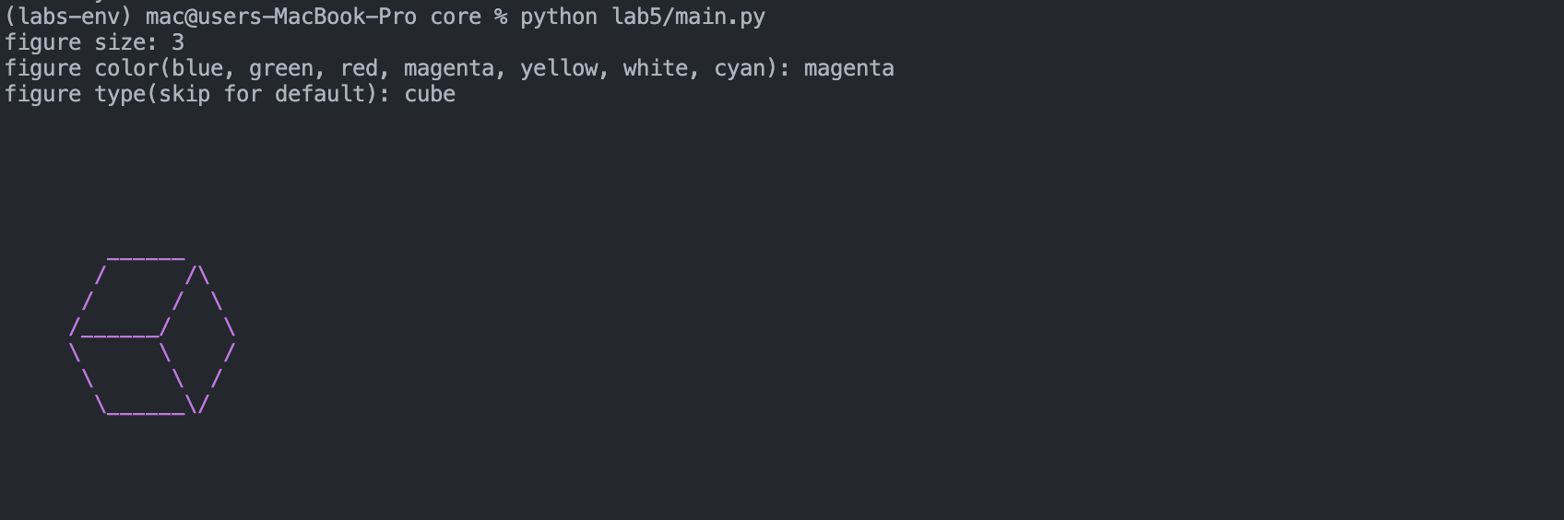

**Висновок:** Під час виконання даної лабораторної роботи було створено додаток для малювання 3D-фігур у ASCII-арті на основі об’єктно - орієнтованого підходу та мови Python.