МІНІСТЕРСТВО ОСВІТИ І НАУКИ УКРАЇНИ

НАЦІОНАЛЬНИЙ УНІВЕРСИТЕТ «ЛЬВІВСЬКА ПОЛІТЕХНІКА»

ІНСТИТУТ КОМП'ЮТЕРНИХ НАУК ТА ІНФОРМАЦІЙНИХ ТЕХНОЛОГІЙ

Кафедра ІСМ



Звіт

до лабораторної роботи №8

На тему “Візуалізація та обробка даних за допомогою спеціалізованих бібліотек Python”

З дисципліни “Спеціалізовані мови програмування”

*Виконав:*

*ст. гр. ІТ-31*

*Іштван Комоній*

*Прийняв:*

*Щербак С. С.*

*Львів - 2023*

**Мета роботи:** Розробка додатка для візуалізації CSV-наборів даних за допомогою Matplotlib та базових принципів ООП (наслідування, інкапсуляція, поліморфізм).

**Хід роботи**

**Програмний код:**

/data.csv

date,income,products_sold,ads_company

2023-12-01, 100, 5, push ads

2023-12-02, 120, 6, push ads

2023-12-03, 105, 4, push ads

2023-12-04, 98, 3, push ads

2023-12-05, 50, 1, push ads

2023-12-06, 324, 20, seo traffic

2023-12-07, 1050, 50, seo traffic

2023-12-08, 980, 43, seo traffic

2023-12-09, 2040, 80, seo traffic

2023-12-10, 673, 20, push ads

2023-12-11, 200, 7, push ads

2023-12-12, 500, 18, seo traffic

/client_application/client_application

from command.invoker import Invoker

from client_application.client_application_receiver import ClientApplicationReceiver

from client_application.commands import DisplayAllcharts, DisplayBarchart, DisplayLinechart, DisplayPiechart, SaveChartCommand

import pandas as pd

class ClientApplication():

def __init__(self):

self.data_source = 'lab8/data.csv'

self.data_frame = None

self.app_receiver = ClientApplicationReceiver()

self.app_invoker = Invoker()

def set_data_source(self, val):

self.data_source = val

def set_data_frame(self, val):

self.data_frame = val

def set_primary_data(self):

data_source = input(

"enter filename of datasource(skip for default): ")

if len(data_source):

self.set_data_source(data_source)

self.set_data_frame(pd.read_csv(self.data_source))

def display_barchart(self):

display_barchart_command = DisplayBarchart(

self.app_receiver, self.data_frame)

self.app_invoker.add_command(display_barchart_command)

self.app_invoker.execute_current_command()

def display_piechart(self):

display_piechart_command = DisplayPiechart(

self.app_receiver, self.data_frame)

self.app_invoker.add_command(display_piechart_command)

self.app_invoker.execute_current_command()

def display_linechart(self):

display_linechart_command = DisplayLinechart(

self.app_receiver, self.data_frame)

self.app_invoker.add_command(display_linechart_command)

self.app_invoker.execute_current_command()

def display_allcharts(self):

display_allcharts_command = DisplayAllcharts(

self.app_receiver, self.data_frame)

self.app_invoker.add_command(display_allcharts_command)

self.app_invoker.execute_current_command()

def save_chart(self, filename):

save_chart_command = SaveChartCommand(

self.app_receiver, self.data_frame, filename)

self.app_invoker.add_command(save_chart_command)

self.app_invoker.execute_current_command()

@staticmethod

def show_menu():

print("choose menu option")

print("[ 1 ] - display bar chart")

print("[ 2 ] - display pie chart")

print("[ 3 ] - display line chart")

print("[ 4 ] - display all charts")

print("[ 5 ] - change sourcefile")

print("[ 6 ] - save chart")

print("[ 0 ] - exit")

def loop_menu(self):

while True:

self.show_menu()

menu_choice = int(input("menu key: "))

if (menu_choice == 1):

self.display_barchart()

elif (menu_choice == 2):

self.display_piechart()

elif (menu_choice == 3):

self.display_linechart()

elif (menu_choice == 4):

self.display_allcharts()

elif (menu_choice == 5):

new_sourcefile = input("enter filename of new datasource: ")

if len(new_sourcefile):

self.set_data_source(new_sourcefile)

self.set_data_frame(pd.read_csv(new_sourcefile))

elif (menu_choice == 6):

filename = input("enter filename: ")

if len(filename):

self.save_chart(filename)

else:

self.save_chart('chart.png')

else:

break

def launch(self):

self.set_primary_data()

self.display_barchart()

self.loop_menu()

/client_application/client_application_receiver

from command.receiver import Receiver

import matplotlib.pyplot as plt

class ClientApplicationReceiver(Receiver):

@staticmethod

def run_display_barchart(data_frame):

data_frame.plot(kind='bar', x='date', y='income', label='Income')

plt.title('Income by date')

plt.xticks(rotation=90)

plt.tight_layout()

plt.show()

@staticmethod

def run_display_piechart(data_frame):

grouped_data = data_frame.groupby('ads_company')['products_sold'].sum()

grouped_data.plot(kind='pie', autopct='%1.1f%%', startangle=90)

plt.title('Products Sold by Ads Company')

plt.tight_layout()

plt.show()

@staticmethod

def run_display_linechart(data_frame):

data_frame.plot(kind='line', x='date', y=['income', 'products_sold'])

plt.title('Income and units sold')

plt.legend(['Income', 'Products Sold'])

plt.xticks(rotation=90)

plt.tight_layout()

plt.show()

@staticmethod

def run_display_allcharts(data_frame):

fig, axs = plt.subplots(2, 2, figsize=(12, 8))

axs[0, 0].bar(data_frame['date'], data_frame['income'], label='Income')

axs[0, 0].set_title('Income by date')

axs[0, 0].legend()

grouped_data = data_frame.groupby('ads_company')['products_sold'].sum()

axs[0, 1].pie(grouped_data, autopct='%1.1f%%', startangle=90)

axs[0, 1].set_title('Products Sold by Ads Company')

axs[1, 0].plot(data_frame['date'],

data_frame[['income', 'products_sold']])

axs[1, 0].set_title('Income and units sold')

axs[1, 0].legend(['Income', 'Products Sold'])

axs[1, 1].axis('off')

plt.setp(axs[1, 0].xaxis.get_majorticklabels(), rotation=90)

plt.setp(axs[0, 0].xaxis.get_majorticklabels(), rotation=90)

plt.tight_layout()

plt.show()

@staticmethod

def run_save_chart(data_frame, filename):

fig, axs = plt.subplots(2, 2, figsize=(12, 8))

axs[0, 0].bar(data_frame['date'], data_frame['income'], label='Income')

axs[0, 0].set_title('Income by date')

axs[0, 0].legend()

grouped_data = data_frame.groupby('ads_company')['products_sold'].sum()

axs[0, 1].pie(grouped_data, autopct='%1.1f%%', startangle=90)

axs[0, 1].set_title('Products Sold by Ads Company')

axs[1, 0].plot(data_frame['date'],

data_frame[['income', 'products_sold']])

axs[1, 0].set_title('Income and units sold')

axs[1, 0].legend(['Income', 'Products Sold'])

axs[1, 1].axis('off')

plt.setp(axs[1, 0].xaxis.get_majorticklabels(), rotation=90)

plt.setp(axs[0, 0].xaxis.get_majorticklabels(), rotation=90)

plt.tight_layout()

plt.savefig(filename)

/client_application/commands

from command.i_command import ICommand

class DisplayBarchart(ICommand):

def __init__(self, _app_receiver, data_frame):

self._app_receiver = _app_receiver

self.data_frame = data_frame

def execute(self):

self._app_receiver.run_display_barchart(self.data_frame)

class DisplayPiechart(ICommand):

def __init__(self, _app_receiver, data_frame):

self._app_receiver = _app_receiver

self.data_frame = data_frame

def execute(self):

self._app_receiver.run_display_piechart(self.data_frame)

class DisplayLinechart(ICommand):

def __init__(self, _app_receiver, data_frame):

self._app_receiver = _app_receiver

self.data_frame = data_frame

def execute(self):

self._app_receiver.run_display_linechart(self.data_frame)

class DisplayAllcharts(ICommand):

def __init__(self, _app_receiver, data_frame):

self._app_receiver = _app_receiver

self.data_frame = data_frame

def execute(self):

self._app_receiver.run_display_allcharts(self.data_frame)

class SaveChartCommand(ICommand):

def __init__(self, _app_receiver, data_frame, filename):

self._app_receiver = _app_receiver

self.data_frame = data_frame

self.filename = filename

def execute(self):

self._app_receiver.run_save_chart(self.data_frame, self.filename)

Результат виконання програми:

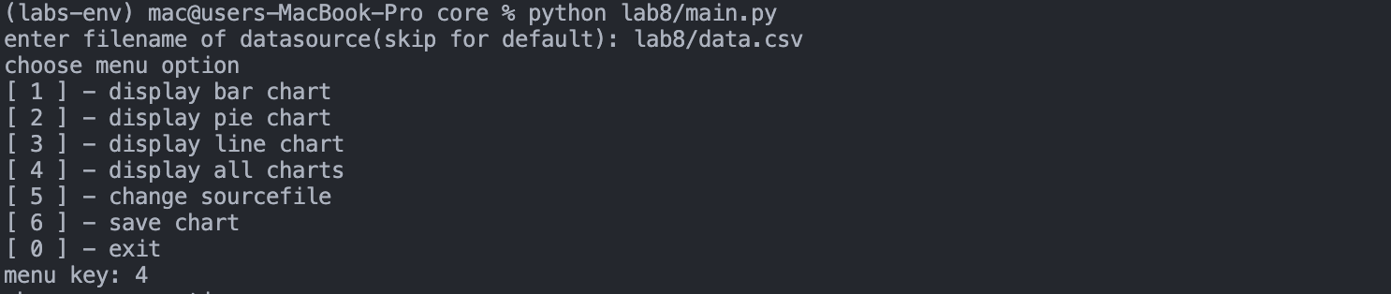

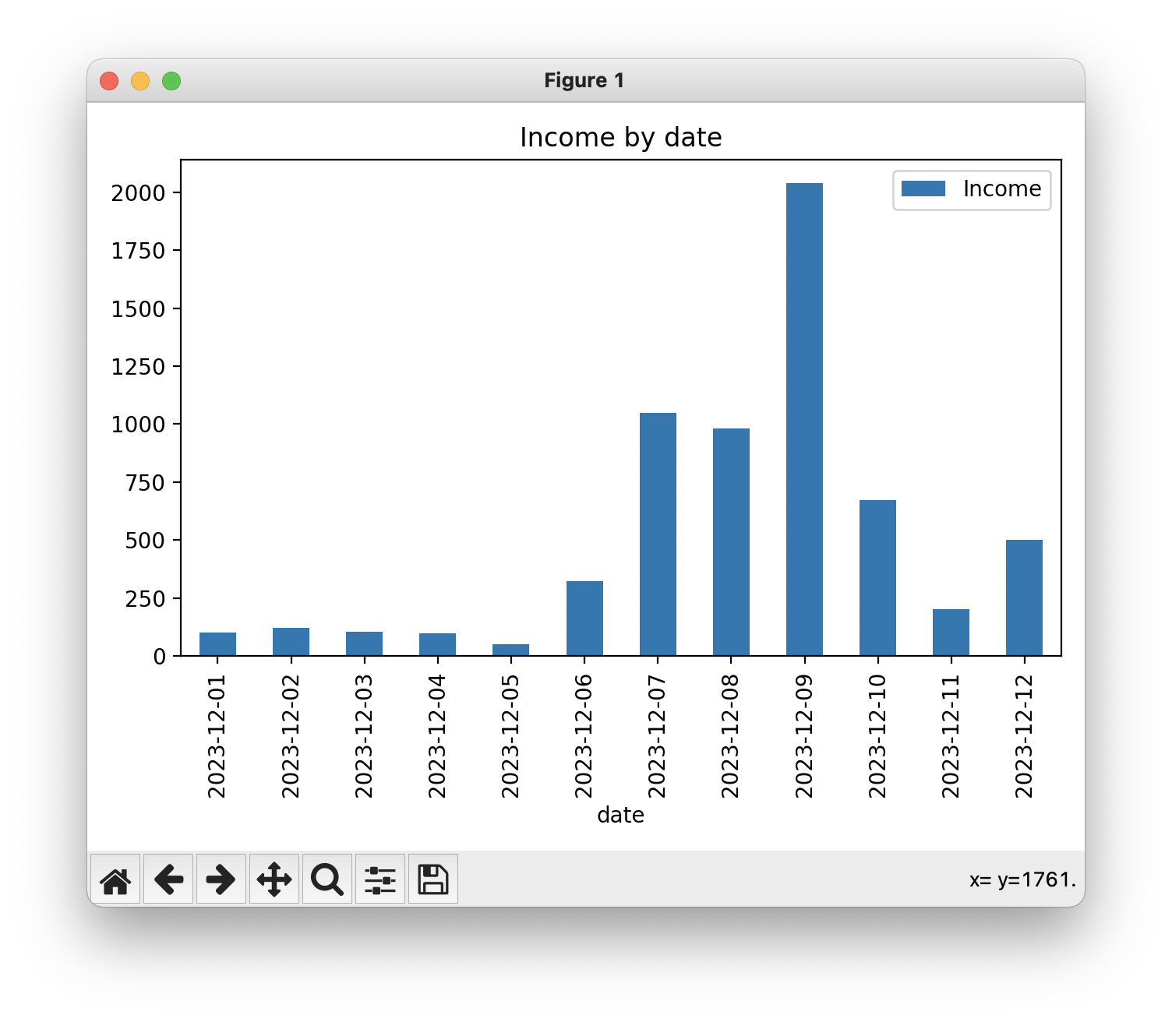

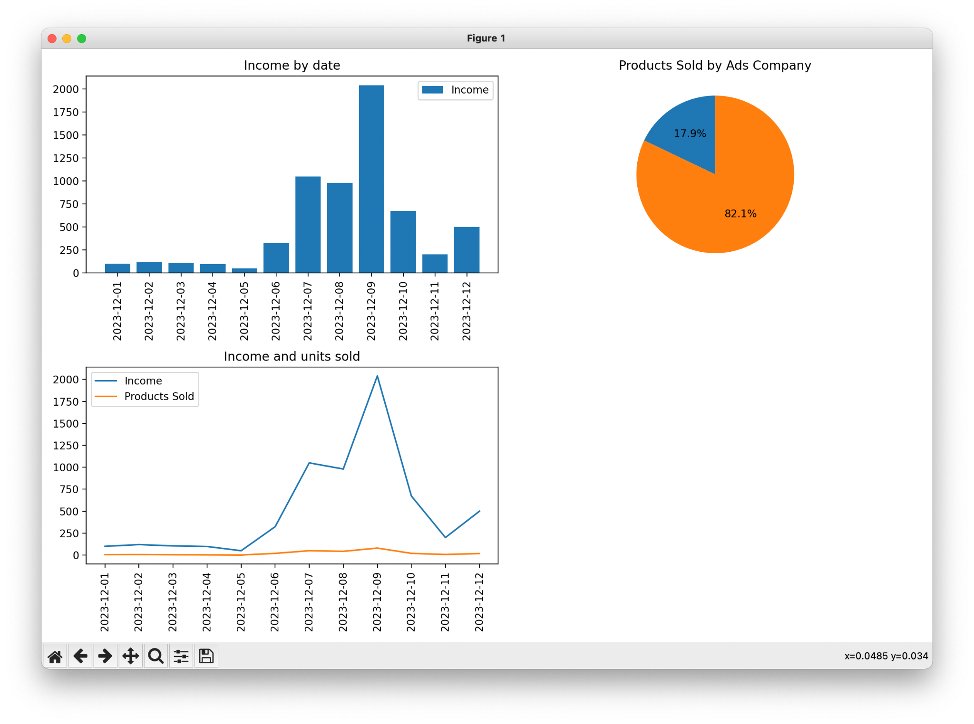

**Висновок:** Під час виконання даної лабораторної роботи було створено додаток для візуалізації CSV-наборів даних за допомогою Matplotlib.