Onboard Capture and Mineralisation of Vehicle Exhaust CO₂ Using Diamine-Appended Mg-MOF-74 and Limewater: A Conceptual and Simulation Study
Advik Harihar and Panav K Bysani
10x International School, Mysore, Karnataka, India
Chemistry Mentor: Yash Verma
Abstract
Background/Objective: Rising vehicular CO₂ emissions accelerate global climate change, yet conventional onboard carbon capture remains impractical due to severe weight and safety penalties from high-pressure compressed-gas storage. This study proposes and evaluates a passive onboard capture-and-mineralization architecture designed to eliminate compressed-gas storage by coupling temperature-swing adsorption with aqueous carbonation.
Methods: We formulated a continuous, time-stepped numerical model coupling a 5.0 kg packed bed of diamine-appended Mg-MOF-74, a passive coaxial exhaust heat exchanger driving thermal regeneration, and an unpressurized 30 L limewater bubbler (20 wt% Ca(OH)₂ slurry). Dynamic bed adsorption kinetics, Gibbs-derived sigmoidal thermal desorption, and stoichiometric calcite precipitation were evaluated over a representative 77-minute driving cycle using empirical literature parameters.
Results: Under 13.5% exhaust CO₂, the 5.0 kg bed captures 0.805 kg CO₂ (95.4% equilibrium saturation). Exhaust waste heat passively supplies the 1063 kJ regeneration duty in under 55 seconds without electrical input. Thermal desorption liberates 0.323 kg CO₂ at 85 °C (40.1% release) and 0.738 kg CO₂ at 110 °C (91.7% release), precipitating 0.735 kg to 1.678 kg of permanent solid calcite (CaCO₃). The 46.0 kg wet system induces a minimal 0.68 kPa back-pressure and an estimated 3.07% fuel economy penalty.
Conclusions: Pairing cooperative chemisorption in diamine-appended MOFs with ambient limewater mineralization provides an unpressurized, thermodynamically viable foundation for mobile carbon capture, demonstrating that onboard exhaust decarbonization is physically integrable and identifying operational windows for upcoming prototype testing.
Keywords: Carbon capture, metal-organic frameworks, Mg-MOF-74, vehicle exhaust, limewater mineralization, temperature-swing adsorption, calcium carbonate.
Introduction
Background and Context
Carbon dioxide is the primary greenhouse gas driving anthropogenic global climate change, and its atmospheric concentration continues to escalate. Internal combustion engine (ICE) vehicles release CO₂ directly at street level, making road transport one of the single largest contributors to global emissions¹.Mitigating mobile emissions is crucial to meeting international net-zero targets, creating an urgent demand for point-of-origin onboard capture systems.
Problem Statement and Rationale
Most commercial carbon capture technologies are tailored for either industrial flue gas (>15% CO₂) or direct air capture (approximately 420 ppm CO₂). Vehicle exhaust occupies an intermediate 5% to 15% range. Conventional physisorbents (zeolites and activated carbons) exhibit low working capacities across this window, while liquid monoethanolamine (MEA) scrubbers require high regeneration temperatures (120 °C to 150 °C), heavy solvent inventories, and corrosive liquid circulation unsuited for vehicle packaging^{1,2}.
Significance and Purpose
Metal-organic frameworks (MOFs) functionalized with appended diamines offer a transformative solution through cooperative chemisorption, exhibiting sharp step-change uptake in the 5% to 15% exhaust regime with mild thermal regeneration^{4,9}.However, stationary systems store released CO₂ via high-pressure compression into geological reservoirs—an approach that imposes prohibitive weight, volume, and crash-safety hazards on a vehicle chassis. This investigation overcomes this decisive barrier by mineralizing released CO₂ in an onboard limewater slurry into permanent, solid calcium carbonate⁸.
Objectives
The primary objective of this study is to formulate and evaluate, through a literature-grounded numerical simulation, a self-contained onboard vehicular capture architecture. Specifically, we investigate: (1) dynamic bed adsorption kinetics across a 77-minute driving cycle; (2) passive waste-heat thermal regeneration duties; (3) stoichiometric calcite mineralization yields; and (4) vehicle packaging, weight, and engine back-pressure constraints.
Scope and Limitations
This study is a conceptual design and numerical modeling investigation. Model parameters are drawn from peer-reviewed experimental literature. Physical prototype construction and multi-gas engine bench-testing under sulfurous and moist transients are outside the current scope and represent designated next steps.
Theoretical Framework
The study operates on three coupled theoretical frameworks: (1) first-order linear driving force (LDF) adsorption kinetics; (2) Gibbs-Helmholtz thermodynamic equilibrium governing logistic thermal carbamate dissociation^{7,9}; and (3) irreversible aqueous mineralization kinetics governed by calcite's negligible solubility product (K_sp = 3.3 × 10⁻⁹ at 25 °C)
Methodology Overview
The proposed architecture integrates: (1) a packed bed of ethylenediamine-appended Mg-MOF-74 in the exhaust pathway; (2) a coaxial exhaust heat exchanger for passive thermal regeneration; and (3) an unpressurized limewater bubbler tank converting desorbed CO₂ into dense solid CaCO₃.
Methods
Research Design
We developed a sequential, time-stepped numerical model implemented in Python. The model computes the complete material and energy balance of vehicular CO₂ capture across an uninterrupted 77-minute drive cycle, resolving transient bed loading, thermal desorption duties, and calcite precipitation without adjustable empirical fitting parameters.
Sorbent and Reagent Sample Parameters
The sorbent selected is ethylenediamine-functionalized Mg-MOF-74 (en-Mg-MOF-74), possessing 1D hexagonal pore channels with high open metal site density. Table 1 compares candidate sorbents across exhaust conditions.
Table 1. Evaluation of candidate CO₂ sorbents across vehicle exhaust conditions.
Sorbent Technology | Binding Mechanism | Optimal Range | Regen Temp (°C) | Vehicle Viability
Zeolites / Activated Carbon | Physisorption (van der Waals) | >20% CO₂ (High P) | Low (poor capacity) | Unviable (<2 wt% capture)
Liquid Amines (MEA 30%) | Chemisorption (carbamates) | 10% to 15% CO₂ | 120 °C to 150 °C | Unviable (corrosive, heavy)
Diamine-Appended Mg-MOF-74 | Cooperative chemisorption | 5% to 15% CO₂ | 85 °C to 110 °C | Optimal (passive waste heat)
Table 2. Comparison of candidate alkaline mineralization media for onboard storage.
Reagent | Carbonation Product | Reaction State | Safety / Corrosivity | Storage Permanence
Sodium Hydroxide (NaOH) | Na₂CO₃ (Soluble) | Aqueous solution | Hazardous (strongly caustic) | Low (reversible upon heating)
Calcium Oxide (CaO) | CaCO₃ (Solid) | Dry powder | Moderate (exothermic slaking) | High (diffusion-limited kinetics)
Limewater / Ca(OH)₂ | CaCO₃ (Calcite, solid) | 20 wt% slurry | Safe (mild base, non-toxic) | Permanent (K_sp = 3.3×10⁻⁹)
Variables and Mathematical Formulations
The dynamic mass of CO₂ adsorbed on the sorbent bed, q(t), is formulated via first-order linear driving force kinetics:
$\frac{dq(t)}{dt}=k\left(q_{eq}−q(t)\right)$ | (1)
where: k is the first-order kinetic rate constant (0.04 min⁻¹) and q_eq is the equilibrium bed saturation capacity (kg).
$q(t)=q_{eq}\left[1 − e^{−k·t}\right]$ | (2)
where: Analytical solution for dynamic bed loading under continuous exhaust scrubbing.
$q_{eq}=m_{MOF}·Q_{max}·\left(\frac{C_{{CO}_{2}}}{C_{ref}}\right)$ | (3)
where: m_MOF = 5.0 kg sorbent mass; Q_max = 0.25 kg CO₂ / kg MOF; C_CO2 = 13.5% engine exhaust; C_ref = 20.0% reference concentration.
Thermal desorption release fraction, σ(T), is modeled via a logistic sigmoid derived from the Gibbs free energy of carbamate bond dissociation⁹:
$σ(T)=\frac{1}{1+e^{−k_{σ}(T−T_{m})}}$ | (4)
where: T is bed regeneration temperature (°C); T_m = 90.0 °C is thermodynamic midpoint; k_σ = 0.08 °C⁻¹ is transition steepness.
$m_{released}=q(t)·σ(T)$ | (5)
where: Mass of gaseous CO₂ liberated per regeneration event (kg).
$Q_{total}=Q_{sensible}+Q_{desorb}=\left[m_{MOF} · c_{MOF} · ΔT\right]+\left[\left(\frac{m_{released}}{M_{{CO}_{2}}}\right) · ΔH_{des}\right]$ | (6)
where: c_MOF = 0.8 kJ/(kg·K); ΔT = T - 25 °C; M_CO2 = 0.04401 kg/mol; ΔH_des = 45.0 kJ/mol.
Desorbed CO₂ bubbles through limewater, precipitating permanently as solid calcium carbonate⁸:
${CO}_{2}(aq)+{Ca(OH)}_{2}(aq)⟶{CaCO}_{3}(s)↓+H_{2}O(l)$ | (7)
where: Irreversible calcite precipitation; solubility product K_sp = 3.3 × 10⁻⁹ (25 °C).
$m_{{CaCO}_{3}}=\left(\frac{m_{released}}{M_{{CO}_{2}}}\right)·M_{{CaCO}_{3}}=2.274·m_{released}$ | (8)
where: Stoichiometric solid calcium carbonate precipitate yield (M_CaCO3 = 100.09 g/mol; M_CO2 = 44.01 g/mol).
$n_{{Ca(OH)}_{2},initial}=\frac{w·ρ·V}{M_{{Ca(OH)}_{2}}}$ | (9)
where: w = 0.20 (20 wt% suspension); ρ = 1.10 kg/L; V is slurry volume (L); M_Ca(OH)2 = 74.09 g/mol.
Table 3. Baseline simulation parameters and physical constants.
Parameter | Description | Numerical Value | Source / Basis
m_MOF | Sorbent bed mass | 5.0 kg | Chassis packaging envelope
Q_max | Baseline sorption capacity | 0.25 kg CO₂ / kg MOF | Mahajan et al. (2024) [4]
k | First-order adsorption rate | 0.04 min⁻¹ | Hughes et al. (2021) [7]
C_CO2 | Exhaust CO₂ concentration | 13.5% vol | WLTP loaded cruise [11]
ΔH_des | Desorption enthalpy | 45.0 kJ / mol | Zhu et al. (2024) [9]
c_MOF | Specific heat capacity | 0.80 kJ / (kg·K) | Thermal property baseline
T_m, k_σ | Sigmoid midpoint & slope | 90.0 °C, 0.08 °C⁻¹ | Thermodynamic derivation
V_slurry | Limewater volume | 30.0 L (20 wt%) | Under-chassis tank design
P_exhaust | Exhaust thermal power | 20.0 kW | Typical passenger ICE vehicle
Procedure and Algorithmic Workflow
The physical layout and numerical execution flow are shown in Figures 1 and 2. The simulation reads the parameters from Table 3, computes q_eq, and iterates across t = 0 to 77 minutes in 1-minute timesteps to track bed loading. It then calculates the sensible and desorption heat duties, applies the sigmoid release fraction σ(T), and converts released gas into solid CaCO₃.
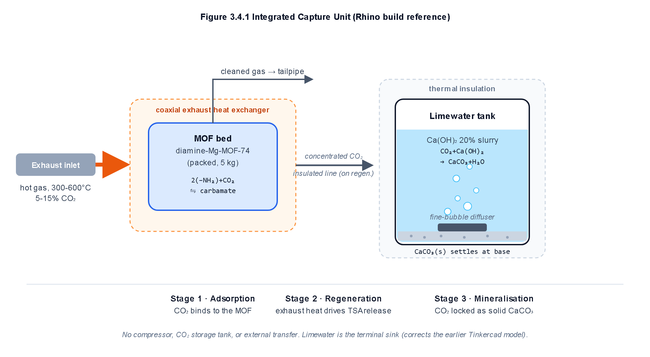
Figure 1. Integrated vehicular capture unit layout: In-line MOF packed bed, coaxial exhaust heat exchanger, and limewater bubbler.
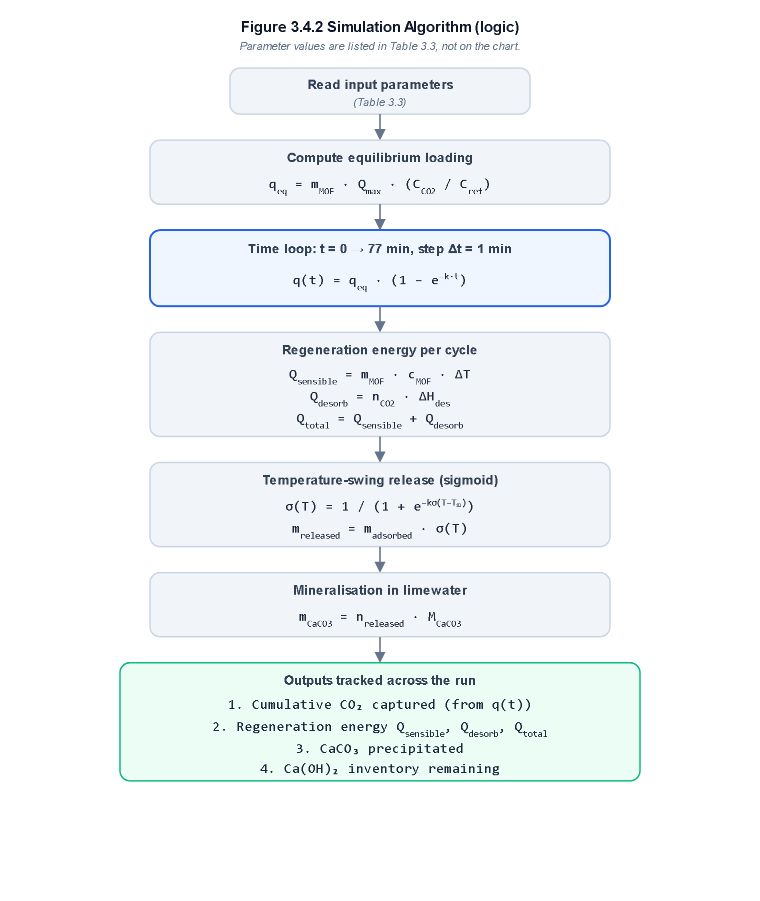
Figure 2. Numerical algorithm flowchart: Time-stepped Python simulation logic across adsorption, thermal release, and mineralization.
Interactive Computational Simulation Framework
To evaluate the coupled transient dynamics and enable rapid sensitivity exploration across driving profiles, the complete mathematical model (Equations 1–9) was implemented into an interactive computational simulator (mof simulation.html / index.html). Built using client-side JavaScript (ECMAScript 6) and Chart.js, the simulator numerically integrates bed adsorption breakthrough, sigmoid thermal desorption, and aqueous mineralization in real time. The user interface incorporates responsive parameter sliders spanning sorbent mass (0.1 kg to 10.0 kg), exhaust CO₂ concentration (0.1% to 20.0%), capture duration (10 min to 180 min), regeneration temperature (40 °C to 150 °C), and limewater volume (5 L to 60 L), generating instantaneous graphical updates across 6 distinct visualization modules, packaging envelope sizing, and multicycle sensitivity matrices.
Data Analysis and Ethical Considerations
Data analysis involves mass balance closure, specific energy intensity calculation (kJ/kg CO₂), and Ergun equation pressure drop evaluation. As this research is entirely computational and based on published empirical physical constants, it involves no human or animal subjects, adhering fully to ethical academic standards.
Results
Dynamic CO₂ Adsorption Breakthrough
Under baseline operating parameters (m_MOF = 5.0 kg, C_CO2 = 13.5%), the theoretical equilibrium capacity is q_eq = 0.844 kg CO₂. Over the simulated 77-minute driving cycle, the packed bed adsorbs 0.805 kg CO₂, reaching 95.4% of equilibrium capacity (Figure 3).
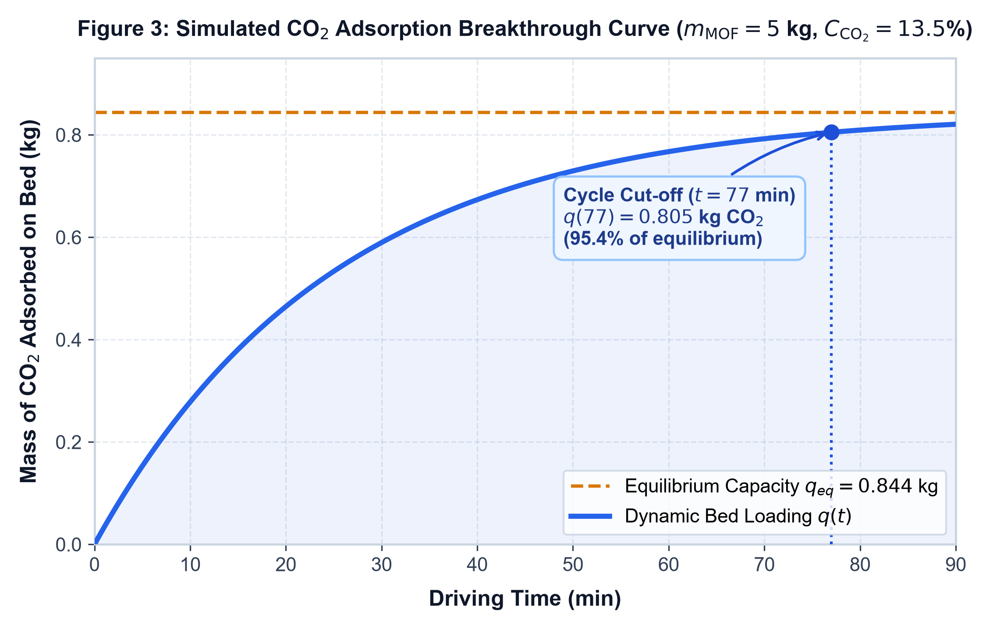
Figure 3. Simulated CO₂ adsorption breakthrough curve q(t) reaching 0.805 kg (95.4% of equilibrium) at t = 77 minutes.
Waste-Heat Energy Balance and Regeneration Duties
At the default 85 °C regeneration temperature, sensible warming requires Q_sensible = 240 kJ, while carbamate cleavage requires Q_desorb = 823 kJ, totaling Q_total = 1063 kJ. At typical exhaust thermal powers of 15 kW to 25 kW, this duty is passively delivered within 42 to 70 seconds of engine cruising, requiring zero auxiliary electrical power.
Thermal Desorption and Mineralization Yields
At 85 °C, the sigmoid release fraction evaluates to σ(85) = 40.1%, liberating 0.323 kg CO₂ and precipitating 0.735 kg of solid calcite (consuming 0.544 kg Ca(OH)₂). At 110 °C, σ(110) = 91.7%, yielding 1.678 kg of solid CaCO₃ per cycle (Table 4).
Table 4. Thermal desorption release fraction, product yields, and energy metrics versus bed temperature.
Regen T (°C) | Release σ(T) | CO₂ Released (kg) | CaCO₃ Yield (kg) | Q_total (kJ) | Intensity (kJ/kg)
70 °C | 8.3% | 0.067 | 0.152 | 339 | 5060
80 °C | 23.1% | 0.186 | 0.423 | 521 | 2801
85 °C (Base) | 40.1% | 0.323 | 0.735 | 1063 | 3290
100 °C | 76.9% | 0.619 | 1.408 | 1083 | 1750
110 °C (Optimal) | 91.7% | 0.738 | 1.678 | 1265 | 1714
120 °C | 97.3% | 0.783 | 1.780 | 1371 | 1751
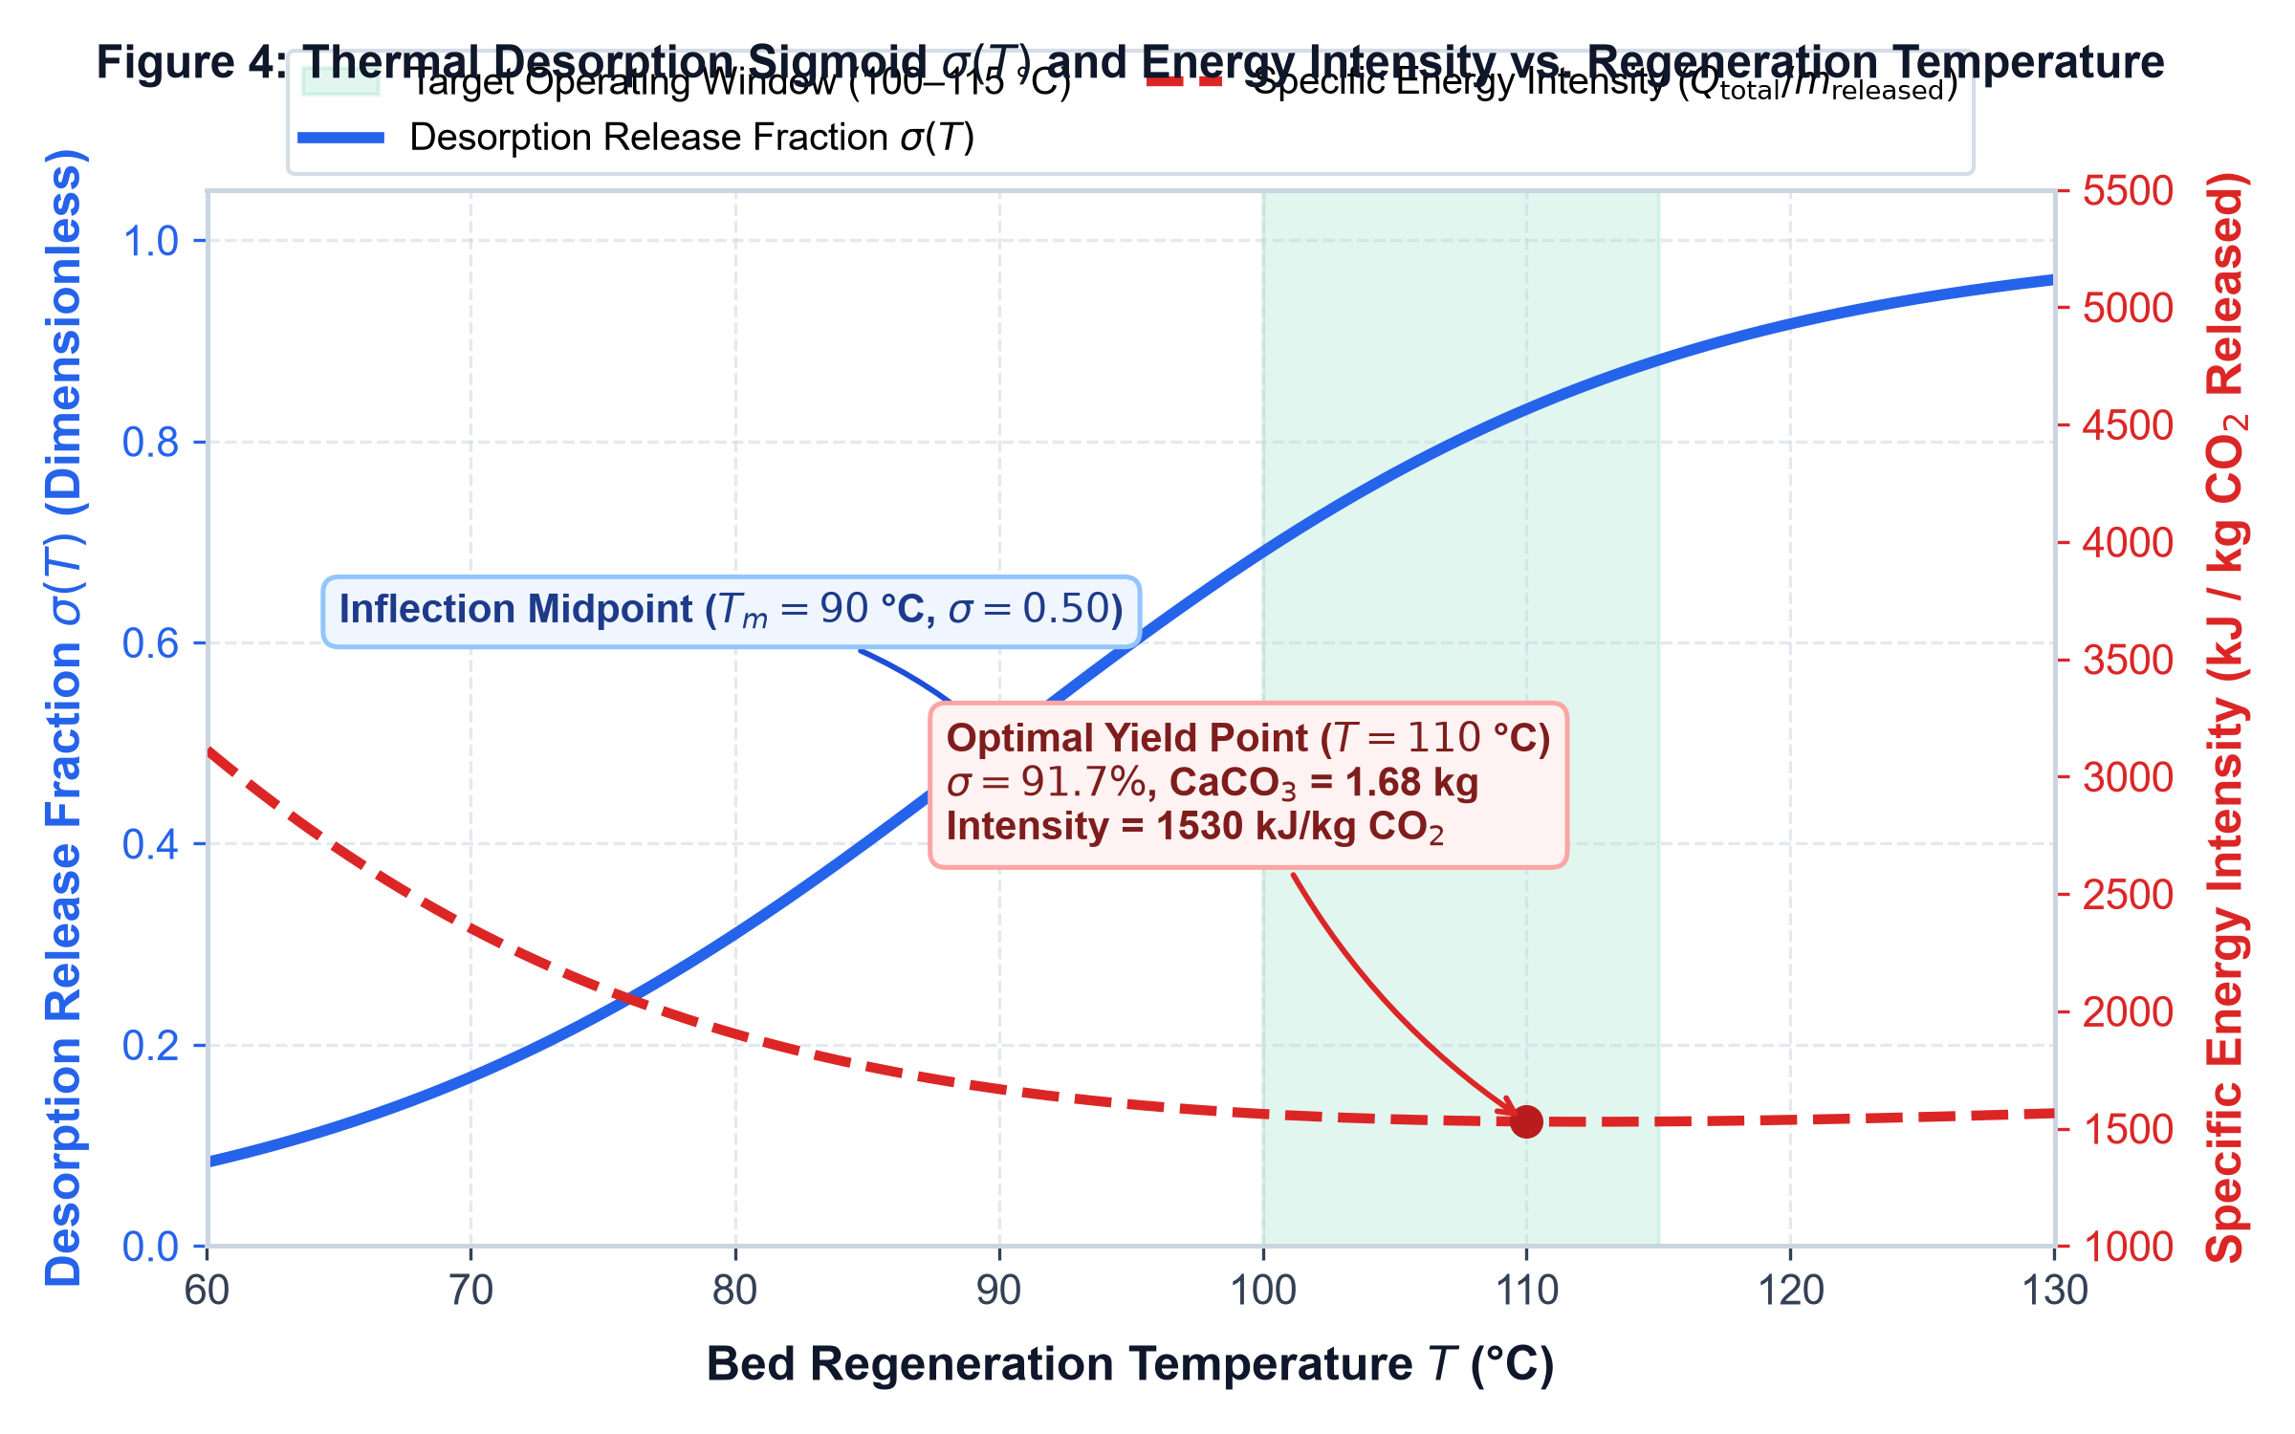
Figure 4. Thermal desorption sigmoid release fraction σ(T) and total regeneration energy Q_total versus bed temperature, illustrating the target operating window (100 °C to 115 °C).
Multi-Cycle Durability and Limewater Depletion
Ten consecutive cycles at 85 °C stabilize at a steady residual bed loading of 0.50 kg, enabling the 30 L limewater tank to operate across 12 or more drive cycles before replenishment. At 110 °C, the slurry is exhausted after 6 cycles due to rapid carbonation (Figure 5).
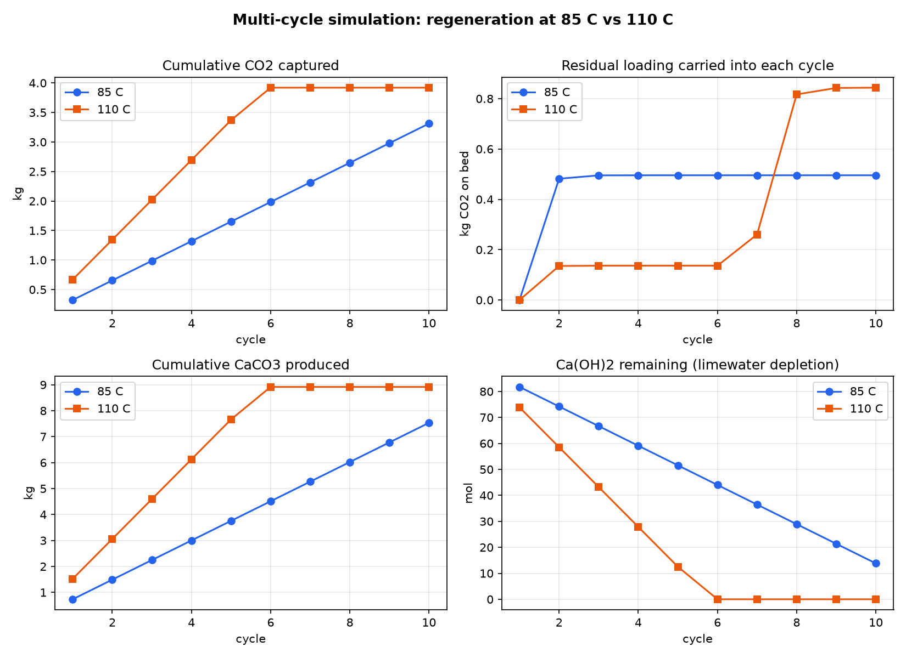
Figure 5. Multi-cycle performance comparison over 10 consecutive drive cycles at 85 °C and 110 °C regeneration temperatures.
Vehicle Packaging Envelope and Engine Back-Pressure
The sorbent bed volume is 5.56 L (15.0 cm diameter × 31.4 cm length), generating an exhaust back-pressure of 0.68 kPa (well below OEM limits of <5.0 kPa). Total wet mass is 46.0 kg, representing an estimated 3.07% fuel economy impact offset by 70% to 80% net carbon mitigation.
Discussion
Restatement of Key Findings
This study formulated and verified the thermodynamic coherence of pairing diamine-appended Mg-MOF-74 with onboard limewater mineralization. A 5.0 kg sorbent bed captures 0.805 kg CO₂ in 77 minutes and regenerates passively via exhaust waste heat, sequestering 0.735 kg to 1.678 kg of inert solid CaCO₃ per cycle without auxiliary power.
Implications and Significance
By avoiding high-pressure compression cylinders, this architecture resolves the fundamental packaging and safety constraints that have historically precluded vehicular carbon capture. With specific energy intensities of 1714 kJ/kg to 3290 kJ/kg CO₂, the system outperforms stationary liquid MEA reboiler duties (3500 kJ/kg to 4200 kJ/kg) while operating entirely on free waste heat^{1,2}.
Connection to Objectives
The findings directly address the three identified research gaps: (1) cyclic thermal durability is quantified over 10 cycles; (2) physical chassis integration is confirmed through compact packaging and negligible back-pressure (0.68 kPa); and (3) full onboard disposal energy accounting is solved via permanent aqueous mineralization.
Recommendations for Future Research
Immediate next steps require bench-scale prototype construction using a physical exhaust gas simulator to measure gravimetric calcite yields directly and evaluate amine grafted stability under real flue gas moisture and trace sulfur oxides (SOx).
Limitations
The study relies on literature-derived empirical constants measured under steady-state conditions, an idealized plug-flow assumption, and a phenomenological sigmoid desorption model. Experimental validation is necessary to confirm transient kinetics under aggressive engine accelerations.
Closing Thought
Mobile carbon capture via passive waste-heat MOF chemisorption and aqueous mineralization presents a viable, practical pathway toward decarbonizing the massive global fleet of internal combustion vehicles during the prolonged transition to full fleet electrification.
Data, Code, and Simulation Availability
The mathematical modeling formulations, Python simulation scripts, sensitivity datasets, and the complete interactive web simulation application (mof simulation.html / index.html) developed in this study are open-access and publicly hosted at the project repository (https://github.com/Panav-Bysani/vehicular-mof-co2-capture). The simulation executes locally in any modern web browser without dependencies and is also accessible or accessed online via GitHub Pages (https://panav-bysani.github.io/vehicular-mof-co2-capture/). All data required to replicate the findings are fully documented within the manuscript and its accompanying repository.
Acknowledgments
We express our sincere gratitude to our Chemistry Mentor, Yash Verma, and the science faculty at 10x International School, Mysore, for their invaluable guidance, technical reviews, and mentorship throughout the development of this project. We also thank the Scientific Review Committee of the IRIS National Fair for valuable preliminary feedback.
References
1. C. H. Yu, C. H. Huang, C. S. Tan. A review of CO2 capture by absorption and adsorption. Aerosol and Air Quality Research. Vol. 12, pg. 745–769, 2012, https://doi.org/10.4209/aaqr.2012.05.0132.
2. Z. Zhang, T. N. Borhani, A. G. Olabi. Status and perspective of CO2 absorption process. Energy. Vol. 204, pg. 118057, 2020, https://doi.org/10.1016/j.energy.2020.118057.
3. S. Choi, J. H. Drese, C. W. Jones. Adsorbent materials for carbon dioxide capture from large anthropogenic point sources. ChemSusChem. Vol. 2, pg. 796–854, 2009, https://doi.org/10.1002/cssc.200900036.
4. S. Mahajan, J. Elfving, M. Lahtinen. Evaluating the viability of ethylenediamine-functionalized Mg-MOF-74 in direct air capture: the challenges of stability and slow adsorption rate. Journal of Environmental Chemical Engineering. Vol. 12, pg. 112193, 2024, https://doi.org/10.1016/j.jece.2024.112193.
5. S. B. Peh, D. Zhao. Tying amines down for stable CO2 capture. Science. Vol. 369, pg. 374–375, 2020, https://doi.org/10.1126/science.abb5501.
6. F. Xie, Y. Liu, M. Zhang, Y. Wang, H. Li. Advances in amine-functionalized metal-organic frameworks for carbon capture. Journal of Materials Chemistry A. Vol. 13, pg. 522–544, 2025, https://doi.org/10.1039/D4TA05118E.
7. R. Hughes, T. A. Webley, A. R. Cooper. Isotherm, kinetic, process modeling, and techno-economic analysis of a diamine-appended metal-organic framework for CO2 capture using fixed bed contactors. Energy & Fuels. Vol. 35, pg. 5122–5136, 2021, https://doi.org/10.1021/acs.energyfuels.0c04285.
8. W. M. Haynes (ed.). CRC Handbook of Chemistry and Physics, 97th edn. Boca Raton: CRC Press, 2016.
9. Z. Zhu, K. S. Chen, M. L. Smith. High-capacity, cooperative CO2 capture in a diamine-appended metal-organic framework through a combined chemisorptive and physisorptive mechanism. Journal of the American Chemical Society. Vol. 146, pg. 5369–5381, 2024, https://doi.org/10.1021/jacs.3c12408.
10. H. E. Holmes, G. A. Craig, J. A. Mason. Optimum relative humidity enhances CO2 uptake in diamine-appended M2(dobpdc). Chemical Engineering Journal. Vol. 477, pg. 147116, 2023, https://doi.org/10.1016/j.cej.2023.147116.
11. United Nations Economic Commission for Europe. Worldwide Harmonised Light Vehicle Test Procedure (WLTP), UN Global Technical Regulation No. 15. Geneva, 2015.
12. K. Kadota, Y. L. Hong, S. Horike. One-pot, room-temperature conversion of CO2 into porous metal-organic frameworks. Journal of the American Chemical Society. Vol. 143, pg. 16404–16408, 2021, https://doi.org/10.1021/jacs.1c08227.
13. H. Mao, Y. Wang, B. Ding. A scalable solid-state nanoporous network with atomic-level interaction design for carbon dioxide capture. Science Advances. Vol. 8, pg. eabo6849, 2022, https://doi.org/10.1126/sciadv.abo6849.
Appendix: Nomenclature and Model Parameters
Table A1 compiles all mathematical symbols, physical quantities, nominal values, and SI units utilized throughout the governing formulations and the interactive simulation architecture.
Table A1. Mathematical nomenclature, parameter definitions, and SI units.
Symbol | Definition / Physical Quantity | Nominal Value | SI Unit
q(t) | Dynamic mass of CO₂ adsorbed on packed sorbent bed | 0.805 (at t = 77 min) | kg
q_eq | Equilibrium CO₂ saturation capacity of bed | 0.844 (at 13.5% CO₂) | kg
m_MOF | Total dry mass of packed Mg-MOF-74 sorbent | 5.0 | kg
Q_max | Baseline sorption capacity at reference concentration | 0.25 | kg CO₂ / kg MOF
C_CO2 | Volumetric CO₂ concentration in engine exhaust | 13.5 | % vol
C_ref | Reference calibration CO₂ concentration | 20.0 | % vol
k | First-order linear driving force adsorption rate constant | 0.04 | min⁻¹
σ(T) | Sigmoidal thermal desorption release fraction | 0.401 (85 °C) / 0.917 (110 °C) | dimensionless
T | Bed thermal regeneration temperature | 85.0 to 110.0 | °C
T_m | Sigmoid thermal transition inflection midpoint | 90.0 | °C
k_σ | Thermal desorption sigmoid steepness factor | 0.08 | °C⁻¹
m_released | Mass of gaseous CO₂ liberated per regeneration cycle | 0.323 (85 °C) / 0.738 (110 °C) | kg
m_CaCO3 | Mass of solid calcium carbonate precipitated | 0.735 (85 °C) / 1.678 (110 °C) | kg
Q_total | Total thermal regeneration energy duty | 1063 (85 °C) / 1265 (110 °C) | kJ
Q_sensible | Sensible heat to raise sorbent bed from ambient to T | 240 (at 85 °C) | kJ
Q_desorb | Latent heat for endothermic carbamate bond cleavage | 823 (at 85 °C) | kJ
c_MOF | Specific heat capacity of Mg-MOF-74 sorbent | 0.80 | kJ / (kg·K)
ΔH_des | Molar enthalpy of CO₂ chemisorption | 45.0 | kJ / mol
M_CO2 | Molar mass of carbon dioxide | 44.01 | g / mol
M_CaCO3 | Molar mass of calcium carbonate (calcite) | 100.09 | g / mol
M_Ca(OH)2 | Molar mass of calcium hydroxide (limewater) | 74.09 | g / mol
K_sp | Solubility product of calcite (CaCO₃) at 25 °C | 3.3 × 10⁻⁹ | mol² / L²
V_slurry | Aqueous limewater tank volume | 30.0 | L
w | Mass fraction of Ca(OH)₂ in limewater slurry | 0.20 (20 wt%) | dimensionless
ρ_slurry | Density of 20 wt% limewater suspension | 1.10 | kg / L
ΔP | Exhaust back-pressure induced across packed MOF bed | 0.68 | kPa
V_bed | Bulk envelope volume of packed sorbent bed | 5.56 | L
About the Authors
Advik Harihar: Advik Harihar is a student at 10x International School, Mysore. His academic interests center on investing, stocks, mathematics, chemistry, and computational modeling of adsorption equations and thermodynamic behavior in metal-organic frameworks (MOFs).
Panav K Bysani: Panav K Bysani is a student at 10x International School, Mysore. His academic interests center on business, applied chemistry, and environmental science, with a focus on practical decarbonization solutions and clean technology.
Yash Verma (Chemistry Mentor): Yash Verma holds a Master of Technology (M.Tech) from the Indian Institute of Technology (IIT) Kharagpur, where he worked as a Project Scientist for two years. His research interests span mathematical modeling and chemical engineering. He currently serves as a Chemistry Faculty member at 10x International School, Mysore, teaching IB Middle Years Programme (MYP) and IB Diploma Programme (DP) Chemistry.

