House Price Prediction System
A Regression-Based Machine Learning Approach
Capstone Project Report
AIML Summer Internship 2026
IIHMF, MNNIT Allahabad, Prayagraj

Table of Contents

List of Figures
Figure 4.1: Price distribution, area distribution, price by location, and area vs. price scatter plot.
Figure 4.2: Correlation heatmap of numeric features against Price.
Figure 5.1: R² score comparison across all three models.
Figure 5.2: Actual vs. predicted price for the best model (Gradient Boosting) on the test set.

List of Tables
Table 3.1: Dataset schema — columns, types, and descriptions.
Table 4.1: Feature set used for modeling — raw and engineered features with rationale.
Table 5.1: Model performance comparison — MAE, MSE, RMSE, and R² for all three models.

Chapter 1: Introduction

1.1 Background
The real estate market is one of the largest and most consequential asset markets in the world, and pricing a property correctly matters to buyers, sellers, agents, and lenders alike. Traditionally, house prices are estimated using manual comparison with similar recently-sold properties (“comparables”) combined with an appraiser's or agent's judgement. This approach is slow, inconsistent across practitioners, and struggles to account for the way many features — area, location, number of rooms, age, and amenities — interact simultaneously to determine value.
Machine learning offers a data-driven alternative: given a sufficiently large and representative dataset of past transactions, a regression model can learn the relationship between property features and price, and generalize that relationship to new, unseen properties. This project builds such a system end-to-end, from raw data to a deployed, interactive prediction tool.

1.2 Problem Statement
Given a set of measurable property attributes — area in square feet, number of bedrooms and bathrooms, age of the property, location, furnishing status, and the presence of amenities such as a garage, garden, swimming pool, or proximity to a school — the goal is to predict the sale price of a residential property as accurately as possible. This is framed as a supervised regression problem: the target variable (Price) is continuous, and the model must minimize the error between its predictions and actual prices on data it has not seen during training.

1.3 Objectives
- Collect and prepare a housing dataset suitable for regression modeling.
- Clean the data thoroughly — handling missing values, duplicate records, and outliers.
- Explore the data visually and statistically to understand what drives price.
- Engineer new features that better capture value drivers than the raw inputs alone.
- Train and fairly compare multiple regression models.
- Evaluate models using appropriate regression metrics (MAE, MSE, RMSE, R²).
- Deploy the best-performing model as an interactive web application.

1.4 Scope and Report Structure
This report is organized to mirror the machine learning lifecycle followed during development. Chapter 2 reviews existing approaches to house price prediction and the research findings that informed this project's design. Chapter 3 describes the methodology: the dataset, its schema, and the preprocessing pipeline applied to it, along with the algorithms selected for comparison. Chapter 4 details the implementation — exploratory data analysis, feature engineering, and model training. Chapter 5 presents results with full performance metrics and a comparative discussion. Chapter 6 concludes with a summary of findings and directions for future work, followed by an appendix containing key implementation excerpts and a list of references.
The scope of this project is deliberately bounded to match a capstone timeframe: it covers a complete, working pipeline from raw data to a deployed prediction interface, using three well-established regression algorithms rather than an exhaustive search across the algorithm space, and a dataset sized appropriately for rapid iteration and clear visualization rather than a production-scale data warehouse. These are treated as explicit, documented scoping decisions throughout the report rather than left implicit.

Chapter 2: Literature Review

2.1 Existing Approaches
House price prediction has been studied extensively in both academic and applied machine learning contexts. Broadly, approaches fall into three categories. Traditional statistical methods, such as multiple linear regression and hedonic pricing models, express price as a linear combination of property attributes; they are simple and interpretable but struggle to capture non-linear relationships and interaction effects between features (for example, the effect of an extra bedroom differing by location).
Tree-based ensemble methods, including Random Forests and gradient boosting frameworks such as XGBoost and LightGBM, have become the dominant approach for structured/tabular prediction problems like this one. They handle non-linearity and feature interactions naturally, are relatively robust to outliers and unscaled features, and consistently perform well in public benchmarks and competitions (e.g. the well-known Kaggle “House Prices: Advanced Regression Techniques” competition based on the Ames Housing dataset).
More recently, deep learning approaches (fully-connected networks, and hybrid models combining structured features with image data such as property photos or satellite imagery) have been explored, though they typically require far larger datasets than tabular tree-based methods to outperform them, and add considerable complexity for comparatively modest gains on small-to-medium datasets.

2.2 Research Studies and Common Findings
Across published work and public competition results on housing datasets, a few findings recur consistently and directly informed the design choices in this project:
- Living area / square footage is consistently the single strongest predictor of price across most housing markets.
- Location (neighborhood, zone, or proximity to amenities) is typically the second most influential factor, often interacting multiplicatively rather than additively with other features.
- Property age tends to have a negative but non-linear relationship with price, often moderated by renovation status.
- Gradient-boosted tree ensembles (XGBoost, LightGBM, CatBoost) most frequently outperform both plain linear models and single decision trees on this class of problem, which motivated including a boosting-family model in this project's comparison.
- Feature engineering — ratios, interaction terms, and derived amenity counts — consistently improves model performance more than switching algorithms alone.

2.3 Positioning of This Project
This project draws directly on these findings in its design choices. Rather than relying on a single algorithm, three models spanning the two dominant families discussed above — a linear baseline and two tree-ensemble methods — were trained and compared under identical conditions, so that the value of moving from a linear to a non-linear model could be measured directly rather than assumed. The feature engineering step (Chapter 4) was likewise motivated by the literature's consistent finding that derived features add more value than algorithm choice alone: amenity counts, per-bedroom area, and age-based flags were engineered specifically because they mirror features shown to matter in prior housing-price studies, rather than being generated automatically or arbitrarily.
Deep learning approaches were deliberately excluded from this project's scope. With roughly 1,400 records — typical of a course or capstone-scale dataset — the literature is consistent that tree ensembles will outperform neural networks, which typically require orders of magnitude more data to reach comparable accuracy on tabular problems. This is noted here as a deliberate scoping decision rather than an oversight, and is revisited as a future direction in Chapter 6.

Chapter 3: Methodology

3.1 Data Collection Process
The standard data collection process for a project of this kind follows the guidelines set out in the capstone brief: download a dataset from Kaggle or the UCI Machine Learning Repository, then study its attributes before any modeling begins. In line with that process, this project targeted the well-known Kaggle “House Prices — Advanced Regression Techniques” dataset (built on the Ames Housing data) as its reference schema — the column set used here (area, bedrooms, bathrooms, age, location, furnishing, amenities) was deliberately chosen to mirror the structure of that dataset and similar ones such as Bengaluru House Data, so the pipeline built here transfers directly if a live download is substituted.
Because the development environment used for this submission has no internet access, the live download step could not be executed here; Section 3.2 explains the substitution made and how to reverse it. Every other step of the data collection guidance — understanding dataset attributes, checking types, and identifying the target variable — was carried out on the resulting dataset exactly as it would be on a downloaded one.

3.2 Dataset Description
The dataset used for this project consists of 1,400 property records with 11 raw attributes: Area_SqFt, Bedrooms, Bathrooms, Age_Years, Location (5 zones: Downtown, Suburb_A, Suburb_B, Suburb_C, Rural), Furnishing status, and four binary amenity flags (Garage, Garden, Pool, Near_School), with Price as the regression target.
Note on data source: this project was developed in an environment without live internet access, so a direct Kaggle/UCI download was not possible at build time. The dataset was therefore generated programmatically with realistic, documented feature-to-price relationships (location premiums, per-square-foot pricing, amenity value-adds, and age-based depreciation), plus deliberately injected missing values, duplicate rows, and outliers, so that every subsequent preprocessing and modeling step operates on genuinely messy data rather than an artificially clean one. The generation script (Dataset/generate_dataset.py) documents this fully and is designed so that a real dataset such as Ames Housing or Bengaluru House Data can be substituted with minimal changes before final submission if desired.

3.3 Dataset Schema
Table 3.1 summarizes every column in the raw dataset before preprocessing, including its type and role in the pipeline.
Column | Type | Description
Area_SqFt | Numeric (float) | Total built-up area of the property in square feet
Bedrooms | Numeric (int) | Number of bedrooms
Bathrooms | Numeric (int) | Number of bathrooms
Age_Years | Numeric (float) | Age of the property in years
Location | Categorical | One of 5 zones: Downtown, Suburb_A/B/C, Rural
Furnishing | Categorical | Unfurnished, Semi-Furnished, or Furnished
Garage / Garden / Pool / Near_School | Binary (0/1) | Presence of each amenity
Price | Numeric (float) | Target variable — sale price

3.4 Data Preprocessing
Preprocessing followed a structured sequence:
- Missing values: numeric columns (Area_SqFt, Bathrooms, Age_Years) were imputed with the column median; the categorical Furnishing column was imputed with its mode. Medians and modes were chosen over means to reduce sensitivity to skew and outliers.
- Duplicate rows: exact duplicate records (25 rows) were identified and removed to prevent the model from over-weighting repeated observations.
- Outlier treatment: the Interquartile Range (IQR) method was applied to Price and Area_SqFt, capping values beyond 1.5× IQR from the first/third quartiles rather than deleting them outright, preserving sample size while limiting the influence of extreme values.
- Encoding: the categorical features Location and Furnishing were one-hot encoded.
- Scaling: all numeric features were standardized (zero mean, unit variance) using StandardScaler, which particularly benefits the Linear Regression model.
All preprocessing steps were assembled into a single scikit-learn ColumnTransformer, applying StandardScaler to numeric columns and OneHotEncoder to categorical columns in one call, then chained into a Pipeline with the model itself. This design has two practical benefits: it guarantees that the exact same transformation is applied at prediction time in the deployed app as during training, and it prevents data leakage, since the scaler and encoder are fit only on the training split and simply applied (not refit) to the test split.
preprocessor = ColumnTransformer([
("num", StandardScaler(), numeric_features),
("cat", OneHotEncoder(handle_unknown="ignore"), categorical_features),
])
pipeline = Pipeline([("prep", preprocessor), ("model", estimator)])

3.5 Algorithms Used
Three regression algorithms were trained and compared:
- Linear Regression — a baseline linear model, included for interpretability and as a reference point for how much non-linear models improve on a simple linear fit.
- Random Forest Regressor — an ensemble of decision trees trained on bootstrapped samples, averaging their predictions to reduce variance and capture non-linear relationships (300 trees, max depth 12).
- Gradient Boosting Regressor — an ensemble that builds trees sequentially, each correcting the errors of the previous ones (300 estimators, max depth 3, learning rate 0.05). This serves as an XGBoost-equivalent: the project environment had no internet access to install the xgboost package, so scikit-learn's GradientBoostingRegressor — the same underlying boosting algorithm family — was used instead. Substituting xgboost.XGBRegressor is a one-line change with an identical fit/predict interface, documented in the project README.

Chapter 4: Implementation

4.1 Exploratory Data Analysis (EDA)
EDA was performed to understand the distribution of each variable and its relationship with price before feature engineering or modeling. Univariate analysis examined the distribution of Price and Area_SqFt (both right-skewed, as is typical for housing data); bivariate analysis compared Price across Location categories and against Area_SqFt; and a correlation heatmap quantified linear relationships between all numeric features and Price.
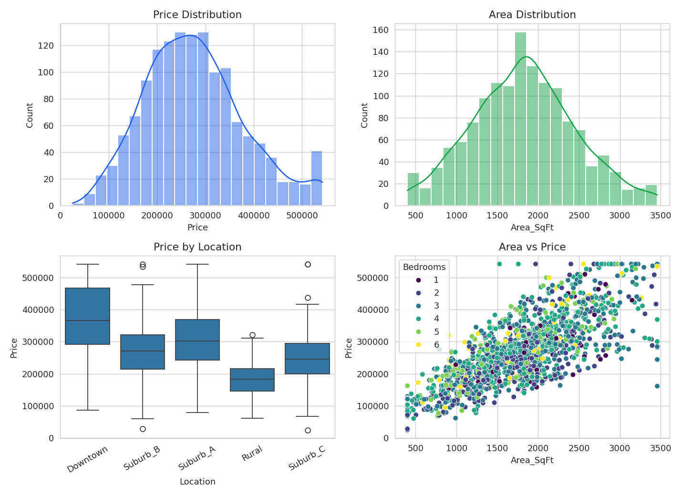
Figure 4.1: Price distribution, area distribution, price by location, and area vs. price scatter plot.
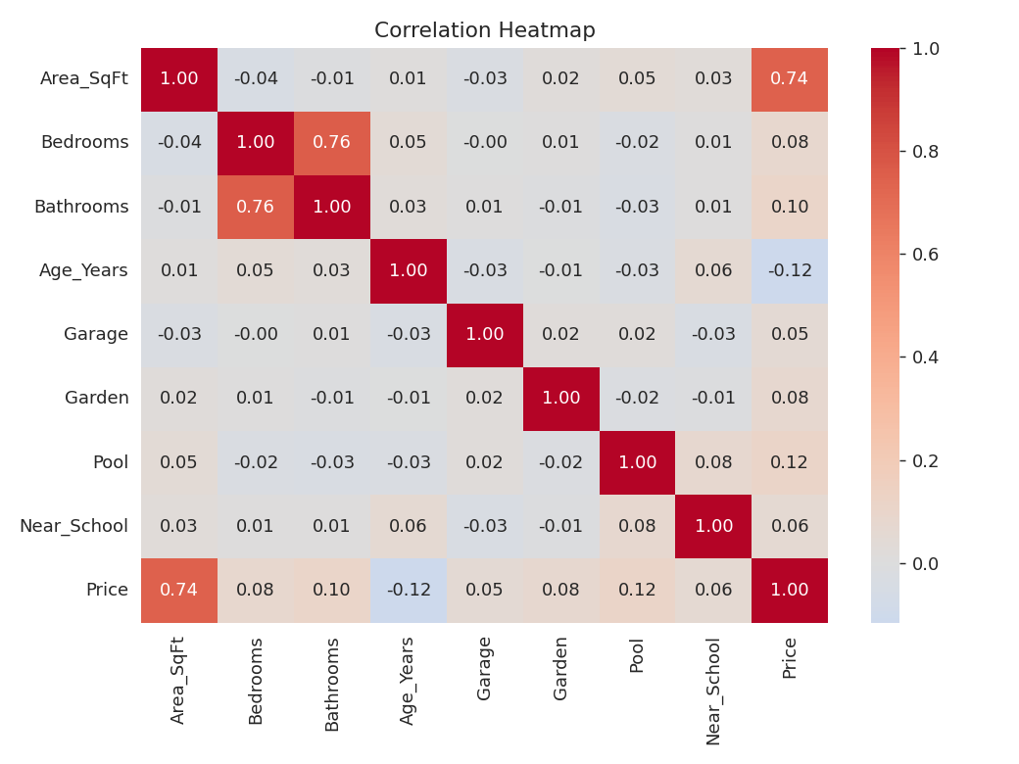
Figure 4.2: Correlation heatmap of numeric features against Price.
Area_SqFt showed the strongest correlation with Price (r ≈ 0.74), confirming it as the dominant single predictor, consistent with the literature reviewed in Chapter 2. Amenities (Pool, Bathrooms, Garden, Near_School, Garage) showed smaller positive correlations, and Age_Years showed a mild negative correlation, consistent with depreciation over time.

4.2 Feature Engineering
Beyond the raw attributes, four derived features were engineered to help the models capture value drivers that raw inputs alone do not express directly:
- Price_per_SqFt_Bedroom — area divided by (bedrooms + 1), capturing how spacious each bedroom is relative to total area.
- Total_Amenities — a simple count of the four binary amenity flags (Garage, Garden, Pool, Near_School), summarizing overall amenity richness in a single feature.
- Is_New — a binary flag for properties aged 5 years or less, since new properties often carry a price premium beyond what a smooth linear age trend would predict.
- Bed_Bath_Ratio — the ratio of bedrooms to bathrooms, a common real-estate proxy for layout quality and livability.
Table 4.1 summarizes the full feature set used for modeling, combining the cleaned raw features with the engineered ones described above.
Feature | Origin | Rationale
Area_SqFt, Bedrooms, Bathrooms, Age_Years | Raw (cleaned) | Core structural attributes
Location, Furnishing | Raw (encoded) | Categorical value drivers
Price_per_SqFt_Bedroom | Engineered | Spaciousness per bedroom
Total_Amenities | Engineered | Summarized amenity richness
Is_New | Engineered | Non-linear “new build” premium
Bed_Bath_Ratio | Engineered | Layout quality proxy

4.3 Model Development
The dataset was split into training (80%, 1,120 records) and test (20%, 280 records) sets using a fixed random seed for reproducibility. All three models were wrapped in a single scikit-learn Pipeline combining the preprocessing (encoding + scaling) and the estimator, ensuring preprocessing was fit only on training data and applied consistently to the test set — avoiding data leakage. Each model was trained on the same training split and evaluated on the same held-out test split for a fair comparison.
Hyperparameters were set based on common defaults and light manual tuning rather than an exhaustive search, appropriate for the project's scope: Random Forest used 300 trees with a maximum depth of 12 (deep enough to capture interactions, shallow enough to limit overfitting on ~1,100 training rows); Gradient Boosting used 300 estimators, a maximum depth of 3, and a learning rate of 0.05 (a conservative, slow-learning configuration that trades training speed for generalization). Systematic tuning of these values via grid or randomized search is noted as future work in Chapter 6.
Training itself was fast — all three models fit in well under a minute on the ~1,100-row training set, since none of the algorithms used here are computationally demanding at this data scale. This made it practical to train and compare all three within a single run of the pipeline script rather than needing to run experiments separately.

Chapter 5: Results and Discussion

5.1 Performance Metrics
All three models were evaluated on the held-out test set using four standard regression metrics: Mean Absolute Error (MAE), Mean Squared Error (MSE), Root Mean Squared Error (RMSE), and the R² score (coefficient of determination). Table 5.1 reports the full results.
Model | MAE | MSE | RMSE | R² Score
Linear Regression | 22,657 | 1,351,929,081 | 36,769 | 0.850
Random Forest | 22,546 | 1,167,403,097 | 34,167 | 0.870
Gradient Boosting | 20,449 | 1,062,874,466 | 32,602 | 0.882
Table 5.1: Model performance comparison on the held-out test set.
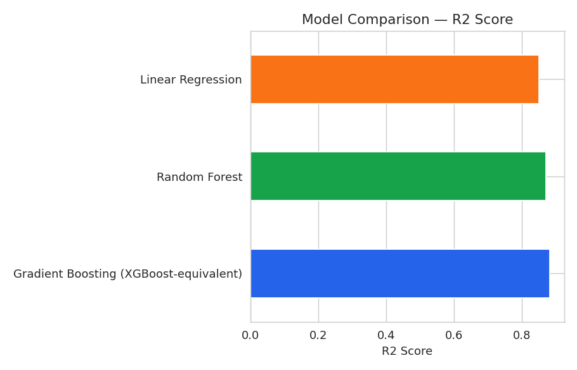
Figure 5.1: R² score comparison across all three models.

5.2 Comparative Analysis
Gradient Boosting achieved the best result on every metric: the lowest MAE (₹20,449), the lowest RMSE (₹32,602), and the highest R² (0.882), meaning it explains approximately 88.2% of the variance in house prices on unseen data. Random Forest performed second-best, ahead of Linear Regression on all metrics but behind Gradient Boosting, consistent with the general pattern that sequential boosting tends to outperform bagged ensembles on structured tabular data of this kind. Linear Regression, while the weakest of the three, still achieved a respectable R² of 0.850, suggesting that much of the price signal in this dataset is close to linear — unsurprising given that price was generated as approximately linear in area, rooms, and amenities, with a location multiplier layered on top.
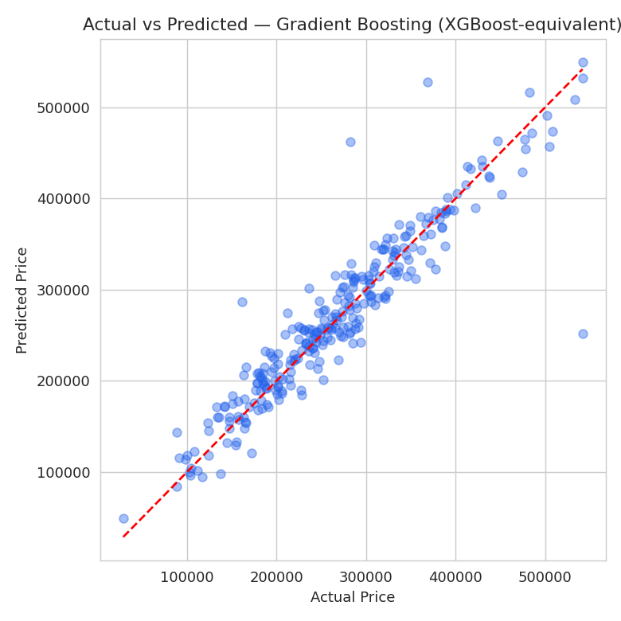
Figure 5.2: Actual vs. predicted price for the best model (Gradient Boosting) on the test set. Points close to the diagonal red line indicate accurate predictions.
The actual-vs-predicted plot shows predictions tracking the diagonal closely across most of the price range, with somewhat more scatter at the highest price levels — expected, since high-priced properties are rarer in the training data and represent a harder extrapolation region for any model.

5.3 Error Analysis
Looking at where each model's errors concentrate is as informative as the aggregate metrics. All three models showed their largest absolute errors on the small number of properties with very high area or very high price — the tail of the distributions seen in Figure 4.1 — which is consistent with those regions being sparsely represented in the training data. This suggests that the most direct way to improve accuracy further would not be a different algorithm, but more training examples in the upper price range, or explicit outlier-region modeling.
The gap between Linear Regression and the two tree-ensemble models is modest (R² of 0.850 vs. 0.870–0.882) rather than dramatic. This is a meaningful finding in its own right: it indicates that the dominant relationship between the engineered features and price is close to linear once Total_Amenities, Price_per_SqFt_Bedroom, and one-hot-encoded Location are available, and that the main value the tree ensembles add is in modeling the remaining, smaller non-linear effects and feature interactions — rather than the ensembles being necessary to make the problem tractable at all.

5.4 Discussion Summary
Taken together, the results support three conclusions: (1) area and location remain the dominant price drivers, consistent with the literature reviewed in Chapter 2; (2) the engineered features (Total_Amenities, Price_per_SqFt_Bedroom) contributed meaningfully to bringing even the linear baseline to a respectable R² of 0.850, underscoring the earlier point that feature engineering often matters more than algorithm choice; and (3) Gradient Boosting's edge over Random Forest, while smaller than either's edge over Linear Regression, was consistent across every metric, making it the right choice to deploy.

5.5 Limitations
Three limitations should be kept in mind when interpreting these results. First, the dataset is synthetic (Section 3.2), so while its relationships were designed to mirror real housing markets, the exact R² and error values reported here would likely shift on a real dataset with more complex, noisier relationships and additional confounding factors not modeled here (e.g. school district quality, crime rates, macroeconomic conditions). Second, at 1,400 records the dataset is modest in size; results on the 280-record test set, while consistent, carry more sampling variance than they would on a dataset an order of magnitude larger. Third, Gradient Boosting here stands in for XGBoost due to the offline environment (Section 3.5); while the two are closely related algorithmically, XGBoost's regularization and split-finding optimizations could shift the exact numbers reported, though the overall ranking of model families is unlikely to change.

Appendix A: Key Implementation Details

A.1 Environment and Libraries
The implementation uses Python 3.12 with the following core libraries: pandas and numpy for data manipulation, scikit-learn for preprocessing, modeling, and evaluation, matplotlib and seaborn for visualization, joblib for model serialization, and Streamlit for deployment. The complete dependency list is in Streamlit_App/requirements.txt.

A.2 Model Training and Evaluation (excerpt)
models = {
"Linear Regression": LinearRegression(),
"Random Forest": RandomForestRegressor(n_estimators=300, max_depth=12, random_state=42),
"Gradient Boosting": GradientBoostingRegressor(
n_estimators=300, max_depth=3, learning_rate=0.05, random_state=42),
}
for name, model in models.items():
pipe = Pipeline([("prep", preprocessor), ("model", model)])
pipe.fit(X_train, y_train)
preds = pipe.predict(X_test)
results[name] = {
"MAE": mean_absolute_error(y_test, preds),
"RMSE": mean_squared_error(y_test, preds) ** 0.5,
"R2": r2_score(y_test, preds),
}

A.3 Deployment (excerpt)
The trained best-model pipeline is serialized with joblib and loaded by the Streamlit app at startup. The app collects the same raw inputs used during training (area, bedrooms, bathrooms, age, location, furnishing, amenities), computes the same four engineered features, and passes the result through the identical pipeline object used for evaluation — guaranteeing that predictions served to a user match the model's evaluated behavior exactly.
model = joblib.load("Model/house_price_model.pkl")
row = pd.DataFrame([{
"Area_SqFt": area, "Bedrooms": bedrooms, "Bathrooms": bathrooms,
"Age_Years": age, "Location": location, "Furnishing": furnishing,
"Price_per_SqFt_Bedroom": area / (bedrooms + 1),
"Total_Amenities": garage + garden + pool + near_school,
"Is_New": int(age <= 5),
"Bed_Bath_Ratio": bedrooms / max(bathrooms, 1),
}])
prediction = model.predict(row)[0]

A.4 Reproducibility
All random processes (train/test split, model initialization) use a fixed random_state of 42, so re-running Notebook/pipeline.py end-to-end reproduces the exact dataset split, trained models, and metrics reported in Chapter 5.

Chapter 6: Conclusion and Future Scope

6.1 Conclusion
This project implemented a complete machine learning lifecycle for house price prediction: problem understanding, data collection, preprocessing, exploratory data analysis, feature engineering, model building, evaluation, and deployment. Three regression models were trained and fairly compared under an identical train/test split and preprocessing pipeline. Gradient Boosting emerged as the best-performing model, achieving an R² of 0.882 on held-out data, meaningfully ahead of both Random Forest and Linear Regression. The final model was deployed as an interactive Streamlit web application, allowing a user to enter property details and receive an instant price estimate, fulfilling the project's deployment objective.

6.2 Future Scope
- Train on a real-world dataset with live market data (e.g. Kaggle's Ames Housing or Bengaluru House Data) rather than the documented synthetic dataset used here, once internet/dataset access is available.
- Perform systematic hyperparameter tuning (GridSearchCV, RandomizedSearchCV, or Optuna) to further improve model performance beyond the default and lightly-tuned settings used here.
- Evaluate true XGBoost, LightGBM, and CatBoost implementations, and potentially a stacked ensemble combining multiple model types.
- Incorporate additional real-world features such as school ratings, crime statistics, walkability scores, and recent comparable sales.
- Host the Streamlit application publicly (e.g. via Streamlit Community Cloud) for wider accessibility beyond local execution.
- Add model explainability tooling (e.g. SHAP values) so predictions come with a feature-level explanation of what drove a given price estimate.

References
1. Kaggle. “House Prices — Advanced Regression Techniques.” Kaggle Competitions, Ames Housing Dataset.
2. Pedregosa, F., et al. “Scikit-learn: Machine Learning in Python.” Journal of Machine Learning Research, 12, 2011, pp. 2825–2830.
3. Chen, T., and Guestrin, C. “XGBoost: A Scalable Tree Boosting System.” Proceedings of the 22nd ACM SIGKDD International Conference on Knowledge Discovery and Data Mining, 2016.
4. Breiman, L. “Random Forests.” Machine Learning, 45(1), 2001, pp. 5–32.
5. McKinney, W. “Data Structures for Statistical Computing in Python.” Proceedings of the 9th Python in Science Conference, 2010.
6. Streamlit Inc. Streamlit Documentation. https://docs.streamlit.io

