INDUSTRIAL VISIT ON – 11/09/2024

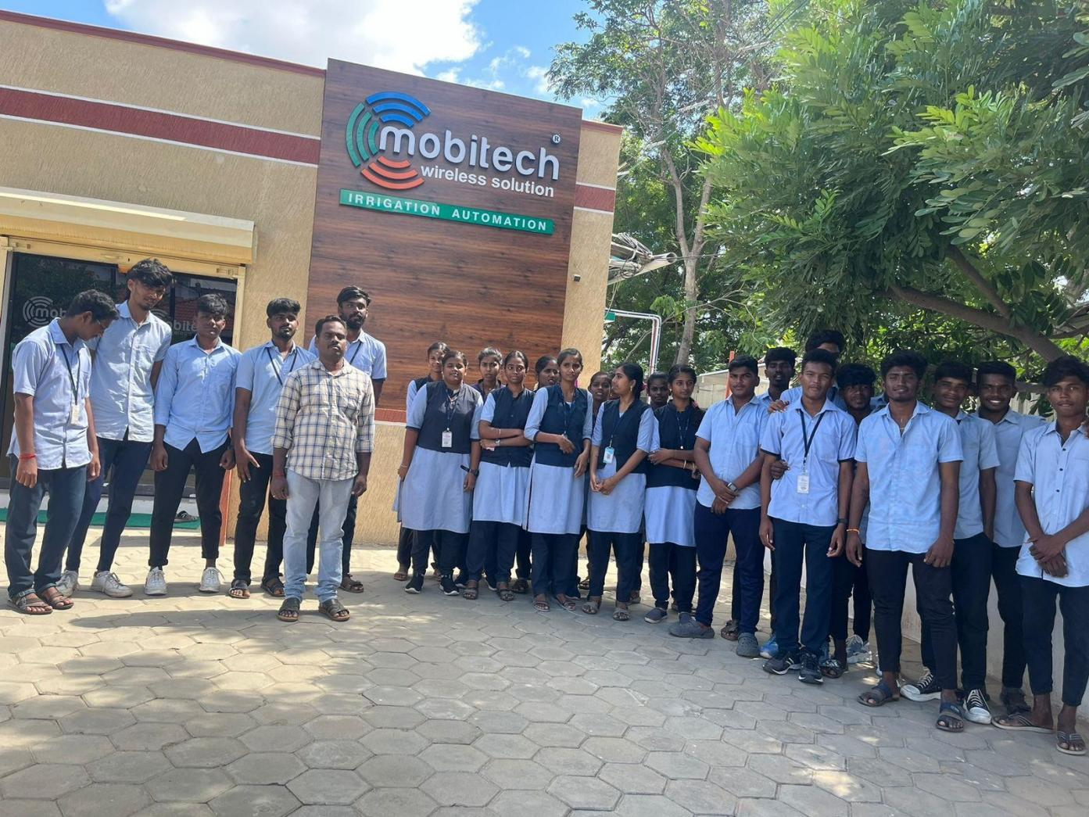
MOBITECH WIRELESS SOLUTION PRIVATE LIMITED

Page No : 22

