Power BI Dashboard Projects
Sales Data Analysis • DAX Measures • Interactive Slicers • Data Visualization

Dashboard 1: City-wise incentive analysis using a line chart and city slicer
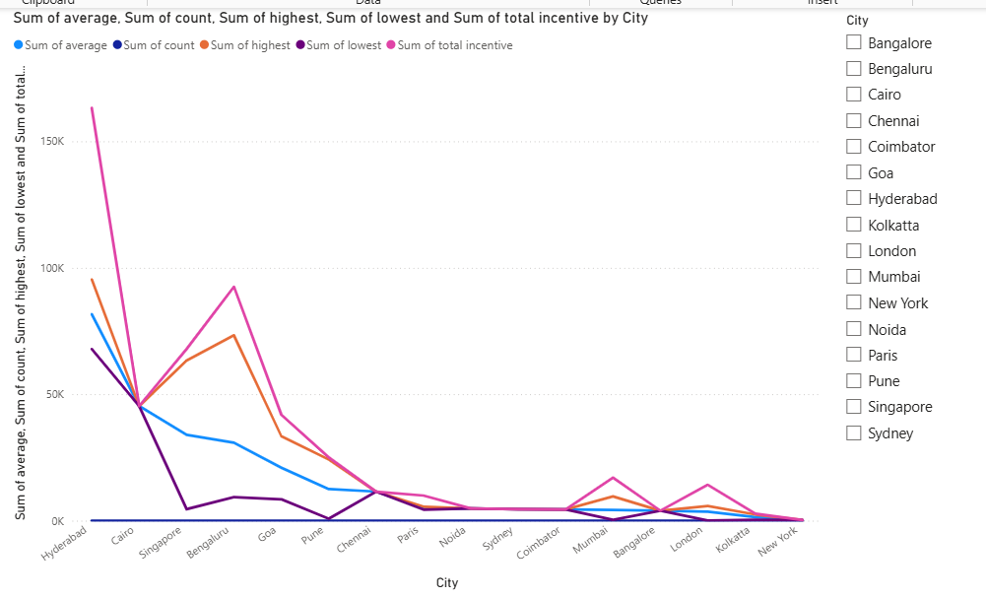

Dashboard 2: City-wise commission distribution using a pie chart
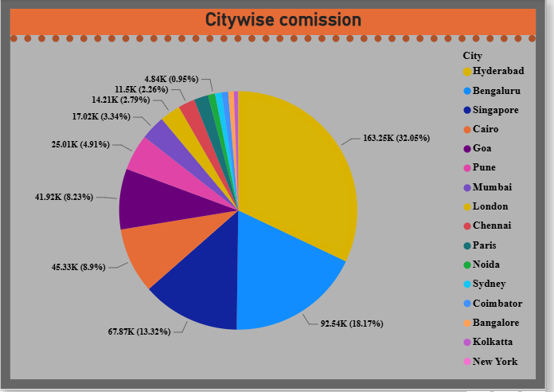

Dashboard 3: Customer-wise bank balance visualization
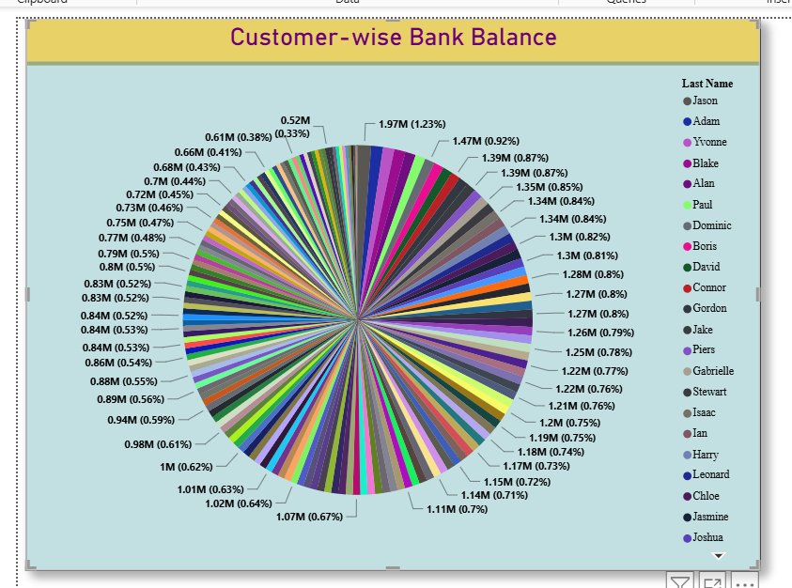

Dashboard 4: City comparison using a column chart and slicer
