Automatic Unique NHI for Agentic Workloads

Challenge
AI agents are inherently non-deterministic systems. Even replicas of the same logical agent may behave differently at runtime based on context, memory, and interactions.

In modern deployments, agents commonly run as multiple instances, such as Kubernetes pods, Nomad allocations, and other container replicas. From a security and governance perspective, organizations must be able to answer:

- Which specific agent instance performed an action?
- Which workload identity initiated a downstream API request?
- Can that identity be cryptographically verified for auditing?

Each running agent instance therefore needs its own unique non-human identity (NHI). The challenge is assigning that identity without forcing developers to add identity logic to agent code or distribute static credentials.

Key design principle
This pattern assigns identity automatically at the platform and infrastructure layer, not in application code.

The capabilities that make this possible are:

- Platform-native workload identity
- Vault JWT Authentication Method
- Vault OIDC Identity Tokens
- Vault Agent or workload template injection

As a result:

- Developers do not modify agent code.
- Identities are generated and injected automatically.
- Every replica receives a unique signed identity token.

Solution overview
Use the platform's native workload identity to authenticate to HashiCorp Vault, then have Vault issue a signed OIDC identity token for that specific workload instance.

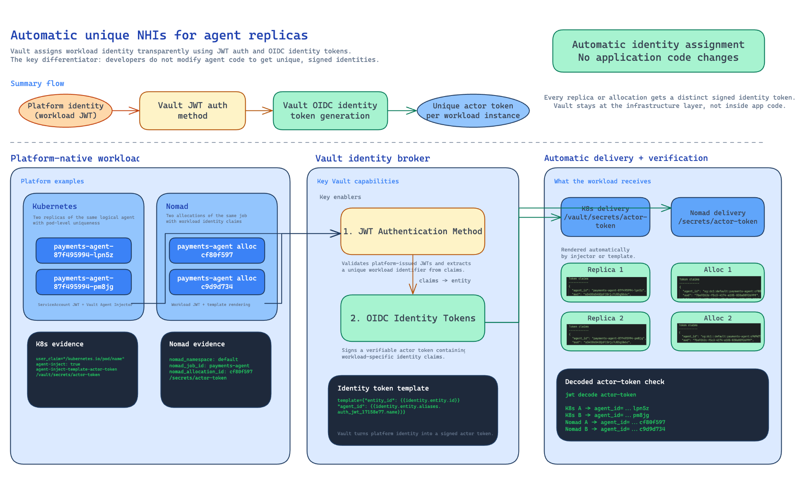

The high-level flow is:

- Agent workloads authenticate to Vault using platform-native identity.
- Vault verifies the workload JWT through the JWT auth method.
- Vault extracts a unique workload identifier.
- Vault generates a signed OIDC identity token.
- The token is injected automatically into the workload.

Each replica therefore receives a cryptographically verifiable identity.

Vault acts as the identity broker:

- The workload presents its platform-native JWT to Vault.
- Vault JWT auth validates that JWT and maps a unique workload claim into the Vault identity alias.
- Vault OIDC identity token templating copies that alias into a signed agent_id claim.
- The workload receives a unique actor token automatically, with no application code changes.

This is the key differentiator: identity assignment happens in the infrastructure layer, not inside the agent code.

Architecture
Platform workload identity -> Vault JWT auth -> Vault entity alias -> Vault OIDC identity token -> unique actor token per workload instance

The pattern depends on two Vault capabilities working together:

- auth/jwt uses user_claim to select a workload-specific identifier from the incoming platform JWT.
- identity/oidc/role uses a template to render that identity alias into the final signed token, for example as agent_id.

In the OIDC template, replace <jwt_mount_accessor> with the accessor of your JWT auth mount.

Platform configuration examples

Kubernetes
Use the pod identity claim as the unique source value:

vault write auth/jwt/role/agent-role \
role_type="jwt" \
bound_audiences="https://kubernetes.default.svc" \
user_claim="/kubernetes.io/pod/name" \
user_claim_json_pointer=true \
token_policies="default,identity-policy"

vault write identity/oidc/role/agent-role \
key="default" \
ttl="1h" \
template="{\"entity_id\": {{identity.entity.id}}, \"agent_id\": {{identity.entity.aliases.<jwt_mount_accessor>.name}}}"

Deliver the token automatically with Vault Agent Injector:

metadata:
annotations:
vault.hashicorp.com/agent-inject: "true"
vault.hashicorp.com/role: "agent-role"
vault.hashicorp.com/auth-type: "jwt"
vault.hashicorp.com/auth-path: "auth/jwt"
vault.hashicorp.com/auth-config-path: "/var/run/secrets/kubernetes.io/serviceaccount/token"
vault.hashicorp.com/agent-inject-secret-actor-token: "identity/oidc/token/agent-role"

Result: two replicas of the same agent receive different signed agent_id values because each pod name is unique.

Nomad
Use Nomad workload identity plus an injected unique allocation-based claim. This example shows a Nomad client node configuration that automatically includes a unique identifier, unique_id, as part of the Nomad workload identity for Vault.

vault {
enabled = true

default_identity {
aud = ["vault.io"]
env = true
file = true
ttl = "1h"

extra_claims {
unique_id = "$${job.region}:$${node.datacenter}:$${node.id}:$${job.namespace}:$${job.id}:$${alloc.id}"
}
}
}

Map that claim in Vault and render it into the OIDC token:

vault write auth/jwt/role/agent-role \
role_type="jwt" \
bound_audiences="vault.io" \
user_claim="/extra_claims/unique_id" \
user_claim_json_pointer=true \
token_policies="default,identity-policy"

vault write identity/oidc/role/agent-role \
key="default" \
ttl="1h" \
template="{\"entity_id\": {{identity.entity.id}}, \"agent_id\": {{identity.entity.aliases.<jwt_mount_accessor>.name}}}"

Render the token into the allocation with a Nomad template:

template {
data = <<EOF
{{- with secret "identity/oidc/token/agent-role" -}}
{{ .Data.token }}
{{- end -}}
EOF
destination = "secrets/actor-token"
}

Result: each allocation receives a different signed agent_id, even for the same logical job.

Workflow

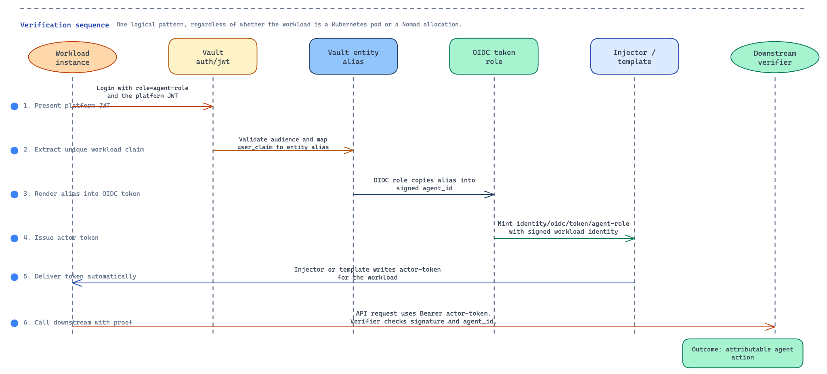
- The workload starts with its platform-native identity. The workload authenticates to Vault through the JWT auth method.
- Vault extracts a unique workload identifier using user_claim.
- Vault binds that identity to the workload's Vault entity alias.
- Vault generates an OIDC identity token whose template includes that alias as agent_id.
- The actor token is delivered automatically to the workload by platform-native injection or templating.
- Downstream systems verify the signed token and can distinguish each agent instance independently.

Security and operational benefits
- No static credentials in code or images.
- No application code changes required to obtain a unique identity.
- Unique agent identity per pod, allocation, or equivalent runtime instance.
- Signed, verifiable actor tokens for downstream trust decisions.
- Stronger audit trails because each agent instance is independently attributable.
- Cleaner separation of concerns: platforms provide workload identity, Vault brokers and signs application-facing identity.

Design guidance
Choose a user_claim that is truly unique per runtime instance. In Kubernetes this can be the pod name or pod ID; in Nomad it can be an allocation-derived claim. The uniqueness of the final agent_id depends on that source claim being unique.

