CAPSTONE PROJECT -02

JOB MARKET ANALYSIS

TEAM ID: PTID-CDA-OCT-25-803
PROJECT ID: PRDA-04 JOB MARKET ANALYSIS

TEAM MEMBERS:
SR.NO | NAME | EMAILID
1 | ADITYA HINGRAJIYA | adityahingrajiya7@gmail.com
2 | AKSHAR PANCHAL | panchalakshar0687@gmail.com
3 | MEDHAKSHI PANDYA | pandyamedhakshi@gmail.com

INDEX

Sr. No | Content | Page no
1 | INTRODUCTION  - Project Objective  - Dataset Overview  - Tools & Technologies Used | 3
2 | DATA ANALYSIS USING SQL  - Questions / Problem Statements  - SQL Queries  - Results & Screenshots of Queries | 4
3 | CHALLENGES DURING EXECUTION  - Technical Challenges  - Solutions/Approach to Fix Them | 19
4 | BUSINESS INSIGHTS | 21
5 | POWERBI DASHBOARDS  - Dashboard Objectives  - Dashboard Screenshots  - Insights from Visuals | 22
6 | CONCLUSION | 24

INTRODUCTION

- In the modern data-driven economy, understanding job market trends is crucial for both job seekers and employers. The dataset consists of 742 records and 42 attributes, providing a comprehensive overview of job titles, salary ranges, company details, required skills, and other organizational factors. By examining these features, the study aims to identify which locations, industries, and qualifications are most in demand, helping stakeholders make informed career and business decisions.
- The main factors analyzed are: states with the highest number of job opportunities, average and range of salaries, and industries leading in Data Science job postings. Additionally, we will discuss trends associated with education levels and salary and the most frequent requirements by employers, too.
- Visualization and interpretation of data are effectively done using Tableau and Power BI. These visualizations uncover patterns and correlations that are not immediately apparent from the raw data. The insights drawn from this project will aid job seekers in identifying the most valuable skills and areas that pay the most, while companies benefit by understanding the competition in the market, salary benchmarks, and demand in the industry. The ultimate goal of this analysis is to bridge the gap in supply and demand in the workforce with more informed decisions in hiring, career planning, and skill development.

DATA ANALYSIS USING SQL
Q.1. Get data from the database with the given credentials.
We connect to the database using valid credentials (username, password, host) through a database driver. Once authenticated, we run SQL queries to retrieve the required data.

Screenshot:
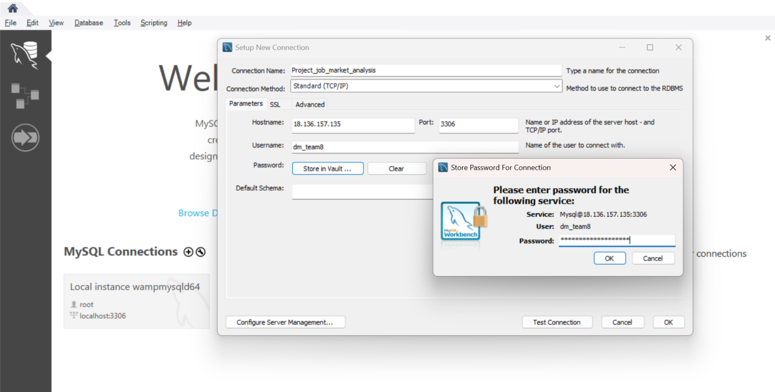

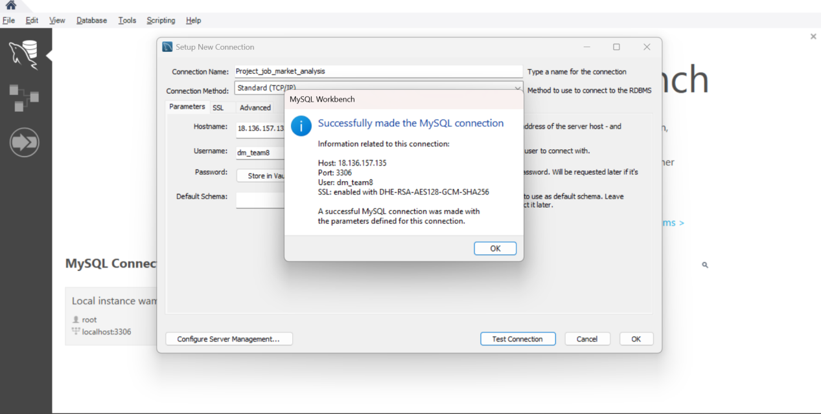

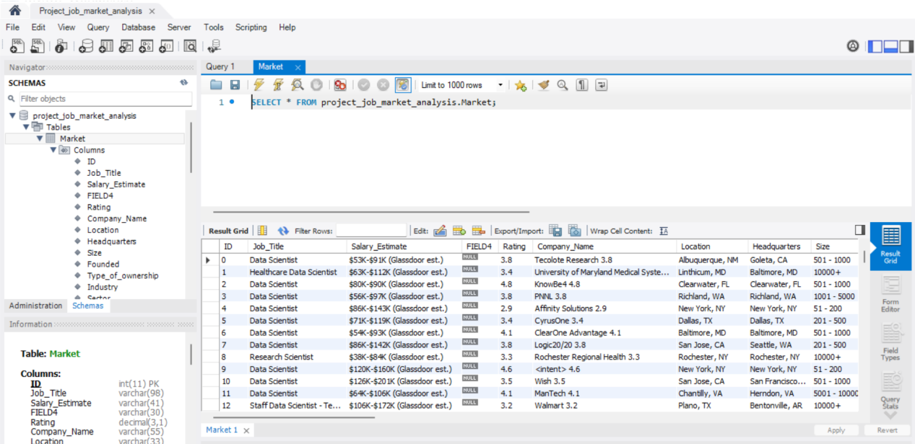

Q.2.States with most number of Jobs.
Query:
select Job_Location, count (*) as Num_of_jobs
From job_market
group by Job_Location
order by Num_of_jobs Desc;
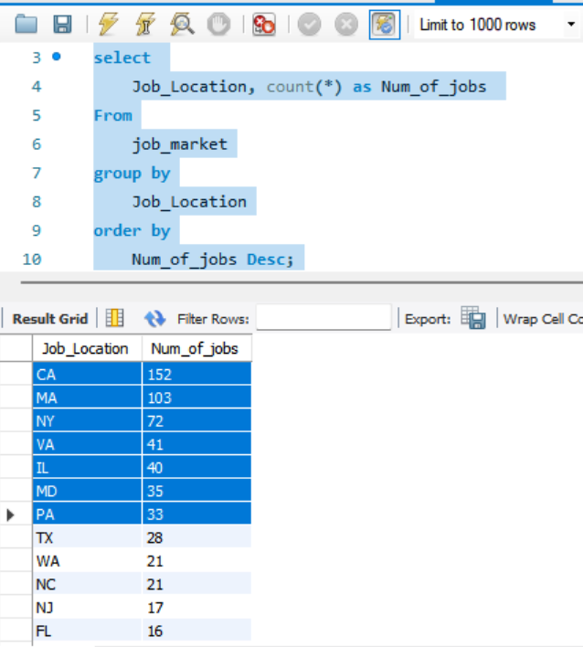
Q.3. Average Minimal and Maximal Salaries in Different States.
Query:
SELECT
Job_Location,
MIN(Avg_Salary_in_k) AS Average_Minimal_Salary,
MAX(Avg_Salary_in_k) AS Average_Maximal_Salary
FROM
job_market
GROUP BY
Job_Location
ORDER BY
Average_Maximal_Salary DESC;

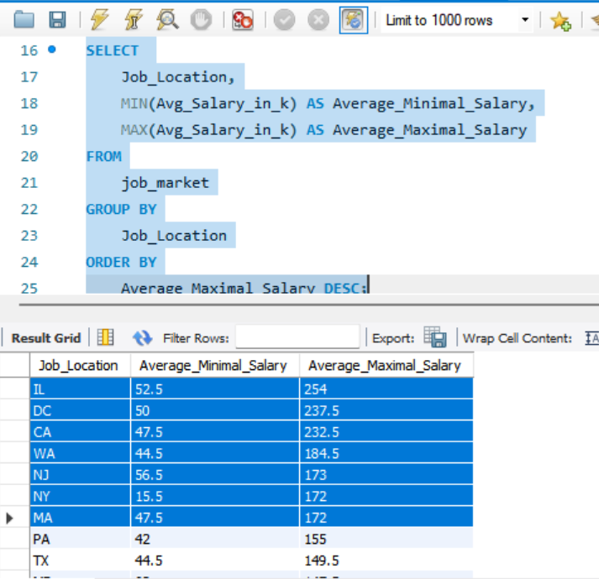

Q.4. Average Salary in Different States.
Query:
Select Job_Location,
Round (avg ((Lower_Salary_in_Thousand_$ + Upper_Salary_in_Thousand_$)/2),2) as Average_Salary_in_K_$
from job_market
group by Job_Location
order by Average_Salary_in_K_$ Desc;

Screenshot:
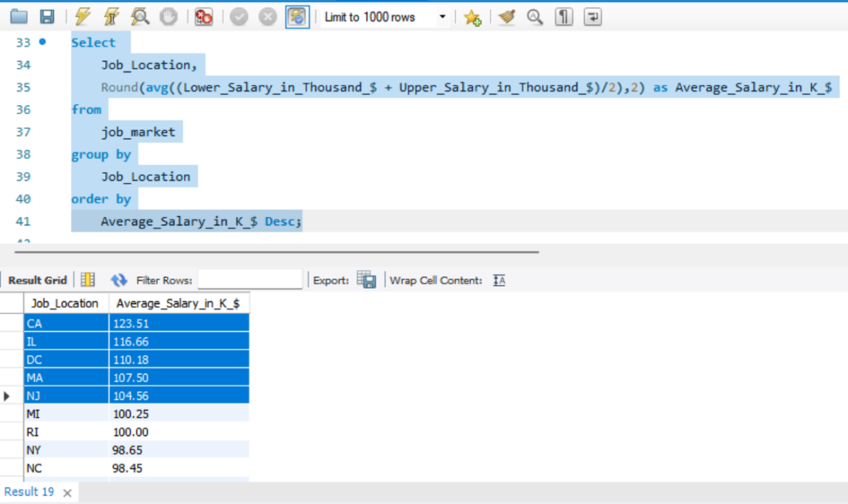

Q.5. Top 5 Industries with maximum number of Data Science related job postings.
Query:
SELECT Industry,
COUNT (*) AS Job_post
FROM job_market
WHERE Job_Title REGEXP 'Scientist|Science'
GROUP BY
Industry
ORDER BY Job_post DESC LIMIT 5;
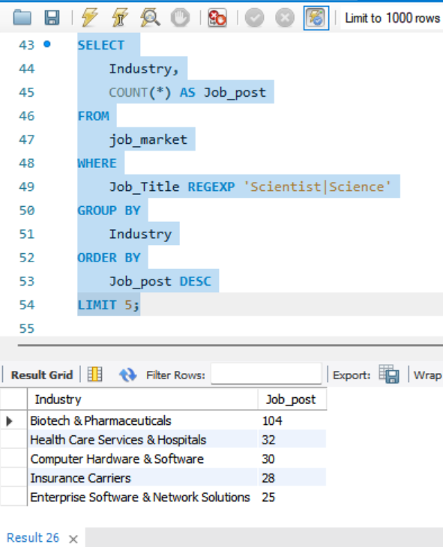
Q.6. Companies with maximum Number of job openings.

Query:
SELECT company_txt as Companies,
COUNT (*) AS Job_opening
FROM job_market
GROUP BY
Companies ORDER BY Job_opening DESC;

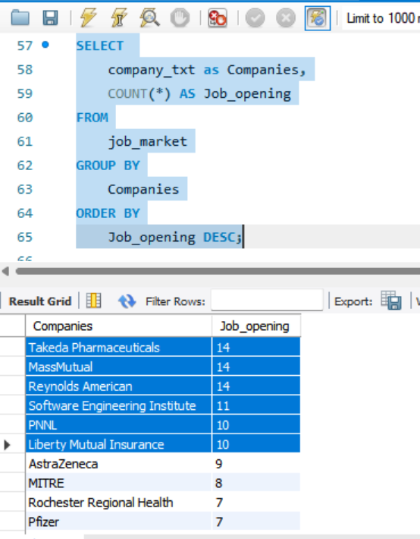

Q.7. Job Titles with most Number of Jobs.
Query:
SELECT company_txt as Companies,
COUNT (*) AS Job_opening
FROM job_market
GROUP BY Companies
ORDER BY Job_opening DESC;

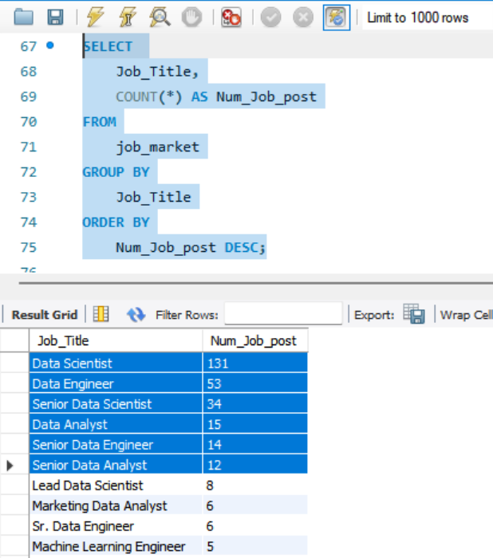

Q.8. Salary of job titles with most number of jobs.
Query:
SELECT Job_Title,
COUNT (*) AS Num_Job_post,
Round (avg ((Lower_Salary_in_Thousand_$ + Upper_Salary_in_Thousand_$)/2),2) as Average_Salary_in_Thousand_USD
FROM job_market
GROUP BY Job_Title
ORDER BY Num_Job_post DESC, Average_Salary_in_Thousand_USD DESC;

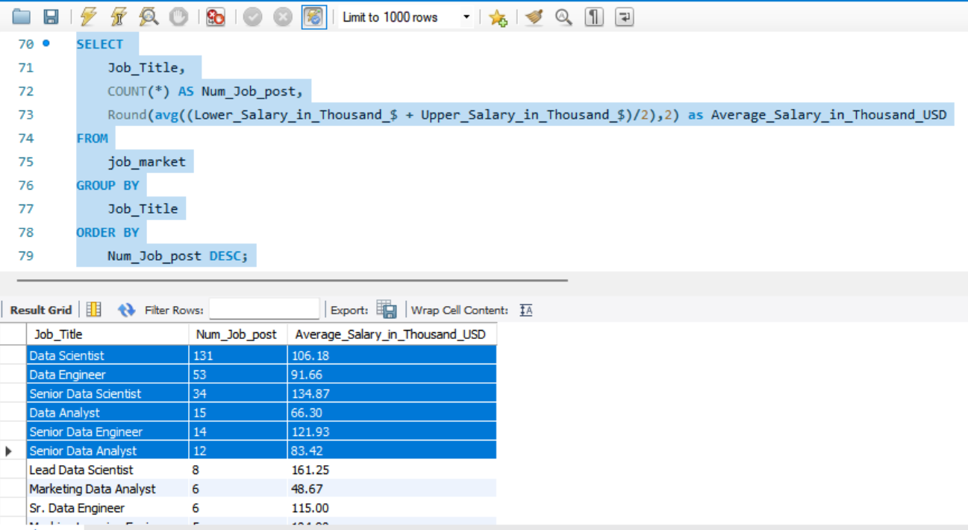
Q.9. Skills required by companies for each job title.
Query:
SELECT
Company_txt as Companies,
Job_Title,
TRIM (BOTH ',' FROM CONCAT_WS (',',
IF (python = 1, 'Python', NULL),
IF (spark = 1, 'Spark', NULL),
IF (aws = 1, 'AWS', NULL),
IF (excel = 1, 'Excel', NULL),
IF (sas = 1, 'SAS', NULL),
IF (keras = 1, 'Keras', NULL),
IF (pytorch = 1, 'PyTorch', NULL),
IF (scikit = 1, 'Scikit-Learn', NULL),
IF (tensor = 1, 'TensorFlow', NULL),
IF (hadoop = 1, 'Hadoop', NULL),
IF (tableau = 1, 'Tableau', NULL),
IF (bi = 1, 'Power BI', NULL),
IF (flink = 1, 'Flink', NULL),
IF (mongo = 1, 'MongoDB', NULL),
IF (google_an = 1, 'Google Analytics', NULL)
)) AS Skills_Required
FROM job_market
ORDER BY Company_txt, Job_Title;

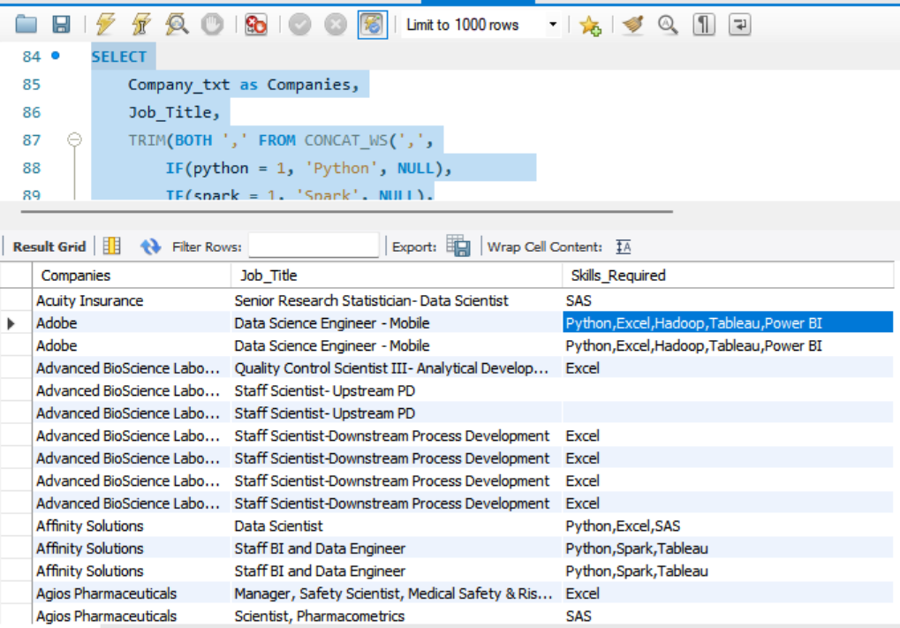

Q.10. Analyse all the features and derive multiple insights.
- Cities with most openings.
Query:
SELECT * FROM jma.job_market;
SELECT Job_City, Job_State, COUNT (*) AS postings
FROM job_market
GROUP BY Job_City, Job_State
ORDER BY postings DESC
LIMIT 20;

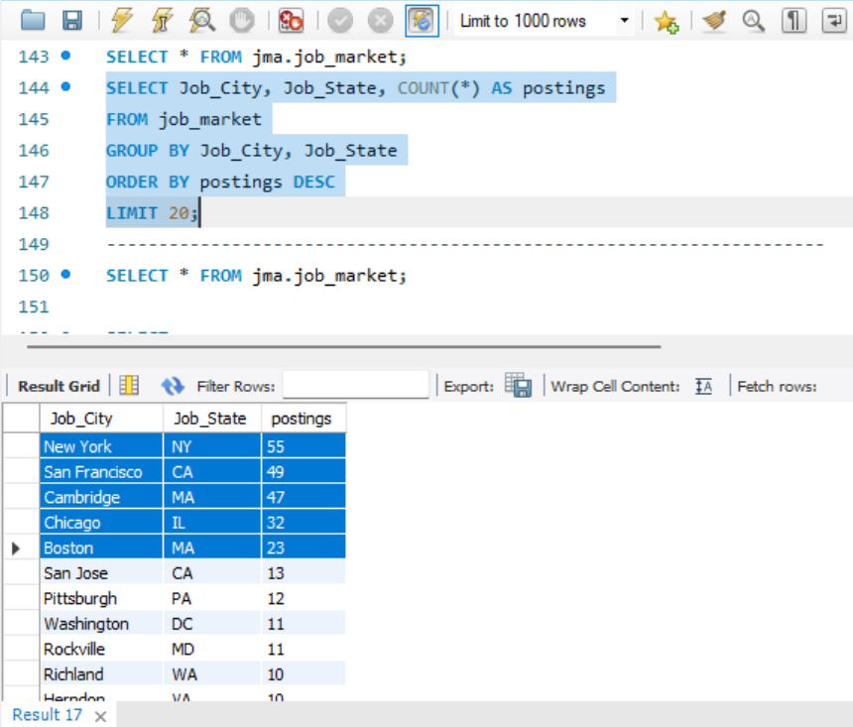

- “Data Science” related vs others (volume & salary)
Query:
SELECT CASE
WHEN Job_Title REGEXP 'Scientist|Science' THEN 'Data Science related'
ELSE 'Other'
END AS Science_bucket,
COUNT (*) AS postings,
Round (avg ((Lower_Salary_in_Thousand_$ + Upper_Salary_in_Thousand_$)/2),2) as Average_Salary_in_K_$
FROM job_market
GROUP BY Science_bucket
ORDER BY postings DESC;
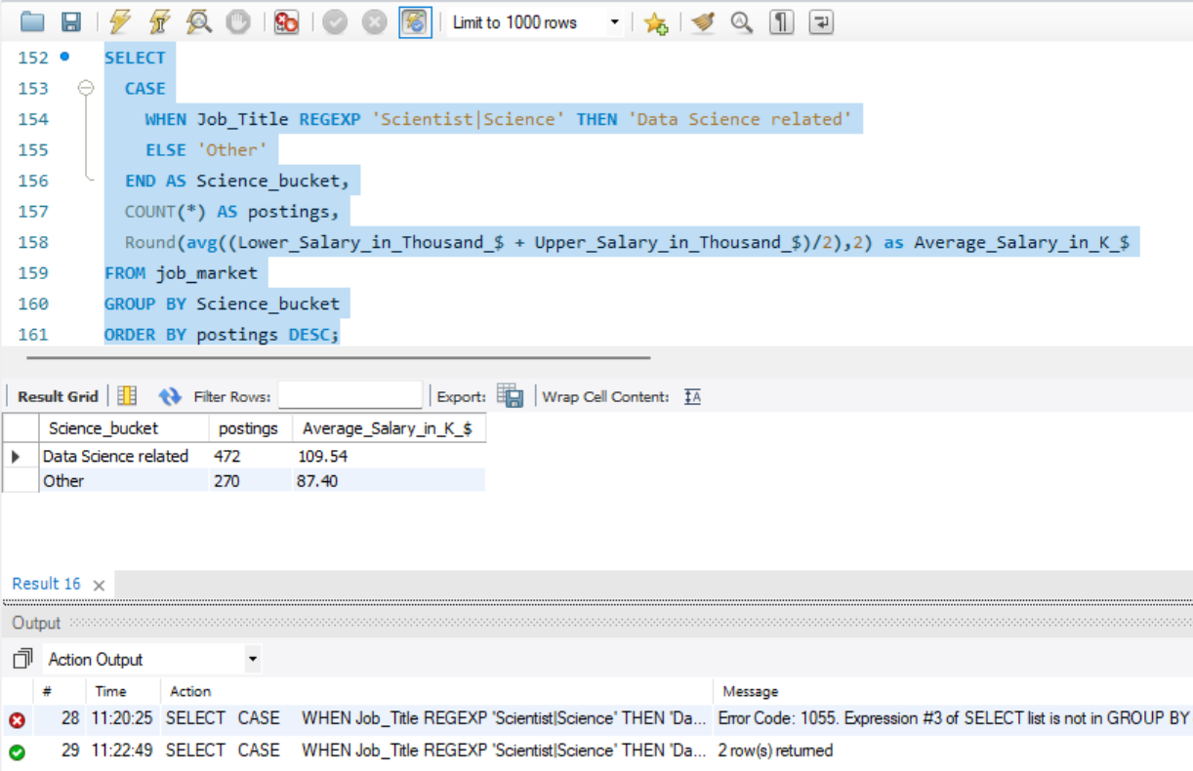

- Salary bands per title (distribution)
Query:
SELECT job_title_sim AS Title,
CASE WHEN ((Lower_Salary_in_Thousand_$+Upper_Salary_in_Thousand_$)/2) < 80 THEN '<80k'
WHEN ((Lower_Salary_in_Thousand_$+Upper_Salary_in_Thousand_$)/2) < 120 THEN '80–120k'
WHEN ((Lower_Salary_in_Thousand_$+Upper_Salary_in_Thousand_$)/2) < 160 THEN '120–160k'
ELSE '160k+'
END AS salary_band_k,
COUNT (*) AS postings
FROM job_market
GROUP BY Title, salary_band_k
ORDER BY Title, postings DESC;
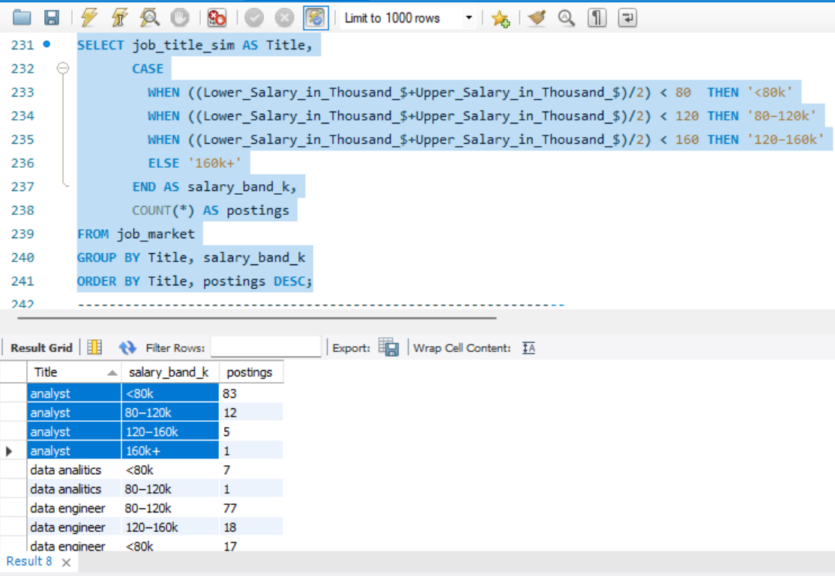

- Top paying titles overall
Query:
SELECT job_title_sim AS Title,
ROUND (AVG ((Lower_Salary_in_Thousand_$ + Upper_Salary_in_Thousand_$)/2),2) AS Avg_Salary_k,
COUNT (*) AS posts
FROM job_market
GROUP BY Title
HAVING posts >= 5
ORDER BY Avg_Salary_k DESC;
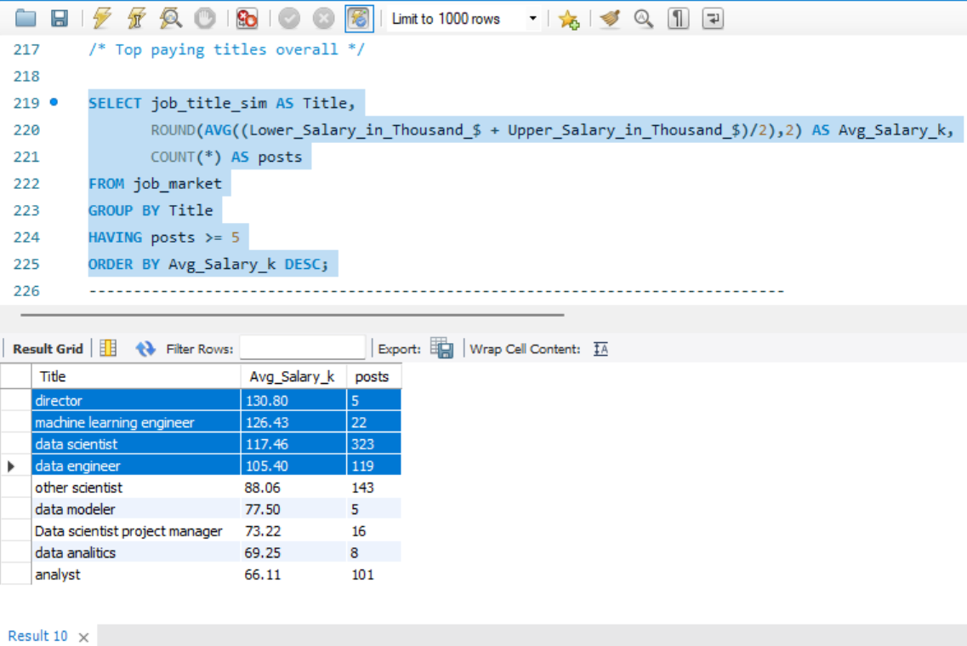

- Most in-demand skills (overall)
Query:
SELECT skill, total_postings
FROM (
SELECT 'python' AS skill, SUM (python) AS total_postings FROM job_market UNION ALL
SELECT 'SQL', SUM (SQL) FROM job_market UNION ALL
SELECT 'aws', SUM (aws) FROM job_market UNION ALL
SELECT 'spark', SUM (spark) FROM job_market UNION ALL
SELECT 'hadoop', SUM (hadoop) FROM job_market UNION ALL
SELECT 'tableau', SUM (tableau) FROM job_market UNION ALL
SELECT 'excel', SUM (excel) FROM job_market) s
ORDER BY total_postings DESC;

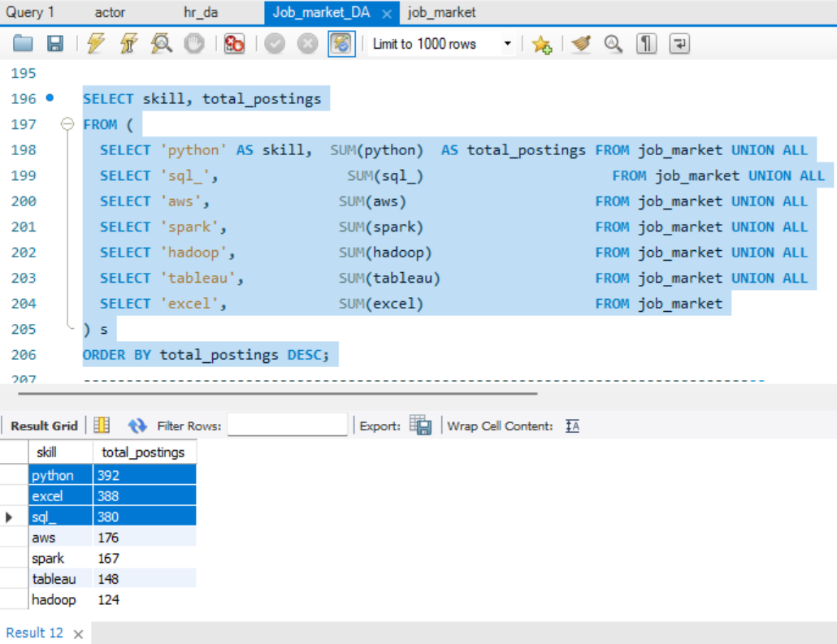

6.Salary spread within each job role
Query:
SELECT job_title_sim AS Title,
COUNT (*) AS postings,
MIN(`Lower_Salary_in_Thousand_$`) AS min_salary_k,
MAX(`Upper_Salary_in_Thousand_$`) AS max_salary_k,
ROUND (AVG ((`Lower_Salary_in_Thousand_$` + `Upper_Salary_in_Thousand_$`) / 2), 2) AS avg_salary_k
FROM job_market
WHERE `Lower_Salary_in_Thousand_$` IS NOT NULL
AND `Upper_Salary_in_Thousand_$` IS NOT NULL
GROUP BY Title
ORDER BY postings DESC;
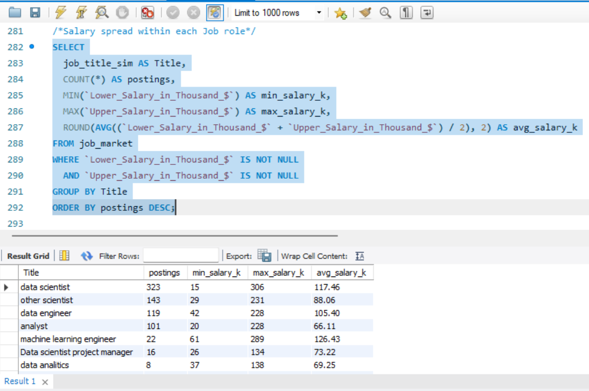

- Average salary by seniority (within each title).
Query:
SELECT
job_title_sim AS Title,
seniority_by_title AS Seniority,
ROUND (AVG ((`Lower_Salary_in_Thousand_$` + `Upper_Salary_in_Thousand_$`) / 2), 2) AS Avg_Salary_k,
COUNT (*) AS posts
FROM job_market
GROUP BY Title, Seniority
ORDER BY Title, Avg_Salary_k DESC;
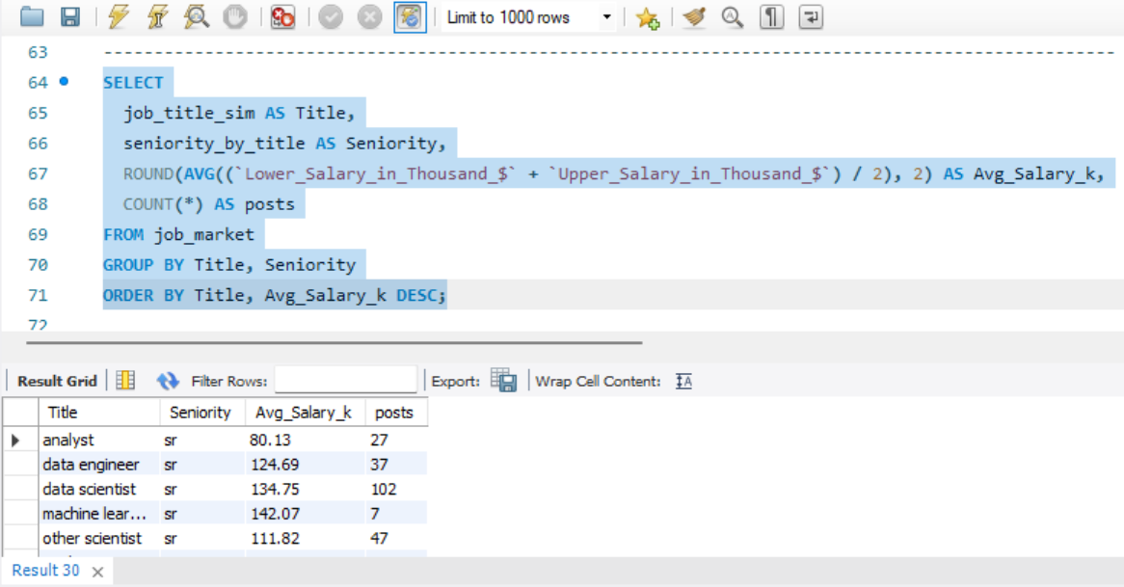

CHALLENGES DURING EXECUTION

Challenges and Solutions
1. Challenge: Dataset contained inconsistent, missing, and incorrectly formatted values.
Solution: Performed detailed data cleaning using Excel/SQL functions to remove nulls, fix formats, and ensure consistency before querying.
2. Challenge: Large dataset size and many columns resulted in slow query execution and difficulty identifying relevant fields.
Solution: Applied indexing, optimized SQL queries, and selected only necessary columns to improve performance and readability.
3. Challenge: Unclear or inconsistent column names made interpretation difficult.
Solution: Referred to dataset documentation/metadata and used SQL aliasing or renaming to make columns meaningful and easier to understand.
4. Challenge: Incorrect or inconsistent data types (e.g., numbers stored as text) caused errors during analysis.
Solution: Converted data types using SQL functions to ensure accurate filtering, aggregation, and calculations.
5. Challenge: Duplicate records across multiple columns and tables affected accuracy.
Solution: Identified and removed duplicate entries to eliminate redundancy and maintain data reliability.
6. Challenge: Long text fields and too many columns made visualization and chart selection difficult.
Solution: Simplified data by selecting essential fields, summarizing text columns, and using sample data to create clear and effective visualizations.
7. Challenge: Selecting suitable and visually balanced colour combinations for charts was difficult.
Solution: Experimented with different colour palettes and used Power BI’s theme customization feature to ensure consistent and professional visuals.
8. Challenge: Crafting meaningful storytelling, clear titles, and impactful insights was challenging.
Solution: Analysed results carefully, identified key trends, and used concise, insight-driven language to improve storytelling quality.

BUSINESS INSIGHTS

- Data driven roles dominate hiring, with Data Scientist and Data Engineer leading, showing companies' strong push toward analytics and automation.
- Python, SQL, and Excel remain the most essential skills, that means the foundational technical capabilities are crucial in most jobs related to data.
- Junior positions are in highest demand, meaning organizations prefer talent that will scale, be cost-efficient, and grow with them.
- Increased average salary for Master’s Degree holders. This shows that advanced education provides massive returns related to career and compensation.
- Industries like Biotech, Pharma, Insurance, and IT show the highest job volume, signaling where market growth and digital transformation are strongest.
- States like CA, IL, and DC offer the best opportunities in terms of salary and indicate geographic clusters where companies are willing to pay a premium for skilled talent.

POWERBI DASHBOARDS

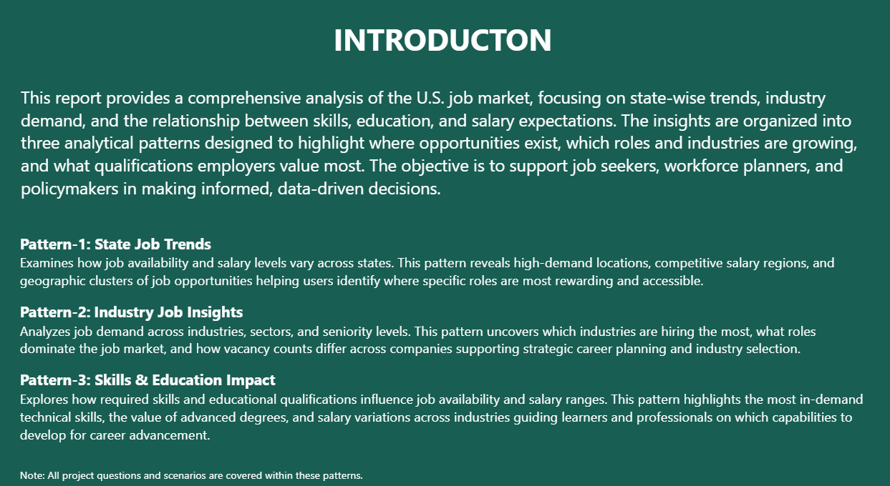

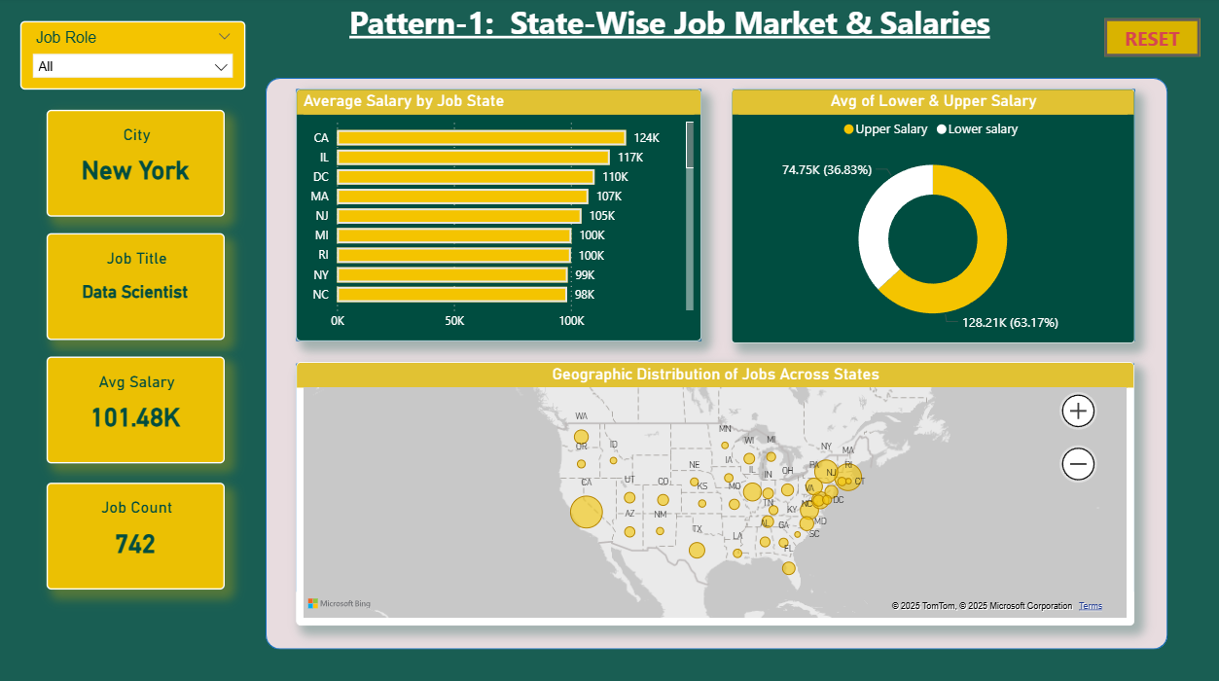

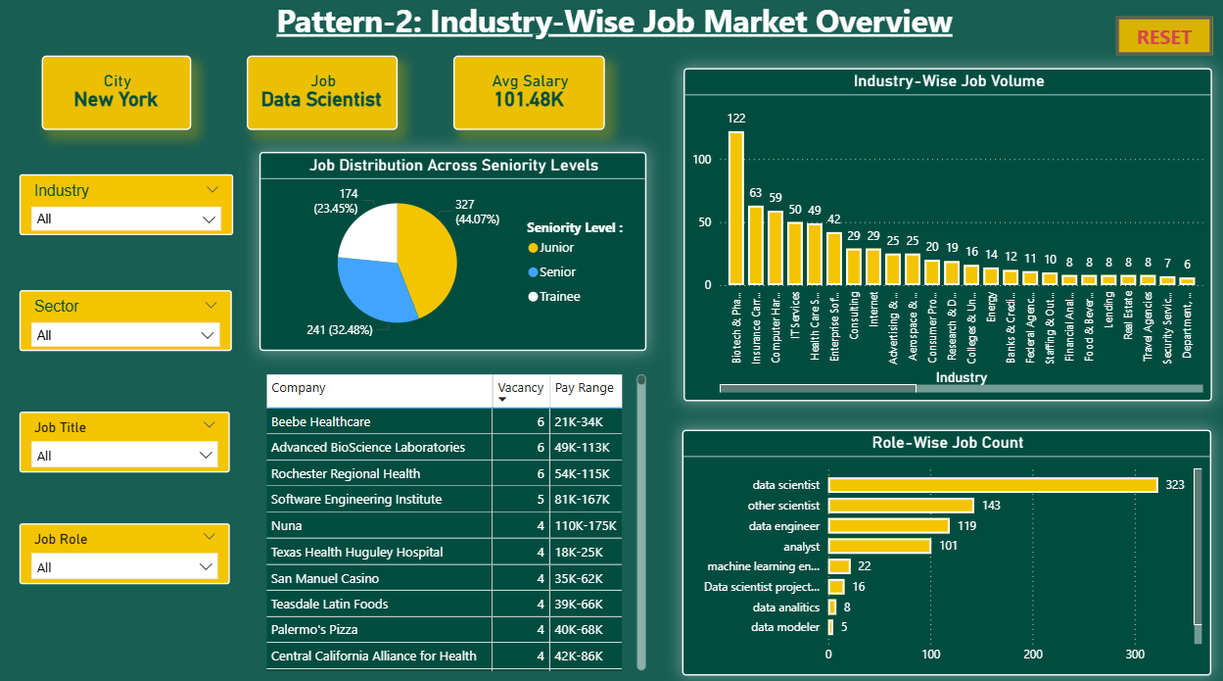

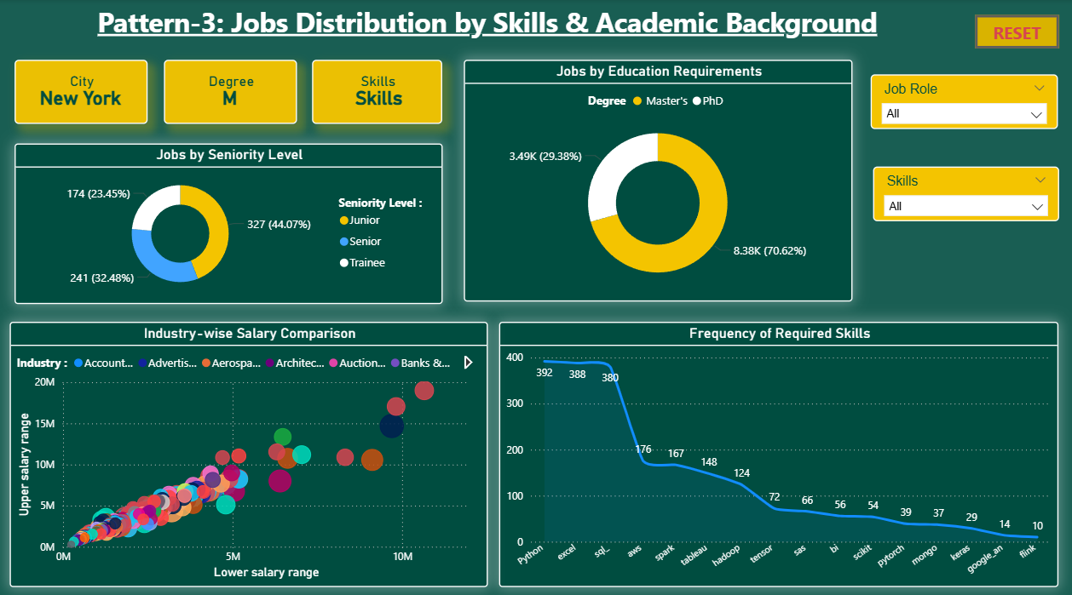

CONCLUSION

- Data Scientist, Data Engineer, and Analyst are leading the job market with a high demand for data-oriented talent. This further points out the continued industry movement toward analytics-driven decision-making.
- Python, Excel, and SQL are the most critical skills, these three form the foundation of most high demand roles. The investment in these core skills greatly enhances job readiness and competitiveness.
- Junior level positions dominate the hiring landscape, meaning firms prefer entry-level talent that is scalable. This trend is indicative of strong opportunities for freshers and early-career professionals.
- Master's degree holders have higher average salaries than PhDs, which is indicative of strong ROI from professional degrees. Education still plays a key role in compensation and career advancement.
- High paying states like CA, IL, and DC and growth heavy industries like Biotech, Pharma, and IT are the drivers of the job market. The clusters showcase the areas where job seekers can target to get better salaries and long-term growth.

