**COVID-19 DATA EXPLORATION BY SQL**

**1) What is the Mortality rate - total deaths divided by total cases**

SELECT Country,Confirmed, Deaths, (Deaths * 1.0 /Confirmed) * 100 as mortality_rate

FROM covid

WHERE Country is not NULL

order by 1,2;

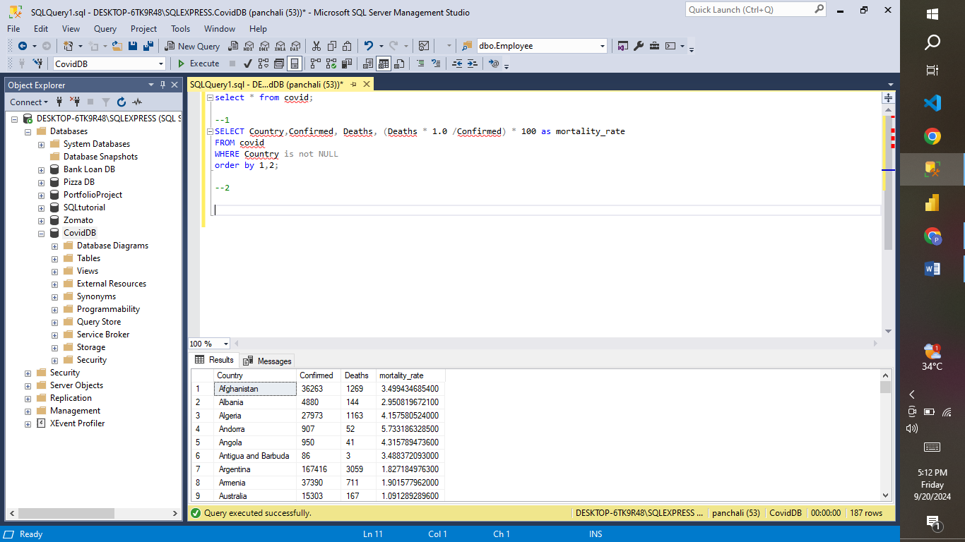

**-- 2) What percentage of the Recovered of Covid**

SELECT Country,Confirmed, Recovered, (Recovered * 1.0 /Confirmed) * 100 as PercentRecoveredCases

FROM covid

WHERE Country is not NULL

order by 1,2;

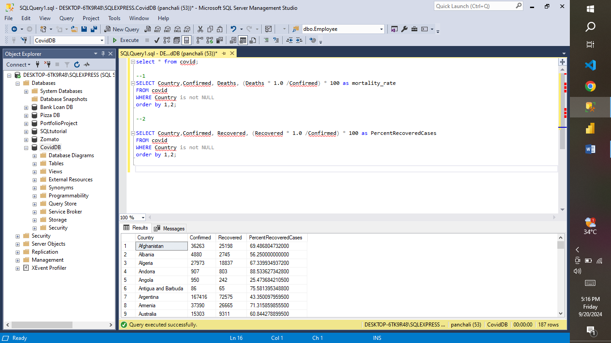

**3) What country has the highest infection rate.**

SELECT Country, Max(Confirmed) as highestInfectionCount

FROM covid

WHERE Country is not NULL

Group by Country

order by max(Confirmed) desc;

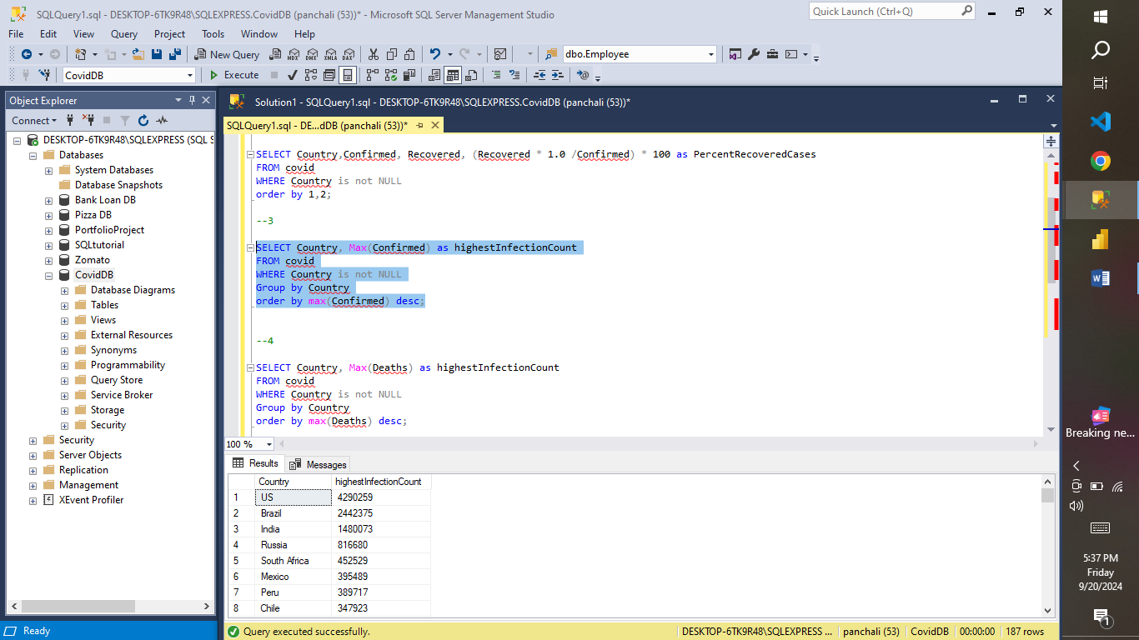

**4) What country has the highest death rate.**

SELECT Country, Max(Deaths) as highestInfectionCount

FROM covid

WHERE Country is not NULL

Group by Country

order by max(Deaths) desc;

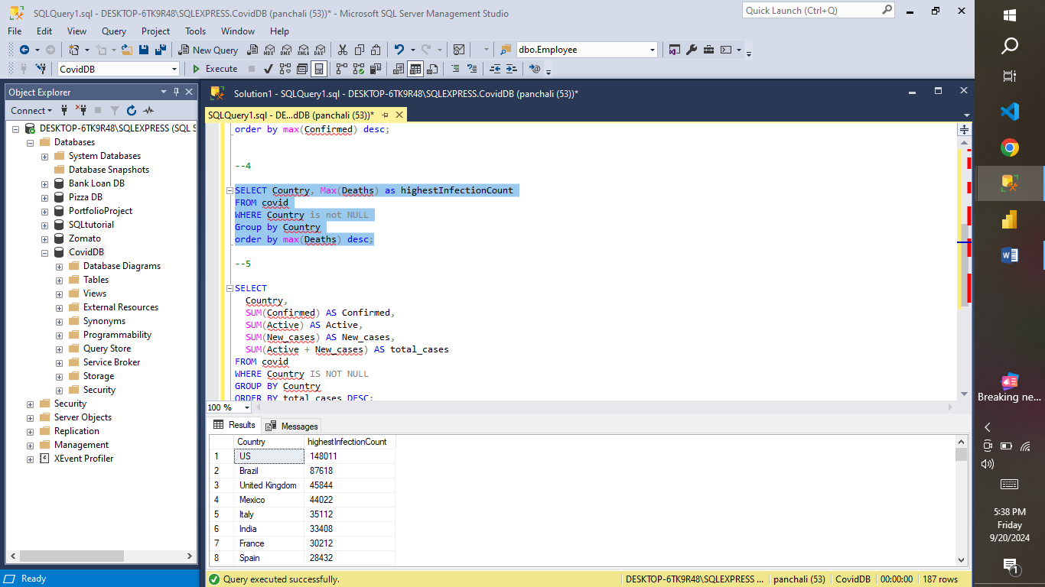

**5) What country has the highest old and new cases.**

SELECT

Country,

SUM(Confirmed) AS Confirmed,

SUM(Active) AS Active,

SUM(New_cases) AS New_cases,

SUM(Active + New_cases) AS total_cases

FROM covid

WHERE Country IS NOT NULL

GROUP BY Country

ORDER BY total_cases DESC;

